 | Class Read | Focused texts | Genres of writing | Objectives covered
Autumn 1 | 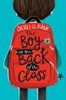  The Boy in the Back of the Class  Onjali Q. Rauf | The Boy in the Back of the Class  Onjali Q. Rauf | Recount | Writing  Choose the appropriate register (formal/informal)  Reading  Apply their growing knowledge of root words, prefixes and suffixes  Continue to read a wide range of challenging stories  Infer characters feelings, thoughts and motives and justify using evidence
 |  |  | Persuasive letter  Informal | Writing  Use hyphens to avoid ambiguity  Use a wide range of cohesive devices  In fiction, consider how authors develop character and setting  Reading  Apply their growing knowledge of root words, prefixes and suffixes  Continue to read a wide range of challenging stories  Evaluate authors’ use of figurative language
 |  |  | Narrative | Writing  Summarise main ideas using evidence  Reading  Apply their growing knowledge of root words, prefixes and suffixes  Continue to read a wide range of challenging stories
Autumn 2 | The Boy in the Back of the Class  Onjali Q. Rauf | 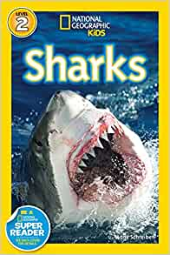  Sharks  National Geographic | Non-chronological reports | Writing  Use perfect form to indicate time/cause. Punctuate bullet points consistently  Use further organisational and presentational devices to structure text  Reading  Distinguish between fact and opinion
 |  | The Boy in the Back of the Class  Onjali Q. Rauf | Information text | Writing  Use a wide range of cohesive devices  Reflect understanding of audience and purpose through choice of grammar, vocabulary, and structure  Use perfect form to indicate time/cause. Punctuate bullet points consistently  Use further organisational and presentational devices to structure text  Reading  Summarise main ideas identifying key details
 |  | 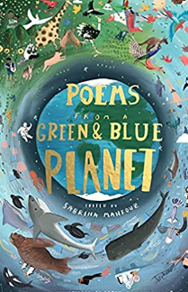  Animal poems  Sabrina Mahfouz | Poetry | Writing  Evaluate how authors use language and consider effect on the reader  Use knowledge of language and structure gained from stories, plays, poetry and non-fiction in their writing  Use further organisational and presentational devices to structure text  Become familiar with figurative language  Evaluate how authors use language and consider effect on the reader  Reading  Perform poems to read aloud for an audience (using intonation, tone, volume to convey meaning)
Spring 1 | 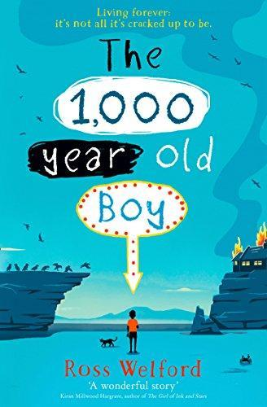  The 1000 year old Boy  Ross Welford | 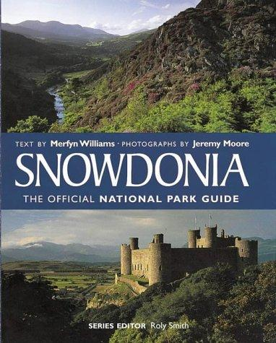  Snowdonia National Guide  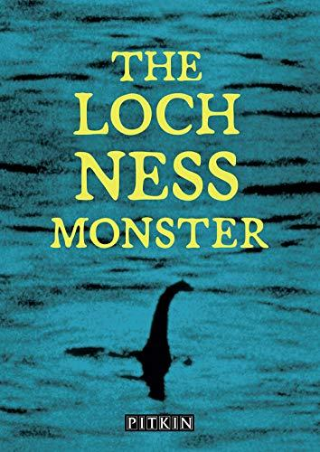  Roxy Smith  Loch Ness Monster  Charles Fawkes | Balanced Argument  Legend of Loch Ness  Narrative/witness sighting from a boy fishing | Writing  Use colons to introduce a list and mark boundaries between clauses  Use further organisational and presentational devices to structure text  Reflect understanding of audience and purpose through choice of grammar, vocabulary, and structure  Reading  Retrieve, record and present information  Writing  Integrate dialogue to advance action and convey character  Develop characters, settings and atmosphere using language and vocabulary from reading books  Use a wide range of devices to build cohesion across paragraphs  Reading  Increase their familiarity with a wide range of books, including myths, legends, and traditional stories  Discuss books and challenge others’ opinion
 |  | The 1000 year old Boy  Ross Welford | Recount of the fire | Writing  Use the passive voice  Use a wide range of cohesive devices  Reflect understanding of audience and purpose through choice of grammar, vocabulary, and structure  Reading  Infer characters feelings, thoughts and motives and justify using evidence  Summarise main ideas identifying key details
Spring 2 | The 1000 year old Boy  Ross Welford | The 1000 year old Boy  Ross Welford | Letter from Jack to Alfie  Informal | Writing  Use knowledge of language from stories, plays and poetry to enhance the effectiveness of their writing  Develop characters, settings and atmosphere using language and vocabulary from reading books  Use a wide range of devices to build cohesion across paragraphs  Reading  Identify how language, structure and presentation contribute to meaning
 |  | 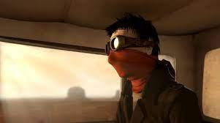  Roads End  Literacy Shed | Write a narrative from the driver’s point of view | Writing  Integrate dialogue to advance action and convey character  Develop characters, settings and atmosphere using language and vocabulary from reading books  Use a wide range of devices to build cohesion across paragraphs  Reading  Increase their familiarity with a wide range of books, including myths, legends, and traditional stories  Discuss books and challenge others’ opinion
 |  |  | Diary entry | Writing  Choose the appropriate register (formal/informal)  Use a wide range of devices to build cohesion across paragraphs  Develop characters, settings and atmosphere using language and vocabulary from reading books  Reading  Apply their growing knowledge of root words, prefixes, and suffixes  Continue to read a wide range of challenging stories  Infer characters feelings, thoughts and motives and justify using evidence
Titanium
Literacy Shed
Summer 1 | 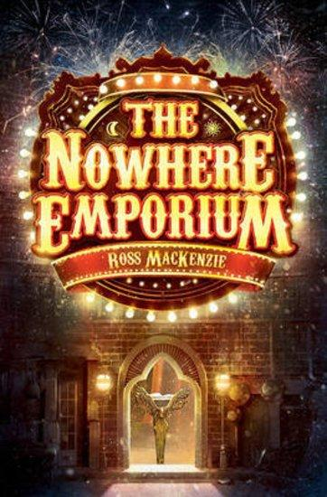  The Nowhere Emporium  Ross Mckenzie | 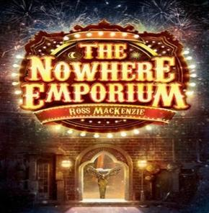  The Nowhere Emporium  Ross Mckenzie | Fantasy fiction  Story set in an imaginary world | Writing  Develop characters, settings and atmosphere using language and vocabulary from reading books  Summarise and present familiar stories in their own words  In fiction, consider how authors develop character and setting  Use a wide range of devices to build cohesion across paragraphs  Reading  Continue to read a wide range of challenging stories  Infer characters feelings, thoughts and motives and justify using evidence
 |  | 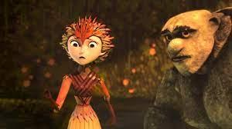  Rock, Paper, Scissors  Literacy Shed | Use dialogue to advance action and create tension | Writing  Develop characters, settings and atmosphere using language and vocabulary from reading books  Integrate dialogue to advance action and convey character  Summarise and present familiar stories in their own words  In fiction, consider how authors develop character and setting  Use a wide range of devices to build cohesion across paragraphs  Develop characters, settings and atmosphere using language and vocabulary from reading books  Reading  Continue to read a wide range of challenging stories  Infer characters feelings, thoughts and motives and justify using evidence
 |  | Pandora  Literacy Shed | Non chronological report | Writing  Link ideas across paragraphs using adverbials of time, place, and number or by varying tense  Use a wide range of devices to build cohesion across paragraphs  Integrate dialogue to advance action and convey character  Develop characters, settings and atmosphere using language and vocabulary from reading books  Reading  Continue to read a wide range of challenging stories  Infer characters feelings, thoughts and motives and justify using evidence  Make comparisons with and across books
Summer 2 | The Nowhere Emporium  Ross Mckenzie | 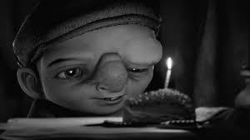  Little Freak  Literacy Shed  Romeo and Juliet  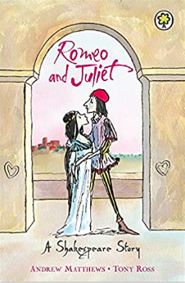  Andrew Mathers  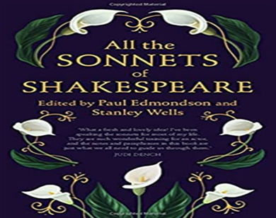  Sonnet  Shakespeare | Descriptive narrative | Writing  Use semi- colons in a longer list and mark boundaries between clauses  Integrate dialogue to advance action and convey character  Develop characters, settings and atmosphere using language and vocabulary from reading books  Use a wide range of devices to build cohesion across paragraphs  In fiction, consider how authors develop character and setting  Reading  Summarise main ideas identifying key details
 |  |  | Shakespeare | Writing  Use knowledge of language from stories, plays and poetry to enhance the effectiveness of their writing  Use knowledge of language and structure gained from stories, plays, poetry and non-fiction in their writing  Note and develop initial ideas drawing on reading  Reading  Identify how language, structure and presentation contribute to meaning  Make comparisons with and across books
 |  |  | Poetry | Writing  Evaluate how authors use language and consider effect on the reader  Use knowledge of language and structure gained from stories, plays, poetry and non-fiction in their writing  Use further organisational and presentational devices to structure text  Reading  Perform poems to read aloud for an audience (using intonation, tone, volume to convey meaning)

Writing Objectives taught throughout:
Write legibly, fluently and with increasing speed
Choose the writing implement best suited to the task
Use active/passive voice for effect
Select appropriate language and vocabulary to reflect their understanding and purpose
Identify audience and purpose when writing
Propose changes to grammar, punctuation, and vocabulary to enhance meaning/effectiveness
Assess effectiveness of own and others’ writing
Evaluate how authors use language and consider the effect on the reader
Writing Objectives taught independently and applied to writing:
Use a wider range of prefixes and suffixes
Spell some words with silent letters
Continue to distinguish between homophones and other words that are often confused
Use dictionaries to check the spelling and meaning of new words
Use morphology and etymology as a strategy for spelling
Use a thesaurus
Reading Objectives taught throughout:
*All Reading Objectives are covered within Guided Reading lessons and within cross-curricular subjects throughout the curriculum
Continue to read/ discuss a wide range of challenging stories, poems, plays, non-fiction and reference books, myths, legends and fairy stories
Discuss and explore the meaning of words in context
Use dictionaries and thesauruses to check meaning of new words/language
Identify and discuss themes and conventions
Ask questions to improve their understanding of the text
Recommend books to peers and give reasons
Be exposed to a wide range of books including myths, legends, fairy stories, modern fiction, fiction from literary heritage and books from other cultures

