 | Class Read | Focused texts | Genres of writing | Objectives covered
Autumn 1 | 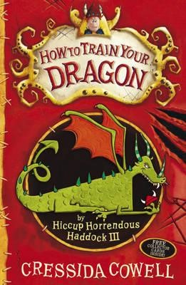  How to train your dragon | 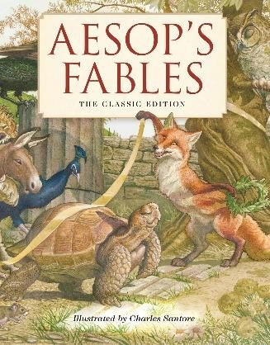  Aesops Fables,  Aesop  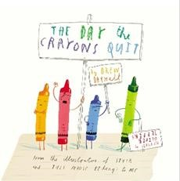  The day the Crayons Quit  Drew Daywalt | Fable  Persuasive  letters/debate | Writing  Link ideas across paragraphs using adverbials of time, place and number or by varying tense.  Proof-read work for spelling and punctuation errors.  Create characters, setting and plot.  Punctuate direct speech with inverted commas.  Express time, place and clause using conjunctions (when, before, after, while, because)  Recognise themes eg good over evil, use of magical devices.  Use the diagonal and horizontal strokes that are needed to join letters and understand which letters, when adjacent to one another, are best left unjoined  Reading  Identify themes and conventions in a wide range of books.  Take turns in high-quality discussions about what they have heard/read.  Make reasoned predictions of what might happen clearly derived from details both stated and implied.  Writing  Use wider range of subordinating conjunctions (before, after, while, when, if, because, although).  Discuss and record ideas.  Compose and practice sentences orally using an increasingly wide range of vocabulary and sentence structure. own and others’ writing, suggesting improvements Discuss words and phrases that capture the reader’s interest.  Writing  Use present perfect verb tense (I have seen).  Draw on examples of writing (structure, vocabulary and grammar) when planning their own work.  Proof-read work for spelling and punctuation errors. Write for a range of purposes.  Reading  Infer characters’ feelings, thoughts and motives and justify using evidence.  Discuss ways that emotive language can be deployed in a text.

 |  | 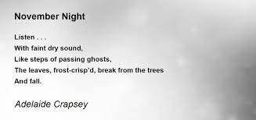  November Nights By Adalaide Crapsey alongside a selection of poetry by John Foster. | To write a Cinquain poem | Writing  Use a dictionary to spell words correctly.  Identify how language, structure, vocabulary, grammar and presentation contribute to meaning.  Reading  Perform poems and play scripts to read aloud for an audience (using intonation, tone, volume and action).  Recognise some different forms of poetry.  Read books that are structured in different way.
Autumn 2

 |  | How to train your dragon  Cressida Cowell  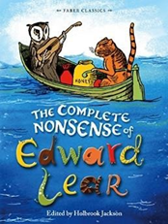  A book of nonesence  Edward Lear  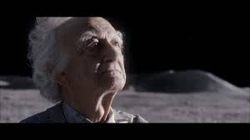  John Lewis Advert 2015 | Diary entry  Limerick  Newspaper report | Writing  Vary sentence openers for effect e.g. adverbs preposition phrases, collective nouns and subordinate clauses Proof read work for spelling and punctuation errors  Reading  Infer characters feelings thoughts and motives and justify using evidence  Writing  Use a dictionary to spell words correctly.  Identify how language, structure, vocabulary, grammar and presentation contribute to meaning.  Reading  Perform poems and play scripts to read aloud for an audience (using intonation, tone, volume and action).  Recognise some different forms of poetry.  Read books that are structured in different way.  Writing  Use a dictionary to spell words correctly.  Identify how language, structure, vocabulary, grammar and presentation contribute to meaning.  Proof-read work for spelling and punctuation errors. Write for a range of purposes.  Punctuate direct speech with inverted commas.  Express time, place and clause using conjunctions (when, before, after, while, because)
Spring 1 | 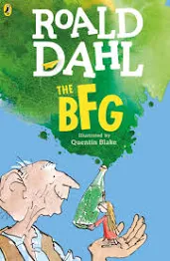  The BFG, Roald Dahl | 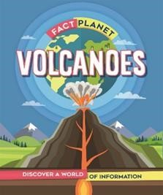 | Explanation text  (Link with Geography)  Character description | Writing  Locate information using contents, index and glossaries. Use simple organizational devices e.g. headings, subheadings.  Be exposed to books that are structured in different ways.  Discuss words and features of a text that capture the reader’s interest.  Express time, place and cause using adverbs (then, next, soon, therefore).  Reading  Retrieve and record information from non-fiction. Take turns in high-quality discussions about what they have heard/read.  Use dictionaries to check meanings of words.  Writing  Vary sentence openers for effect e.g. adverbs preposition phrases, collective nouns and subordinate clauses Proof read work for spelling and punctuation errors  Use varied and rich vocabulary including adjective, expanded noun phrases, adverbs preposition phrases, collective nouns, similes and alliteration  Vary sentence openers for effect e.g. adverbs preposition phrases, collective nouns and subordinate clauses  Discussing words and phrases that capture the reader’s interest and imagination  Reading  Ask questions to improve understanding of a text.  Take turns in high-quality discussions about what they have heard/read.  Use dictionaries to check meanings of words.  Infer characters feelings thoughts and motives and justify using evidence

 |  | 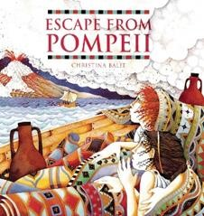  Escape from Pompeii  Christina Balit | Narrative  (Link with Geography and history) | Writing  Write non-narrative using simple organisational devices, e.g. headings and subheadings. Use the correct determiner a/an.  Understand how to place an apostrophe in words with regular plurals.  Reading  Ask questions to improve understanding of a text.  Retrieve and record information from a non-fictional text.  Read books structured in different ways.
Spring 2 |  | 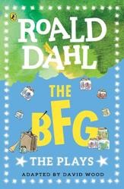  The BFG, the play script  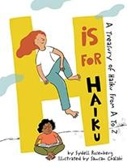  H is for Haiku,  Sydell Rosenburg  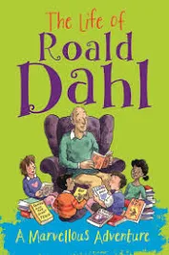  By Emma Fiscal | Write a play script  Performance poetry (Haiku)  Biography | Writing  Write from memory simple sentences dictated by the teacher.  Suggest changes to grammar and vocabulary.  Use semi colons to show who is speaking.  Use brackets to show what actions are being performed. Retell stories orally.  Reading  Perform poems and playscripts to read aloud for an audience(using intonation, tone, volume and action).  Retell some stories orally.  Read books that are structured in different way.  Writing  Identify how language, structure, vocabulary, grammar and presentation contribute to meaning.  Suggest changes to grammar and vocabulary.  Identify how to count syllables in a word. Compose and practice sentences orally using an increasingly wide range of vocabulary and sentence structure.  Proof-read work for spelling and punctuation errors  Reading  Recognise some different forms of poetry.  Perform poems and playscripts to read aloud for an audience(using intonation, tone, volume and action). Take turns in high-quality discussions about what they have heard/read.  Read books that are structured in different way.  Writing  Use the diagonal and horizontal strokes that are needed to join letters and understand which letters, when adjacent to one another, are best left unjoined.  Draft and write by:  Composing and rehearsing sentences orally (including dialogue), progressively building a varied and rich vocabulary and an increasing range of sentence structures English appendix 2  Organising paragraphs around a theme  Proofread for spelling and punctuation errors  Read their own writing aloud to a group or the whole class, using appropriate intonation and controlling the tone and volume so that the meaning is clear  Reading  Retrieve and record information from non-fiction  Take turns in high-quality discussions about what they have heard/read.  Read books structured in different ways.  Read aloud and to understand the meaning of new words they meet.  Read further exception words, noting the unusual correspondences between spelling and sound, and where these occur in the word  Checking that the text makes sense to them, discussing their understanding, and explaining the meaning of words in context  Ask questions to improve their understanding of a text

Summer 1 | 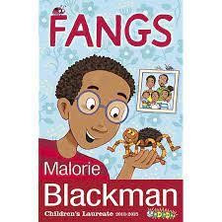  Fangs by Malorie  Blackman | 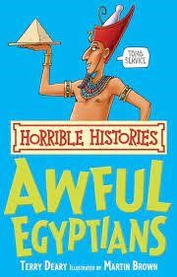  Horrible Histories  Awful Egyptions  Atlas of adventures  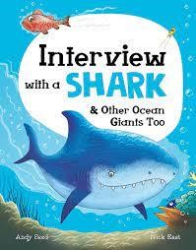  Interview with a shark  By Andy Seed | Recount  (Link with History)  Interview | Writing  Using the present perfect form of verbs in contrast to the past tense  Choosing nouns or pronouns appropriately for clarity and cohesion and to avoid repetition  Using conjunctions, adverbs and prepositions to express time and cause  Using fronted adverbials  Using commas after fronted adverbials  Indicating possession by using the possessive apostrophe with plural nouns  Reading  Take turns in high-quality discussions about what they have heard/read.  Ask questions to improve understanding of a text.  Writing  Use varied and rich vocabulary including adjective, expanded noun phrases, adverbs preposition phrases, collective nouns, similies and alliteration  Draw on examples of writing structure, vocabulary and  grammar when planning own work  Suggest changes to grammar and vocabulary  Proof read work for grammar and punctuation  Reading  Take turns in high-quality discussions about what they have heard/read.  Read books structured in different ways.

 |  | 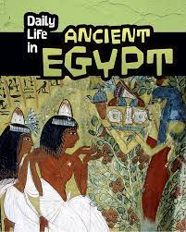 | Information Leaflet  (Link with History) | Writing  Use varied and rich vocabulary including adjective, expanded noun phrases, adverbs preposition phrases, collective nouns, similes and alliteration  Vary sentence openers for effect e.g. adverbs preposition phrases, collective nouns and subordinate clauses  Reading  Ask questions to improve understanding of a text.  Retrieve and record information from a non-fictional text. Read books structured in different ways.
Summer 2 |  | 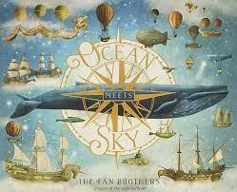  Ocean meets the sky  By the fan brothers  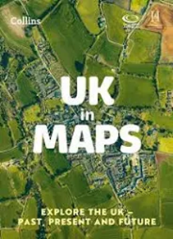  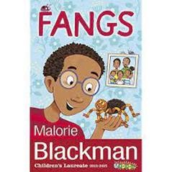  Fangs by Malorie Blackman | Setting description  To write instructions  (Link with Geography)  Predict and write next part of the story | Writing  Use similar writing to identify and understand vocabulary  (“magpie “ words and phrases to use in their own writing) Use varied and rich vocabulary, expanded nouns phrases, adverbs, preposition phrases, collected, similes and alliteration.  Vary sentence openers for effect e.g. adverbs, preposition phrases and subordinate clause.  Discuss and record ideas  Reading  Identify how language, structure, vocabulary grammar and presentation contribute to meaning  Writing  Proofread for spelling and punctuation errors  Read their own writing aloud to a group or the whole class, using appropriate intonation and controlling the tone and volume so that the meaning is clear  Use wider range of subordinating conjunctions (before, after, while, when, if, because, although).  Discuss and record ideas.  Compose and practice sentences orally using an increasingly wide range of vocabulary and sentence structure. own and others’ writing, suggesting improvements  Reading  Ask questions to improve understanding of a text.  Retrieve and record information from a non-fictional text. Read books structured in different ways.  Writing  Organise paragraphs around a theme  Build cohesion within a paragraph  Reading  Identify how language, structure, vocabulary grammar and presentation contribute to meaning  Infer characters feelings thoughts and motives and justify using evidence

Writing Objectives taught throughout

Write from memory simple sentences dictated by the teacher.
Proof-read work for spelling and punctuation errors.
Build on KS1 wide range of stories, poetry, plays, myths, legends, non-fiction and reference books.
Write for a range of purposes.
Use similar writing to identify and understand vocabulary and language (“magpie” words and phrases to use in their own writing).

Writing Objectives taught independently and applied to writing:
Use a wider range of prefixes and suffixes.
Spell words that are often misspelt.
Spell a wide range of homophones.
Use the diagonal and horizontal strokes that are needed to join letters and understand which letters, when adjacent to one another, are best left unjoined
Increase the legibility, consistency and quality of their handwriting Know which letters are best left unjoined.
Note the unusual correspondences between spelling and sound Reading Objectives taught throughout:
- apply their growing knowledge of root words, prefixes and suffixes (etymology and morphology) as listed in English Appendix 1, both to read aloud and to understand the meaning of new words they meet
- read further exception words, noting the unusual correspondences between spelling and sound, and where these occur in the word.
- preparing poems and play scripts to read aloud and to perform
- discussing words and phrases that capture the reader’s interest and imagination
- recognising some different forms of poetry
- retrieve and record information from non-fiction
- participate in discussion about both books that are read to them and those they can read for themselves
- Listen to and discuss a wide range of challenging stories, poems, plays, non fiction and referenece books, myths, legends and fairy stories.
*All Reading Objectives are covered within Guided Reading lessons and within cross-curricular subjects throughout the curriculum

