ST ANDREW’S METHODIST PRIMARY SCHOOL

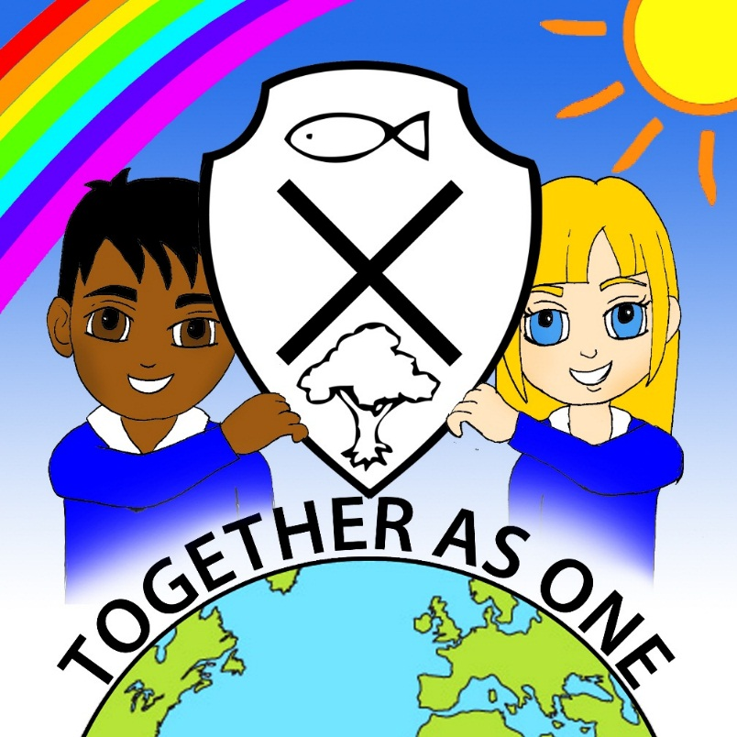

Science Policy

Reviewed February 2023

Headteacher Date:

Chair of Governing Board Date:

Date of Next Review February 2025

This policy has been scrutinized to ensure it meets the requirements of the single equality duties. The school will make every reasonable adjustment to comply with the duties and actively avoid discrimination.

Our Vision

Our school’s Christian vision, ‘Striving for excellence, together as one with God’ reflects our partnership of shared experiences, talents, interests and enthusiasm to investigate the natural world around us. Each member of the school accepts the responsibility of caring for one another and for God`s world. Science enables each individual to grow and develop in recognition that they are a unique person living in a diverse world.

Aims of the Science Policy

Our Science Policy follows The National Curriculum 2014 for Science Guidelines and aims to ensure that all pupils:
- develop scientific knowledge and conceptual understanding through the specific disciplines of Biology, Chemistry and Physics;
- develop understanding of the nature, processes and methods of Science through different types of science enquiries that help them to answer scientific questions about the world around them;
- are equipped with the scientific knowledge required to understand the uses and implications of Science, today and for the future.

Why teach Science?

A high-quality Science education provides foundations for understanding the world. Science has changed our lives and is vital to the world’s future prosperity. Through building key foundational knowledge and concepts, pupils should be encouraged to recognise the power of rational explanation and develop a sense of excitement and curiosity about natural phenomena. They should be encouraged to understand how key knowledge and concepts can be used to explain what is occurring, predict how things will behave, analyse results and draw conclusions. This understanding should be consolidated through their appreciation of applications of Science in today`s society and economy.

Through Science teaching, we are developing in our children:

- a positive attitude towards Science and an awareness of its fascination
- an understanding of Science through enquiry and investigation
- confidence and competence in scientific knowledge, concepts and skills
- an ability to reason, predict, think logically and to work systematically and accurately
- an ability to communicate scientifically
- to work both independently and in co-operation with others
- the ability and meaning to use and apply science across the curriculum and real life

School Curriculum and Planning

The 2014 National Curriculum programmes of study will create the base for planning teaching and learning in science within our school, supported by plans and resources from Sigma Science and the Primary Science Teaching Trust (PSTT), which staff will use to plan Key Learning and promote the use of relevant scientific vocabulary within each topic. Sigma Science provides a complete scheme for Primary Science and is designed so that children learn through investigation, experimentation and scientific enquiry. In addition to this, we will use opportunities of child-led interests to deepen and widen our scientific knowledge and understanding and encourage individual enquiry.

The programmes of study for Science are set out year-by-year for Key Stages 1 and 2 within our long term plan of unit coverage (see below). The science curriculum is planned and sequenced so that the new knowledge and skills the children are learning build upon what they have been taught before, whilst preparing them for what will come next. We are however, only required to teach the relevant programme of study by the end of the key stage. Within each key stage, school has the flexibility to introduce content earlier or later than set out in the programme of study and may introduce key stage content during an earlier key stage if appropriate.

Science lessons will be creative and exciting; carefully planned to engage and meet the needs of all our children in practical science. Where appropriate, opportunities will be taken to utilise our local environment in science lessons and expertise from teachers, parents and local ‘scientists’.
A display board within each class will be dedicated to Science in order to promote subject importance as well as developing ‘Sticky Knowledge’ and reinforcing key scientific vocabulary within topics, suggested within our Science Vocabulary Progression document.

Long Term Plan Unit Coverage- (Nursery- Year 6)
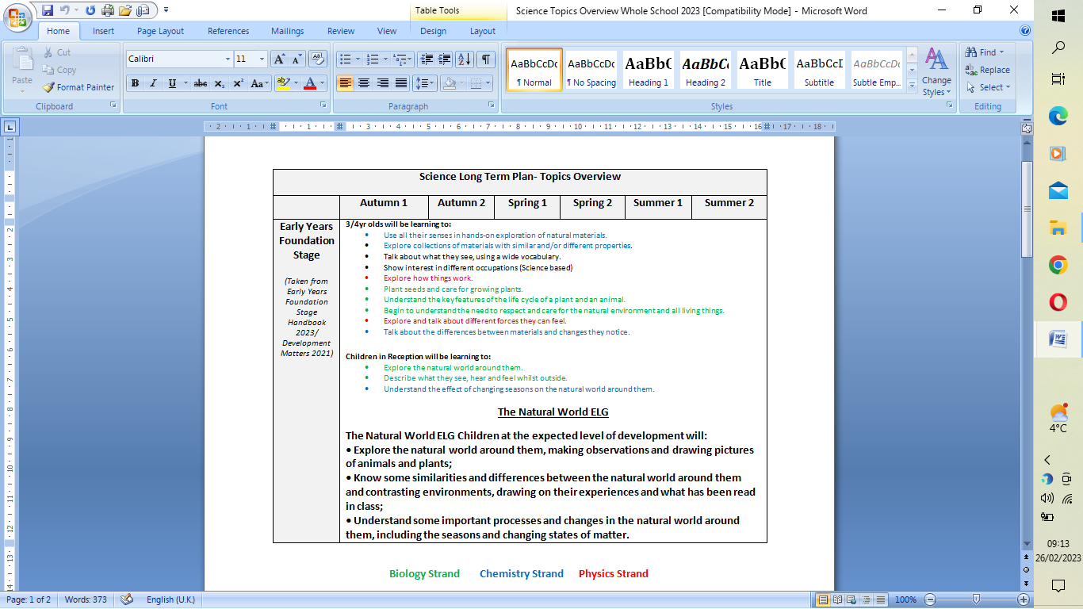

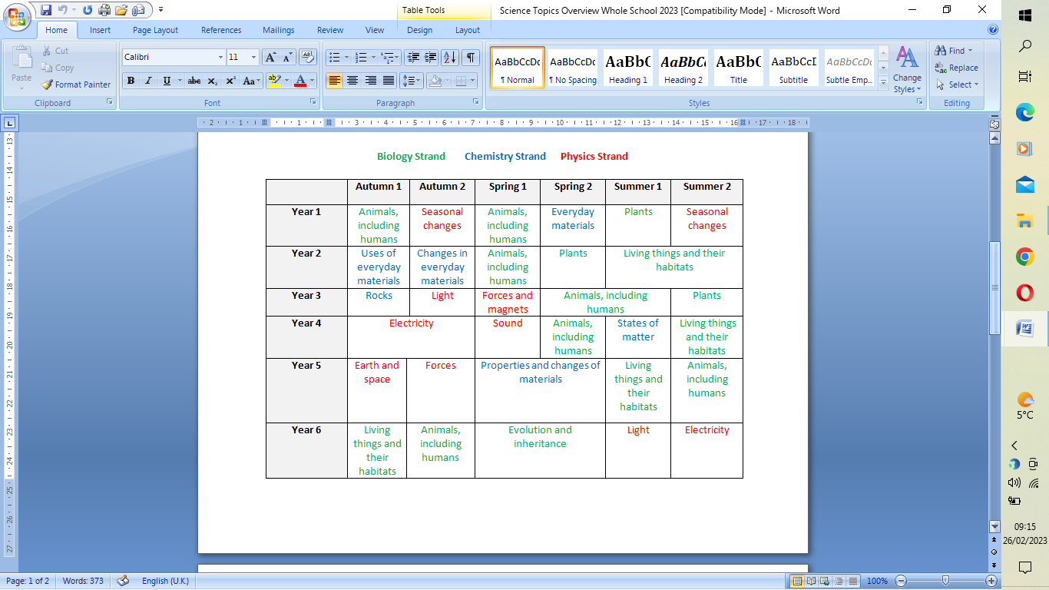

Scientific knowledge and conceptual understanding

The programmes of study describe a sequence of knowledge and concepts. While it is important that pupils make progress, it is also vitally important that they develop secure understanding of each key block of knowledge and concepts in order to progress successfully to the next stage.
Pupils should be able to describe associated processes and key characteristics in common language, but they should also be familiar with, and use, technical terminology accurately and precisely. They should build up an extended knowledge and use of specialist vocabulary. They should also apply their mathematical knowledge to their understanding of Science, including collecting, presenting and analysing data in different forms and use of electronic equipment.

The nature, processes and methods of science

‘Working Scientifically’ specifies the understanding of the nature, processes and methods of Science for each year group. It should not be taught as a separate strand.

Attainment targets

By the end of each key stage, pupils are expected to know, apply and understand the matters, skills and processes specified in the relevant programme of study.

Early Years Foundation Stage (EYFS)- Nursery and Reception.

Science at Foundation Stage is covered in the 'Understanding the World' area of the EYFS Curriculum. It is introduced indirectly through activities that encourage every child to explore, problem solve, observe, predict, think, make decisions and talk about the world around them.
During their first years at school, our children will explore creatures, people, plants and objects in their natural environments. They will observe and manipulate objects and materials to identify differences and similarities. They will also learn to use their senses, feeling dough or listening to
sounds in the environment, such as birds, sirens or the rain. They will make observations of animals and plants by first hand experiences such as planting and growing vegetables and herbs and observing closely life-cycle changes with chicks and caterpillars. The weather is discussed within every season to allow opportunity for the children to talk about changes they observe and explain why some things occur. Children will be encouraged to ask questions about why things happen and how things work. They might take part in activities such as opening a mechanical toy to see how it works, investigating which objects float or sink, increasing the incline of a slope to observe how fast a vehicle travels or explore changing states by cooking, cooling and heating materials such as chocolate and butter. Children will also be asked questions about what they think will happen (predict) to help them communicate, plan, investigate, record and evaluate findings.

Key Stage 1- Years 1 and 2

The main focus of science teaching in Key Stage 1 is to enable pupils to experience and observe phenomena, looking more closely at the natural and humanly-constructed world around them. They should be encouraged to be curious and ask questions about what they notice. They should be helped to develop their understanding of scientific ideas by using different types of scientific enquiry to answer their own questions, including observing changes over a period of time, noticing patterns, grouping and classifying things, carrying out simple comparative tests and finding things out using secondary sources of information. They should begin to use simple scientific language to talk about what they have found out and communicate their ideas to a range of audiences in a variety of ways. Most of the learning about Science should be done through the use of first-hand practical experiences, but there should also be some use of appropriate secondary sources, such as books, photographs, videos, electronic devices and The Internet.
Pupils should read and spell scientific vocabulary at a level consistent with their reading and spelling knowledge at Key Stage 1.

Lower Key Stage 2 – Years 3 and 4

The main focus of Science teaching in Lower Key Stage 2 is to enable pupils to broaden their scientific view of the world around them. They should do this through exploring, talking about, testing and developing ideas about everyday phenomena and the relationships between living things and familiar environments, and by beginning to develop their ideas about functions, relationships and interactions. They should ask their own questions about what they observe and make some decisions about which types of scientific enquiry are likely to be the best ways of answering them, including observing changes over time, noticing patterns, grouping and classifying things, carrying out simple fair tests and finding things out using secondary sources of information including electronic devices and The Internet They should draw simple conclusions and use some scientific language, first, to talk about and, later, to write about what they have found out. ‘Working Scientifically’ must always be taught through, and clearly related to, substantive Science content in the programme of study.

Pupils should read and spell scientific vocabulary correctly and with confidence, using their growing reading and spelling knowledge.

Upper Key Stage 2 – Years 5 and 6

The main focus of Science teaching in Upper Key Stage 2 is to enable pupils to develop a deeper understanding of a wide range of scientific ideas. They should do this through exploring and talking about their ideas; asking their own questions about scientific phenomena; and analysing functions, relationships and interactions more systematically.
At Upper Key Stage 2, they should encounter more abstract ideas and begin to recognise how these ideas help them to understand and predict how the world operates. They should also begin to recognise that scientific ideas change and develop over time. They should select the most appropriate ways to answer Science questions using different types of scientific enquiry, including observing changes over different periods of time, noticing patterns, grouping and classifying things, carrying out fair tests and finding things out using a wide range of secondary sources of information including electronic devices and The Internet. Pupils should draw conclusions based on their data and observations, use evidence to justify their ideas, and use their scientific knowledge and understanding to explain their findings. Pupils should read, spell and pronounce scientific vocabulary correctly.

‘Working and thinking scientifically’ must always be taught through, and clearly related to, substantive Science content in the programme of study.

Assessment

At St. Andrew's we use assessment to inform and develop our teaching. Teacher assessment is informed by:

- Teachers having discussions with and observing groups of pupils performing investigations such as the focussed TAPS plans, provided by the Primary Science Teaching Trust (PSTT), in order to assess scientific enquiry represented by ‘Working Scientifically’ statutory requirements of the National Curriculum for Science 2014.
- Marking of written work;
- Sonar Assessment Tracker, which highlight specific objectives for units within each year group and the requirements for Working Scientifically
- Using Sigma Science assessments to assess scientific knowledge and understanding (Years 1-6). Teachers administer a brief written test at the end of each year group unit. At the end of an academic year each individual pupil’s cumulative score can be converted to a percentage. This percentage will then provide the teacher with a ‘Standard Achieved’ judgement (Emerging, Expected or Exceeding), in relation to the expected learning within their year group. Sigma Science assessments are used in conjunction with Sonar Assessment, and can be used to inform staff of any gaps in learning, ensuring that all concepts and information are embedded. Information can be used during discussion with children, staff, parents and/or within an end of year report.
- Sonar Science Assessments are able to be collated and analysed by the Subject leader, with feedback then given to the Head teacher/Deputy Head.
- Assessment in the Early Years Foundation Stage is based on teacher observations, discussion and work collated within Learning Journeys.

Monitoring and Evaluation

Progress in science is monitored and evaluated in the following ways;
- analysis of pupil progress data
- scrutiny of pupils’ work
- learning walks
- monitoring of planning
- discussion with staff and children
- SIP action plans and policy reviews.
- Review of teaching resources and subject guidelines.

Safety

We follow the COSHH guidance ‘Be Safe’.
See also general risk assessments for Science/ Design and Technology/ Art
Teachers can also access advice/ suggestions from CLEAPSS. For full procedures please visit the CLEAPSS website: http://primary.cleapss.org.uk

Parental Involvement

Following guidelines, parents may be involved in class based work if they can offer a particular skill or extend and compliment the class teacher’s skills and knowledge, monitor and support homework. We also seek to involve parents within parent curriculum workshops and provide an overview of Science learning within the Knowledge Organisers, that are shared on our online learning platform Seesaw. Science based homework may also be set by the class teacher, in order to support class teaching. During the COVID-19 pandemic, when pupils were required to learn from home, Science was included within the weekly timetable of work provided on Seesaw. Pupils were provided with regular work relating to the unit of work within each year group.

Reporting to Parents

There is an opportunity to discuss progress in science with parents during the Autumn and Spring term parent/pupil consultations. Parents are also invited into school to view workbooks from across the curriculum during our 'Book Look' sessions, which allow parents the opportunity for parents to ask questions that they may have relating to the work their child is covering. Teachers also include a summary of Science; commenting on assessment, within the annual written school report in July.

Marking Work
Refer to the whole School Marking Policy.

Whole School Development

At St. Andrews we are part of ‘STEM Learning’. Staff are encouraged to access STEM resources and Inset will be planned, when required, to support Whole School responses and, where possible, individual professional needs. Science will be discussed during staff meetings and the Co-ordinator/Head teacher will update staff regarding any changes or developments within Science. Our school is also part of a Science Cluster, which enables Science Co-ordinators from our local area to meet and discuss Science, share resources and updates from training, which is then communicated to staff within our school.

This policy should be considered alongside policies on:

- Equal opportunities
- Health and Safety
- Special Educational Needs
- English as an Additional Language
- Information Technology

