NURSERY
UNDERSTANDING OF THE WORLD -EYFS | AUTUMN 1 | AUTUMN 2 | SPRING 1 | SPRING 2 | SUMMER 1 | SUMMER 2
UNDERSTANDING OF THE WORLD -EYFS | The Natural World  Children will know the names of body parts: heads, arms, hands, legs, feet, neck  Key Vocab  Body, Head, Eyes, Nose, Mouth, Eyes, Ears, Arms, Hands, Legs, Feet, Neck | The Natural World  Children will know how materials change when cooking, cooling and heating.  Key Vocab  Material, Change, Cook, Heat, Melt Cool, Freeze | The Natural World  Children will make collections of natural materials to investigate and talk about.  Children will know how materials change when melting.  Key Vocab  Material, Natural, Wood, Sticks, Straw, Grass, Rocks, Stones, Pebbles, Grass, Leaves, Hard, Soft, Water, Ice | The Natural World  Children will know that seeds can turn into plants. Children will begin to understand how it takes time to grow fruit and vegetables.  Children will plant and grow a fruit/vegetable/herb.  Key Vocab  Seed, Plant, Grow, Change, Fruit, Vegetable, Herb | The Natural World  Children will know that a butterfly comes from an egg.  Children will know how to respect and care for living things.  Children will investigate light, dark and shadows.  Key Vocab  Change, Grow, Egg, Caterpillar, Chrysalis, Pupa, Adult, Butterfly  Light, Dark, Shadow | The Natural World  Children will explore and talk about forces including magnets, floating/sinking and stretching.  Key Vocab  Magnet, Push, Pull, Float, At the top of..., Sink, At the bottom of..., Underneath, Stretch

RECEPTION
UNDERSTANDING OF THE WORLD -EYFS | AUTUMN 1 | AUTUMN 2 | SPRING 1 | SPRING 2 | SUMMER 1 | SUMMER 2
UNDERSTANDING OF THE WORLD -EYFS | The Natural World  Children will know the names of body parts: shoulders, elbows, knees, ankles.  Children will know the 5 senses.  Children will know that this time of year is Autumn.  Key Vocab  Body, Shoulders, Elbows, Knees, Ankles, See, Sight, Smell, Listen, Hear, Touch, Feel, Tongue, Taste,  Season, Autumn, Day, Night  September, October, November | The Natural World  Children will identify plastic and metal.  Children will know what material a magnet picks up.  Key Vocab  Material, Plastic, Metal, Hard, Soft, Bendy, Shiny, Magnet, Pulls, Attracts, Magnetic | The Natural World  Children will know that this time of year is Winter.  Children will explore floating and sinking.  Key Vocab  Season, Winter, Float, Sink, Light, Heavy, Daylight  December, January, February | The Natural World  Children will know the names of the 4 seasons and weather associated with them.  Children will know the life cycle of a sunflower.  Children will know how to care for a plant.  Children will know that this time of year is Spring.  Key Vocab  Season, Autumn, Winter, Spring, Summer, Cold, Dark, Snow, Ice, Daylight, Night, Sun, Warm, Hot,  Life Cycle, Change, Grow, Seed, Plant, Shoots, Bud, Soil, Leaves, Petals, Sunflower, Flower, Care for, Water, Sunlight  March, April, May | The Natural World  Children will observe how a tree has changed over the 4 seasons.  Children will observe changes and growth of chicks.  Children will know the life cycle of a chick.  Key Vocab  Leaves, Brown, Orange, Yellow, Green, Full, Bare, Fall, Life Cycle, Change, Grow, Hen, Egg, Hatching, Chick, Nest, Adult, Lay, Cockerel, Incubate | The Natural World  Children will know that this time of year is Summer.  Children will know that some animals can live underwater.  Children will melt and solidify different substances such as chocolate and butter.  Key Vocab  Season, Summer, Pond, River, Lake, Sea, Ocean, Underwater (Names of animal relating to habitat )  Cook, Heat, Melt, Cool, Freeze, Harden, Soften  June, July, August
EARLY LEARNING GOAL (ELG)
The Natural World
Explore the natural world around them, making observations and drawing pictures of animals and plants. Know some similarities and differences between the natural world around them and contrasting environments, drawing on their experiences and what has been read in class. Understand some important processes and changes in the natural world around them, including the seasons and changing states of matter.
Working Scientifically

Investigate Find Out Explore What if...?
*Suggested Equipment Focus = Using Hand Lenses (Magnifiers), Bug Hunt Equipment

YEAR 1
SCIENCE - YEAR 1  ience | AUTUMN | SPRING | SUMMER
SCIENCE - YEAR 1  ience | Animals, including Humans  National curriculum objectives  Identify, name, draw and label the basic parts of the human body and say which part of the body is associated with each sense.  - Know and name the parts of the human body that can be seen  - Draw and label the parts of the human body that can be seen  - Match a sense to the part of the body it is associated with.  - To understand what each sense is used for  Key Vocab  Human, Body, Legs, Knees, Arms, Elbows, Hands,  Head, Back, Eyes, Ears, Nose, Mouth, Feet, Neck, Shoulders,  Ankles, Tongue, See, Hear, Touch, Feel, Taste, Sight, Wrists  TAPS PLAN LINKS  Animals inc Humans: Body Parts  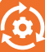 | Animals, including Humans  National curriculum objectives  Identify and name a variety of common animals including fish, amphibians, reptiles, birds and mammals, identify and name a variety of common animals that are carnivores, herbivores and omnivores and describe and compare the structure of a variety of common animals (fish, amphibians, reptiles, birds and mammals, including pets)  - Classify a range of animals by the above groups.  - Classify animals by what they eat as above  - Sort living and non living things  Key Vocab  Herbivore, Carnivore, Omnivore, Fish, Reptiles, Mammals, Birds, Amphibians (+ examples of each), Wings, Scales, Tail, Beak, Fur, Feathers  TAPS PLAN LINKS  Animals inc Humans: Animal classification  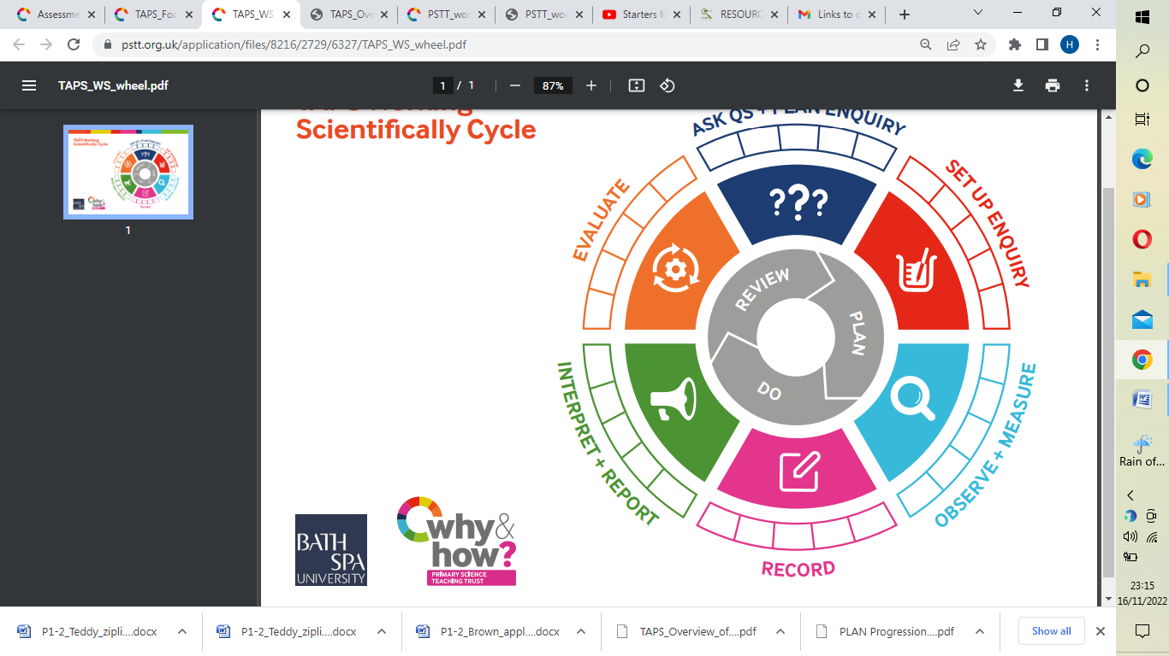 | Plants  National curriculum objectives  identify and name a variety of common wild and garden plants, including deciduous and evergreen trees  identify and describe the basic structure of a variety of common flowering plants, including trees.  - Understand what is meant by wild and garden plants  - Understand the meaning of deciduous and evergreen  - Know and name some common wild and garden plants  - Know and name some common deciduous and evergreen trees  - Know and name the petals, leaves, stem and roots of a plant  - Know and name roots, trunk and branches of a tree  Key Vocab  Leaves, Flowers, Petals, Fruit, Seeds, Tree, Roots, Bulb, Trunk, Stem, Branches, Deciduous, Evergreen, Blossom, Oak, Holly, Willow, Birch, Chestnut, Conker, Daisy, Buttercup, Rose, Daffodil  TAPS PLAN LINKS  Plants: structure leaf look  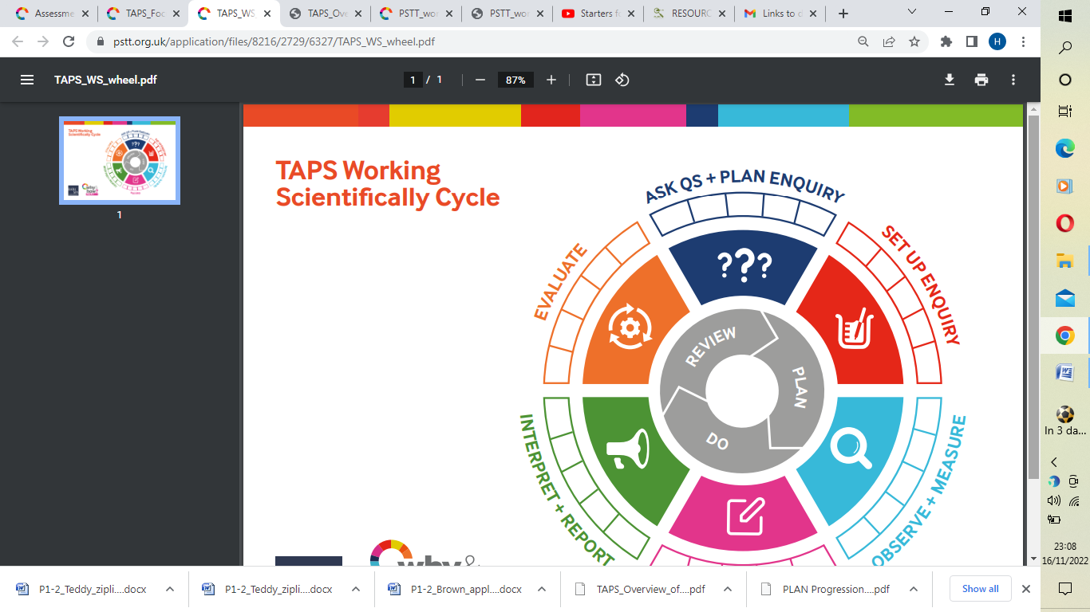
SCIENCE - YEAR 1 | Seasonal changes  National curriculum objectives  Observe changes across the four seasons, observe and describe weather associated with the seasons and how day length varies.  - Know the name of the season and the type of weather in that season  - Know what weather is associated with Autumn/Winter  - Talk about how features of the environment change from Summer to Autumn  - Talk about how features of the environment change from Autumn to Winter  - Know how to dress appropriately for Autumn/Winter weather  Key Vocab  Season, Autumn, Winter, Spring, Summer, Warm, Hot, Moon,  Night, Light, Dark, Cold, Day, Daylight, Sunlight, Change, Frosty,  Snowy, Dewy, Rain, Growth, New life  TAPS PLAN LINKS  Seasons: Seasonal Change  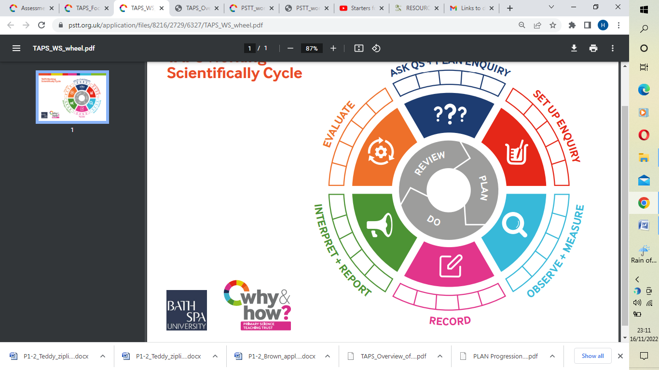 | Everyday materials  National curriculum objectives  Distinguish between an object and the material from which it is made  identify and name a variety of everyday materials, including wood, plastic, glass, metal, water, and rock, describe the simple physical properties of a variety of everyday materials and compare and group together a variety of everyday materials on the basis of their simple physical properties.  - Know that an object is made from a material  - Match an object to each everyday material e.g. wood, plastic, glass, metal, water and rock  - Compare and group objects by the material they are made from  - Describe the properties of the everyday materials (above)  Key Vocab  Metal, Stone, Rock, Hard, Soft, Bendy, Water, Stiff, Fabric, Brick, Rough, Smooth  TAPS PLAN LINKS  Materials: reflection test  Materials: transparency  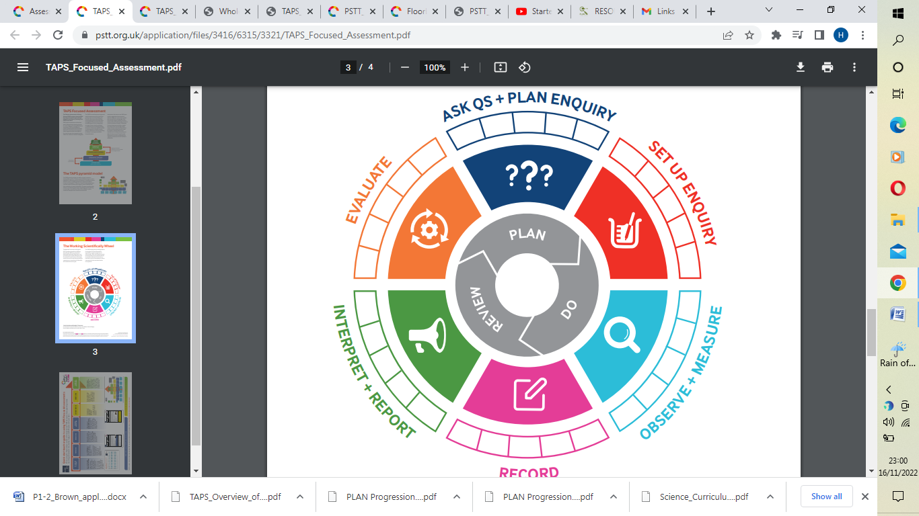  Materials: floating and sinking  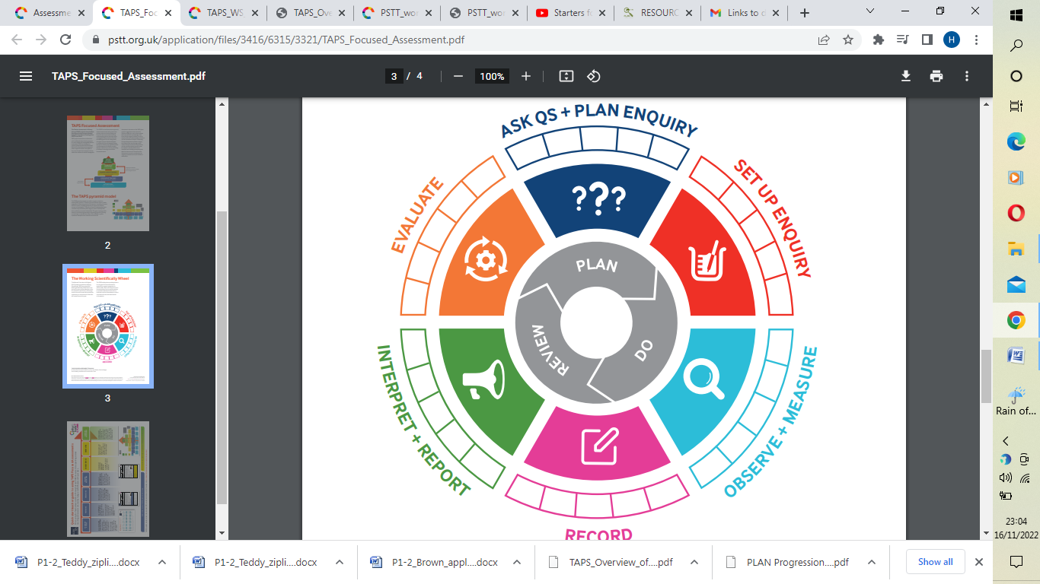  Materials: Bridge testers | Seasonal changes  National curriculum objectives  Observe changes across the four seasons, observe and describe weather associated with the seasons and how day length varies.  - Know the name of the season and the type of weather in that season  - Know what weather is associated with Spring/Summer  - Talk about how features of the environment change from Winter to Spring  - Talk about how features of the environment change from Spring to Summer  - Know how to dress appropriately for Spring/Summer weather  Key Vocab  Season Spring, Summer, Warm, Hot, Rain, Growth, New life  TAPS PLAN LINKS  Seasons: Seasonal Change
Working Scientifically

What…? How ….? Why …? Similar Different Best and Worst Change Plan

Look Biggest and Smallest Compare Sort and Group

*Suggested Equipment Focus = Using Hand Lenses (Magnifiers), Beakers, Pipettes, Syringes, Egg Timers

YEAR 2
SCIENCE - YEAR 2 | AUTUMN | SPRING | SUMMER
SCIENCE - YEAR 2 | Uses of everyday materials  National curriculum objectives  Identify and compare the suitability of a variety of everyday materials, including wood, metal, plastic, glass, brick, rock, paper and cardboard for particular uses  - Identify the material that a group of objects are made from  - Compare and group objects by their properties  - Describe the properties of the everyday materials using scientific vocabulary i.e. transparent/opaque  - Investigate the suitability of different materials relating to their properties i.e. why are windows made from glass?  - Make a prediction as to which material would suit a purpose e.g. best raincoat material  Key Vocab  Material, Hard, Soft, Stiff, Rough, Smooth, Bendy, Brick, Fabrics,  Shiny, Stretchy, Dull, Waterproof, Absorbent, Opaque, Transparent, Cardboard, Elastic, Foil  TAPS PLAN LINKS  Materials: Waterproof  Materials: Rocket mice  Materials hunt  Materials: Boat | Animals, including humans  National curriculum objectives  Notice that animals, including humans, have offspring which grow into adults, Find out about and describe the basic needs of animals, including humans, for survival (water, food and air) and describe the importance for humans of exercise, eating the right amounts of different types of food, and hygiene  - Understand that animals include humans  - Understand that animals produce offspring and name some  - Understand that offspring grow and change into adults  - Understand that animals have basic needs, which must be met, for survival  - Identify that animals need water, food and air in order to survive  - Understand that exercise is important and plays a role in keeping healthy  - Understand that in order to have a healthy diet, foods must be balanced  - Understand the importance of hygiene in keeping healthy  Key Vocab  Adult, Young, Offspring, Survival, Water, Air, Food, Kitten, Calf, Puppy, Exercise, Hygiene  TAPS PLAN LINKS  Animals inc Humans: Handspans | Living things and their habitats  National curriculum objectives  Explore and compare the differences between things that are living, dead, and things that have never been alive,identify that most living things live in habitats to which they are suited and describe how different habitats provide for the basic needs of different kinds of animals and plants, and how they depend on each other,identify and name a variety of plants and animals in their habitats, including microhabitats anddescribe how animals obtain their food from plants and other animals, using the idea of a simple food chain, and identify and name different sources of food  - Classify things by living, dead or never lived  - Know how a specific habitat provides for the basic needs of things living there (plants and animals)  - Match living things to their habitat  - Name some different sources of food for animals  - Know about and explain a simple food chain  Key Vocab  Pond, Lake, Living, Dead, Habitat, Food chain, Predator, Prey, Woodland, Desert  TAPS PLAN LINKS  Living Things: Woodlice habitats  Living Things: Nature spotters  Living and non-living
SCIENCE - YEAR 2 | (Changes in) Everyday materials  National curriculum objectives  Find out how the shapes of solid objects made from some materials can be changed by squashing, bending, twisting and stretching  - To understand that materials can change  - To explore and investigate squashing, bending, twisting and stretching a range of everyday materials  - To understand that a material changes by an action such as squashing, bending, twisting and stretching  Key Vocab  Solid, Shape, Squashing, Bending, Twisting, Stretching | Plants  National curriculum objectives  Observe and describe how seeds and bulbs grow into mature plants and find out and describe how plants need water, light and a suitable temperature to grow and stay healthy  - Understand that seeds and bulbs change and grow into mature plants  - Through observation, describe how seeds and bulbs change in appearance as they grow  - Investigate what plants need to grow and stay healthy  - Understand that plants need water, light and a suitable temperature to grow and stay healthy  Key Vocab  Grow, Seeds, Water, Bulbs, Sunlight, Suitable Temperature, Healthy, Germinate,  Decompose  TAPS PLAN LINKS  Plants: Compare Growth
Working Scientifically

Observe Change Slowly Quickly Describe Name Identify Label Record Measure Bigger and Smaller Pattern Notice Cycle Predict

*Suggested Equipment Focus = Using Hand lenses (Magnifiers), Magnifiers linked to ICT, Egg Timers, Simple Digital Timers

YEAR 3
SCIENCE - YEAR 3 | AUTUMN | SPRING |  | SUMMER
SCIENCE - YEAR 3 | Rocks  National curriculum objectives  Compare and group together different kinds of rocks on the basis of their appearance and simple physical properties, describe in simple terms how fossils are formed when things that have lived are trapped within rock and recognise that soils are made from rocks and organic matter  - Compare and group together different kinds of rocks on the basis of their appearance and simple physical properties, giving reasons  - Describe in simple terms how fossils are formed when things that have lived are trapped within rock  - Recognise that soils are made from rocks and organic matter.  - Know about and explain the difference between sedimentary, metamorphic and igneous rock  Key Vocab  Fossils, Soils, Sandstone, Granite, Marble, Pumice, Crystals,  Sedimentary, Metamorphic, Igneous, Absorbent, Porous, Durable, Permeable, Impermeable  TAPS PLAN LINKS  Rocks: Rock reports  Eco Action |  | Forces and Magnets  National curriculum objectives  Compare how things move on different surfaces, notice that some forces need contact between 2 objects, but magnetic forces can act at a distance, observe how magnets attract or repel each other and attract some materials and not others, compare and group together a variety of everyday materials on the basis of whether they are attracted to a magnet, and identify some magnetic materials, describe magnets as having 2 poles and predict whether 2 magnets will attract or repel each other, depending on which poles are facing.  - Compare how things move on different surfaces  - Notice that some forces need contact between two objects, but magnetic forces can act at a distance  - Observe how magnets attract or repel each other and attract some materials and not others, giving reasons  - Compare and group together a variety of everyday materials on the basis of whether they are attracted to a magnet, and identify some magnetic materials  - Describe magnets as having two poles  - Predict whether two magnets will attract or repel each other, depending on which poles are facing.  - Know how a simple pulley works and use one to lift an object  Key Vocab  Push, Pull, Attract, Magnetic, Force, Contact, Attract, Repel, Friction, Poles  TAPS PLAN LINKS  Forces: shoe grip  Forces: magnet tests  Forces: Cars down ramps  Forces: Balloon rockets |  | Animals including Humans  National curriculum objectives (Split)  Identify that humans and some other animals have skeletons and muscles for support, protection and movement.  - Identify that humans and some other animals have skeletons and muscles for support, protection and movement  Key Vocab  Movement, Protection, Muscles, Bones, Skull, Skeletons  TAPS PLAN LINKS  Animals inc Humans: investigating skeletons

SCIENCE - YEAR 3 | Light  National curriculum objectives  Recognise that they need light in order to see things and that dark is the absence of light, notice that light is reflected from surface, recognise that light from the sun can be dangerous and that there are ways to protect their eyes, recognise that shadows are formed when the light from a light source is blocked by an opaque object and find patterns in the way that the size of shadows change.  - Recognise that they need light in order to see things and that dark is the absence of light  - Notice that light is reflected from surfaces  - Recognise that light from the sun can be dangerous and that there are ways to protect their eyes  - Recognise that shadows are formed when the light from a light source is blocked by an opaque object  - Find patterns in the way that the size of shadows change.  Key Vocab  Light, Dark, Shadows, Mirror, Reflective, Reflection, Light Source, Cast  TAPS PLAN LINKS  Light: Making Shadows | Animals including Humans  National curriculum objectives (Split)  Identify that animals, including humans, need the right types and amount of nutrition, and that they cannot make their own food; they get nutrition from what they eat.  - Identify that animals, including humans, need the right types and amount of nutrition, and that they cannot make their own food; they get nutrition from what they eat  - Know about the importance of a nutritious, balanced diet  - Know how nutrients, water and oxygen are transported within animals and humans  Key Vocab  Nutrition, Balanced  TAPS PLAN LINKS  Cupcake parachutes | Plants  National curriculum objectives  Identify and describe the functions of different parts of flowering plants: roots, stem/trunk, leaves and flowers, explore the requirements of plants for life and growth (air, light, water, nutrients from soil, and room to grow) and how they vary from plant to plant, investigate the way in which water is transported within plants and explore the part that flowers play in the life cycle of flowering plants, including pollination, seed formation and seed dispersal.  - Identify and describe the functions of different parts of flowering plants: roots, stem/trunk, leaves and flowers  - Explore the requirements of plants for life and growth (air, light, water, nutrients from soil, and room to grow) and how they vary from plant to plant  - Investigate the way in which water is transported within plants  - Explore the part that flowers play in the life cycle of flowering plants, including pollination, seed formation and seed dispersal.  Key Vocab  Light, Water, Flower, Soil, Air, Nutrients, Compost, Reproduction, Transportation, Dispersal, Pollination,  TAPS PLAN LINKS  Plants: measuring plants  Ice cream  Plants: Function of stem
Working Scientifically

Gradually Identify Observe Recognise Investigate Record Units Table Fair Evidence Research Length Observations Prediction

*Suggested Equipment Focus = Digital Magnifiers, Dissection Kits, Thermometers, Mirror, Torches, Different Magnets (for example, Bar, Ring, Button and Horseshoe).

YEAR 4
SCIENCE - YEAR 4 | AUTUMN | SPRING | SUMMER
SCIENCE - YEAR 4 | Electricity  National curriculum objectives  Identify common appliances that run on electricity, construct a simple series electrical circuit, identifying and naming its basic parts, including cells, wires, bulbs, switches and buzzers, identify whether or not a lamp will light in a simple series circuit, based on whether or not the lamp is part of a complete loop with a battery, recognise that a switch opens and closes a circuit and associate this with whether or not a lamp lights in a simple series circuit and recognise some common conductors and insulators, and associate metals with being good conductors.  - Identify and name appliances that require electricity to function  - Construct a series circuit  - Identify and name the components in a series circuit (including cells, wires, bulbs, switches and buzzers)  - Predict and test whether a lamp will light within a circuit  - Know the difference between a conductor and an insulator; giving examples of each  Key Vocab  Cell, Wire, Bulb, Switch, Buzzer, Battery, Loop, Circuit, Series,  Conductors, Insulators, Brightness  TAPS PLAN LINKS  Electricity: Circuit products  Electricity: Conductors | Sound  National curriculum objectives  Identify how sounds are made, associating some of them with something vibrating, recognise that vibrations from sounds travel through a medium to the ear, find patterns between the pitch of a sound and features of the object that produced it, find patterns between the volume of a sound and the strength of the vibrations that produced it and recognise that sounds get fainter as the distance from the sound source increases.  - Know how sound is made, associating some of them with vibrating  - Know how sound travels from a source to our ears  - Know the correlation between pitch and the object producing a sound  - Know the correlation between the volume of a sound and the strength of the vibrations that produced it  - Know what happens to a sound as it travels away from its source  Key Vocab  Volume, Vibration, Wave, Pitch, Tone, Speaker, Travels, Ear, Hear, Sound, Loud, Quiet  TAPS PLAN LINKS  Sound: Investigating pitch  Sound: String telephones | States of Matter  National curriculum objectives  Compare and group materials together, according to whether they are solids, liquids or gases, observe that some materials change state when they are heated or cooled, and measure or research the temperature at which this happens in degrees Celsius (°C) and identify the part played by evaporation and condensation in the water cycle and associate the rate of evaporation with temperature.  - Know the temperature at which materials change state  - Know about and explore how some materials can change state  - Know the part played by evaporation and condensation in the water cycle  - Group materials based on their state of matter (solid, liquid and gas)  Key Vocab  Solid, Liquid, Gas, Evaporation, Condensation, Particles, Temperature, Freezing, Heating, Precipitation  TAPS PLAN LINKS  Materials: Drying materials  Materials: Measure temp  Materials: Dunking biscuits
SCIENCE - YEAR 4 |  | Animals, including Humans  National curriculum objectives  Describe the simple functions of the basic parts of the digestive system in humans, identify the different types of teeth in humans and their simple functions and construct and interpret a variety of food chains, identifying producers, predators and prey.  - Identify and name the parts of the human digestive system  - Know the functions of the organs in the human digestive system  - Identify and know the different types of human teeth  - Know the functions of different human teeth  - Use and construct food chains to identify producers, predators and prey  Key Vocab  Mouth, Herbivore, Carnivore, Omnivore, Tongue, Teeth, Oesophagus,  Stomach, Small Intestine, Large Intestine, Incisor, Molar, Canine  TAPS PLAN LINKS  Animals inc Humans: Teeth (eggs) in liquid | Living things and their habitats  National curriculum objectives  Recognise that living things can be grouped in a variety of ways, explore and use classification keys to help group, identify and name a variety of living things in their local and wider environment and recognise that environments can change and that this can sometimes pose dangers to living things.  - Use classification keys to group, identify and name living things  - Know how changes to an environment could endanger living things  Key Vocab  Vertebrates, Invertebrates, Fish, Amphibians, Reptiles, Birds Mammals,  Snails, Slugs, Worms, Spiders, Insects, Environment, Habitats  TAPS PLAN LINKS  Living Things: Local survey
Working Scientifically

Similarities Differences Research and Source Scientists Discovery Process Cycle Measurements Conclude Evaluate Rank Plan Vary

Keep the Same/Constant Bar Graph Table Tally

*Suggested Equipment Focus = Thermometers, Simple Data Loggers, Electrical Circuit Components- E.g. making a circuit using Wires, Bulb, Cell, Switch

YEAR 5
SCIENCE - YEAR 5 | AUTUMN | SPRING | SUMMER
SCIENCE - YEAR 5 | Earth and Space  National curriculum objectives  Describe the movement of the Earth and other planets relative to the sun in the solar system, describe the movement of the moon relative to the Earth, describe the sun, Earth and moon as approximately spherical bodies and use the idea of the Earth’s rotation to explain day and night and the apparent movement of the sun across the sky.  - Describe the movement of the Earth, and other planets, relative to the Sun in the solar system  - Describe the movement of the Moon relative to the Earth  - Describe the Sun, Earth and Moon as approximately spherical bodies  - Use the idea of the Earth’s rotation to explain day and night and the apparent movement of the sun across the sky.  Key Vocab  Day, Night, Sun, Moon, Star, Earth, Planet, Dwarf Planet,  Axis, Rotation, Phases of the Moon, Constellation, Waxing, Waning, Full, New, Year, Month, Gravity, Tilt, Elliptical Pathway  Planet Names- (MY VERY EASY METHOD JUST SPEEDS UP NAMING) Mercury, Venus, Earth, Mars, Jupiter, Saturn, Uranus, Neptune  TAPS PLAN LINKS  Space: Craters  Space: Solar system research | Forces  National curriculum objectives  Explain that unsupported objects fall towards the Earth because of the force of gravity acting between the Earth and the falling object, identify the effects of air resistance, water resistance and friction, that act between moving surfaces and recognise that some mechanisms including levers, pulleys and gears allow a smaller force to have a greater effect.  - Explain that unsupported objects fall towards the Earth because of the force of gravity acting between the Earth and the falling object – and the impact on our lives.  - Identify the effects of air resistance, water resistance and friction, that act between moving surfaces  - Recognise that some mechanisms, including levers, pulleys and gears, allow a smaller force to have a greater effect.  Key Vocab  Force, Air resistance, Water resistance, Friction, Gravity, Newton, Gears, Pulleys, Lever, Pivot, Fulcrum  TAPS PLAN LINKS  Forces: Paper planes  Forces: Spinners  Forces: Bottle flip  Forces: Aquadynamics  Forces: Marble run | Animals, including Humans  National curriculum objectives  Describe the changes as humans develop to old age.  - Describe the changes as humans develop to old age  - Create a timeline to indicate stages of growth in humans  Key Vocab  Baby, Young, Toddler, Teenager, Old, Elderly, Growth Development,  Puberty  TAPS PLAN LINKS  Humans: Growth survey
SCIENCE - YEAR 5 | Properties and changes of materials  National curriculum objectives  Compare and group together everyday materials on the basis of their properties, including their hardness, solubility, transparency, conductivity (electrical and thermal), and response to magnets, know that some materials will dissolve in liquid to form a solution, and describe how to recover a substance from a solution, use knowledge of solids, liquids and gases to decide how mixtures might be separated, including through filtering, sieving and evaporating, give reasons, based on evidence from comparative and fair tests, for the particular uses of everyday materials, including metals, wood and plastic, demonstrate that dissolving, mixing and changes of state are reversible changes and explain that some changes result in the formation of new materials, and that this kind of change is not usually reversible, including changes associated with burning and the action of acid on bicarbonate of soda.  - Compare and group together everyday materials on the basis of their properties, including their hardness, solubility, transparency, conductivity (electrical and thermal), and response to magnets  - Know that some materials will dissolve in liquid to form a solution, and describe how to recover a substance from a solution  - Use knowledge of solids, liquids and gases to decide how mixtures might be separated, including through filtering, sieving and evaporating  - Give reasons, based on evidence from comparative and fair tests, for the particular uses of everyday materials, including metals, wood and plastic  - Demonstrate that dissolving, mixing and changes of state are reversible changes  - Explain that some changes result in the formation of new materials, and that this kind of change is not usually reversible, including changes associated with burning and the action of acid on bicarbonate of soda. | Living things and their habitats  National curriculum objectives  Describe the differences in the life cycles of a mammal, an amphibian, an insect and a bird and describe the life process of reproduction in some plants and animals.  - Describe the differences in the life cycles of a mammal, an amphibian, an insect and a bird  - Describe the life process of reproduction in some plants and animals.  - Know the life cycle of different living things e.g. mammal, amphibian, insect  - Understand how plants reproduce  - Understand how animals reproduce  Key Vocab  Mammals, Reproduction, Foetus, Embryo, Womb, Gestation, Insects, Amphibian,  Bird, Offspring, Classification, Vertebrates, Invertebrates, Micro-organisms,  Reptiles  TAPS PLAN LINKS  Living Things: Life cycle research
Key Vocab

Transparent, Opaque, Hardness, Solubility, Translucent,
Magnetic, Filter, Evaporation, Dissolving, Mixing, Thermal conductor/insulator, Electrical conductor/ insulator

TAPS PLAN LINKS
Materials: dissolving
Materials: Nappy absorbency
Materials: Insulation layers
Materials: Sugar cubes
Materials: Champion tapes

Working Scientifically

Classify Interpret Pattern Relationship Prediction Analyse Conclude Evaluate Rank Variable Constants Control Repeat

Key Relationship Line Graph

*Suggested Equipment Focus = Taking Measurements, using a range of Scientific Equipment, with increasing accuracy and precision, Equipment linked to Evaporating, Filtering, Sieving, Melting and Dissolving, Newton Meters, Data Loggers

YEAR 6
SCIENCE - YEAR 6 | AUTUMN | SPRING | SUMMER
SCIENCE - YEAR 6 | Living things and their habitats  National curriculum objectives  Describe how living things are classified into broad groups according to common observable characteristics and based on similarities and differences, including micro-organisms, plants and animals and give reasons for classifying plants and animals based on specific characteristics.  - Describe how living things are classified into broad groups according to common observable characteristics and based on similarities and differences, including micro-organisms, plants and animals  - Give reasons for classifying plants and animals based on specific characteristics  - Know how living things have been classified  Key Vocab  Classification, Vertebrates ,Invertebrates, Micro-organisms, Amphibians, Reptiles, Mammals, Insects  TAPS PLAN LINKS  Living things: Outdoor keys  Living things: Invertebrate research | Evolution and Inheritance  National curriculum objectives  Recognise that living things have changed over time and that fossils provide information about living things that inhabited the Earth millions of years ago, recognise that living things produce offspring of the same kind, but normally offspring vary and are not identical to their parents and identify how animals and plants are adapted to suit their environment in different ways and that adaptation may lead to evolution.  - Recognise that living things have changed over time and that fossils provide information about living things that inhabited the Earth millions of years ago  - Recognise that living things produce offspring of the same kind, but normally offspring vary and are not identical to their parents  - Identify how animals and plants are adapted to suit their environment in different ways and that adaptation may lead to evolution  Key Vocab  Fossils, Adaptation, Evolution, Characteristics, Reproduction, Genetics  TAPS PLAN LINKS  Evolution: Fossil habitats  Evolution: egg strength | Light  National curriculum objectives  Recognise that light appears to travel in straight lines, use the idea that light travels in straight lines to explain that objects are seen because they give out or reflect light into the eye, explain that we see things because light travels from light sources to our eyes or from light sources to objects and then to our eyes and use the idea that light travels in straight lines to explain why shadows have the same shape as the objects that cast them.  - Recognise that light appears to travel in straight lines  - Use the idea that light travels in straight lines to explain that objects are seen because they give out or reflect light into the eye  - Explain that we see things because light travels from light sources to our eyes or from light sources to objects and then to our eyes  - Use the idea that light travels in straight lines to explain why shadows have the same shape as the objects that cast them  Key Vocab  Light, Reflection, Refraction, Spectrum, Rainbow, Colour  TAPS PLAN LINKS  Light: Light questions  Light: Investigating shadows
SCIENCE - YEAR 6 | Animals, including Humans  National curriculum objectives  Identify and name the main parts of the human circulatory system, and describe the functions of the heart, blood vessels and blood, recognise the impact of diet, exercise, drugs and lifestyle on the way their bodies function and describe the ways in which nutrients and water are transported within animals, including humans.  - Identify and name the main parts of the human circulatory system.  - Know the functions of the heart, blood vessels and blood  - Know the impact of diet, exercise, drugs and lifestyle on the way their bodies function  - Know the ways in which nutrients and water are transported within animals, including humans  Key Vocab  Exercise, Circulatory, Heart, Blood Vessels, Veins, Arteries,  Oxygenated, Deoxygenated, Valve, Chamber, Respiration  TAPS PLAN LINKS  Animals inc Humans: Heart rate |  | Electricity  National curriculum objectives  Associate the brightness of a lamp or the volume of a buzzer with the number and voltage of cells used in the circuit, compare and give reasons for variations in how components function, including the brightness of bulbs, the loudness of buzzers and the on/off position of switches and use recognised symbols when representing a simple circuit in a diagram.  - Associate the brightness of a lamp or the volume of a buzzer with the number and voltage of cells used in the circuit  - Compare and give reasons for variations in how components function, including the brightness of bulbs, the loudness of buzzers and the on/off position of switches  - Use recognised symbols when representing a simple circuit in a diagram  Key Vocab  Cell, Wire, Bulb, Switch, Buzzer, Battery, Loop, Circuit, Series,  Conductors, Insulators, Brightness, Loudness, Position, Current, Voltage, Voltmeter, Amps, Motor  TAPS PLAN LINKS  Electricity: Bulb brightness  Electricity: Conductive dough
Working Scientifically

Hypothesis Variable Constants Evaluate Plan Conclude Interpret Classify Categorise Database Enquiry Control Repeat Support Refute

Degree of Trust Scatter Graph

*Suggested Equipment Focus = Taking Measurements, using a range of Scientific Equipment, with increasing accuracy and precision, Electrical Circuit Components- E.g. making a circuit using Wires, Bulb, Cell, Buzzers, Motors, Switches, Data Loggers

