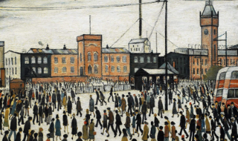*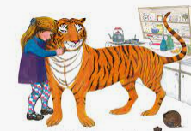St Andrews Methodist Primary School*

*Year 1 Knowledge Planner – Spring 1*

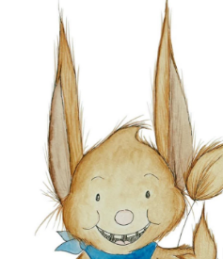

RE

We will be learning about what it means to belong to a faith community.

Computing

In computing we will be looking at algorithms and understand that these are sets of instructions.

English

We are reading The Tiger Who Came To Tea by Judith Kerr.

We will be writing character profiles, writing letters, creating tea party invites and writing our own versions of the story.

Maths

Some of the work we will be learning in maths will be to compare numbers using language more than, greater than, less than and fewer. We will be learning to add and subtract 10 to an amount and counting in 2’s, 5’s and 10’s. We will use numicon and base 10 to help us partition numbers into tens and ones.

History

In History we will be learning about significant people.

We will be learning who Princess Diana and LS Lowry are. Why Lowry is important in Salford and what he is famous for

We will also be learning about what impact Princess Diana had on the world.

P.E

This half term the children will be taking part in multi-sports skills.

RHE

This half term is about health and hygiene. We will learn what being healthy means and who helps help them to stay healthy (eg; parent, doctor, dentist). We will learn that things people put into or onto their bodies can affect how they feel. Why hygiene is important and how simple hygiene routines can stop germs from being passed on and what can be done daily to take care of yourself.

Phonics

We are practising phonics daily in school following the scheme – Supersonic Phonics Friends. If you wish to play some phonics games at home, please take a look at www.phonicsplay.co.uk and there are also phonics games on Purple Mash too.

Science

This half term we will be learning all about animals, labelling and classifying them.