**Numeracy**

* To become comfortable using the Grid method in times tables.
* To use compensation when dealing with the 9 times tables.
* To be able to understand and solve positive integer scaling problems.
* To be able to understand and solve correspondence problems.

# **Art**

* Explore the artwork of William Morris.
* To sketch natural objects.
* To design a printing block.
* To create and use the printing block.
* To explore the idea of quality over quantity in art.

# **Literacy**

- Write play scripts with clear and thoughtful speech

- Have a clear narrative and plot.

- Use stage directions clearly and correctly.

- Present with intonation and expression.

- Give and receive constructive criticism.

***Knowledge Organiser Spring 1***

**Science**

Animals including humans.

* Explore nutrition and what makes a balanced diet.
* Identify a variety of bones in our body and why they are important to us.
* Identify a variety of muscles in our body and why they are important.
* What is good hygiene and how can we achieve it?
* Compare our diets and bodies to different animals around the world.

# **Relationship Education**

* How families are different.
* What are families like and how do they care for each other?
* How they care for each other.
* Common features of a family.

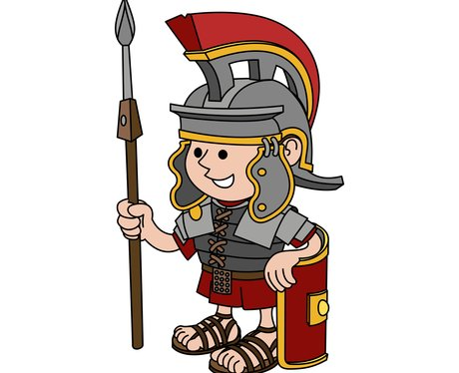



**Computing**

* To understand why and when we may use spreadsheets.
* To create bar charts and graphs using different commands and tools.

**Geography**

To know and label the three layers of the earth

To explain how a volcano is formed

To know where a famous volcano is located across the world

To understand where ‘The Ring of Fire’ is located

To understand how people might feel during an eruption/earthquake and understand the devastation this can cause

# **R.E**

**How and why do people of different faiths pray?**

* Explore how and why Christians pray.
* Explore of Hindus pray and for what reasons
* Explore how Muslims pray and why they pray.
* Identify similarities and differences between these different faiths.

# **Spanish**

* Speaking, reading, and writing words linked to school objects including colours.

# **Music**

* Bob Marley – Three Little Birds

**PE**

Athletics

- use running, jumping, throwing and catching in isolation and in combination

- develop flexibility, strength, technique, control and balance [for example, through athletics and gymnastics]