RE

I can tell you about belonging to a community

I can name at least two different religions and tell you what their followers believe

I can tell you about different religious celebrations such as Ramadan.

Science

I can identify different materials

I know how materials can be changed by squashing, bending, twisting and stretching

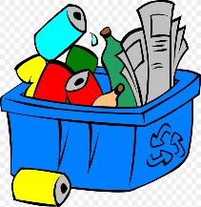



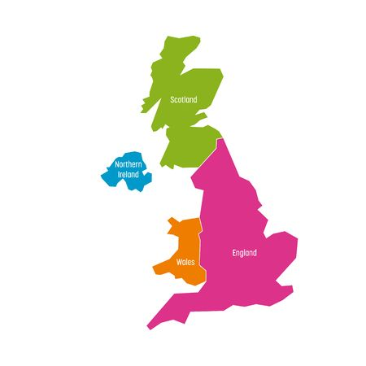

Geography

I can name the 4 countries of the UK continents of the world

I can locate the 4 countries of the UK continents

I can begin to name the surrounding seas

I can name and locate the capital cities of the UK

History – The Great Fire of London

Art

I can choose and use different grades of pencil when drawing

I know how to use charcoal, pencil and pastel to create art

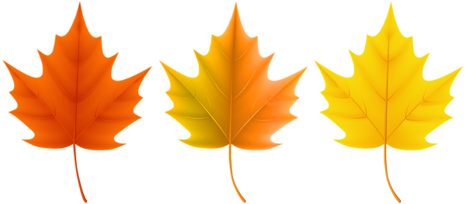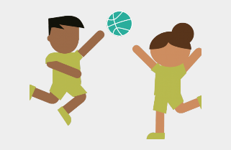

Music

I can sing songs and chant rhymes.

I can listen to recorded music

PE

I can master basic movements including running, catching, throwing as well as balance agility and co-ordination.