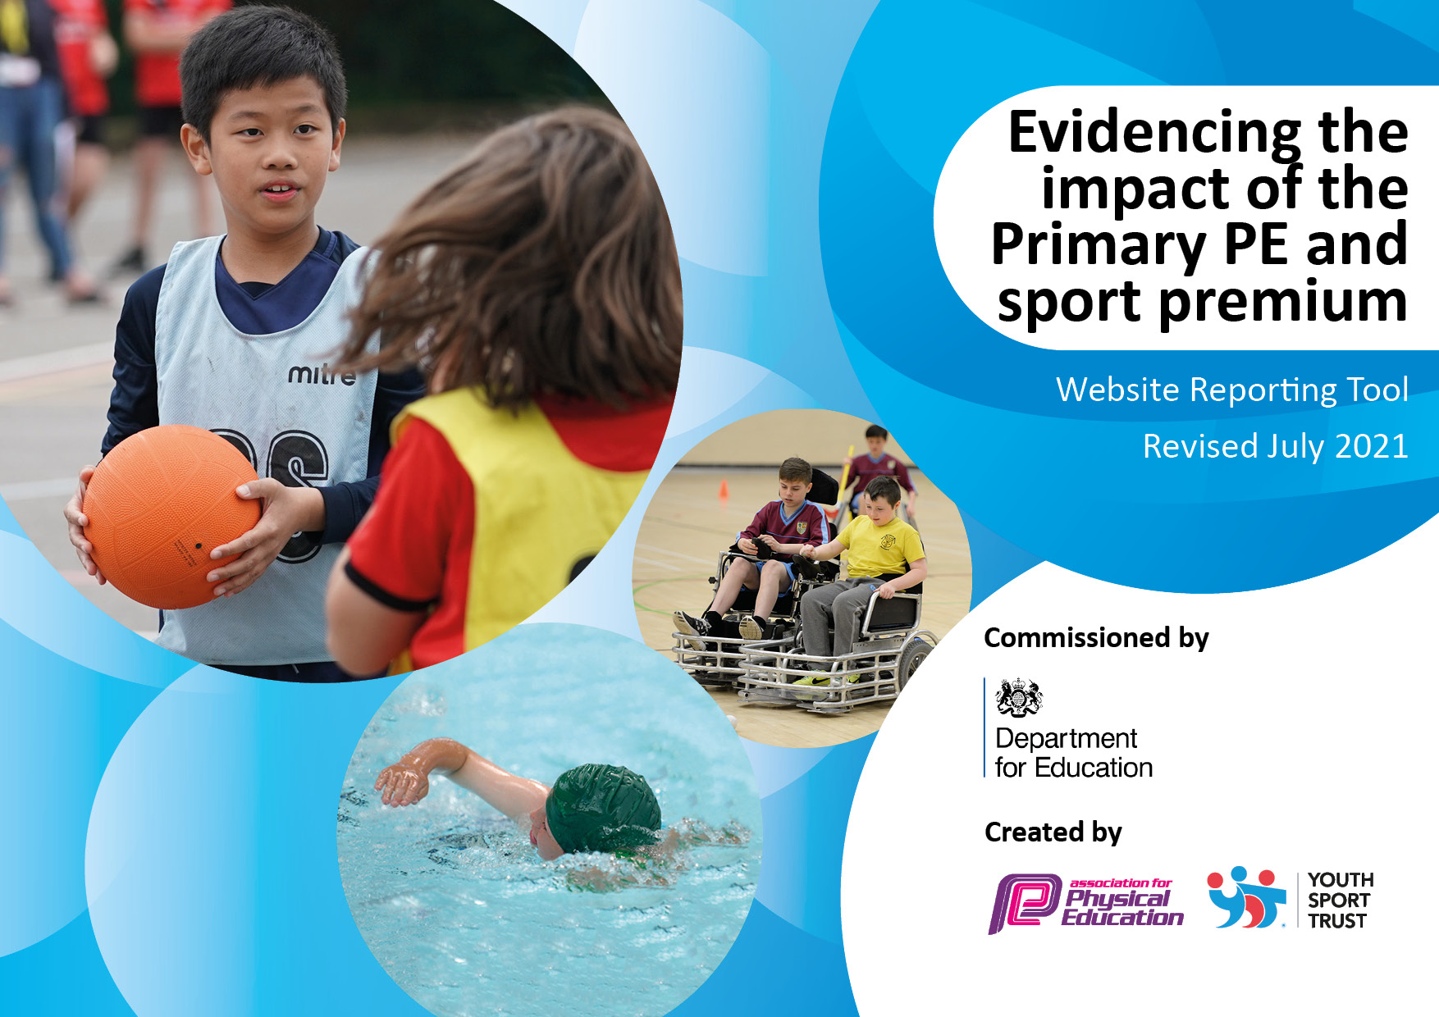

St Andrew’s Methodist Primary School

Impact of the Primary and Sport Premium Grant 2021-2022
Details with regard to funding
Please complete the table below.

Total amount carried over from 2019/20 | £ £ 4540.36
Total amount allocated for 2020/21 | £ 17897
How much (if any) do you intend to carry over from this total fund into 2021/22? | £968
Total amount allocated for 2021/22 | £ 17880
Total amount of funding for 2021/22. To be spent and reported on by 31st July 2022. | £ 18848
Swimming Data
Please report on your Swimming Data below.

Meeting national curriculum requirements for swimming and water safety.  N.B. Complete this section to your best ability. For example you might have practised safe self-rescue techniques on dry land which you can then transfer to the pool when school swimming restarts.  Due to exceptional circumstances priority should be given to ensuring that pupils can perform safe self rescue even if they do not fully meet the first two requirements of the NC programme of study | 100%
What percentage of your current Year 6 cohort swim competently, confidently and proficiently over a distance of at least 25 metres?  N.B. Even though your pupils may swim in another year please report on their attainment on leaving primary school at the end of the summer term 2022.  Please see note above | 100%
What percentage of your current Year 6 cohort use a range of strokes effectively [for example, front crawl, backstroke and breaststroke]?  Please see note above | 60%
What percentage of your current Year 6 cohort perform safe self-rescue in different water-based situations? | 60%
Schools can choose to use the Primary PE and sport premium to provide additional provision for swimming but this must be for activity over and above the national curriculum requirements. Have you used it in this way? | No

Action Plan and Budget Tracking
Capture your intended annual spend against the 5 key indicators. Clarify the success criteria and evidence of impact that you intend to measure to evaluate for pupils today and for the future.

Academic Year: 2021/22 | Total fund allocated: £ 18,848 | Date Updated: July 2022
Key indicator 1: The engagement of all pupils in regular physical activity – Chief Medical Officers guidelines recommend that primary school pupils undertake at least 30 minutes of physical activity a day in school |  |  |  | Percentage of total allocation:
 |  |  |  | 28%
Intent | Implementation |  | Impact
Your school focus should be clear what you want the pupils to know and be able to do and about  what they need to learn and to  consolidate through practice: | Make sure your actions to achieve are linked to your intentions: | Funding allocated: | Evidence of impact: what do pupils now know and what can they now do? What has changed?: | Sustainability and suggested next steps:
To engage and include all children in fun, physical activities during lunch time sessions. We will be inviting coaches in at dinner times to positively influence playground behaviour and ensure children are focused on engaging activities, which will develop their physical skills, social skills and wellbeing. | PE coaches funded to deliver range of lunchtime sports activities;  - Ball skills  - Running  - Athletics  - Football  - Multi skills  Funding used for swimming lessons, additional adults and transport for two year groups (Y4 and Y5)  Developed sensory garden for well-being in KS2 quad. | £2,320  £3000 | - Improved pupils behaviour at breaktimes  - Pupils’ sports’ skills have progressed.  - Pupils’ confidence in swimming and other sports has grown. | - Y4 and Y5 pupils to attend swimming lessons in 2022-23  - Same level of funding to be allocated to coaches for lunchtime sports’ clubs.
Key indicator 2: The profile of PESSPA being raised across the school as a tool for whole school improvement |  |  |  | Percentage of total allocation:
 |  |  |  | 16%
Intent | Implementation |  | Impact
Your school focus should be clear what you want the pupils to know and be able to do and about  what they need to learn and to  consolidate through practice: | Make sure your actions to achieve are linked to your intentions: | Funding allocated: | Evidence of impact: what do pupils now know and what can they now do? What has changed?: | Sustainability and suggested next steps:
Continue to replenish PE and playground equipment, to help ensure high quality PE sessions are taking place and the equipment is of a very good standard.  EYFS children to be involved in a range of engaging and developmental physical activities. | - Maintenance of Multi-gym and all weather pitch areas  - Checks on large PE equipment eg; benches, mats, climbing frames.  - Replacement of fencing to ball areas on KS2 playground.  - Replacement of expendable resources eg; footballs.  - Replacement of equipment in EYFS outdoor area. | £3,000 | - Multi-gym and all weather pitch in use every break/lunchtime time.  - All weather pitch used for outdoor PE lessons. | - Outdoor classroom to have play spaces resurfaced for safe physical activitiy.  - Subject leader to be given management time to monitor and evaluate PE.  - New school improvement plan to contain PE action plan for next 12 months.  - PE strategy to be shared with governors.

Key indicator 3: Increased confidence, knowledge and skills of all staff in teaching PE and sport |  |  |  | Percentage of total allocation:
 |  |  |  | 3%
Intent | Implementation |  | Impact
Your school focus should be clear | Make sure your actions to | Funding | Evidence of impact: what do | Sustainability and suggested
what you want the pupils to know | achieve are linked to your | allocated: | pupils now know and what | next steps:
and be able to do and about | intentions: |  | can they now do? What has
what they need to learn and to |  |  | changed?:
consolidate through practice:
All teachers to deliver high quality PE lessons. | PE subject lead given time to attend PE cluster group meetings.  PE subject lead allocated time to monitor teaching and learning in PE.  Teaching assistants used to deliver Netball club. | £150  £400 | - Good practice between PE leads shared.  - PE curriculum schemes and plans shared.  - Network of PE leads led to inter school competitions. | - Attend cluster meetings in 22-23  - Quality of provision to be monitored by subject leader  - Curriculum review to ensure high quality planning.
Key indicator 4: Broader experience of a range of sports and activities offered to all pupils |  |  |  | Percentage of total allocation:
 |  |  |  | 30%
Intent | Implementation |  | Impact
Your school focus should be clear | Make sure your actions to | Funding | Evidence of impact: what do | Sustainability and suggested
what you want the pupils to know | achieve are linked to your | allocated: | pupils now know and what | next steps:
and be able to do and about | intentions: |  | can they now do? What has
what they need to learn and to |  |  | changed?:
consolidate through practice:
Ensure that all children have the best possible start in life by ensuring their health and wellbeing is of paramount importance through the delivery of knowledgeable and skilful PE sessions and after school sessions. | Wide range of after-school sports’ activities offered include;  - Football  - Netball  - Multi-skills  - Athletics  - Cricket  PE timetabled for 2 lessons per week, one indoor, one outdoor.  Subsidised residential visit to Lledr Hall outward bound centre for all Y6 pupils. | £1,320  X2 lunch clubs per week + x2 after school sessions per week = £160 per week /  £400  2 staff to run afterschool netball club for 20 weeks.  £4,000 | - Children with SEND have fully accessed extra-curricular sports’ club and PE lessons. | - Revisit planning resources  - PE lead and SLT to complete curriculum review of PE.

Key indicator 5: Increased participation in competitive sport |  |  |  | Percentage of total allocation:
 |  |  |  | 3%
Intent | Implementation |  | Impact
Your school focus should be clear | Make sure your actions to | Funding | Evidence of impact: what do | Sustainability and suggested
what you want the pupils to know | achieve are linked to your | allocated: | pupils now know and what | next steps:
and be able to do and about | intentions: |  | can they now do? What has
what they need to learn and to |  |  | changed?:
consolidate through practice:
To use sports’ funding to fund sports coach to train pupils for interschool competitions and transport (mini bus) to enable us to take part in the competitive tournaments with other schools in the local area. | - Interschool cross country relay race (KS2)  - Interschool athletics competition (KS2)  - Interschool cricket competition (Y4)  - EYFS Sports’ Day  - KS1 Sports’ Day  - KS2 Sports activity day | £500 | Pupil’s cricket skills have developed.  Pupils have joined a range of out of school sports’ clubs which include athletics, cricket, martial arts and football.  Gifted and talented pupils have joined football clubs eg; Bolton wanderers youth team. | To enter these competitions again next year.  To continue with additional cricket coaching in school for other year groups.  To use Premier sports coaches to train pupils in athletics events.

Signed off by
Head Teacher: | Anne Barker
Date: | 16th July 2022
Subject Leader: | Danielle Smith
Date: | 16th July 2022
Governor: | Geoff Jones
Date: | 16th July 2022

