Homework Menu – Summer 2
English  Can you write a diary about a day in the life of a Victorian child – rich or poor  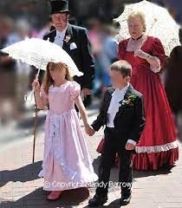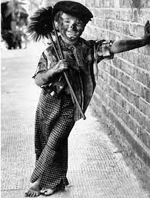 | History  What can you tell me about Victorian Manchester?  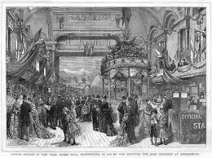 | Times tables  Do you know ALL your times tables? Record your speed and try and improve it – we are aiming to answer each question in 6 seconds. | Maths  Can you learn how to tell the time?  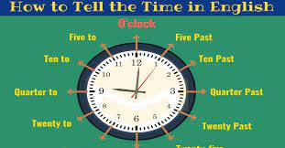
Art  Can you take some photographs of interesting things – perhaps you could take some pictures of reflections. | RHE  Tell me or show me what you are doing to be kind and caring to our world – this could be people, animals or the environment | Science/English  Can you tell me about the life cycle of a frog?  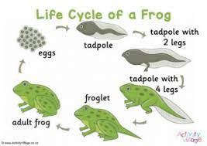 | DT  Can you learn to sew? To do this you will need to thread a needle…  