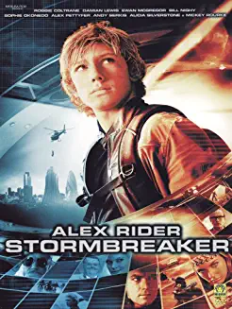**Year 4 Knowledge Organiser – Spring term 1**

**Maths**

* Fractions and decimals
* length and perimeter
* This term we will be learning our 4, 3 and 6 times tables. We will continue to recap the others.

**By the end of year 4 it is expected that children will know all multiplication facts by heart. Please encourage your child to use times tables rockstars as often as possible**

**Writing**

Genres of writing – persuasion, letter writing, poetry

Text – Wonder

Stormbreaker – Alex Rider

**Spelling**

To spell the words from the year 3 and 4 list

To spell further homophones

To use prefixes and suffixes

To edit their work to check for spelling errors

**Reading**

* Develop positive attitudes to reading
* Understand what they read
* Retrieve and record information
* Infer using what they know

**Grammar**

Using apostrophes for contracted words and possession

To ensure their writing makes sense – was/were, what/that, did/done

To use inverted commas

**Watch this space… we are hoping to hold a times tables session for you to attend with your child to share strategies to help them with their times tables test**

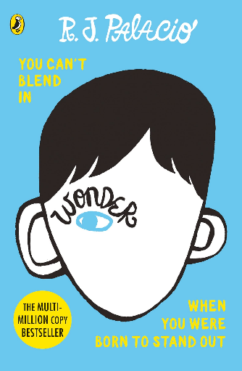

Spring 1

**Computing**

Select and use software to accomplish given goals

Recognise acceptable and unacceptable behaviour using technology

**Spanish**

Read and understand a short passage

Explain the main points in a short passage

Read a short passage independently

Use a bilingual dictionary or glossary to look up new words

Start to speak, using a full sentence

**RHE**

how everyday things can affect feelings

how feelings change over time and can be experienced at different levels of intensity

the importance of expressing feelings and how they can be expressed in different ways

how to respond proportionately to, and manage, feelings in different circumstances

ways of managing feelings at times of loss, grief and change

how to access advice and support to help manage their own or others’ feelings

**Music**

We will continue to sing songs. We will also begin to use notation.

**PE**

We are so lucky to have PE specialist this half term teaching us team games

**Art/DT**

Use sketchbooks to help create facial expressions.

Know how to show facial expressions and body language in sketches and paintings

Know how to use marks and lines to show texture in art.

Know how to use line, tone, shape and colour to represent figures and forms in movement

Know how to sculpt clay and other mouldable materials

Use ideas from other people when designing

Produce a plan and explain it

Measure accurately

Evaluate and suggest improvements for designs

Explain how the original design has been improved

**Geography**

Know how to plan a journey within the UK, using a road map

Know where the main mountain regions are in the UK

Know, name and locate the main rivers in the UK

Know and label the main features of a river

Know the name of and locate a number of the world’s longest rivers

Know the names of a number of the world’s highest mountains

Explain the features of the water cycle

Know why most cities are located by a river

**Science**

Know how sound is made, associating some of them with vibrating

Know how sound travels from a source to our ears

Know the correlation between pitch and the object producing a sound

Know the correlation between the volume of a sound and the strength of the vibrations that produced it

Know what happens to a sound as it travels away from the source

**RE -** Why are festivals important to some religions?

Make connections between stories, symbols and beliefs with what happens in at least two festivals (A2).

Ask questions and give ideas about what matters most to believers in festivals (e.g. Easter, Eid) (B2).

Identify similarities and differences in the way festivals are celebrated within and between religions (A3).

Explore and suggest ideas about what is worth celebrating and remembering in religious communities and in their own lives (C1).