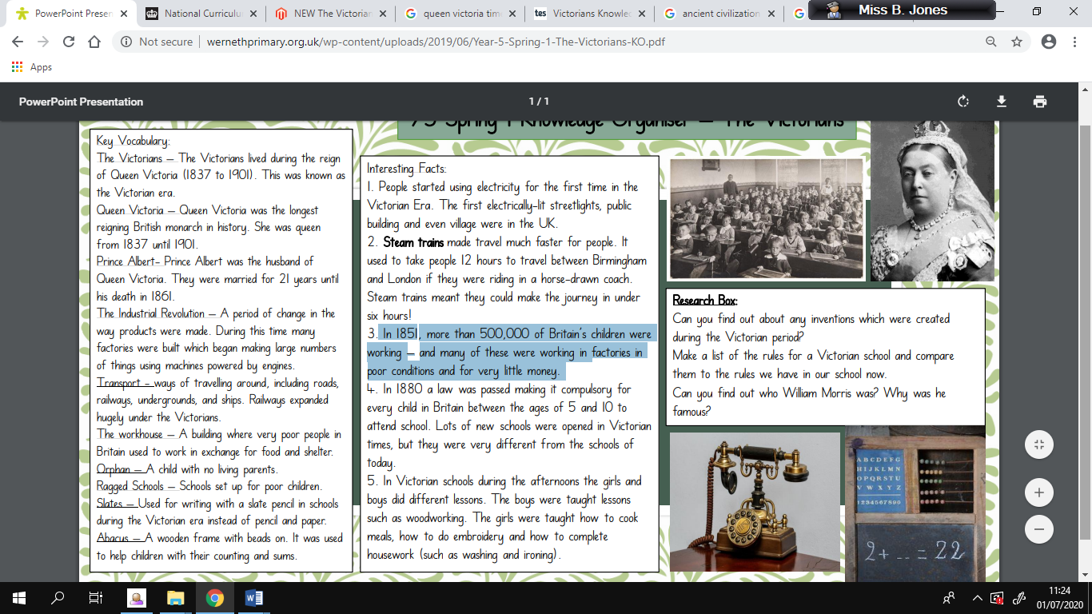

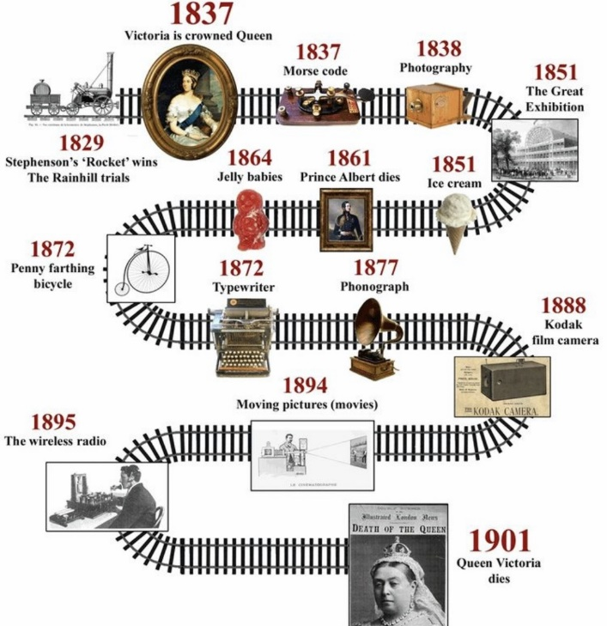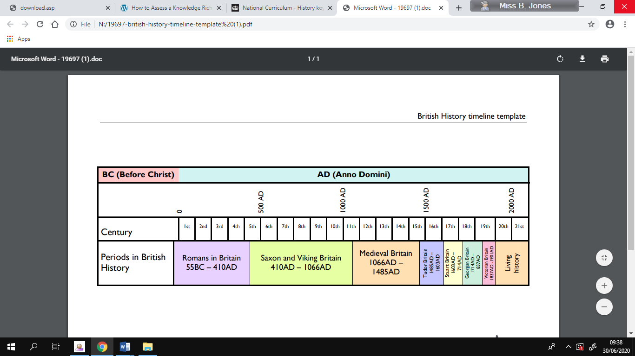

Key Dates

**Sticky Knowledge**

* The Victorian era is named after Queen Victoria who reigned over Britain and a world Empire for 64 years.
* It was a time of great wealth and poverty.
* The Victorian period saw many major inventions that made travel and communication easier for many people.
* The impact that the Industrial Revolution had on the people of Britain.
* In 1851, more than 500,000 of Britain’s children were working – and many of these were working in factories in poor conditions and for very little money.

**British History Timeline**

**Key Vocabulary**

**Knowledge Planner – The Victorians**