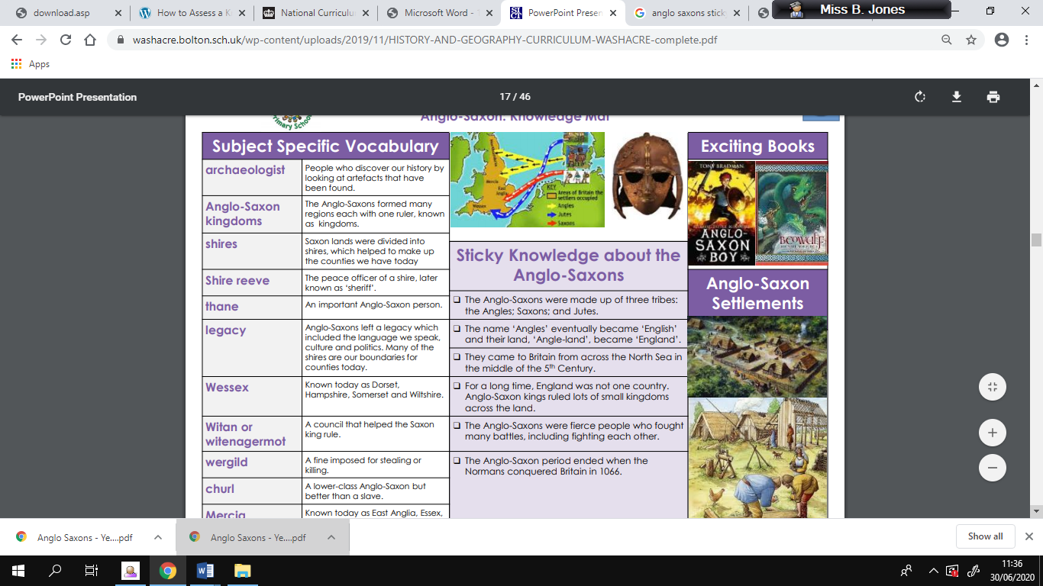

**Key Knowledge**

**Sutton Hoo**- In 1939, archaeologists discovered an Anglo-Saxon ship burial at Sutton Hoo in Suffolk.

**Place names**- Many of today’s place names come from Anglo-Saxon words Eg: Birmingham

Many of today’s English words are based on Saxon words Eg: days of the week, England

**Exciting books to read:**

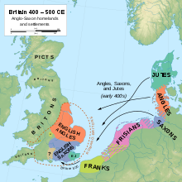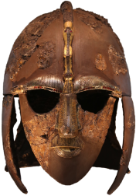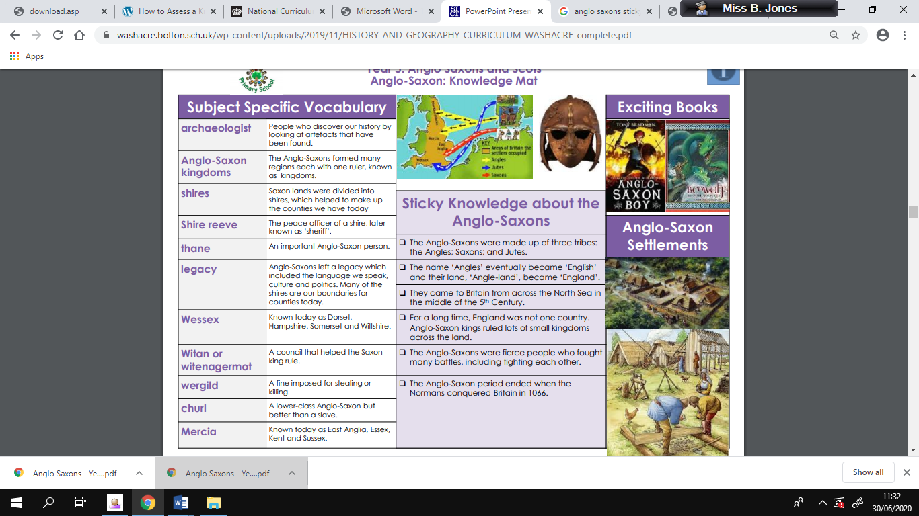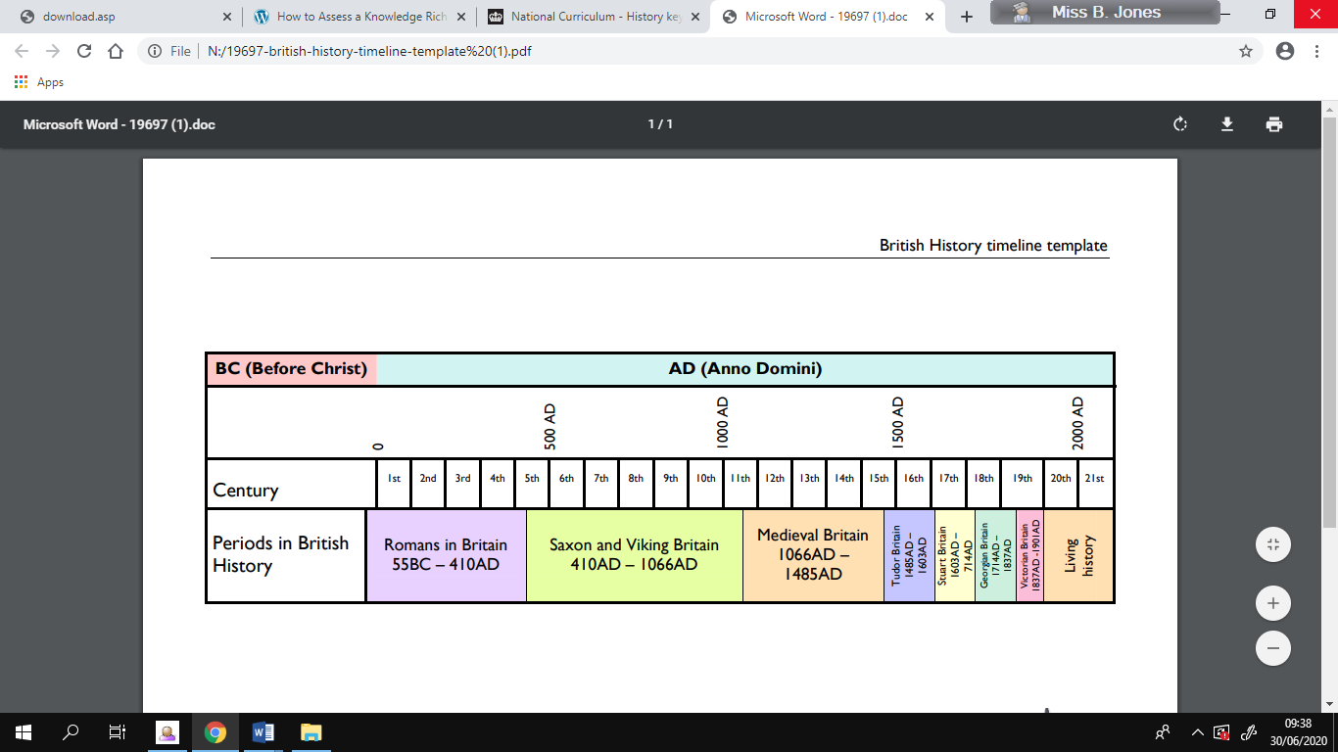

**British History Timeline**

**Sticky Knowledge**

* Roman empire began to fall and Anglo Saxons came to Britain for land.
* The Anglo-Saxons were fierce people who fought many battles, including fighting each other.
* The Anglo-Saxons were made up of three tribes: the Angles, Saxons and Jutes.
* The Anglo Saxons put systems in place to manage law and order such as shire reeve, thane who make decisions about problems, wergild.
* The Anglo-Saxon period ended when the Normans conquered Britain in 1066.

**Key Vocabulary**

**Knowledge Planner – The Anglo Saxons**