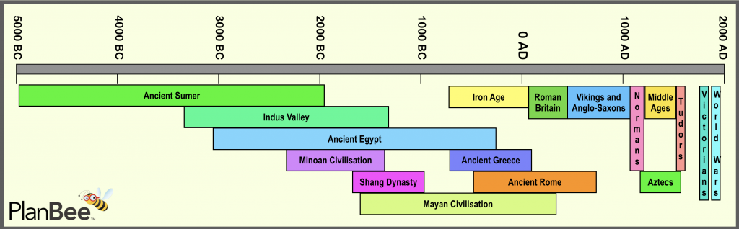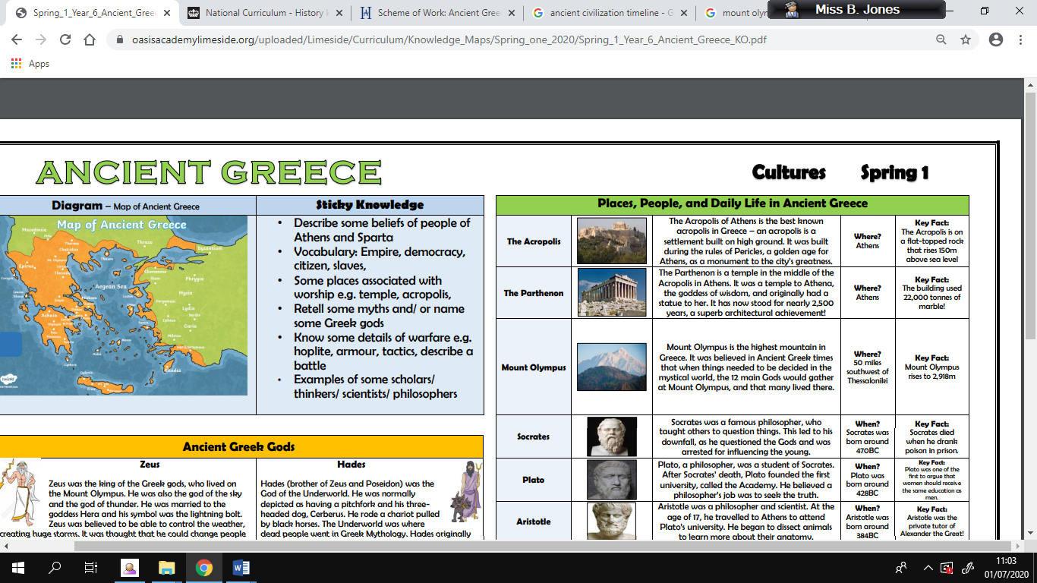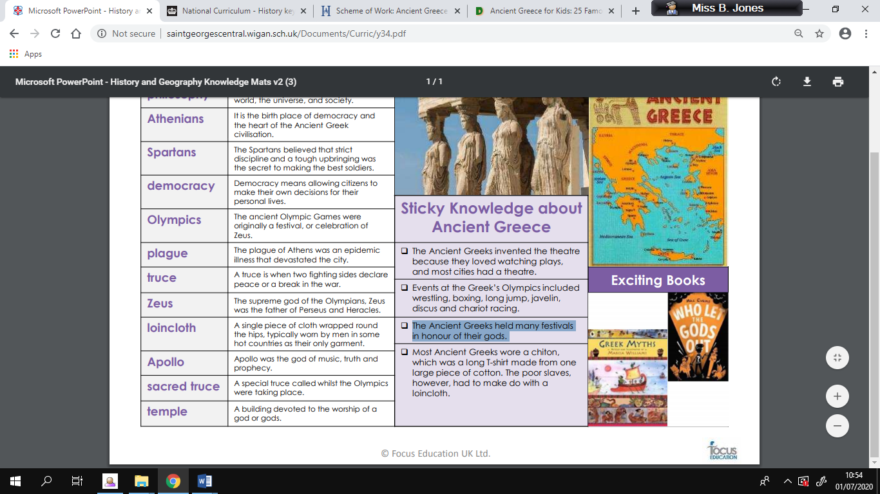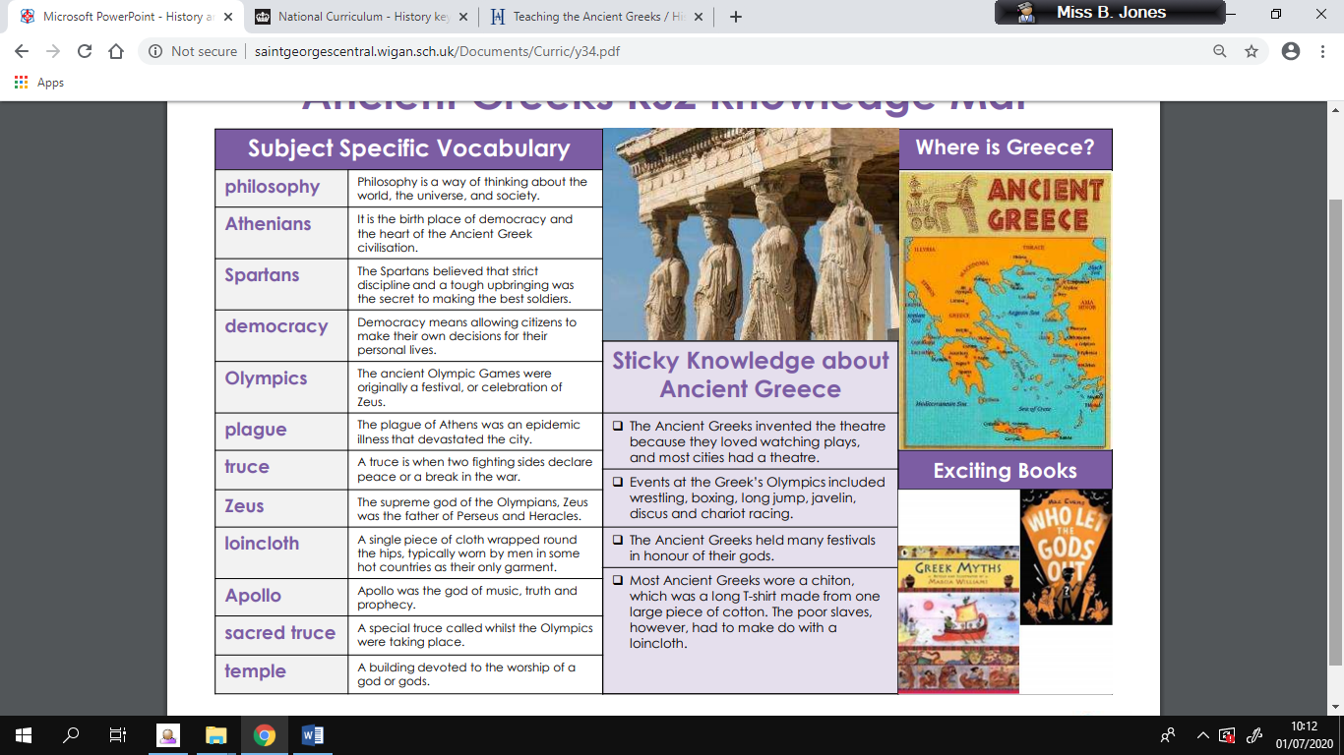

**Ancient Civilization Timeline:**

**Famous Places:**

**Exciting books to read:**

**Sticky Knowledge**

* Find out about the city states of Athens and Sparta
* The Ancient Greeks invented the theatre because they loved watching plays, and most cities had a theatre.
* Some places were associated with worship e.g. temple, acropolis
* Events at the Greek’s Olympics included wrestling, boxing, long jump, javelin, discus and chariot racing
* The Ancient Greeks held many festivals in honour of their gods.
* Know some details of warfare e.g. hoplite, armour, tactics, describe a battle
* Examples of some scholars/ thinkers/ scientists/ philosopher

**Key Vocabulary**

**Knowledge Planner – The Ancient Greeks**