**Knowledge Planner – The Ancient Egyptians**

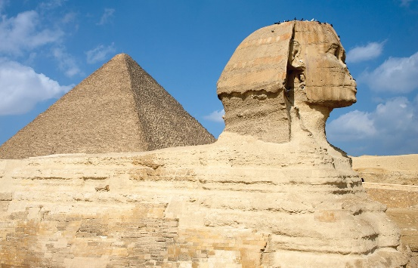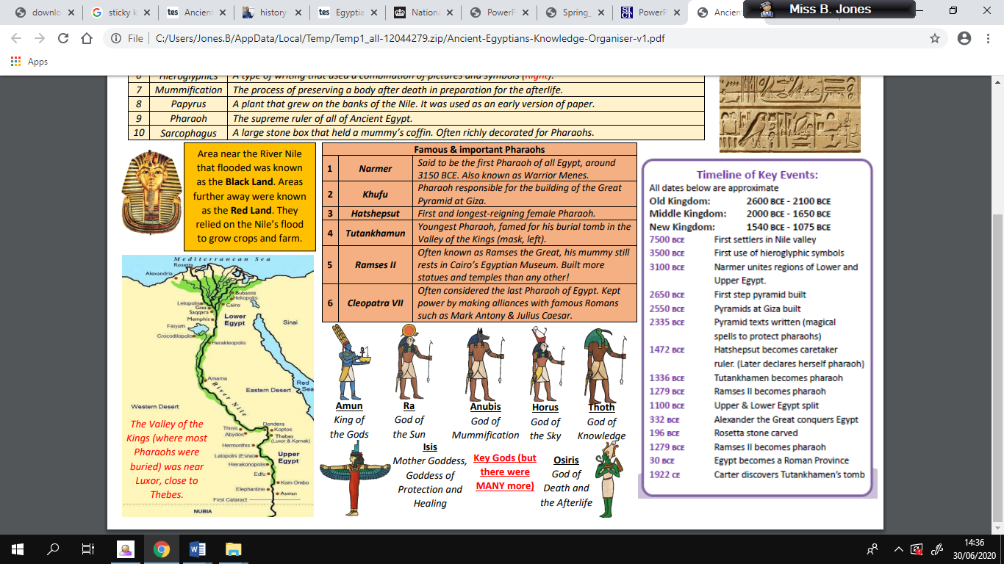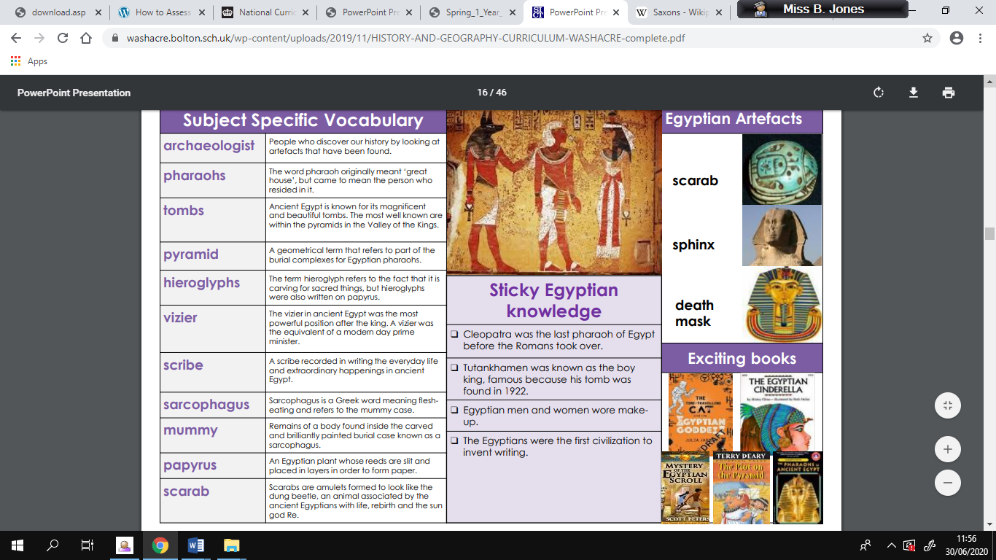

**Sticky Knowledge**

* Tutankhamen was known as the boy king, famous because his tomb was found in 1922.
* The Egyptians were the first civilization to invent writing.
* There were three kingdoms: Old, Middle and New.
* The lands were ruled by a sequence of pharaohs
* The land around the River Nile provided excellent soil for agriculture
* Cleopatra was the last pharaoh of Egypt before the Romans took over.

**Key Vocabulary**

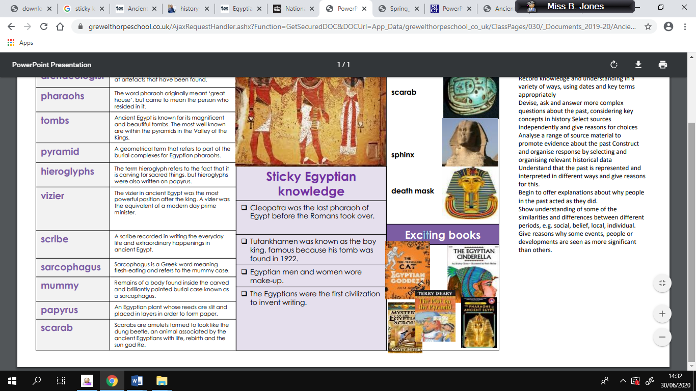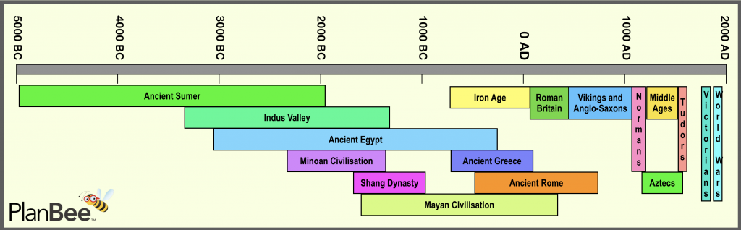

**Exciting**

**books**

**to read:**

**Ancient Civilization Timeline:**