

Computing

I will understand what algorithms are and predict what might happen when they are followed, use code to make a computer program, understand what object and actions are, understand what an event is, use an event to control an object. To begin to understand how code executes when a program is run and plan and make a computer program.

PE

I can master basic movements including running, catching, throwing as well as balance agility and co-ordination.

I can begin to apply these in a range of activities participate in team games, developing simple tactics for attacking and defending.

Art.

I will use a range of materials creatively.

I will develop a wide range of art and design techniques in using colour, pattern, texture, line, shape, form and space

I will learn about the work of a range of artists, craft makers and designers, describing the differences and similarities between different practices and disciplines, and make links to my own work.

I Know how to show how people feel in paintings and drawings

I Know how to use pencils to create lines of different thickness in drawings

Science

I can name the seasons and the type of weather in that season.

I can name the petals, leaves, stem and roots of a plant

I can compare basic differences between humans and animals.

Music

I can use my voices expressively and creatively by singing songs and speaking chants and rhymes.

play tuned and untuned instruments musically

listen with concentration and understanding to a range of high-quality live and recorded music.



RHE

I can explain who is special to me and why.

I can explain what types of different families I belong to.

I can talk about the differences and similarities between my own and other families.

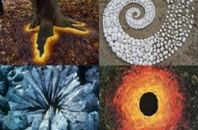

RE

I can talk about some simple ideas about Christian beliefs about God and Jesus.

I can re-tell a story that shows what Christians might think about God, in words, drama and pictures, suggesting what it means.

I can engage in discussion about believing in God and offer my ideas.

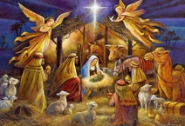

Geography

I can identify seasonal and daily weather patterns in the United Kingdom and the location of hot and cold areas of the world in relation to the Equator and the North and South Poles.

I know which is the hottest and coldest season in the UK

I know and recognise main weather symbols