**Numeracy**

* To add and subtract numbers with up to 3 digits using the formal column method
* To add and subtract numbers mentally
* Solve problems, including missing number problems, using number facts, place value, and more complex addition and subtraction
* Estimate answers using the inverse operations
* Recall and use multiplication and division facts for 2,3,4,5 tables.

# **English**

*Fairy Tales / Persuasive Letters*

Write a narrative with a clear structure, setting, characters and plot

- Create and develop plots based on a model

- Use prepositions and adverbs

- Use inverted commas for direct speech

- Use appropriate tone and intonation to present their writing to a group.

***Knowledge Organiser Autumn 2***

# **Art**

*Digital Art*

-Know how to use sketches to produce a final piece of art

-Know how to use digital images and combine with other media

-Know how to use IT to create art which includes their own work and that of others

# **Relationship Education**

*Emotional Wellbeing*

* To learn about different feelings and emotions people experience
* How feelings can change and to find out what helps people to feel good
* Why expressing feelings and emotions is important
* How to manage and get help to support with feelings and emotions

**Science**

*Animals including humans*

- Identify that animals, including humans, need the right types and amount of nutrition, and that they cannot make their own food; they get nutrition from what they eat

- Identify that humans and some other animals have skeletons and muscles for support, protection and movement.

- Know about the importance of a nutritious, balanced diet

- Know how nutrients, water and oxygen are transported within animals and humans

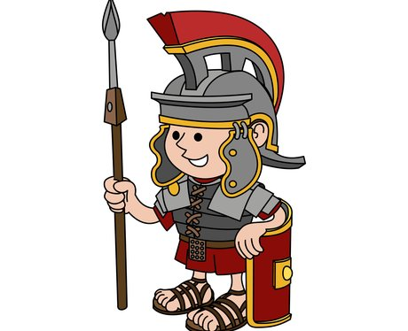



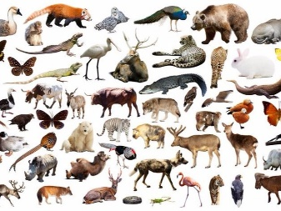

**History**

*Romans*

**-** Know how Britain changed from the Iron Age to the end of the Roman occupation

- Know how the Roman occupation of Britain helped to advance British society

- Know how there was resistance to the Roman occupation and know about Boudica

- Know at least one famous Roman emperor.

**Computing**

*Coding*

- Write programs that accomplish specific goals

- Discern when it is best to use technology and where it adds little or no value

- Design a sequence of instructions, including directional instructions

# **Spanish**

-Name and describe people, a place and an object

-Give response using a short phrase

-Write phrases from memory

# **Music**

- Create repeated patterns with different instruments

- Improve work: explaining how it has been improved

**PE**

*Cricket/Dance*

* Be aware of space and use it to support team-mates and to cause problems for the opposition
* Know and uses rules fairly
* Perform dances using a range of movement patterns
* Compare their performances with previous ones and demonstrate improvement to achieve their personal best

# **R.E**

**What do different people believe about God?**

-Describe some of the ways in which Christians Hindus and/or Muslims describe God

-Ask questions and suggest some of their own responses to ideas about God