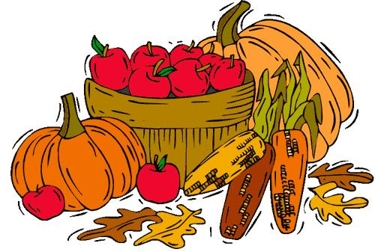

Harvest: Friday 15th October 2019

27th September 2021

Dear Parents/Carers,

The children will be celebrating Harvest in school on 15th October.

This year, we are again donating items collected to ‘Mustard Tree’. This is a local charity, which has a base in the Little Hulton precinct. The charity supports people on low incomes in many ways. This includes giving out food parcels to people who have no means of buying food, helping homeless people find shelter, running courses to enable people to gain skills, and providing emotional support when times are difficult. I am sure you will agree this is a worthy cause.

For our Harvest efforts we are asking for donations of non-perishable foods e.g. tins, packets and bottles (e.g. rice, pasta, soup, beans etc) to support the Mustard Tree in their work. You may send in your donation as soon as possible and anytime up to the 15th October.

Thanking you in anticipation.

Yours sincerely,

Mrs A Barker
Headteacher

