# **Literacy**

- Write a narrative with a clear structure, setting, characters and plot

- Create and develop plots based on a model

- Use Preposition

- Use adverbs

- Use inverted commas for direct speech

**Numeracy**

-Read and write numbers to at least 1000 in numerals and in words.

-Recognise the place value of each digit in a three-digit number (hundreds, tens and ones).

-Partition numbers in different ways.

-Compare and order numbers up to 1000.

-Solve number problems and practical problems involving these ideas.

***Knowledge Organiser Autumn 1***

# **Art**

-Know how to use sketches to produce a final piece of art

-Know how to use digital images and combine with other media

-Know how to use IT to create art which includes their own work and that of others

**Science**

-Compare and group together different kinds of rocks on the basis of their appearance and simple physical properties, giving reasons

-Describe in simple terms how fossils are formed when things that have lived are trapped within rock

-Recognise that soils are made from rocks and organic matter.

-Know about and explain the difference between sedimentary, metamorphic and igneous rock.

# **Relationship Education**

How can we be a good friend?

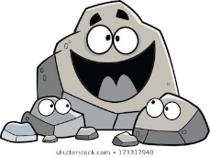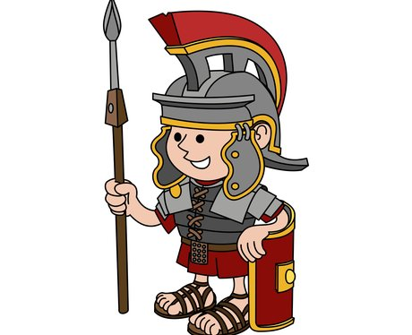



# **R.E**

**What do different people believe about God?**

-Describe some of the ways in which Christians Hindus and/or Muslims describe God

-Ask questions and suggest some of their own responses to ideas about God

# **Spanish**

-Name and describe people, a place and an object

-Give response using a short phrase

-Write phrases from memory

# **Music**

-Combine different sounds to create a specific mood or feeling

**PE**

-Adapt sequences to suit different types of apparatus and criteria

-Explain how strength and suppleness affect performance

-Improvise freely and translate ideas from a stimulus into movement

-Share and create phrases with a partner and small group

-Remember and repeat dance perform phrases

**History**

**-** Know how Britain changed from the Iron Age to the end of the Roman occupation

- Know how the Roman occupation of Britain helped to advance British society

- Know how there was resistance to the Roman occupation and know about Boudica

- Know at least one famous Roman emperor.

**Computing**

- Use technology respectfully and responsibly

- Know different ways they can get help, if concerned