ST ANDREWS METHODIST PRIMARY SCHOOL

New Nursery Intake
2021 Information Booklet



Adapted: June 2021 Review date: June 2022

St. Andrew’s Methodist Nursery

Contact Details

The School address is: - Prescott Street,
Little Hulton,
Worsley,
Manchester
M28 0ZA

The School telephone number is: 0161 790 3194
The School Website address is: www.standrewsmethodistschool.co.uk

The maintaining authority is the Salford Local Authority.

The Local Authority address is:-
Charlotte Ramsden
Director of Children’s Services,
Civic Centre
Chorley Road
Swinton

The Local Authority phone number is: 0161 793 2500

1

Welcome
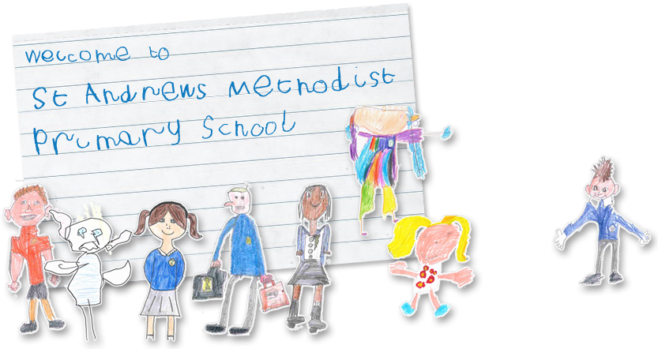

We would like to take this opportunity to welcome you and your family to our school. St. Andrew’s Nursery class is for children aged 3-4 years. The Nursery and Reception Class (for children aged 4-5 years) form the Early Years Foundation Stage (EYFS) of St. Andrew’s Methodist Primary School.

Staff Information

Mrs A Barker –Headteacher
Mrs J Plant – Deputy Headteacher

The Early Years Staff are:-
Miss D Smith – Nursery Teacher
Mrs P O’Leary- Nursery Teaching Assistant
Mrs B Connolly- Nursery Teaching Assistant
Mrs K Saysell – Reception Teacher (Early Years Phase Leader)
Mrs R McNally- Reception Teaching Assistant

2

General Information- Nursery

The Nursery Day

Nursery times are: - Full Time (9.00am – 3.15pm)
Lunch (11.30am – 12.00pm)
Lunch break (12.00pm– 1.20pm)
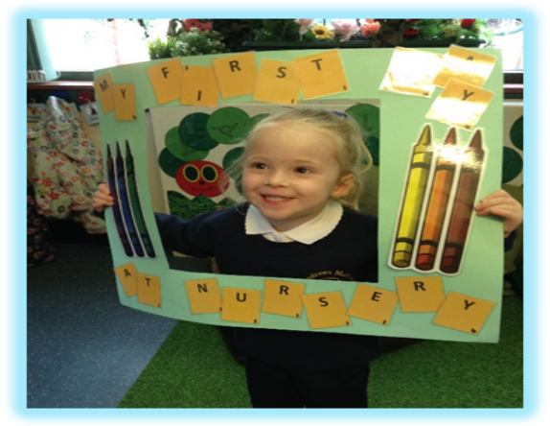
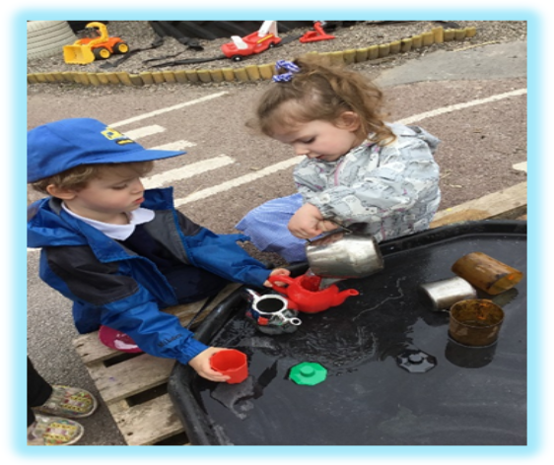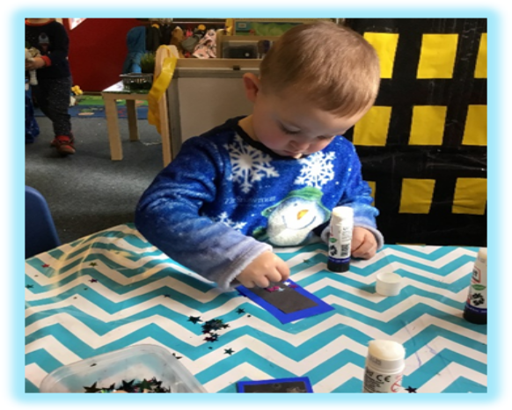
It is important that you are punctual at the start of the session and collecting your child. The gate will be locked at approximately 9.05am after which you will need to use the main entrance and let the office know your child has arrived. At the end of the school day the Nursery gate will be locked at 3.20pm. Your child will then need to be collected from the main school office. When waiting at the gate in the morning, please keep your child by your side at all times and off the staff car park. Please do not park on the staff car park.
3

Lunchtime/Snack Provision in the Nursery

All Nursery children are required to have a school meal. Sitting together eating a meal helps to develop social skills and encourages the children to try different foods.

School meals currently cost £2.10 per day (£10.50 per week.) Please note that this is subject to change. This is payable via the parent pay app of which you will receive a username and password when your child starts nursery.
If you have any queries re Parent Pay please contact the school office.
You may be eligible for free school meals.
For further information, contact:-
Salford Direct @ Civic Centre Tel: 0161 909 6508 (Office hours vary.)
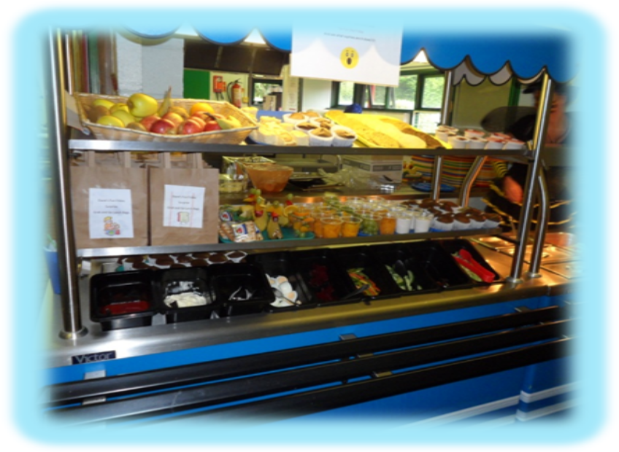

Milk will be provided each day for your child along with a portion of fruit. School milk is provided free of charge to children under five years old. The milk and fruit will be provided on a snack table so the children have continuous access to it. The children will also have access to fresh water throughout the school day.

4

Talking about Nursery

It is important that you talk about coming to Nursery before your child starts. Explain that there will be other children there, and lots of exciting things to do and play with. Explain that you will have to leave them in the nursery with the other children, but that you love them very much and will always come back. Mention the names of the Nursery staff in a happy positive way.

Below are some pictures that will assist you with talking about Nursery.

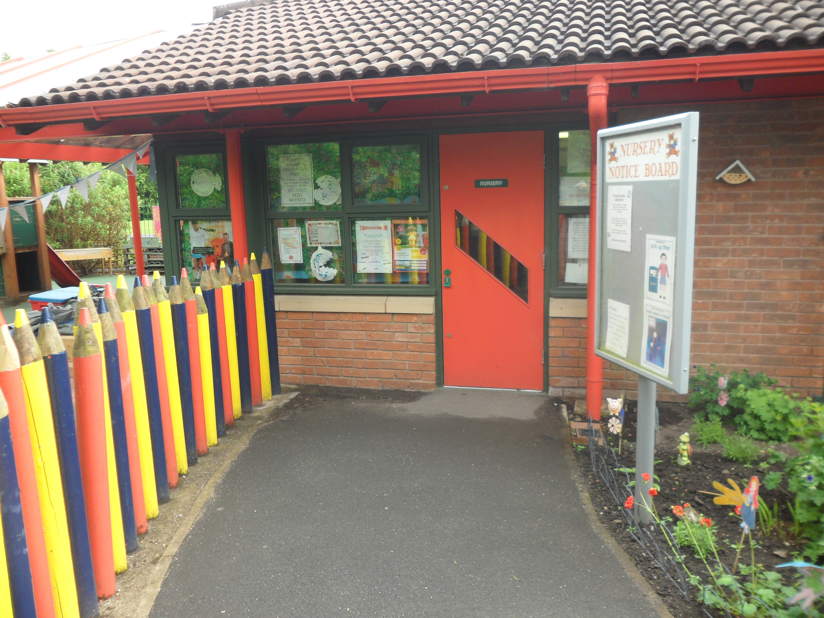  This door is where the children enter the Nursery in the morning and where they leave at home time. | 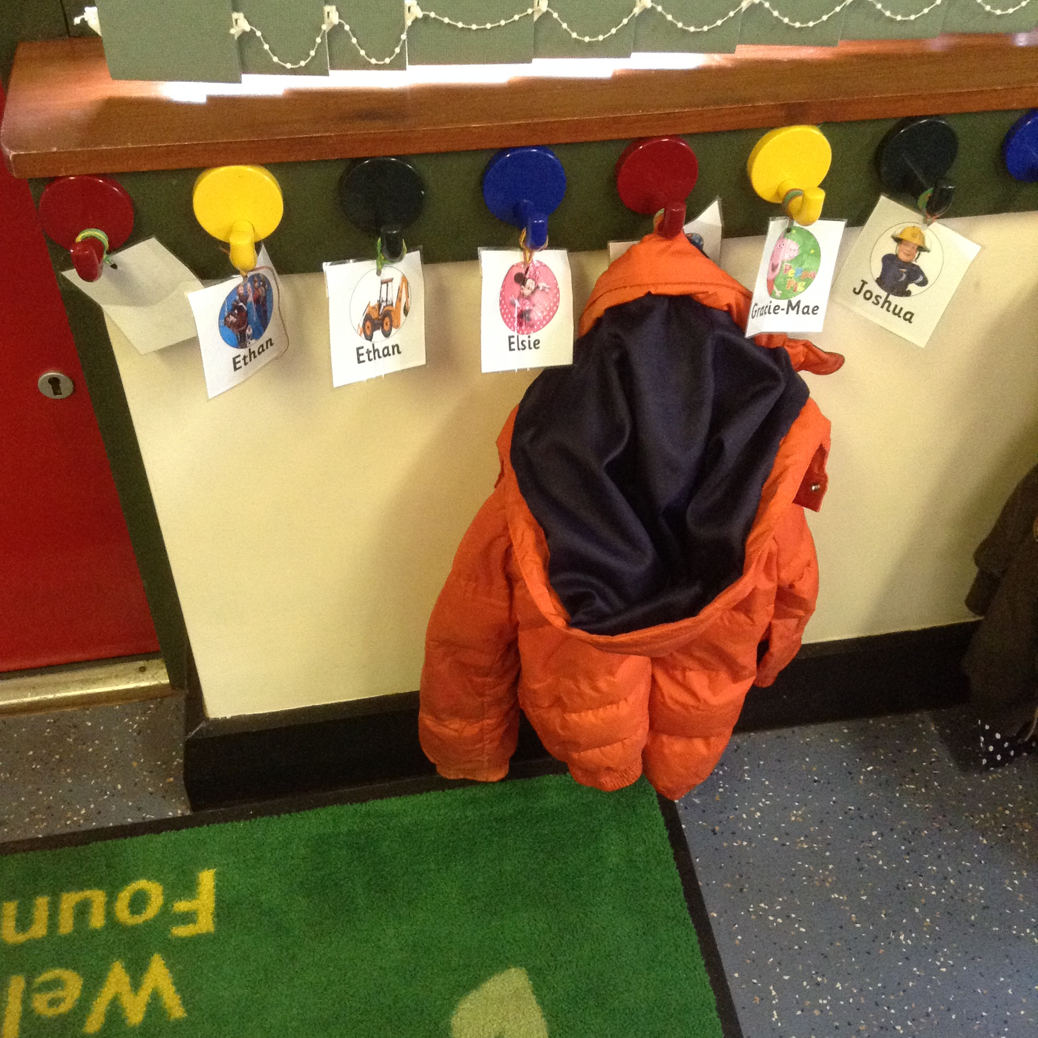  This is where they will hang their coat. | 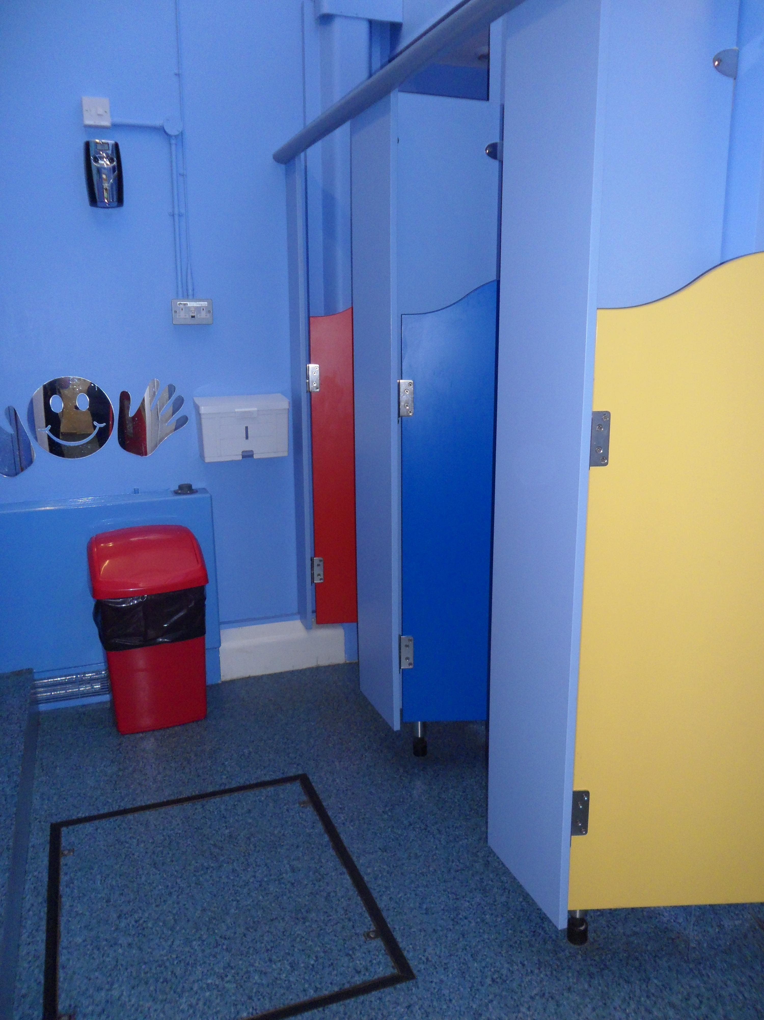  These are our Nursery toilets.
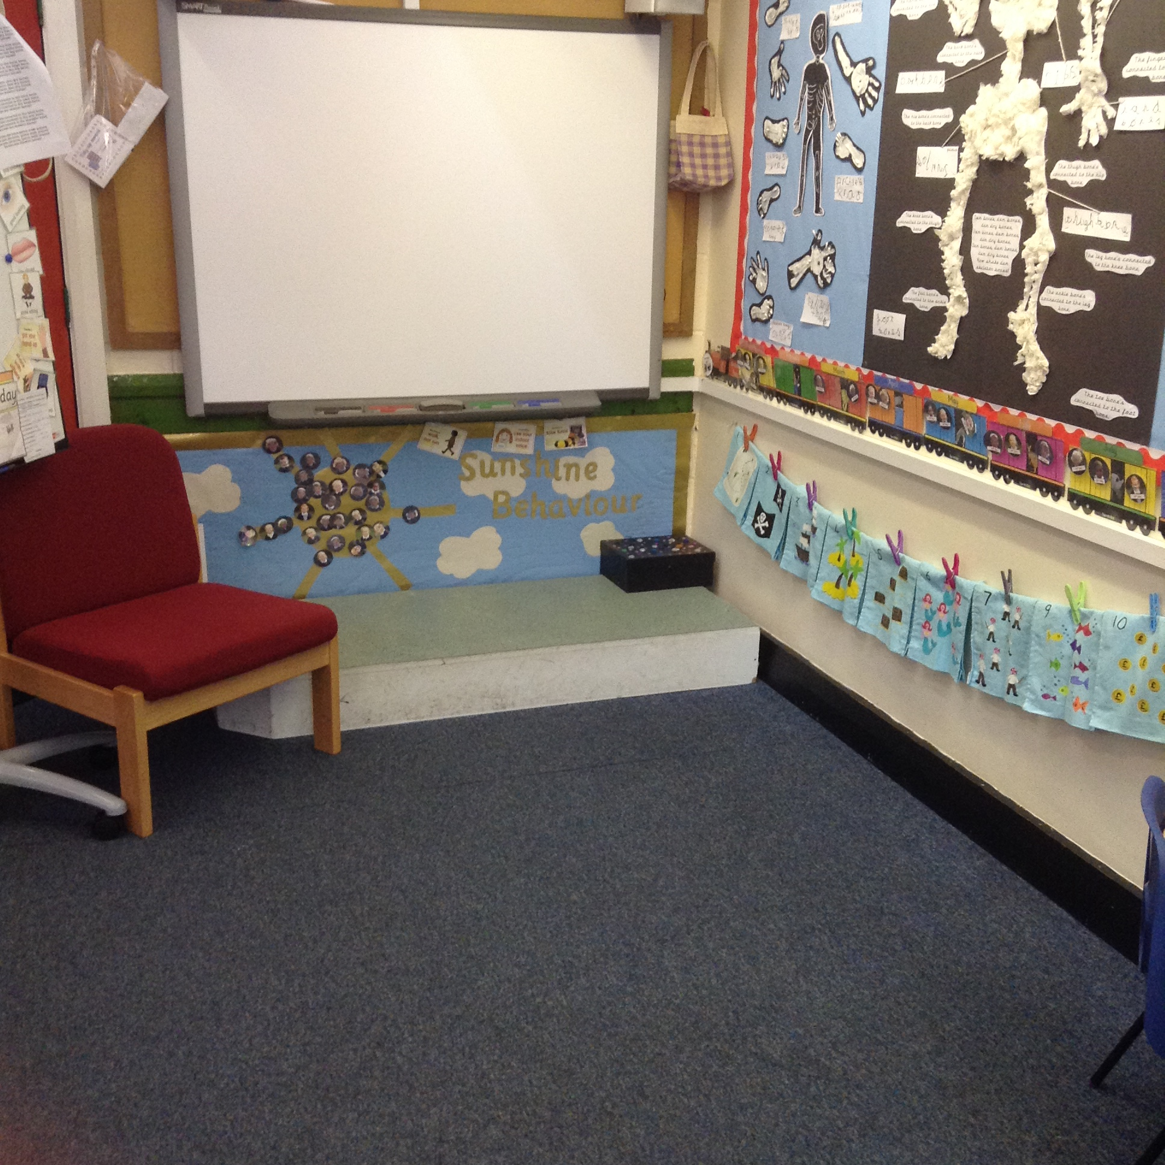  This is our carpet area. | 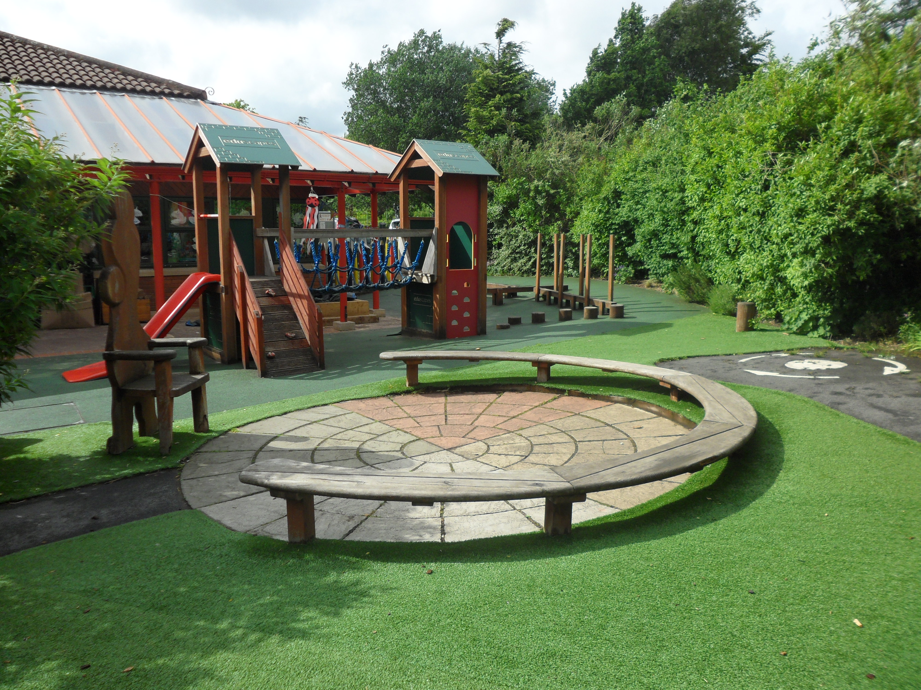  This is our exciting outdoor area. | 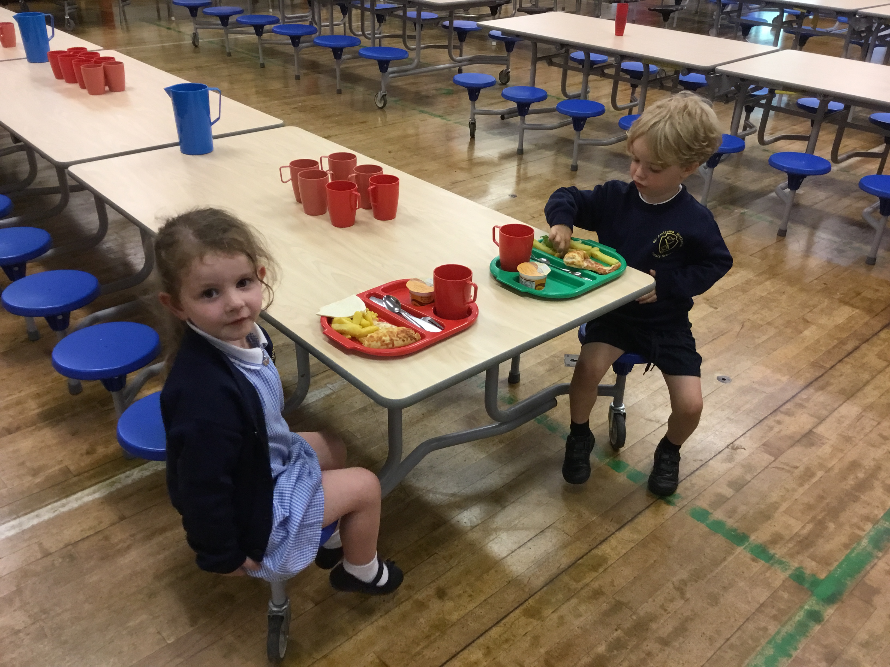  This is our hall where the children will eat their lunch.
5
5

Other Nursery Information

When your child has settled in, the class will be separated into three groups and each group will be assigned a key worker. Your parents evening appointment will be with the teacher, plus your child’s key worker. Below are pictures of the staff that work within our Nursery.





We have a Foundation Stage Fund to which we invite you to contribute.
If you so wish, the sum of 50p each week will be collected on a Monday morning along with dinner money if applicable. We use the fund to buy baking ingredients, resources and other items, which we may need to buy for the benefit of the children. We have a lot of special events, days and celebrations in the Foundation Stage that the school fund pays for.

Sweets, crisps or chocolate are not allowed in the Nursery as a portion of fruit is given to each child every day as a snack. We ask that children do not bring their own toys from home as it can cause upset if they become lost or broken. We have a wide variety of toys for the children to access each day at Nursery.
6

6

Miss Smith (Nursery Teacher)

Mrs Connolly
(Nursery Teaching Assistant)

Mrs O'Leary
(Nursery Teaching Assistant)

Transition into our Nursery



In order to ensure a smooth transition into our Nursery we take the opportunity to gather as much information about your child as possible. If your child already attends a childcare setting such as a Nursery or play group, then we liaise with staff and discuss each child’s needs and interests.

.

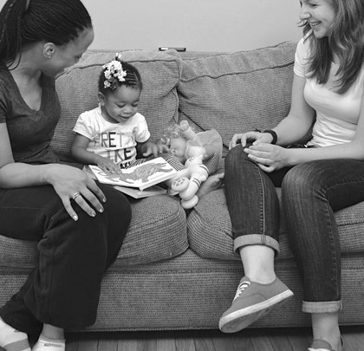

7

Uniform
All our Nursery children wear uniform. The Nursery uniform comprises: -
Navy Sweatshirt with school logo,
White polo T-shirt,
Navy tracksuit bottoms,
Blue checked or grey dresses/skirts
Grey shorts or trousers
Black school shoes
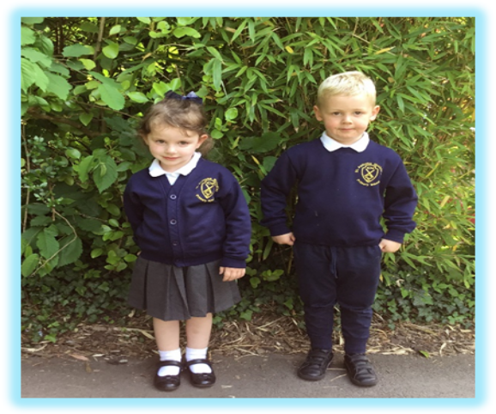

You can purchase your child’s full school uniform from Brigade.uk.com. The website is easy to use, on the website you just need to type in our school name which will take you to our uniform.

Nursery children do not require a PE kit. However, they do require a PE bag containing spare clothes, underwear and socks that can stay in school in case of an accident or change of clothes when necessary. These PE bags can be purchased online too.

Children should wear sensible shoes, preferably with a velcro fastening to encourage independence when dressing and undressing.

We would like the children to keep a pair of wellingtons in school for outdoor play on rainy days, and a sunhat for sunny days. Included in your pack is a consent form for your permission for us to apply sun cream to your child. We do have our own supply of factor 50 sun cream in school, however if you wish to send in one from home then this must be kept in school.
8

7

Please put nametags in school clothing and coats, or mark them with a name to avoid confusion or loss. Please continue to check these throughout the school year.
We would like all children to have a school book-bag. They are available to buy from the school office.
If it is a wet day and your child comes to school in wellingtons, please bring shoes to change into.
We provide protective clothing and aprons for activities such as painting, sand and water play, art and baking. We also have waterproof jackets for outdoor play on rainy days.
Please do not allow your child to bring any other bags, as space in the cloakroom is limited.
A photographer will take individual photographs of your child before Christmas and as a group in the summer. Please remember that you are under no obligation to buy the photographs.
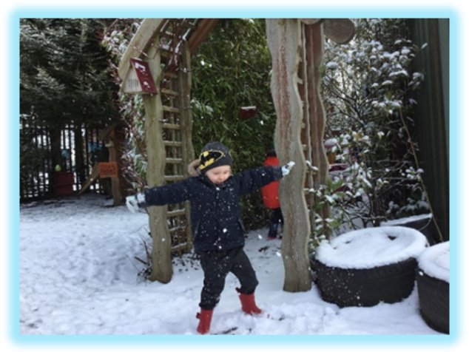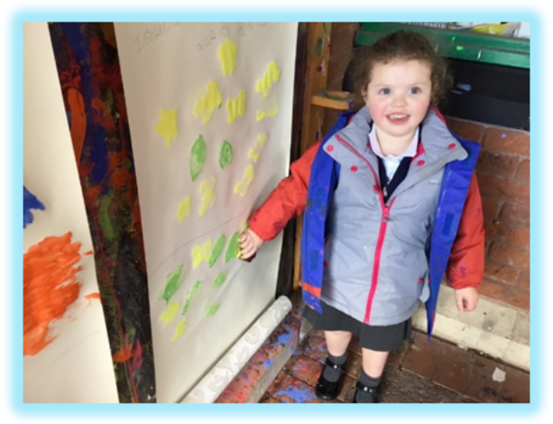
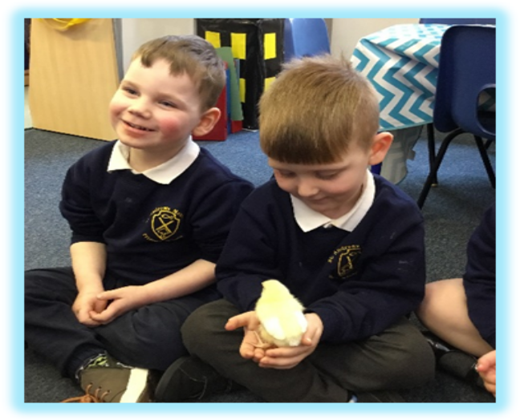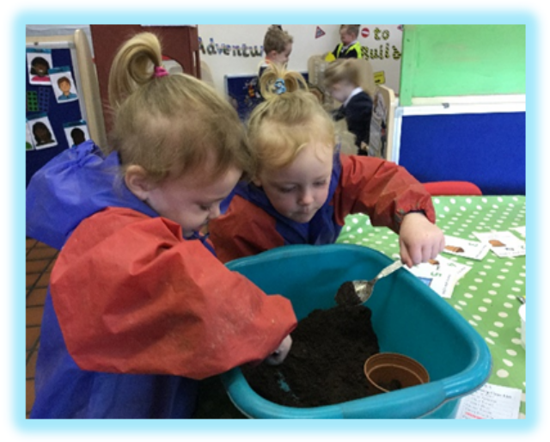
9

7

Absences from Nursery

If your child is ill and cannot come to school, please ring and let us know.
A poorly child is happier at home, even if he/she cries to come to school.
We do not administer any medicines in the Nursery. If your child needs an inhaler, you will need to provide an extra one for school, along with a spacer and complete a form.

If your child needs a course of medicine e.g.: antibiotics, Penicillin etc, we feel it is necessary that he/she remains at home with you until the course of medicine is finished and your child is fully recovered.

If your child is taken ill whilst at Nursery, we will contact you at home or work. An emergency contact form must be completed when your child enters Nursery, with at least two phone numbers listed for emergencies. Please notify us immediately if there are any changes of phone numbers or place of work so that our records are kept up to date.

If your child has sickness or diarrhoea, we ask that you keep them off school for 48 hours after the last episode as part of our First Aid Policy.
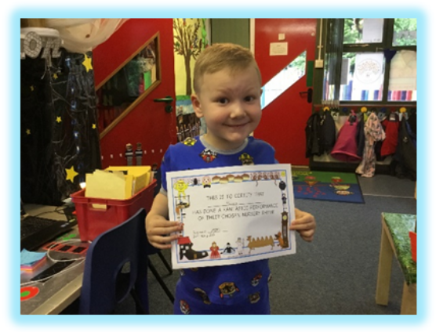
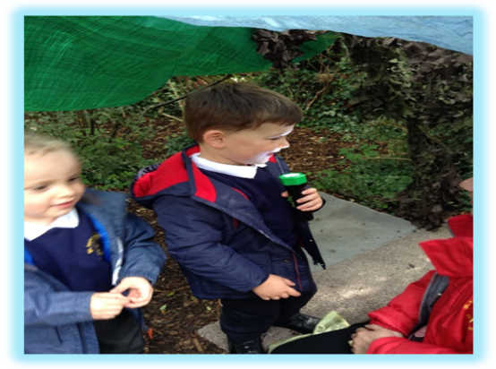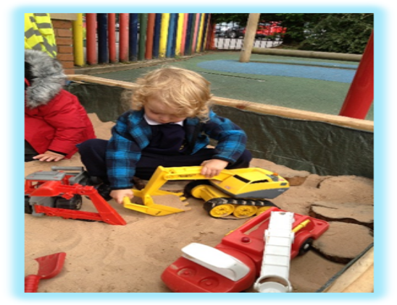
10

Learning in the Foundation Years

We will provide a happy, safe and caring environment for your child. We will provide a quality, well-planned Foundation Years education for your child in accordance with the DfES document entitled ‘The Early Years Foundation Stage’. We will offer your child a wide range of valuable learning experiences, which aim to underpin all future learning. Our aims are to promote development in these areas.

Personal Social & Emotional Development
We aim to help your child adjust to and enjoy school, to relate to other children and adults in school, to learn to become part of a group, to share and take turns, to become more independent, to co-operate and to build self-confidence and self esteem.

Communication and Language
We aim to develop language to communicate needs, thoughts and feelings and to provide the foundations for literacy by developing the basic skills in reading and writing. We will be following the Letters and Sounds document for phonic development.

Physical Development- Fine Motor & Gross Motor
Physical skills and co-ordination are developed through use of apparatus and games. These skills include running, jumping, climbing, balancing, throwing etc. We have outdoor play every day at nursery in our exciting garden, which has a large climbing frame, mini assault course and roadway. There are also planned P.E sessions in the hall, some with specialist coaches. Fine manipulative skills are developed in many ways, for example through threading, cutting, painting and colouring, pencil play, malleable activities and small construction kits. We aim to establish positive attitudes towards a healthy and active way of life.
11



Literacy- Reading and Writing
Children in the foundation stage are encouraged to read and write every day in a variety of different ways. In nursery, children will practise writing their name and forming letters correctly. Children will enjoy a variety of books, both fiction and non-fiction each day. We encourage parents to enjoy sharing books regularly with their child. Your child will receive a library book of their choice and a comprehension book-it is very important that you read these books at home regularly and write comments in their reading record book.
Children in the nursery will take part in a daily phonics session each day. We use the ‘Letters and Sounds’ document to support our phonics teaching in school.

Mathematics – Number
We aim to cover important aspects of mathematical understanding and provide the foundations for numeracy. This is achieved through a wide range of practical and play activities. This promotes understanding of patterns, sequences, sorting, matching, counting and problem solving and encourages the use of appropriate language to develop simple mathematical ideas.

Understanding of the World
We aim to encourage your child’s natural curiosity of the world around them by providing a wide range of exciting activities which encourage and require observation and which will foster an interest in the natural world and the people in it. The opportunities we provide will naturally encourage your child to ask questions Why? What? Where? Who? thus providing a foundation for historical, geographical, scientific and technological learning. Our Foundation Stage Outdoor Adventure Play Area will give many opportunities to observe plants and wildlife at first hand.
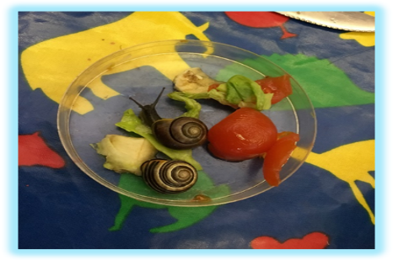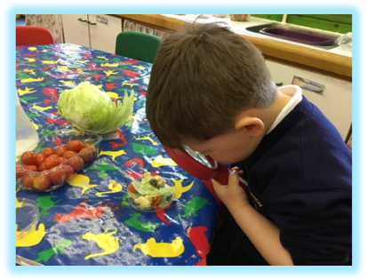
Expressive Arts and Design
We aim to develop the senses, imagination and to provide creative experiences through a wide range of art activities, drama, music, stories and poems.
12

How to Help Your Child Prepare for Nursery
We encourage that all children are toilet trained. If this is proving a problem, please contact Nursery staff before your child is due to start at the Nursery so that an appropriate plan can be put into place. Occasionally, your child may have a toileting accident in school. If this happens, a member of the Nursery staff will assist with cleaning your child and changing them into clean clothes. Parents will need to sign a Personal Care Consent form in order for staff to do so. Any clothes provided from Nursery need to be cleaned and returned to school as soon as possible. Please return any clothing within a named carrier bag and place them within your child’s book bag.
If your child can do the following things it would be most helpful as we encourage independence as much as possible.
- Wash and dry own hands,
- use a knife, fork and spoon,
- suck through a straw,
- manage his/her own clothes at the toilet,
- put coat on and off and hang it up,
- wipe his/her nose,
- take off and put on shoes (without fastening them).
- take off and put on their socks

Please try to find time to read stories and nursery rhymes to your child. Choose books with large attractive illustrations. Visit the local library and encourage your child to choose their own books. Encourage him/her to sit with you to share, listen and look. It is also a good idea to watch suitable pre-school television programmes with your child and talk about them. Let your child help you around the house, with washing up, baking, setting the table, tidying away toys etc. Talk with your child as much as possible, explaining what you are doing and asking him/her simple questions. Listen to replies and respond to them giving praise for any achievement-
No matter how small. Your child learns from you!
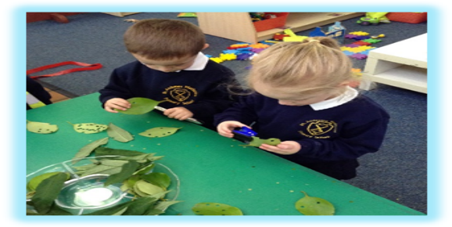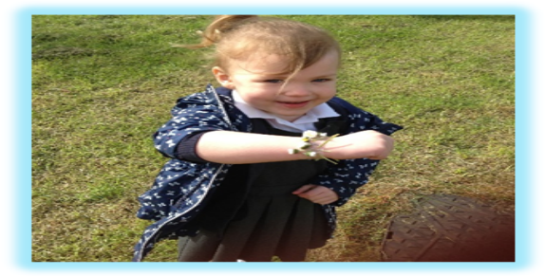
13

13

