26th January 2021

Dear Parent or Carer

Government Advice, Critical Workers, Remote Learning

Important information regarding pupil attendance: January 2021

I want to thank you for the very supportive approach you have taken during these exceptionally challenging times. I also want to acknowledge the difficulties many of you are experiencing at the moment balancing your work and other commitments with supporting your child with their education.

As you know, COVID cases have been increasing after Christmas right across the country; and indeed, here in Salford the number of cases still remain high with pressure on the NHS and care services.

Government Guidance
We know we all need to do what we can to reduce the spread of the virus. We need to reduce contact with others outside of our homes and ensure we are social distancing, wear face coverings, maintain handwashing, be aware of Covid symptoms and get a test if symptoms develop. That is why the Government has given clear guidance on restricting attendance in schools during this latest national lockdown. This guidance makes it clear that the most important contribution you can make is to keep your child at home if you can safely do so.

The Government has updated and published a list of those parent / carers who are deemed to be critical workers as well as pupils who are considered vulnerable. The guidance also states that where possible schools should keep group sizes small and keep the numbers accessing school as low as possible. Any additional space available where there are lower numbers of pupils attending should be used wherever possible to maximise the distance between pupils and between staff and other people.

Critical workers
If you are a critical worker and you are being asked to work from home and it is possible for you to keep your child at home with you or another family member, we do ask that you do this in order to help schools keep class sizes small, reduce contacts and maintain a safe environment.

Remote Education
For children who are working from home, your school is providing remote education, this will look different from school to school and for different age groups. This may mean some resources being sent to you by email or through the post for your child to complete, or it may mean teachers uploading work onto a remote learning computer platform that the school is using. Headteachers have made decisions about what will work best for the children and families in their school. Remote learning does not necessarily mean your child’s teacher will be teaching face-to-face online lessons, although there may be some of this during the week. Some of the online learning may involve completion of tasks for your child to send back to school digitally, or he/she may be asked to watch some pre-recorded content. https://www.salford.gov.uk/cvinfoforparents provides some useful information and your child’s school will be give you the information you need about what is provided and they will help support your child with this as well as giving you guidance as to how
1

you can help.

Whilst I recognise this remains a challenging time for all, I thank you for your patience and ask that you support our school staff and each other by respecting the decisions that have been made, particularly if you have not been able to access a school place. Please continue to work with your school to find a safe and sensible solution to help us fight the virus in Salford.

Yours faithfully,

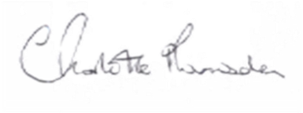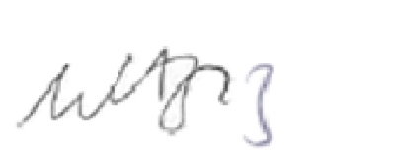
Charlotte Ramsden Muna Abdel Aziz
Strategic Director, People Director of Public Health

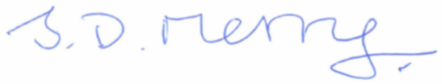
Councillor John Merry Deputy City Mayor & Lead Member for Children’s
and Young People’s Services

2

