Dear Parent,

You are now able to book a COVID-19 test for your child/ren who attend our school if they feel unwell with ‘non-classical’ COVID-19 symptoms. While we know a lot of people are more likely to catch winter viruses at this time of year, in Salford we still want to rule out the possibility of COVID-19 and encourage children to get tested.

Please note:

- We are still advising immediate isolation to anyone who is suffering three classical symptoms, namely: new continuous cough; a high temperature (fever); or a loss of or change in normal sense of taste or smell, or have a positive test result

- Pupils who are unwell with any of the symptoms below are not expected to isolate immediately but we would advise that they go for a test to rule out COVID-19.

Non-classical symptoms include:

- Vomiting/nausea/off your food
- Diarrhoea
- Sleeping more than usual/extreme tiredness
- Listless/restless/agitated
- Shortness of breath
- Feeling cold
- Headache
- Severe body aches
- Sore throat
- Congested or runny nose
- Skin rash
- Complaining of anything that is not feeling themselves
- To book a test please visit www.gov.uk/get-coronavirus-test and, when prompted, click the box “My local council has asked me to get a test, even though I do not have symptoms” (see below).

Best wishes,

Atypical COVID-19 testing: Your questions answered

What are we asking?

The ‘classical’ symptoms of COVID-19 are widely known as:

- a high temperature,
- a new continuous cough
- a change to your sense of smell/taste

As soon as someone shows one of these symptoms, they must self-isolate immediately and book a test for COVID-19.

In Salford, we’re taking this one step further in our fight against the virus and now advising high school pupils who feel unwell in any way to book a test to rule out COVID-19.

Why?

We’re heading into winter when we know people are more likely to pick up bugs and viruses, which has always been the case before COVID-19 arrived.

We have seen some people who fall ill with other symptoms at the start of their illness, can then go on to develop the ‘classical’ COVID-19 symptoms.

We are also acutely aware of how much disruption has been caused to our children’s education over the last few months and we want to minimise this as much as possible. If we encourage pupils to get tested as soon as they start to feel unwell, it helps us find positive cases earlier so they and their close contacts can isolate as soon as possible, stopping the spread of the virus and keeping classes open.

What are the non-classical (atypical) symptoms?

Non-classical symptoms include:

- Vomiting / nausea / off their food
- Diarrhoea
- Sleeping more than usual / extreme tiredness
- Listless / restless / agitated
- Shortness of breath
- Feeling cold
- Headache
- Severe body aches
- Sore throat
- Congested or runny nose
- Skin rash
- Complaining of anything that is not feeling themselves

If your child is generally not feeling themselves, we advise you to book a COVID-19 test for them.

How do I book a test for my child?

Go to www.gov.uk/get-coronavirus-test and, when prompted, click the box that “My local council has asked me to get a test, even though I do not have symptoms”.

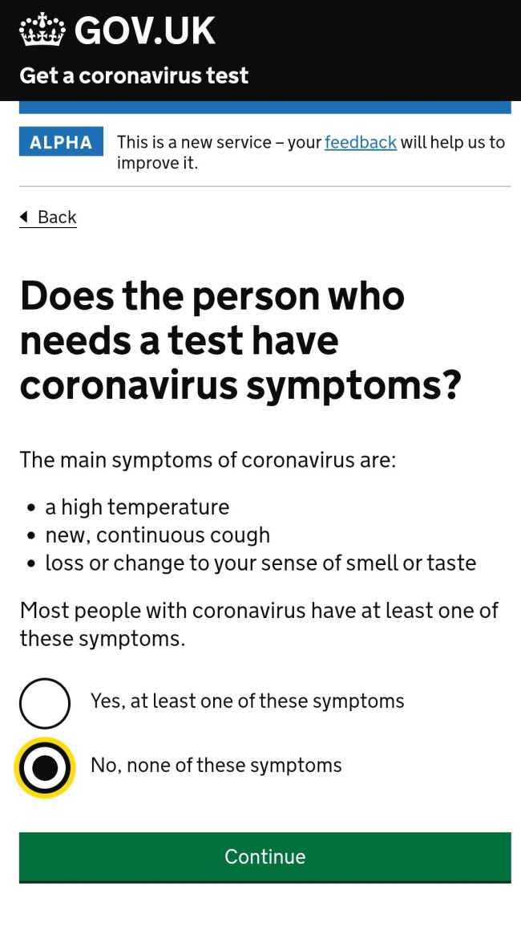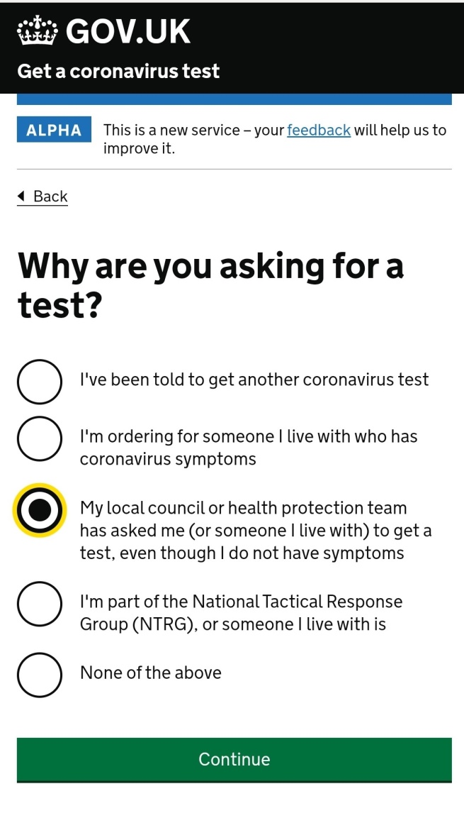

Does my child need to self-isolate?

If your child feels unwell but doesn’t have the ‘classical’ COVID-19 symptoms, we’re encouraging you in Salford to get them tested to rule out the possibility it’s COVID-19.

They do not need to self-isolate unless they test positive or go on to develop one of the three classical symptoms of COVID-19 (high temperature, new continuous cough or changes to sense of taste/smell).

