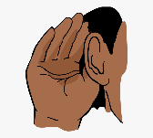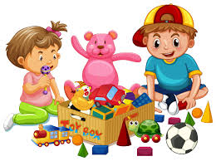

**Communication and Language**

I am learning how to sit nicely and listen to the teacher.

I am learning to understand questions that my teachers ask me.

I am beginning to talk to my friends and teachers confidently and jump from topic to topic.

**Personal, Social & Emotional Development**

I am making lots of new friends at my new nursery.

I am starting to join in with other children in my class.

I am coming into school with big smiles.

**Literacy**

I am learning how to look after books and read them independently.

I am learning how to sit and listen to short stories.

I am learning how to give meaning to the things that I draw and paint.

I am listening carefully to different environmental sounds.

**How Physical Development**

I am learning how to draw simple shapes (such as circles) and turn them into faces.

I am learning how to tell my teachers my needs and wants throughout the day.

I am learning how be independent in self-care, but still often need adult support.

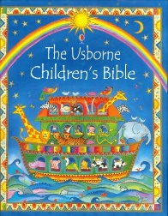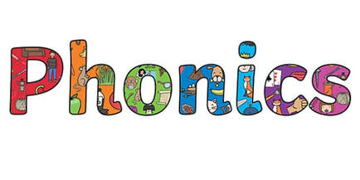

**Understanding the World**

I am learning all about my friends.

I am talking about significant events from my own experience (30-50).

I am learning how to talk about the living things that I see in the outdoor area at my new school.

I am beginning to be interested in the technological toys in my class.

Marvellous Me!

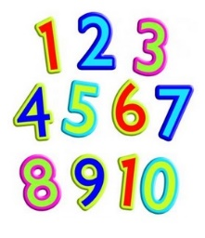

**RE**

I am learning how to talk about people who are special to me

I am discussing what makes my family special and why.

**Expressive Art and Design**

I join in with songs at group times.

I am learning how to construct with the construction toys.

**Mathematics**

I am learning to count on my own.

I am learning to recognise numbers in the environment.

I am learning how to recognise shapes that I play with.