

**Mount St Joseph**

**VIRTUAL OPEN EVENING**

**Please log onto our website:** [**www.msj.bolton.sch.uk**](http://www.msj.bolton.sch.uk) **on**

**Thursday 24th September 2020 from 4:00pm onwards**

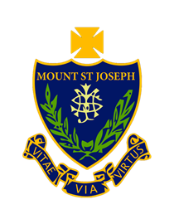

**Let your child develop their individual talents and explore exciting learning opportunities.**

“Pupils speak enthusiastically of their pride in belonging to **a multi-cultural** and **diverse community**”

Ofsted

“The school’s work to ensure that students are **safe** and **secure** is outstanding”

Ofsted

A Community of Learners, Believers and Friends.

Greenland Road, Farnworth, Bolton, Bl4 0HU. 01204391800

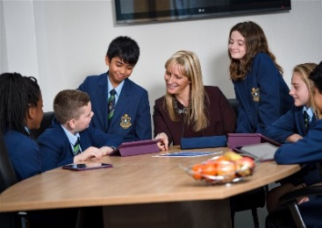 

A Community of Learners, Believers and Friends.

Dear parent and carer

I would like to warmly welcome you to Mount St Joseph Catholic School.

Our ethos is underpinned by the gospel values of serving others, tolerance, compassion and forgiveness. As a community of learners, believers and friends, we are committed to the spiritual, moral, educational and social development of all in our community.

We believe strongly in the power of high expectations of our students and of ourselves and in the importance of personal goals that are meaningful to each individual. We know that every student has their own potential and we are determined to help them fulfil it. We aim to enable all students to take part in exciting learning inside and outside of the classroom, so that they can make rapid and sustained progress.

We are proud of our team of dedicated staff who provide an inspiring, structured and supportive learning environment, in which every student is challenged to realise their full potential and encouraged to be ambitious for their futures. Our school sustained good results; they are attributable to the hard work and high aspirations of our students, the strong teaching from our committed and talented staff, the outstanding pastoral support and a clear commitment to raising achievement from all members of the school community.

There is a strong emphasis on providing opportunities for students to further build their confidence, self-esteem, interpersonal relationships and to develop their resilience to overcome problems. We aim for all our students to enjoy their time at Mount St Joseph School, to have memories and friends that will last a life time and to leave with the qualifications, personal skills and attributes needed to be successful young adults.

Please take the time to watch our virtual tour available on our website to meet all our wonderful MSJ community. If you have any further questions, please do not hesitate to contact us on: [reception@msj.bolton.sch.uk](mailto:reception@msj.bolton.sch.uk) or 01204 391800

A Devany

Headteacher

Mount St Joseph

**OPEN EVENING**