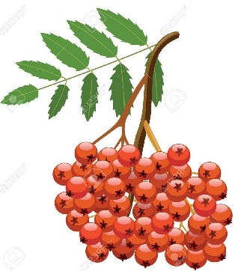
Hello everyone, Mrs Hodgkinson here, your new Y6 teacher.
Our class will be known as ‘Year 6 Rowan’

The Rowan tree is such a beautiful tree with its bright red berries and just like this tree I know you’re all going to shine and bear such wonderful fruit, with all your hard work in the coming year. Mrs Lysons will be joining us and we are both delighted about teaching you in your final year at St Andrews.

Year 6 is a sensational year! We work hard in all subjects and although at times we all may find some learning tricky, don’t worry, we are always there to support you and to guide you all the way to success. We don’t want any of you to worry about Year 6; quite the opposite we want you to LOVE IT!

In preparation for Year 6 we will be uploading some Y6 activities onto your Y5 Seesaw account. These tasks will give you an idea of the type of work we will be completing from September, and it will also encourage you to maintain good learning habits, such as reading every day.
Please use your QR Code from Year 5 when logging in.

On the St Andrews Methodist Primary School website, we have also made a short video on under the ‘Transition’ section for you to view, explaining a bit more about our year together.

If you have any questions, please do not hesitate to ring the school office to make a telephone appointment with us.

We are very much looking forward to seeing you in September. Our classroom is the Y6 classroom facing the playground. You will enter the classroom from the door facing the playground, where both I and Mrs Lysons will meet you on Monday 7th September.
Don’t forget your water bottles!

Here is a short video by the Woodland Trust informing you all about the Rowan tree.
What a perfect name for our class.
https://www.youtube.com/watch?v=pHoCsCsxExA

Have a lovely summer with your families.

Mrs Hodgkinson & Mrs Lysons

