ST ANDREWS METHODIST PRIMARY SCHOOL

New Reception Parents Information Booklet



Adopted: June 2020 Review date: June 2021

St. Andrew’s Methodist Nursery

Contact Details

The School address is: - Prescott Street,
Little Hulton,
Worsley,
Manchester
M28 0ZA

The School telephone number is: 0161 790 3194
The School Website address is: www.standrewsmethodistschool.co.uk

The maintaining authority is the Salford City Council Educational Authority.

The Education Office address is:-
Charlotte Ramsden
Director of Children’s Services,
Civic Centre
Chorley Road
Swinton

The Education Office number is: 0161 793 2500

1

Welcome
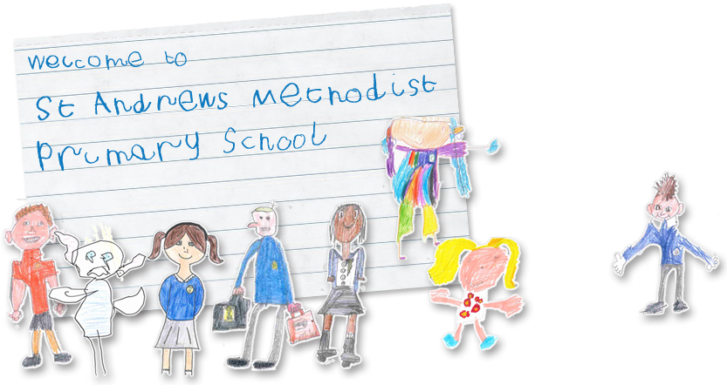

We would like to take this opportunity to welcome you and your family to our school. The Nursery and Reception Class form the Early Years Foundation Stage (EYFS) of St. Andrew’s Methodist Primary School.

Staff Information

Mrs A Barker –Headteacher
Mrs J Plant – Deputy Headteacher

The Early Years Staff are:-
Miss K Storey – Reception Teacher
Mrs J Gibbons- Reception Teaching Assistant
Miss Smith – Nursery Teacher
Mrs P O’Leary- Nursery Teaching Assistant
Mrs B Connolly – Nursery Teaching Assistant

2

General Information

The School Day

Reception times are: - Full Time (8.55am – 3.20pm)

Lunch- 12.25pm
Lunch break (12.00pm– 1.20pm)

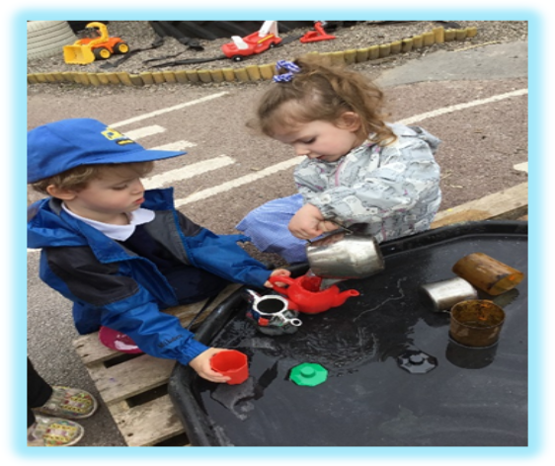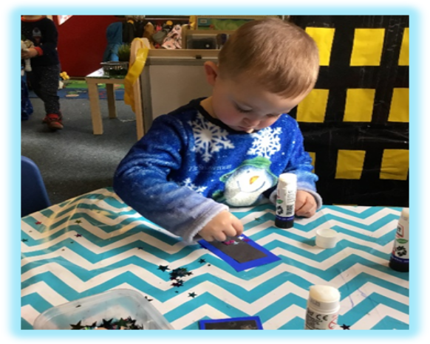

It is important that you are punctual at the start of the session and collecting your child. The gate will be locked at approximately 9.00am after which you will need to use the main entrance and let the office know your child has arrived. At the end of the school day the Reception gate will be locked at 3.25pm. Your child will then need to be collected from the main school office. When waiting at the gate in the morning, please keep your child by your side and keep them off playground fixtures and grassed areas.

3

Lunchtime/Snack Provision in Reception

From September 2014 the Government introduced Free School Meals for all children in Reception, Year 1 and Year 2. This type of Free School Meal is referred to as Universal Infant Free Schools Meals as they are not dependent on meeting any qualifying income criteria.
However, if you receive Income Support, Jobseeker’s Allowance or Child Tax Credit (not Working Tax Credit) and have an annual income that does not exceed £16,190, we would still encourage you to apply for Free School Meals. Our school receives part of its annual budget based on how many children are on the Free School Meals register. It also entitles your child to free school milk.
If you need any further information please contact the school office.
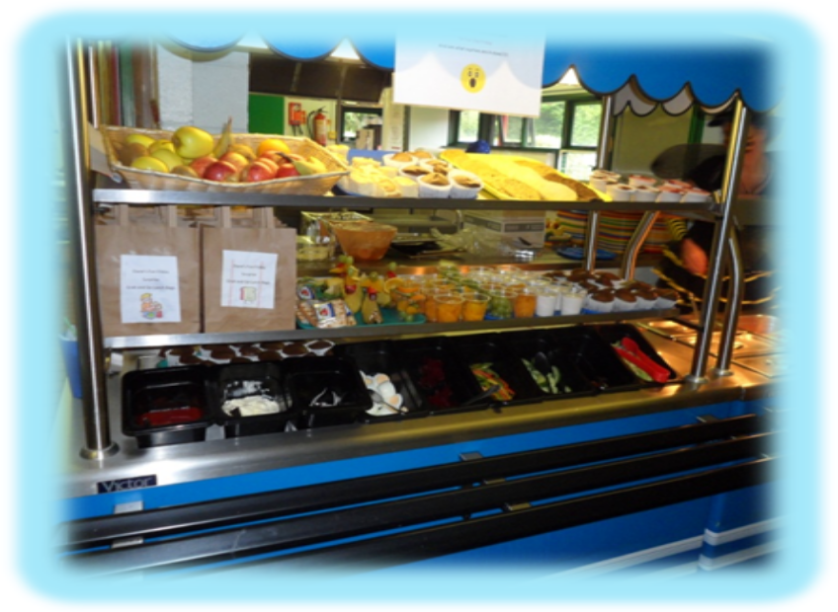

Milk will be provided each day for your child along with a portion of fruit. School milk is provided free of charge to children under five years old. They will then be sent a payment letter the term after their fifth birthday. The milk and fruit will be provided on a snack table so the children have continuous access to it. The children will also have access to fresh water throughout the school day. You do not need to provide water bottles.

4

Talking about their New Class

As part of our effective transition into Reception, our children are already very familiar with the reception environment. However, it is still important that you talk about the process of moving into Reception before your child starts. Mention the names of the Reception staff in a happy positive way. If you would like to make arrangements to come and visit the Reception class before your child starts then this can be arranged with the reception teacher.
Below are some pictures that will assist you with talking about Reception.

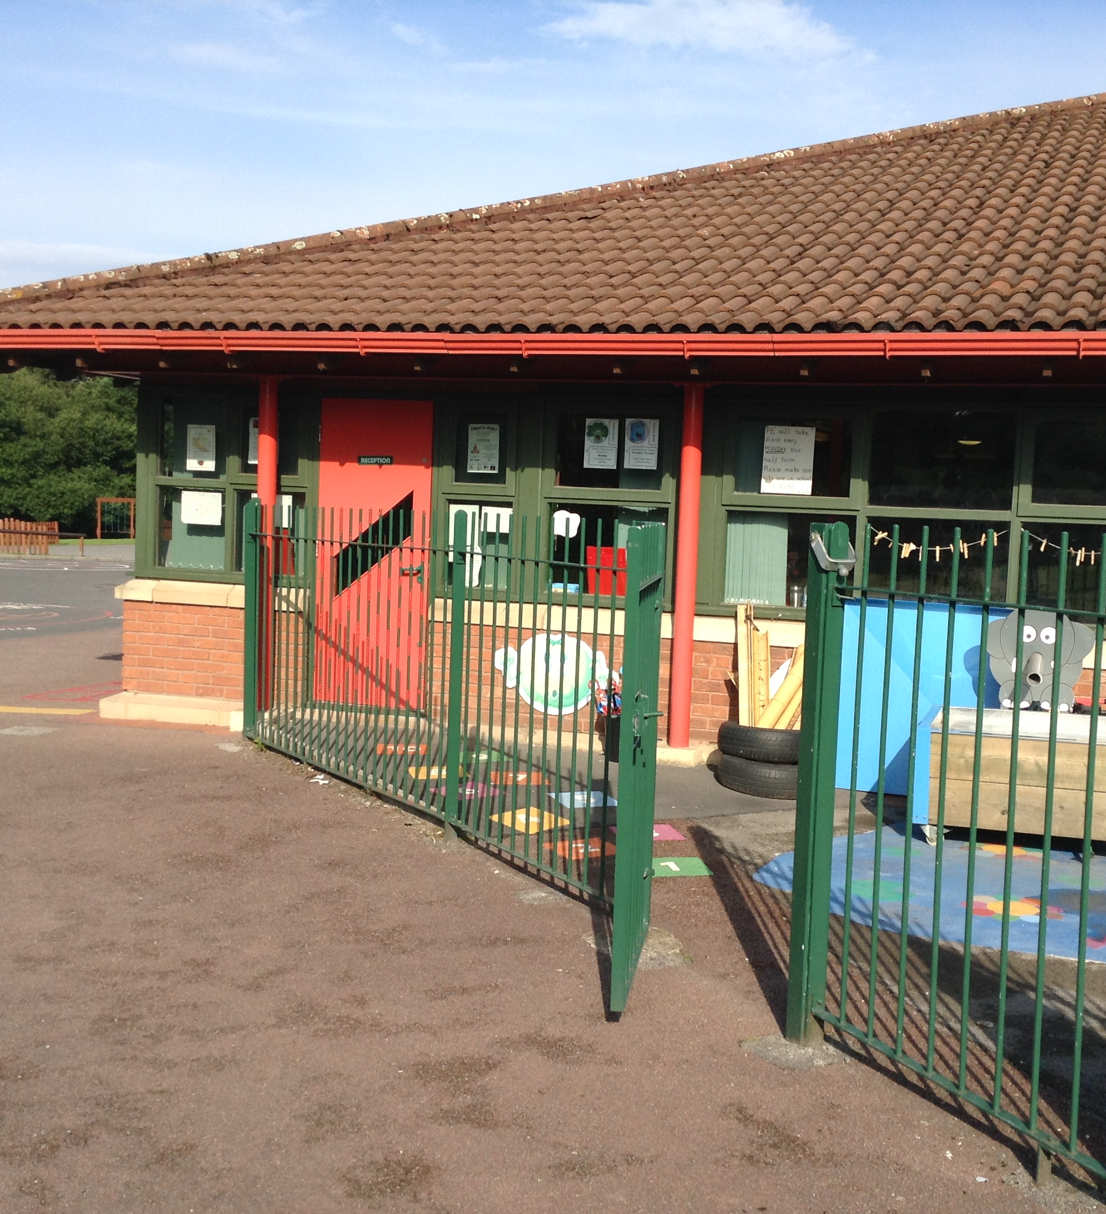  This is the outside entrance to the Reception Classroom. | 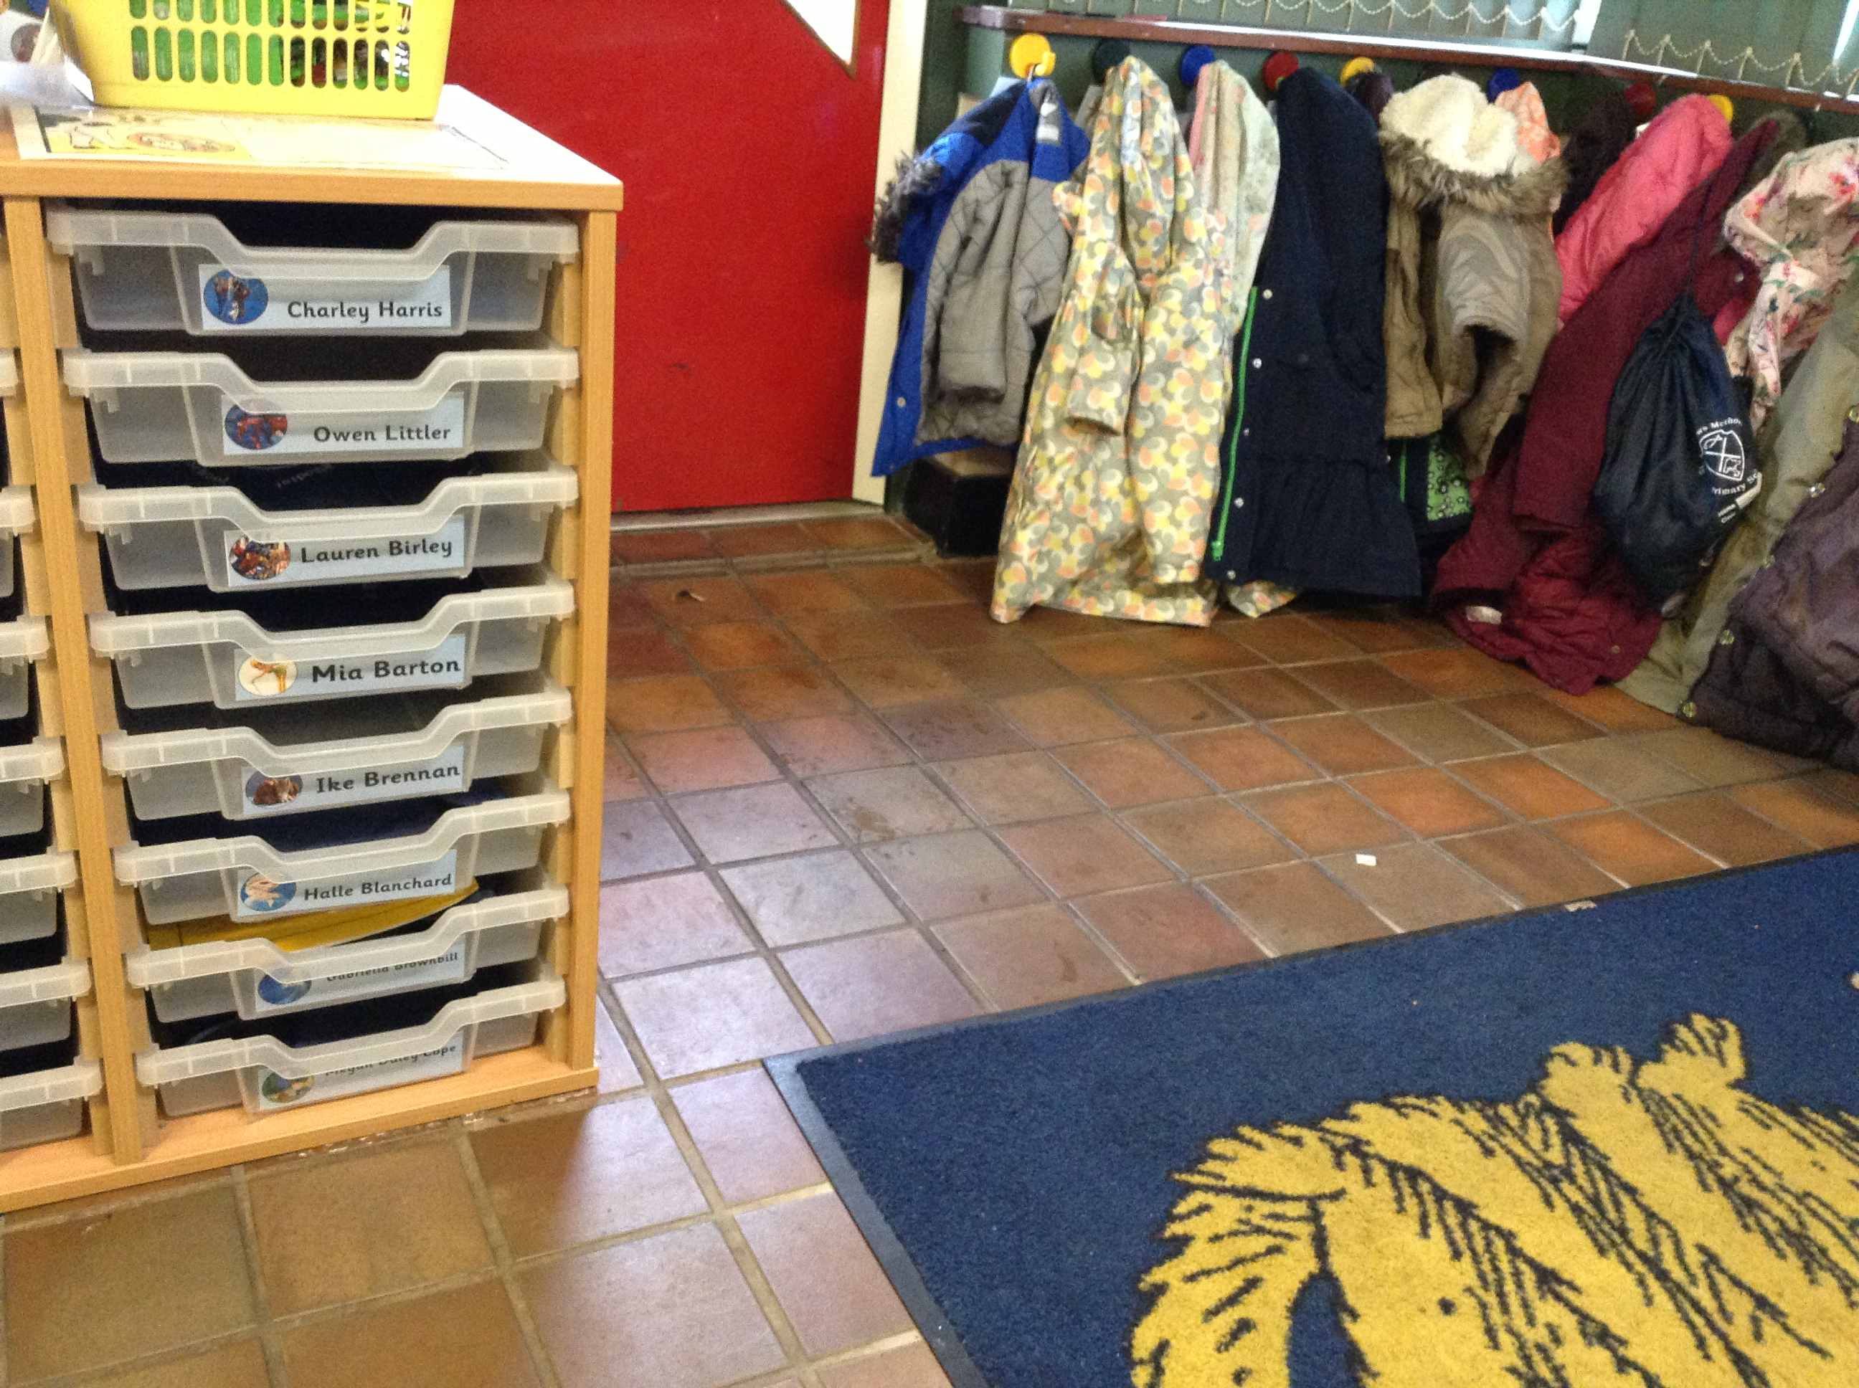  This is where they will hang their coat and put away their book bag. | These are our Reception toilets.
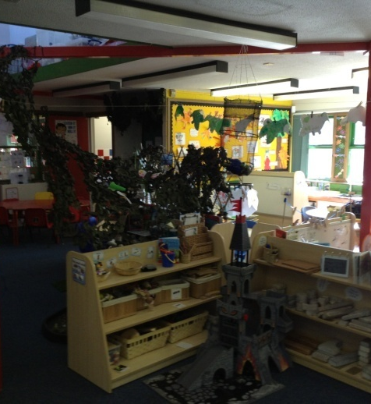  This is our classroom | 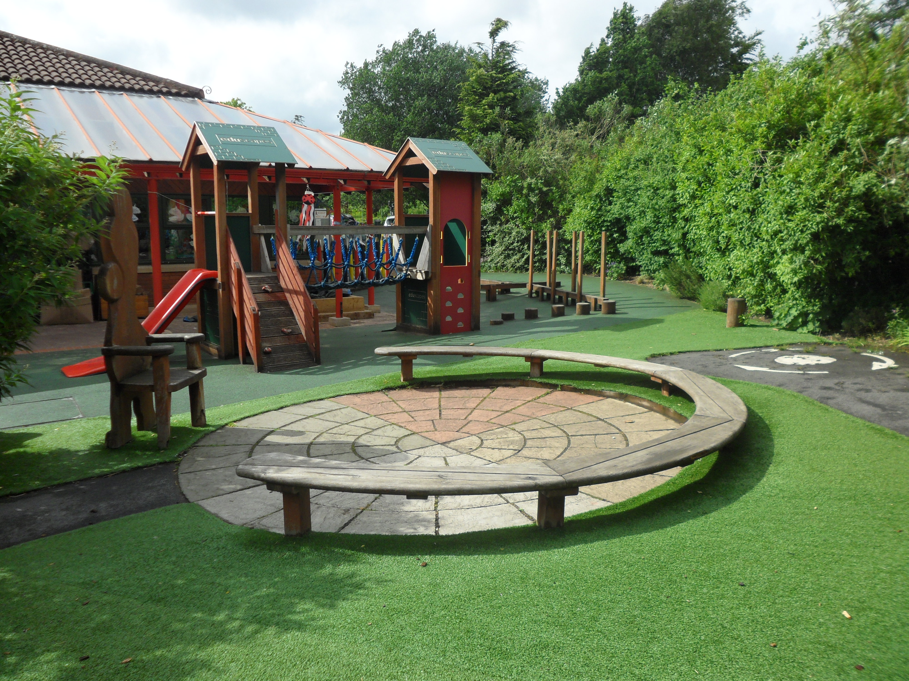  This is our exciting outdoor area. | 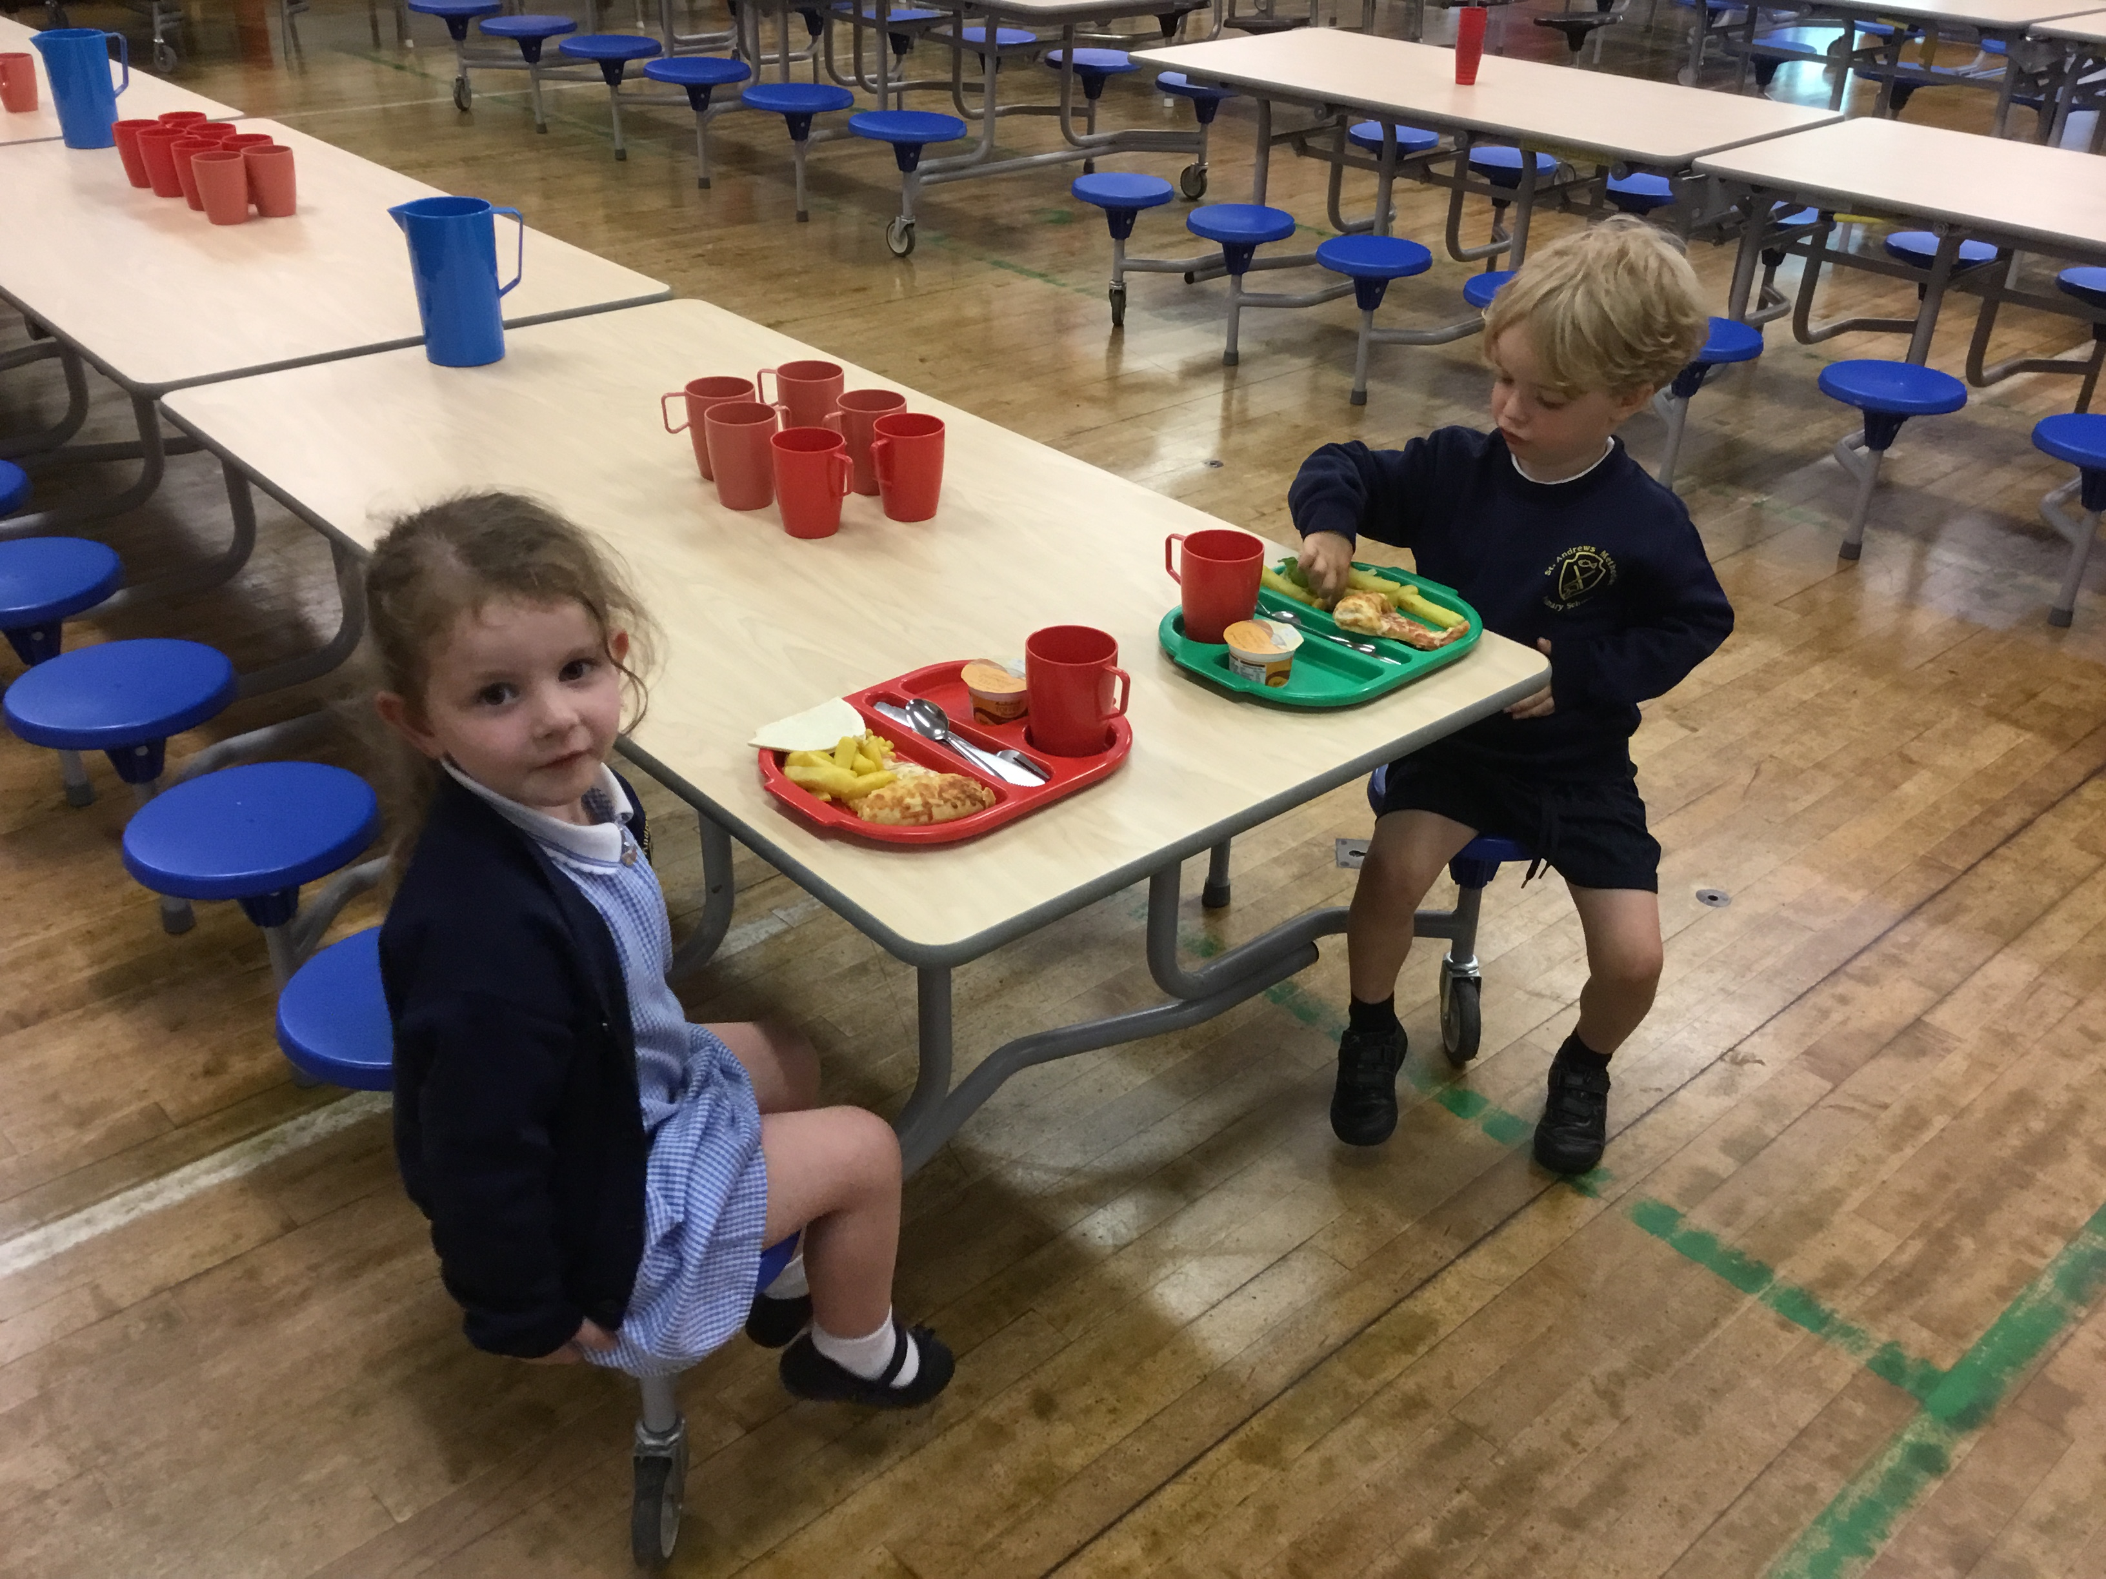  This is our hall where the children will eat their lunch.

5

Other Reception Information

The Reception class will have 2 members of staff. Miss Storey the class teacher and Mrs Gibbons the teaching assistant. Mrs Gibbons will be there to greet you in the morning and you will see Miss Storey at hometime. If you have any messages you would like Miss Storey to know in the morning, Mrs Gibbons would be happy to pass these on, or you can come to the main entrance before 8.50am and speak to the teacher yourself.


Miss Storey Mrs Gibbons
Class Teacher Teaching Assistant

We have a Foundation Stage Fund to which we invite you to contribute.
The sum of 50p each week will be collected on a Monday morning. We use the fund to buy baking ingredients, resources and other items, which we may need to buy for the benefit of the children. We have a lot of special events, days and celebrations in the Foundation Stage that the school fund pays for, these include our parent mix-up sessions.

Sweets, crisps or chocolate are not allowed in Reception as a portion of fruit is given to each child every day as a snack.
We encourage children not to bring their own toys from home as it can cause upset if they become lost or broken. We have a wide variety of toys for the children to access each day at Reception

6

6
6

6

Uniform
All children who attend our Reception class must wear the school uniform. This comprises: -
Navy Sweatshirt with school logo,
White polo T-shirt,
Blue checked or grey dresses/skirts
Grey shorts or trousers
Black school shoes
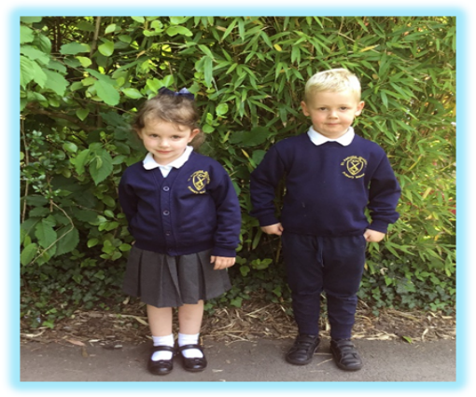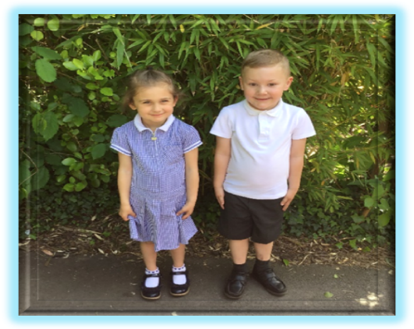
Children should wear sensible shoes, preferably with a velcro fastening to encourage independence when dressing and undressing.

Children take part in weekly PE Sessions in the school hall so all children must have a PE kit, however school pumps are not required until outdoor games take place within the summer term. The reception teacher will notify you when this is due to start.
We are the main supplier for uniform. Below is a price list of uniform that can be purchased from our school office:
- Sweatshirts £10.50 (24” – 32”) White PE tops with logo £7.00
- Sweatshirts £13.00 ( 34”S M L) Navy PE shorts £6
- Sweat cardis £12.50 PE bag £5.00
- Book Bags £ 7.50 Full PE kit (top/shorts/bag) £1611.00

We would like the children to keep a pair of wellingtons in school for outdoor play on rainy days, and a sunhat for sunny days. Included in the consent and agreement pack is a form for your permission for us to apply sun cream to your child. We do have our own supply of factor 50 sun cream in school, however if you wish to send in one from home then this must be kept in school.
7

7

Please put nametags in school clothing and coats, or mark them with a name to avoid confusion or loss. Please continue to check these throughout the school year.
Children in Reception must have a school book bag in order to take home reading books, keywords etc. Please check these daily for any letters. They are available to buy from the school office.
If it is a wet day and your child comes to school in wellingtons, please bring shoes to change into.
We provide protective clothing and aprons for activities such as painting, sand and water play, art and baking. We also have waterproof jackets for outdoor play on rainy days.
Please do not allow your child to bring any other bags, as space in the cloakroom area is limited.
A photographer will take individual photographs of your child before Christmas and as a group in the summer. Please remember that you are under no obligation to buy the photographs.
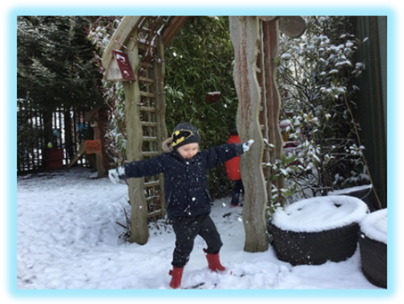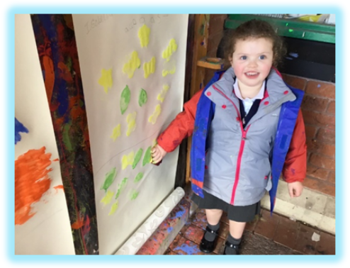
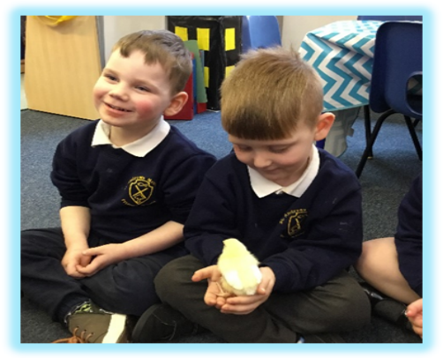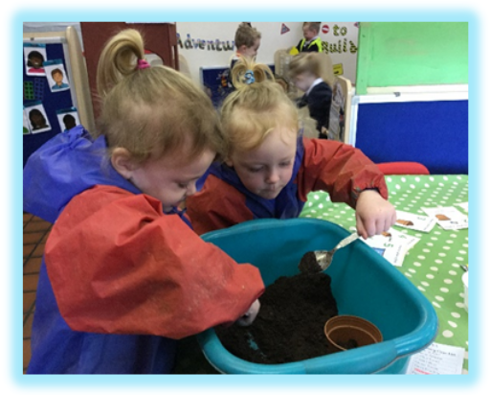

8

7

Absences from School

If your child is ill and cannot come to school, please ring and let us know.
A poorly child is happier at home, even if he/she cries to come to school.
We do not administer any medicines in school. If your child needs an inhaler, you will need to provide an extra one for school, along with a spacer and complete a form.

If your child needs a course of medicine e.g.: antibiotics, Penicillin etc, we feel it is necessary that he/she remains at home with you until the course of medicine is finished and your child is fully recovered.

If your child is taken ill whilst at Nursery, we will contact you at home or work. An emergency contact form must be completed before your child starts, with at least two phone numbers listed for emergencies. Please notify us immediately if there are any changes of phone numbers or place of work so that our records are kept up to date.

If your child has sickness or diarrhoea, we ask that you keep them off school for 48 hours after the last episode as part of our First Aid Policy.
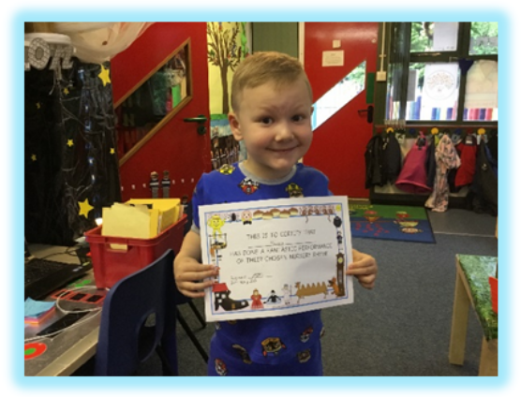
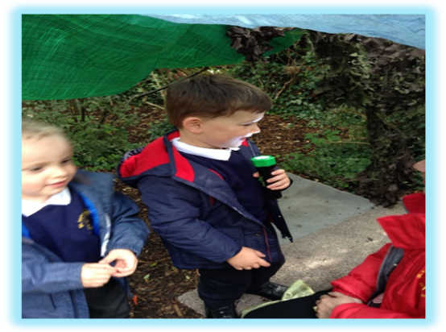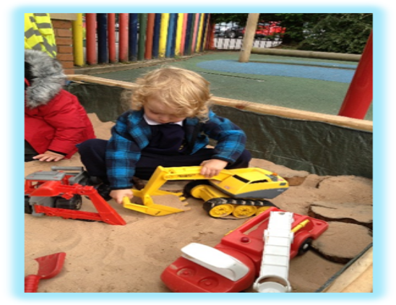
9

Learning in the Foundation Years

We will provide a happy, safe and caring environment for your child. We will provide a quality, well-planned Foundation Years education for your child in accordance with the DfES document entitled ‘The Early Years Foundation Stage’. We will offer your child a wide range of valuable learning experiences, which aim to underpin all future learning. Our aims are to promote development in these areas. At the end of Reception, children are assessed against 17 Early Learning Goals. More information about these can be found within the booklet:- ‘What to Expect, When?’
This document can be accessed on the school website or at:
http://www.foundationyears.org.uk/2015/03/what-to-expect-when-a-parents-guide/

Personal Social & Emotional Development
We aim to help your child adjust to and enjoy school, to relate to other children and adults in school, to learn to become part of a group, to share and take turns, to become more independent, to co-operate and to build self-confidence and self esteem.
Physical Development
Physical skills and co-ordination are developed through use of apparatus and games. These skills include running, jumping, climbing, balancing, throwing etc. We have outdoor play every day at nursery in our exciting garden, which has a large climbing frame, mini assault course and roadway. There are also planned P.E sessions in the hall, some with specialist coaches. Fine manipulative skills are developed in many ways, for example through threading, cutting, painting and colouring, pencil play, malleable activities and small construction kits. We aim to establish positive attitudes towards a healthy and active way of life.

10



Communication and Language
We aim to develop language to communicate needs, thoughts and feelings and to provide the foundations for literacy by developing the basic skills in reading and writing.

Literacy- Reading and Writing
Children in the foundation stage are encouraged to read and write every day in a variety of different ways. In Reception, children will practise writing daily. This year throughout school, we will be teaching the children to write in a cursive script. Children in Reception and the infants will be taught precursive and then when they are ready the will be taught to join. A copy of the font can be found at the back of the booklet. The children will be expected to follow the correct letter formations and these will be taught using memorable rhymes. Children will enjoy a variety of books, both fiction and non-fiction each day. We encourage parents to enjoy sharing books regularly with their child. In addition to this your child will be provided with two reading books and a set of Reception keywords. We use a variety of reading schemes within our school. One of the books provided will focus on developing your child’s phonic skills and the other book will encourage your child to talk about the story and the characters developing their comprehension and recognising patterns and rhymes.
It is important for you to read daily with your child and make a note of this within their reading record.

Mathematics – Number and Space, Shape and Measures
We aim to cover important aspects of mathematical understanding and provide the foundations for numeracy. This is achieved through a wide range of practical and play activities. This promotes understanding of patterns, sequences, sorting, matching, counting and problem solving and encourages the use of appropriate language to develop simple mathematical ideas.

11

Expressive Arts and Design
We aim to develop the senses, imagination and to provide creative experiences through a wide range of art activities, drama, music, stories and poems.
12

Understanding of the World
We aim to encourage your child’s natural curiosity of the world around them by providing a wide range of exciting activities which encourage and require observation and which will foster an interest in the natural world and the people in it. The opportunities we provide will naturally encourage your child to ask questions “Why? What? Where? Who?” thus providing a foundation for historical, geographical, scientific and technological learning. Our Foundation Stage Outdoor Adventure Play Area will give many opportunities to observe plants and wildlife at first hand.

Expressive Arts and Design
We aim to develop the senses, imagination and to provide creative experiences through a wide range of art activities, drama, music, stories and poems.
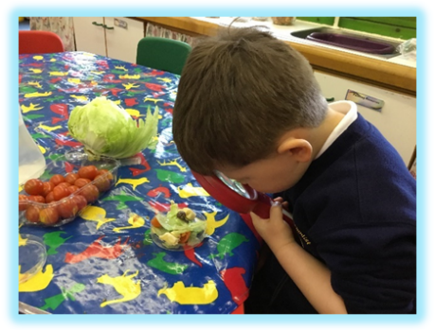
Literacy- Phonics
Phonics is a part of children’s learning that is taught throughout the Early Years and Key stage One. As a school we follow a scheme called ‘Letters and Sounds’. This is delivered in phases and covers a variety of skills that will support your child in learning how to read and write. When starting in Reception most children will have already covered Phase one which is about listening to sounds in the environment, rhythm and rhyme and hearing and saying sounds in simple words. Then will then move onto Phase Two which focuses on sounds hearing, reading and writing sounds within words. Phonics sessions are delivered in small groups and tailored to your child’s needs. You will be invited to attend a Phonic Meeting/Workshop which will provide you with more information about how you can support your child at home.
12

Home-school Links

At St Andrew’s, we view parents as partners and value your contribution and support towards your child’s education and to all aspects of school life in general. There are lots of ways in which St Andrew’s encourages links between home and school. We hold whole school fund raising events, which we invite you to support and get involved in. In the Early Years, we have special activities such as sponsored events, non-uniform days, etc.
You will also receive regular newsletters giving you information about things going on in Reception as well as telling you about forthcoming events. Headteacher newsletters for the whole school are also circulated where appropriate.
As well as this we will send out a letter at the beginning of the school year asking about your child’s interest and previous experience and learning. You will also receive a letter each half term telling you what the topic will be for and outlining intending learning experiences. We encourage you to have input within your child’s learning journey by regularly sending in observations from home on our WOW stars! More information will be provided at the start of the school year.
Every term, you will be invited to spend some time in the morning or afternoon with your child in school as part of our Come and Play themed ‘Mix-Up sessions’. These provide a wonderful opportunity for you to visit the classroom, try a variety of fun activities with your child and find out what your child likes to do in school.


13

Your Child’s Progress

Your Child’s Progress

In Reception, we hold two parents’ evenings during the school year – usually in October and March. This gives parents the opportunity to visit the Reception staff and talk with the teacher about your child. Parents can also look at children’s work and see some examples of things the children have been doing.
You will also receive a detailed written report in July. At the end of Reception you will receive a Learning Journey which will be made up of the photos we have taken of your child to document their progress as part of their Foundation Stage Profile. You can always ask to look at your child’s Learning Journey throughout the year. Please arrange this through your child’s class teacher.
Please feel free to make an arrangement to come into school before or after school starts to discuss any matters concerning your child. We will be more than happy to talk to you.



14

In Reception, we hold two parents’ evenings during the school year – usually in October and March. This gives parents the opportunity to visit the Reception staff and talk with the teacher about your child. Parents can also look at children’s work and see some examples of things the children have been doing.
You will also receive a detailed written report in July. At the end of Reception you will receive a Learning Journey which will be made up of the photos we have taken of your child to document their progress as part of their Foundation Stage Profile. You can always ask to look at your child’s Learning Journey throughout the year. Please arrange this through your child’s class teacher.
Please feel free to make an arrangement to come into school before or after school starts to discuss any matters concerning your child. We will be more than happy to talk to you.

Our Website

We have a school website which can be found at
www.standrewsmethodistschool.co.uk

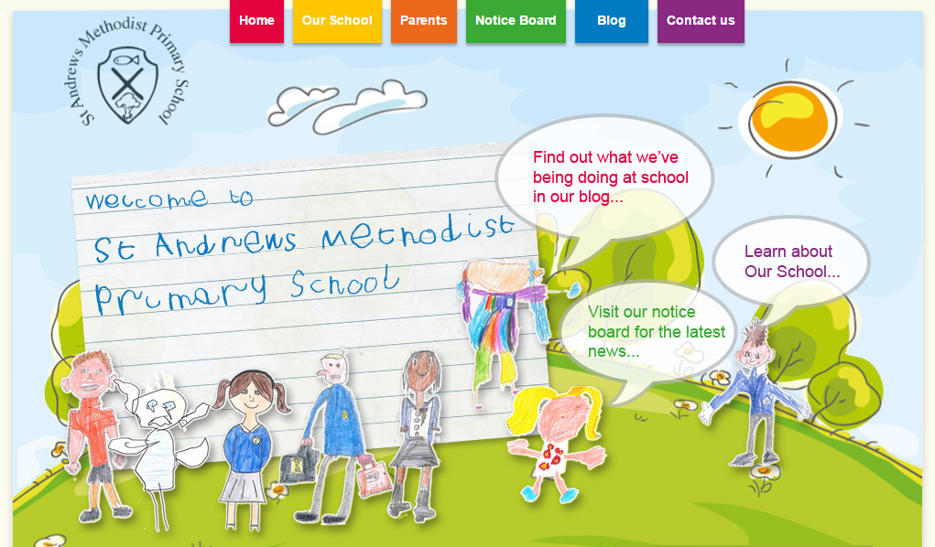

On this website you can find lots of information about the school, policies, recent newsletters, upcoming events and our school blog.

The school blog is where the teachers upload information/pictures about the goings on in their class. You will be able to see pictures of things happening and find out about what you child has been up to. We aim to update this weekly.

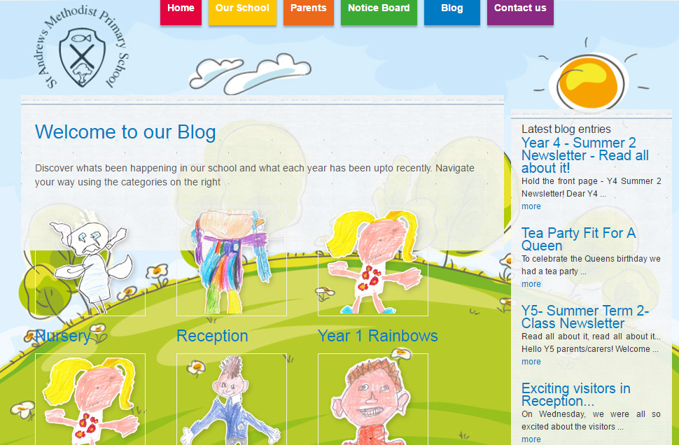

15

Our Website

We have a school website which can be found at
www.standrewsmethodistschool.co.uk

On this website you can find lots of information about the school, policies, recent newsletters, upcoming events and our school blog.

The school blog is where the teachers upload information/pictures about the goings on in their class. You will be able to see pictures of things happening and find out about what you child has been up to. We aim to update this weekly.

Reception Key Words
The children will come home with a set of words to practise. These will be in sets with tricky words, ones they can’t sound out, and high frequency words. The best way to teach children to read these words is through practise. These are words which they should know by sight and are encouraged not to ‘sound them out’.
These will be checked when your child reads in school and be changed when the teacher feels that your child knows them well enough and can confidently read them.
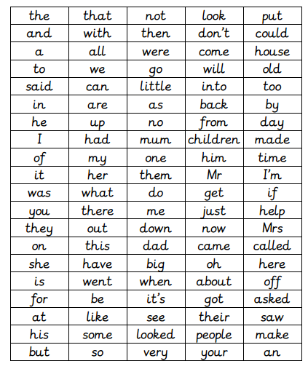

Meet the Reading Book Characters
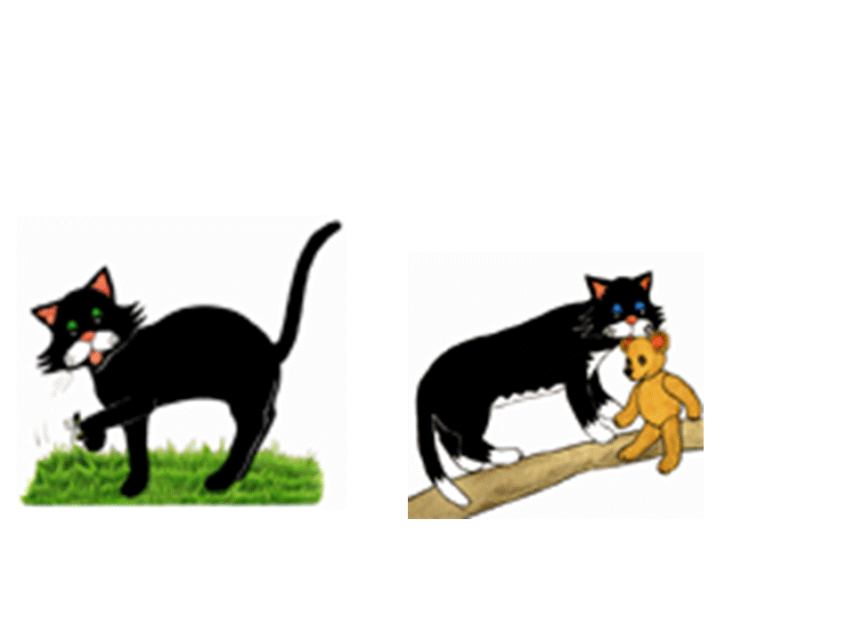



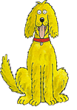


Jelly Bean Wellington
Kevin Lotty
Kipper Floppy Biff Chip
Mum Dad Wilf Wilma Gran
Meet the Characters

Letter Formation

a b c d e f g h i j k l m n o p q r s t u v w x y z

