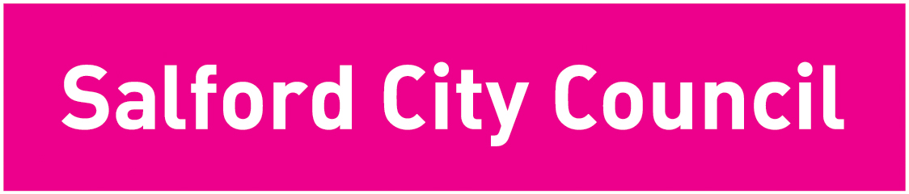
People Directorate
Salford City Council, Unity House
Salford Civic Centre, Chorley Road
Swinton, M27 5AW
Web www.salford.gov.uk

2nd June 2020
Dear parents and carers
St Andrew’s Methodist Primary School school is committed to keeping both children and staff members safe now they have returned to school. We would like to inform you about what schools will be doing and what we ask of you as parents or carers if your child shows symptoms of coronavirus (COVID19).
The most common symptoms of coronavirus (COVID19) are a recent start of any of the following
- A new continuous cough
- A high temperature (feel hot to touch on the chest or back)
- A loss or change in your normal sense of taste or smell
A well child/young person feels 100% well, seems themselves and not displaying any changes in behaviour or their daily routines. .
An unwell child could be a possible case of COVID19. Other symptoms that have been linked to covid is vomiting, diarrhoea, sleeping more than usual, agitated, cold, headaches - anything that may indicate they are not feeling themselves.
Please don’t send your child into school if:
- They are unwell in any way
- Anyone in the household is unwell, awaiting testing or their result or has been tested positive.
What happens if a child/young person or member of staff becomes unwell at school?
As soon as the school is made aware, the child, young person or staff member will be sent home and advised to isolate until the result of the COVID test is known. The school will arrange any necessary cleaning.

How do I get a test for my child?
If your child is displaying symptoms of coronavirus, your school will give you details of how to book a test at the local testing site, AJ Bell Stadium. When you have the result, please tell the school whether it is positive or negative.

What happens if a child, young person or staff member tests positive:
- The person should isolate for seven days minimum. The person needs to be 48 hours symptom-free prior to return school settings.
- Members of their household should self-isolate for 14 days. The 14 days is the time it takes for symptoms to show if you have been infected.
- The rest of their bubble/class/group within their school (children and adults) will be sent home and advised to self-isolate for 14 days (and offered testing if symptoms develop).
- The other household members who live with the person in the bubble/class/group do not need to self-isolate unless the child, young person or staff member they live with in that group subsequently develops symptoms
- The school will send a Salford City Council’s ‘Warn and Inform’ letter to all parents just to let you know there is a case in the school and to remind them to watch out for symptoms.

If my child tests positive, do I need to tell people they have been in contact with?
Yes. You need to log onto the NHS Test and Trace portal https://contact-tracing.phe.gov.uk/and share details of all their close contacts. Salford Infection Control team can help you identify contacts, call 0161 793 3599 or email PHSecretary@salford.gov.uk

All close contacts (household, school related or any other close contacts) will receive a letter or text to advise them to self-isolate.
What happens if my child tests negative?
Your child can return to school when they are 48 hours symptom free. Household members can end their isolation straight away following the negative test, unless someone else in the household is waiting for the result of their test.

What do I need to do if either myself or my child has been in ‘contact’ with somebody who has tested positive
A ‘contact’ is a person who has been close to someone who has tested positive for coronavirus (COVID-19) anytime from 2 days before the person was symptomatic up to 7 days from onset of symptoms (this is when they are infectious to others).
For example, a contact can be:
- People who spend significant time in the same household as a person who has tested positive for coronavirus (COVID-19)
- Close personal relationships/partners
- A person who has had face-to-face contact with someone who has tested positive for coronavirus (COVID-19), including: being coughed on, having a face-to-face conversation within one metre, or having skin-to-skin physical contact, or any contact within one metre for one minute or longer
- A person who has been within 2 metres of someone who has tested positive for coronavirus (COVID-19) for more than 15 minutes
- A person who has travelled in a small vehicle with someone who has tested positive for coronavirus (COVID-19) or in a large vehicle or plane near someone who has tested positive for coronavirus (COVID-19)

In a schools/setting context, all children/staff in the ‘bubble’ will be classed as a close contact. If you or your child falls into one of the categorises above of a contact they must self-isolate at home because you are at risk of developing symptoms in the next 14 days and could spread the virus to others before the symptoms begin. If you have concerns for your health, contact your GP or NHS 111 online. In an emergency, contact 999.

What happens if somebody in wider school community tests positive?
If a member of our wider school community (e.g. a parent/carer, a member of our cleaning staff, a governor) tests positive. They need to let the school know immediately so they can identify if the positive person has had contact with anyone who attended the school in the previous 48 hours before the onset of symptoms or date of the test. Contact tracing will take place to understand the types of contact the individual has had both in school and out of school.
We would like reiterate ways to reduce the spread of coronavirus disease and the risk of you and anyone you live with getting ill with COVID-19:
- Maintain physical distancing and to stay at least 2 metres from other.
- Stay out of crowded places and avoid mass gathering
- Wash your hands with soap and water often – do this for at least 20 seconds
- use hand sanitiser gel if soap and water are not available
- wash your hands as soon as you get home
- cover your mouth and nose with a tissue or your sleeve (not your hands) when you cough or sneeze
- put used tissues in the bin immediately and wash your hands afterwards
- keep your hands away from your face (eyes, nose and mouth)

Please keep this letter for future reference. We would like to reassure you that we are doing all we can to keep your children safe and we thank you in advance for following this advice and guidance.
Yours sincerely
Mrs A Barker (Headteacher)

