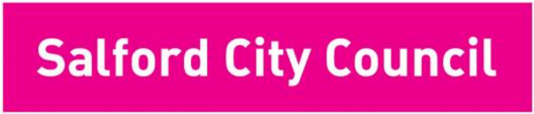

People Directorate

Salford City Council, Unity House,

Salford Civic Centre, Chorley Road,
Swinton,
M27 5AW

Email

charlotte.ramsden
@salford.gov.uk

Web

www.salford.gov.u
k

My Ref

CR
/HR/SY

Monday 18th May 2020

Dear Parent/Carer/Guardian

Following the Prime Minister’s announcement on Sunday we now understand that, from week of 1st June at the earliest, the Government is aiming to increase the numbers of children attending primary schools. The Prime Minister announced the planned return of children from Nursery, Reception and years 1 and 6 and asked that secondary schools and colleges start to provide some face-to-face contact with staff for students in year 10 and year 12. Special Schools will also work towards a phased return of more children but without a focus on specific year groups. This of course is all dependent on the rate of infection for COVID-19 from now until then.

This announcement and subsequent guidance from the Government has answered some questions but it is clear that there are many things which still need clarification before schools and colleges could substantially increase the numbers attending. There are many practical questions which we currently do not have answers to and which we are working together with schools, settings and colleges and the DFE to resolve.

The vast majority of Salford schools are open currently for vulnerable children and children of key workers and we are incredibly grateful for the service they have continued to provide in these challenging times. The offer of places for vulnerable children and children of key workers will continue in this next phase.

Salford City Council is committed to supporting all schools to safely open for more children. However, this will be a gradual approach towards the government’s ambition, and we are supporting schools in seeking answers to their questions to make appropriate plans. Headteachers, with the full support of the Local Authority, will only be welcoming the number of children back into their schools, that they deem to be safe and therefore the timescales set nationally may not be followed. This number of children attending may increase as the summer term progresses, but this will be driven by a robust risk assessment process. The safety and wellbeing of our children and staff is of paramount importance.

There are many specific considerations unique to individual schools, settings and colleges which they are best placed to understand and plan for. This includes the different needs of their cohorts of children or young people and local communities, the size and shape of buildings and the numbers of staff that are available to work. This means that there cannot be a uniform approach across the City in response to this announcement. Settings, schools and colleges will have to develop their own flexible plans and work at their own pace from 1st June in order to start to safely and gradually increase the number of children attending at any one time.

For this reason, in our primary schools it is highly unlikely that children in the identified priority year groups will be able to attend school full time. Schools are likely to have to prioritise certain year groups and not make an offer to them all. Your school will, of course, be in touch with you to provide more information about their plans for a phased return of additional children in due course. We would ask you to support your school leaders at this time and be patient, they are working as quickly as they can to put plans in place during this difficult time.

It is clear that any return for children and young people will not look the same as before COVID19. Schools are considering of how best to support our children and young people at this time, with a focus on their mental health and emotional wellbeing as well as their learning.

This pandemic has brought with it stress, uncertainty and anxiety for all of us including our children and young people. We all want to get our children and young people back into education as soon as possible and we want to reassure you that everyone in Salford’s education community is working together as hard as they can during this time to ensure the wellbeing and safety of our children and plan for this first phase of wider opening.

Thank you for taking the time to read this letter.

Yours sincerely

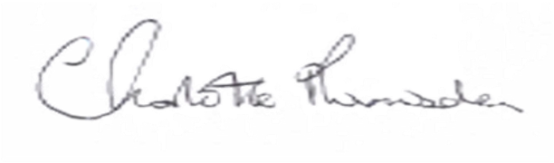

Charlotte Ramsden – Strategic Director Cathy Starbuck - Assistant Director, Education, Work and Skills

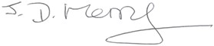
Councillor John Merry
Deputy City Mayor and Lead Member for Children’s and Young People’s Services

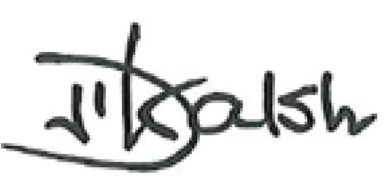
Councillor John Walsh
Executive Support Member for Education and Learning

