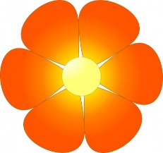

Year 5 Topic Letter Spring 1

**RE**

Understand 5 pillars of Islam

Describe the key belief of Muslims and explain how it affects their life.

Find out more about the life of the Prophet

Describe how and why Muslim people pray

Look for similarities and differences between prayer in

Islam and prayer in Christianity

**Geography**

The Water Cycle

Explain why Cities are located close to rivers

Explain why people are attracted to live near rivers

Explain the course of a river

Name and locate famous rivers

**Literacy**

This half term we will focus on writing narratives.

Children will write different types of stories. Our

learning focus will be:

Build cohesion across paragraphs

Develop characters through description and action

Use consistent and correct tense

Use stylistic devices to create effects in writing

**Numeracy**

By the end of the half term children should be able to:

Read and write decimal numbers as fraction

Write percentages as a fraction

Recognise percent sign and that percent is part of 100

Find the area and perimeter of more complex shapes

**Science**

Compare and group everyday materials

Know some materials dissolve in liquid to form a solution

Investigate filtering, sieving and evaporating

Explain how changes result in a change of state

**Important Dates**

World Book Day Thursday 5th March

Class Assembly Friday 6th March

Parents Evening Tuesday 17th March