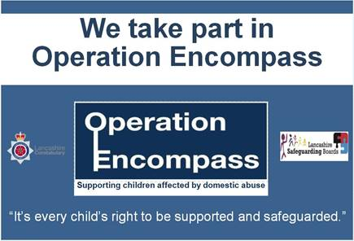

Dear Parent/Carer,

**Re: Operation Encompass**

The school has been given the opportunity to take part in a project that will run jointly between schools and Greater Manchester Police.

Operation Encompass has been designed to provide early reporting to schools, i.e. prior to 9 .00 a.m. on the next school day, of any domestic abuse incidents that occur outside of school, but which might have an impact on a child attending school the following day. During the school term this information will be shared on school days. When incidents occur on a Friday, Saturday or a Sunday, the police will contact the relevant school the following Monday.

A nominated member of school staff, known as a Key Adult, will be trained to liaise with the police. At St Andrew’s Methodist Primary School our Key Adult is Mrs A Barker, headteacher. They will be able to use information that has been shared with them, in confidence, to ensure that the school is able to support children and their families. Information will be shared where it is identified that a child or young person was present, witnessed or was involved in a domestic abuse incident.

We always endeavour to offer the best support possible to our pupils and believe that Operation Encompass is going to be beneficial and supportive for all concerned; children and families

Some information about Encompass is included in this letter but if you would like more information about this new initiative, details can be viewed online at in our safeguarding policy or you can contact our Key Adult at school.

Thank you for your continued support

Chair of Governors Head Teacher