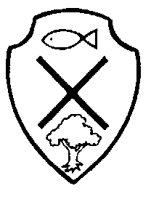
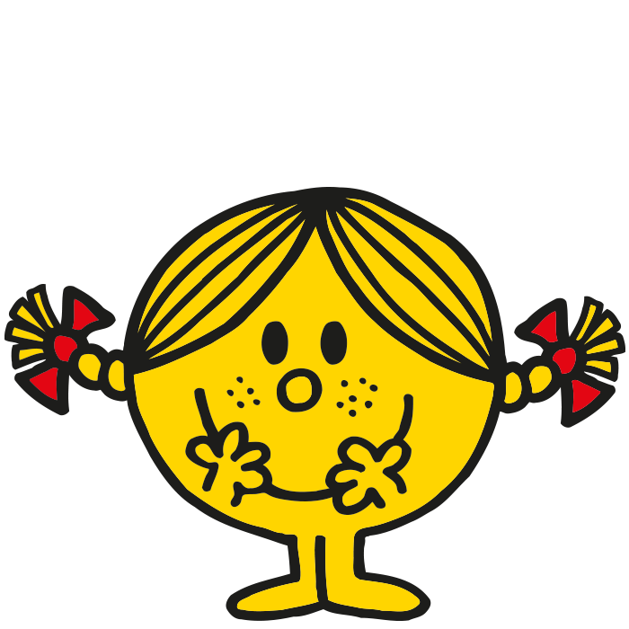
Year 2 Class Newsletter- Summer Term 2
Literacy

Writing- In our literacy lessons, we will be mainly completing written work surrounding our class text: George’s Marvellous Medicine by Roald Dahl.
Reading- Please can I ask that daily reading at home is maintained, as part of ongoing homework. Reading each evening is crucial to your child’s reading development! The children are encouraged to place any finished reading books into the classroom’s- ‘Swap Box’, so that they can be changed for taking home, each evening. Books will only be swapped in school, once they’ve been read and listened to by an adult; therefore it is important that reading records are signed. Please ensure reading book bags are sent into school every day.
Phonics- The children will continue to complete daily phonic sessions. Please can I ask that spelling lists are practised regularly at home, in preparation for our weekly spelling test. This is now a permanent homework task, alongside their reading book. Practise should be little but often, until your child can securely write each word- these will be tested every Friday.

Term Dates:
5th June
-
24th
July

Numeracy
In our numeracy lessons, the children will be covering work surrounding:
- Counting and reading scales in 2’s,5’s and 10’s
- Recalling x2, x5 and x10 table facts from memory and recognising the inverse number facts
- Telling the time
- Money including giving change
Problem-solving will be incorporated and developed throughout all coverage areas.
Additionally, we will still be undertaking a weekly BIG MATHS test- this is extra numeracy to reinforce and consolidate the basic number and calculation skills required of the children.



What else are Y2 learning about this term?

RE/PSHE- We are going to continue with our learning about How we care for others in the world.
Music- The children will participate in a weekly session of hymn practice to develop their singing skills. We will also be including music opportunities in class, when possible.
Art/D&T- The children will look closely at art and craft work involving the seaside They will be using a variety of artistic and design skills to complete set pieces of work.
PE- This half-term, the children will be involved in preparations for our sports day. Please ensure PE bags are in school at all times with the full kit- clearly named.
Computing- This half-term, the children will be exploring how to communicate ideas e.g. data bases
Science- The children will be completing a scientific unit surrounding work on: Healthy Diets, Electricity and Forces
Topic- We will be continuing our topic about the Seaside in the past and features of an island linked to Katie Morag
Special dates for your diary this half-term …

14th June – Class Assembly
20th June – Visit from Dino Dig
22nd June – Summer Fair
3rd July – Year 1 and 2 trip to Imagine That.
18th July – Sports Day ( Weather permitting)

*Please remember to check and empty school bags daily for further letters*

