L.O.I know how Christians welcome a new baby Wednesday 9th May
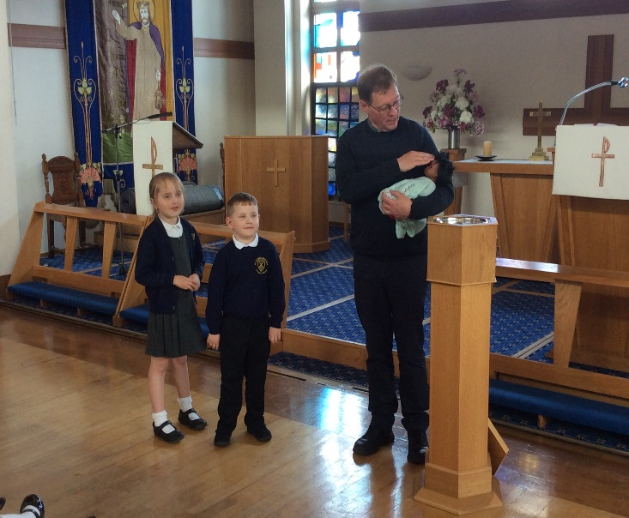
Today we went to Walkden Methodist Church. Reverend Garfield told us about Baptism. He showed us the font and told us that it is a way of showing that you belong to God and that he cares for us. Reverend Garfield baptised our three children (dolls) Claude, Erin and Rosie with their parents. We had three sets of parents; Kaci May and Riley D, Isla and Amelia and Isabella to show that there are all kinds of different families.
