**Year 1 Class Newsletter- Summer Term 1**

**Literacy**

**Writing-** In our literacy lessons, we will be looking at some well known fairy stories and some modern fairy stories. We shall focus on characters and describing them. We will continue to practice spelling the days of the week and some of the Year 1 common exception words.

**Reading-** Please can I ask that daily reading at home is maintained, as part of ongoing homework. ***Reading each evening is crucial to your child’s reading development!*** Books will be only be changed in school, once they’ve been read and listened to by an adult; therefore it is important that reading records are signed. **Please ensure reading book bags are sent into school every day.**

**Phonics-** The children will continue to complete daily phonic sessions.

**Numeracy**

**In our numeracy lessons, the children will be covering work surrounding:**

* Counting in 2s, 5s and 10s.
* Using number bonds to solve adding3 numbers
* Adding and subtracting including finding missing numbers.
* Multiplication and Division
* Fractions
* Measures – length, weight and capacity “Practical Measures Week” with Y2.

**Problem-solving will be incorporated and developed throughout all coverage areas**

**Term Dates**

15th April-24th May 2019

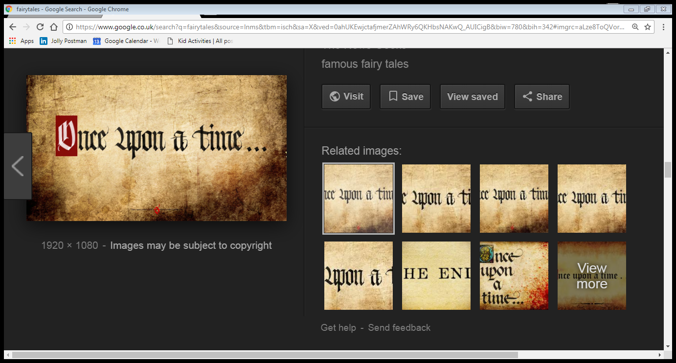

**What else are Y1 learning about this term?**

**Geography-**This half-term, we will be thinking about our local area and The United Kingdom

**RE/PSHE-** The children will be discussing belonging and what that means for different religions. We will continue discussing different feelings in PSHE.

**Music-** The children will participate in a weekly session of hymn practice to develop their singing skills. We will also be including music opportunities in class, when possible.

**Art/D&T-** The children will also explore different pencils, shading and mixing shades

**PE-** This half-term, the children will be continuing to develop their ball skills and improving their co-ordination. They will also begin to develop their skills in Athletics.

**Computing-** In computing the children will be creating photo stories

**Science-** The children will be completing scientific units surrounding work on Plants

**Special dates for your diary this half-term…**

***Music week – 20th May 2019***