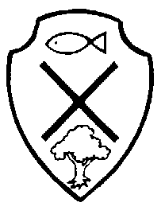
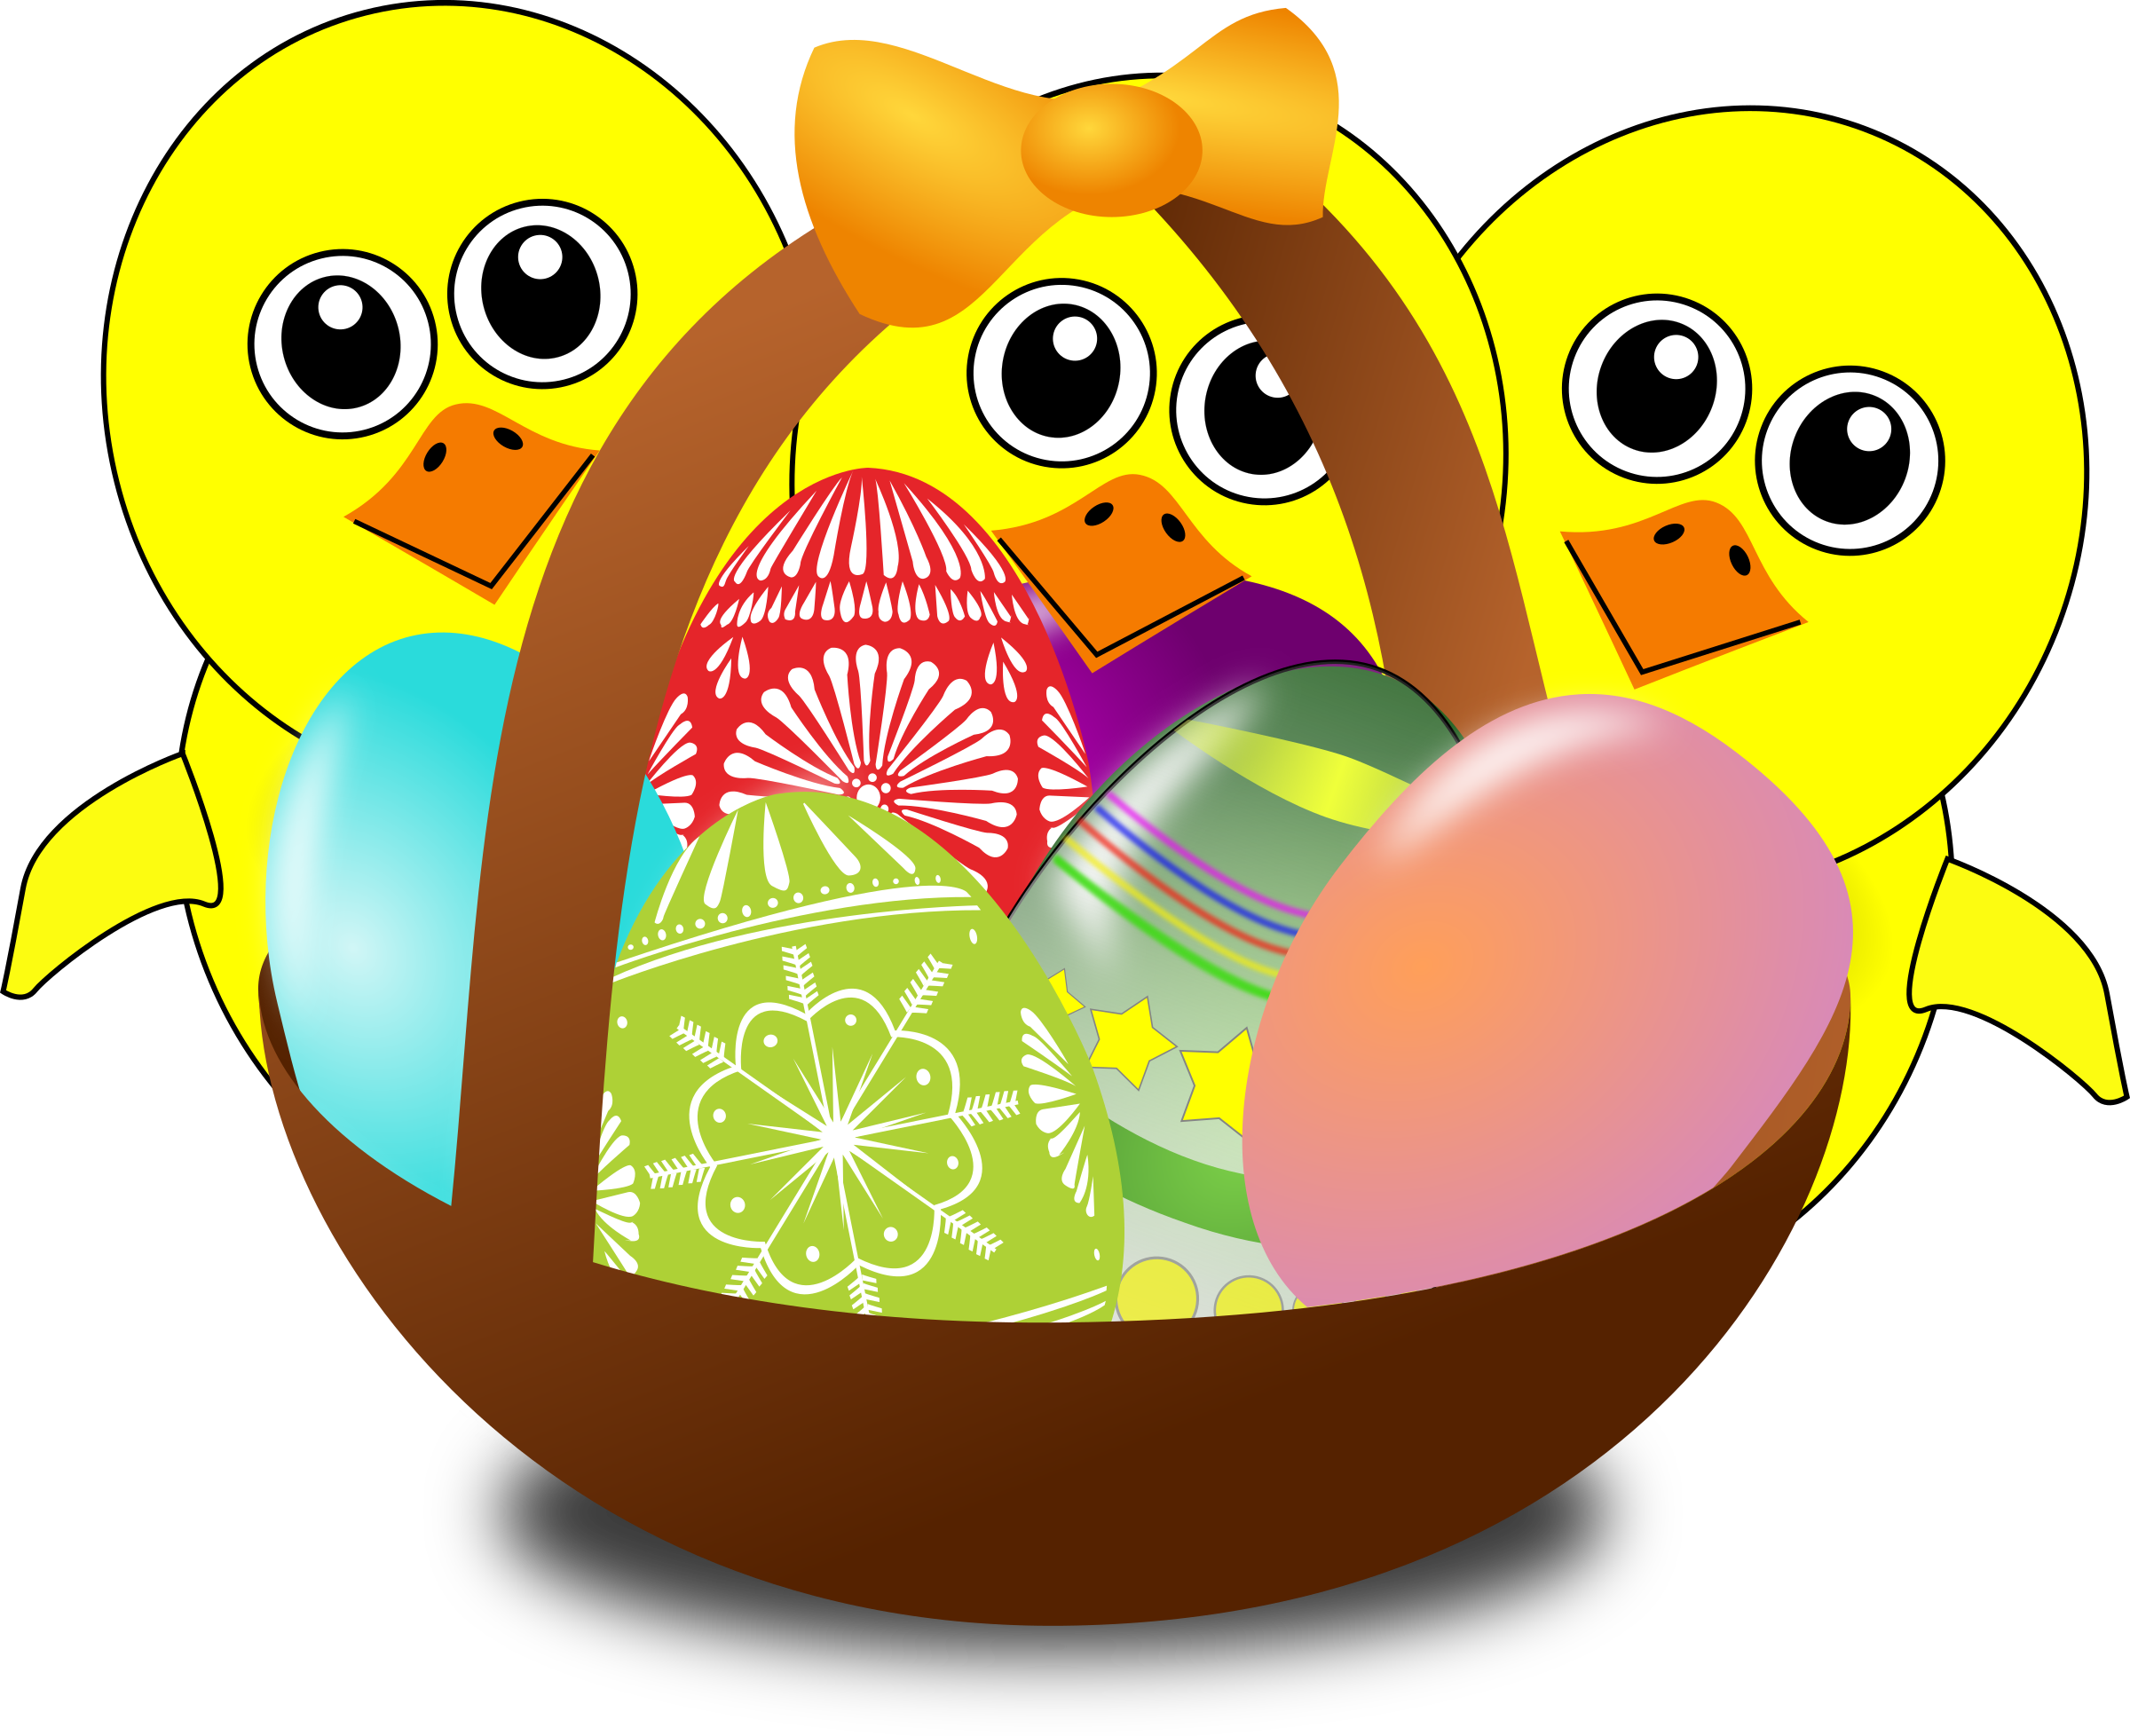
Year 2 Class Newsletter- Spring Term 2
Numeracy
In our numeracy lessons, the children will be covering work surrounding:
- Rounding numbers to 100 to the nearest 10
- Lines of symmetry in 2D shapes
- Identifying, representing and estimating numbers using different representations, including the number line
- Adding and subtracting multiples of 10
- Solving missing addition and subtraction number problems
- Recalling x2, x5 and x10 table facts from memory
- Telling the time
- Money
Problem-solving will be incorporated and developed throughout all coverage areas.
.

Term Dates:
25th February-
29th
March

Literacy
Writing- In our literacy lessons, we will be mainly completing written work surrounding our class text: The Way back Home by Oliver Jeffers. We will also now begin to complete thorough practise of comprehension-based activities to build up answering techniques, speed and pace, in preparation for SAT’s week, next half-term.

Reading- Please can I ask that daily reading at home is maintained, as part of ongoing homework. Reading each evening is crucial to your child’s reading development! The children are encouraged to place any finished reading books into the classroom’s- ‘Swap Box’, so that they can be changed for taking home, each evening. Books will only be swapped in school, once they’ve been read and listened to by an adult; therefore it is important that reading records are signed. Please ensure reading book bags are sent into school every day.

Phonics- The children will continue to complete daily phonic sessions. Please can I ask that spelling lists are practised regularly at home, in preparation for our weekly spelling test. This is now a permanent homework task, alongside their reading book. Practise should be little but often, until your child can securely write each word- these will be tested every Friday.



What else are Y2 learning about this term?
History – We will be learning about Neil Armstrong and the first moon landing.
RE/PSHE- We are going to be learning about the names of the ‘sacred books’ in Christianity, Judaism and Islam; understanding why they’re important texts. We will also study the story of Easter towards the end of the half-term, in line with the upcoming celebration.
Music- The children will participate in a weekly session of hymn practice to develop their singing skills. We will also be including music opportunities in class, when possible.
Art/D&T- The children will look closely at design techniques linked to our theme of the moon landing and Mother’s Day (designing a card) and Easter (designing a card and egg basket) in the upcoming weeks.
PE- This half-term, the children will be completing a series of‘ street dance’ sessions with one of the P.E.coaches. Please ensure PE bags are in school at all times with the full kit- clearly named.
Computing- This half-term, the children will be exploring how to successfully research content, using the internet. They will be learning how to ‘copy and ‘paste’ images into research tasks.
Science- The children will be completing a scientific unit surrounding work on: Animals and Humans- including: what animals and humans need to survive, exercise and healthy living, habitats, early food chains and offspring.
Special dates for your diary this half-term …

- Thursday 7th March- World Book Day 2019-

- Tuesday 19th March- Parent’s Evening- Letters will be sent out shortly for you to book in your preferred consultation time- this is based on a first come, first served basis, so please remember to send back your slip to avoid disappointment.
*Please remember to check and empty school bags daily for further letters*

