**Year 1 Class Newsletter- Summer Term 2**

**Literacy**

**Writing-** In our literacy lessons, we will be continuing our Fairy Tale theme but looking at some modern fairy stories. We shall be looking at speech marks. Hopefully we shall also read and write seaside posetry. We will continue to practice spelling the days of the week and some of the Year 1 common exception words.

**Reading-** Please can I ask that daily reading at home is maintained, as part of ongoing homework. ***Reading each evening is crucial to your child’s reading development!*** The children are encouraged to place any finished reading books into the classroom’s- *‘Swap Box’*, so that they can be changed for taking home, each evening. Books will be only be swapped in school, once they’ve been read and listened to by an adult; therefore it is important that reading records are signed. **Please ensure reading book bags are sent into school every day.**

**Phonics-** The children will continue to complete daily phonic sessions.

**Numeracy**

**In our numeracy lessons, the children will be covering work surrounding:**

* Counting regularly
* Adding and subtracting including finding missing numbers.
* Position and Direction – left, right, forwards, backwards
* Money – making amounts using different coins
* Data Handling – reading and using charts and graphs
* Measures – including centimetres

**Problem-solving will be incorporated and developed throughout all coverage areas**

**Term Dates**

6th June – 20th July 2018

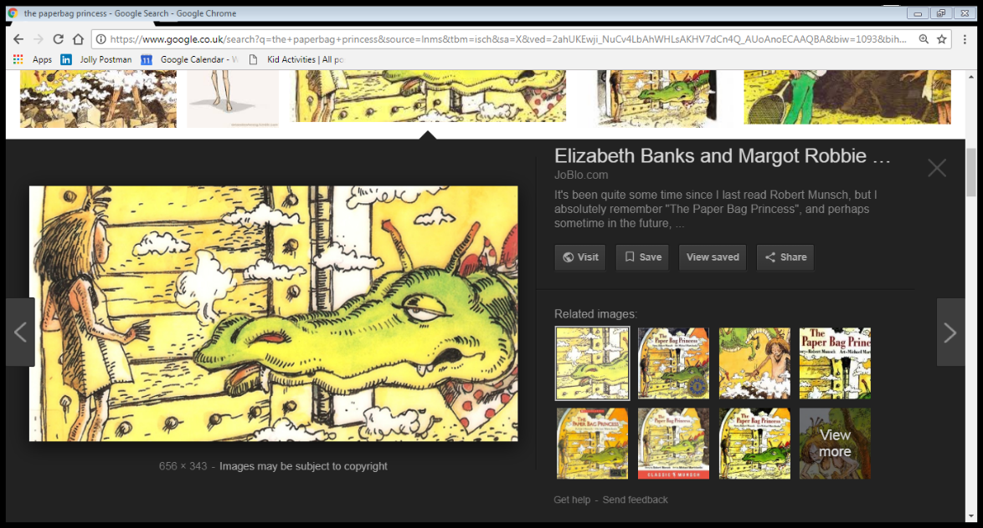

**Special dates for your diary this half-term…**

***Non Uniform day – 15th June***

***Summer Fair - 16th June***

***Year 1 assembly – 22nd June***

***Dunham Massey Trip – Tuesday 26th June***

***School Disco – 9th July***

***Sports Day – 12th July (weather permitting)***

**What else are Y1 learning about this term?**

**Geography-**This half-term, we will be thinking about maps and mapping skills

**History** – We shall be thinking about famous people e.g. The Queen

**RE/PSHE-** The children will be continuing the theme of belonging and what that means for different religions. We will continue discussing different feelings in PSHE.

**Music-** The children will participate in a weekly session of hymn practice to develop their singing skills. We will also be including music opportunities in class, when possible.

**Art/D&T-** The children will continue with our moving vehicles. The children will also explore different pencils, shading and mixing shades

**PE-** This half-term,.The children will be working on a variety of skills in preparation for Sports Day. We shall also beworking on balancing skills. **Please ensure PE bags are in school with full kit- clearly named.**

**Computing-** In computing the children will be practicing different skills from throughout the year.

**Science-** The children will be completing scientific units about the seasons