Gentle reminders & Diary Dates

* All children must have their PE kit in school
* If your child brings a lunch can you ensure it contains healthy snacks
* Can you please put suncream on your child before school and bring in some sun screen and a hat for your child to keep at school
* School Summer fair is on the 16th June
* We have an assembly on the 29th June
* Bags to school collection is on the 20th April
* 25th May we are having a pyjama day to raise funds for Alder Hay children’s hospital. The donation will be £1

Literacy.

We will be reading lots of fairy tales.

Children will continue to read at school, it is very important that you also read at home so your child meets their ELG.

We will be writing lots of sentences about the books that we have read.

We are making our own book about our magic bean plant.

Some children will also be writing stories.

Our new topic is Fairy Tales. We will be looking at numerous Fairy Tales and some of our work will be based on these. Here are some of the things that we will be learning.

Summer 2018.

Fairy Tales

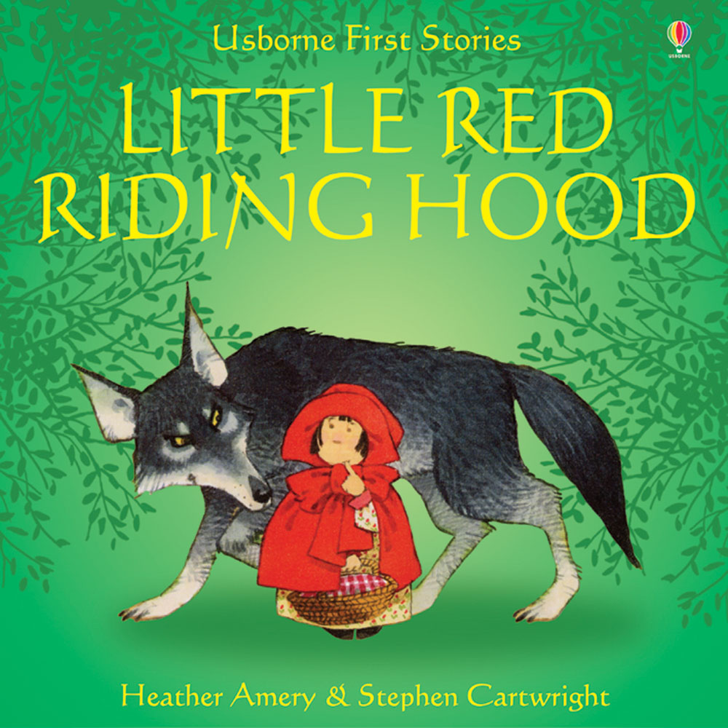

Mathematics.

We are continuing to practise writing, recognising and ordering numbers.

Continuing to practise adding and subtracting.

Learning how to double, halve and share things.

We will be learning about distance and time.

We will be continuing to practise our shape recognition and also discuss their properties.

Some children will also be practising how to count in 2’s, 5’s and 10’s.

Physical Development.

In PE we are lucky enough to have the football coach again this term. Every Tuesday we will be doing football.

All children must have their full PE kits in school please.

We will be continuing to encourage children to form their letter correctly and handle tools safely.

Communication and Language Development.

 We are discussing lots of fairy tales and encouraging the children to predict the key events.

We will be continuing to ask children lots of ‘how’ and ‘why’ questions.

We will be encouraging children to create their own narrative in our new castle role play area.

Knowledge and Understanding of the world.

This term we are planting our own magic beans and watching them grow. We will also be creating our own books and writing about our magic beanstalk.

Personal, Social and Emotional Development.

We continue to develop children's wellbeing , confidence and self-esteem. We try to ensure that all children play cooperatively and take turns, we aim to provide lots of new activities so children can gain the confidence to try new things and encourage children to follow routines and boundaries.