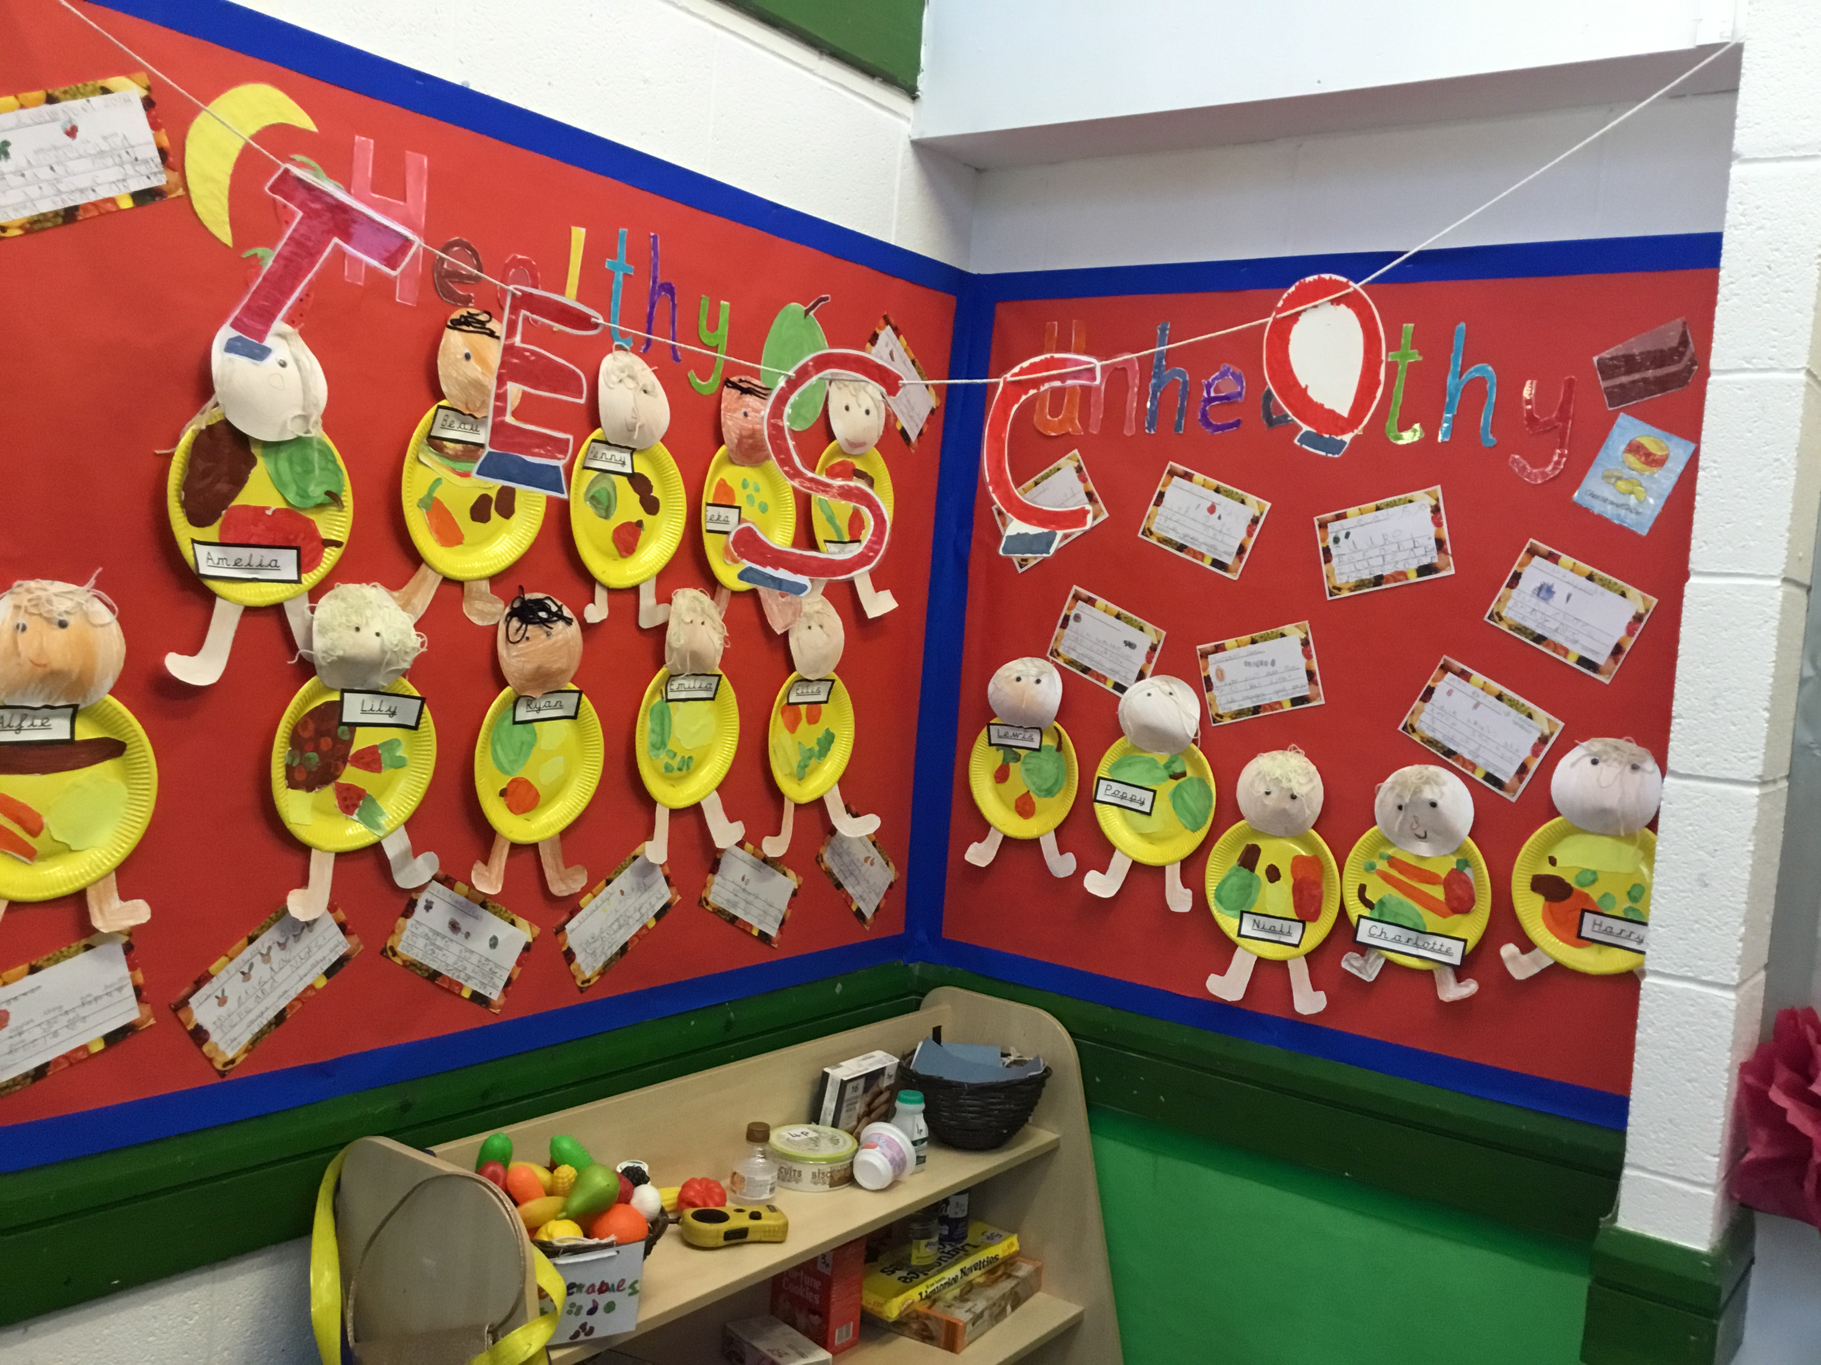

Expressive Arts and Design.

We are creating a display

About our favourite foods.

This term children some of the children’s learning is going to be based around the subject ‘Healthy Me’. We have changed our role play into Tesco- the children really enjoy playing in there! Take a look at some of the things that we will be doing…

**Spring 2 Newsletter**

**Gentle Reminders.**

* All children need a PE kit in school and pumps
* If you would like to donate to our EYFS fund it is just 50p a week
* Parents evening will be on the 20th March, times can be selected shortly.
* We need volunteers to attend the Easter service at church on the 28th March
* Dogs Trust are coming in to visit our class on the 5th March
* Easter Mix Ups are this term, times are to be chosen shortly

Communication and Language Development.

Children will be following and giving instructions whilst making food.

We always promote positive communications between children and adults.

Knowledge and Understanding of the world.

* We will be using the IPads to do research on healthy and unhealthy foods.
* We are pretending to be shop keepers and pay for things like we see grown ups do in shops

Personal, Social and Emotional Development.

We are continuing the have relevant PSHE lessons which are relevant to the children.

Physical Development.

This term we have a PE coach called Tom in from the Premiership Football Club. We will be learning how to control a ball and use a variety of movements successfully.

We are learning all about how to be healthy and why we need to exercise and eat well.

We are cooking some simple foods.

Mathematics.

We are using money in our shop to add up amounts and pay for items.

We are going to measure time using stop watches and timers and also talk about time.

We are continuing to practise our 3D and 2D shapes.

We are learning about doubling, halving and sharing.

We are continuing to practise adding and subtracting.

We are discussing distance.

**Please can you practise writing and working out sums with your children. Additionally, if you child is unable to write their numbers please practise these too.**

Literacy

**Please read with your child every day-this is vital! Also, please practise writing sentences with your child and also practise writing their high frequency words.**

**Instructional Writing.**

This week we have already learnt something new-how to write instructions. We read the book ‘The Best Chip’, take a look at us m making our own chips and then instructions to tell people how we made the chips.

