St Andrew’s Methodist Primary School.

Year 3 Newsletter of work.

Literacy
Work this half term will be continuing the BFG and enjoying some Christmas stories such as My Penguin Osbert by E.C.Kimmel.
- To begin using complex and compound sentences confidently.
- Writing adverts.
- Writing Stories.
- Diary entries
- Poetry on Bonfire Night.
- Performing Poetry
- Writing in the present tense.
- Editing and improving work.
- Using adverbs, prepositions and conjunctions to express time, place and cause.

We will also be writing Non – fiction texts based on Angry Earth.
Numeracy

Some of the work will include:
- Mental strategies and calculations
- Column addition
- Column Subtraction
- Sequences and multiplication facts
- Mental Multiplication
- Mental Division
- Written methods of multiplication.
- Written methods of division.
- Problem solving for all calculations.
- 3, 4 and 8 times tables practise.

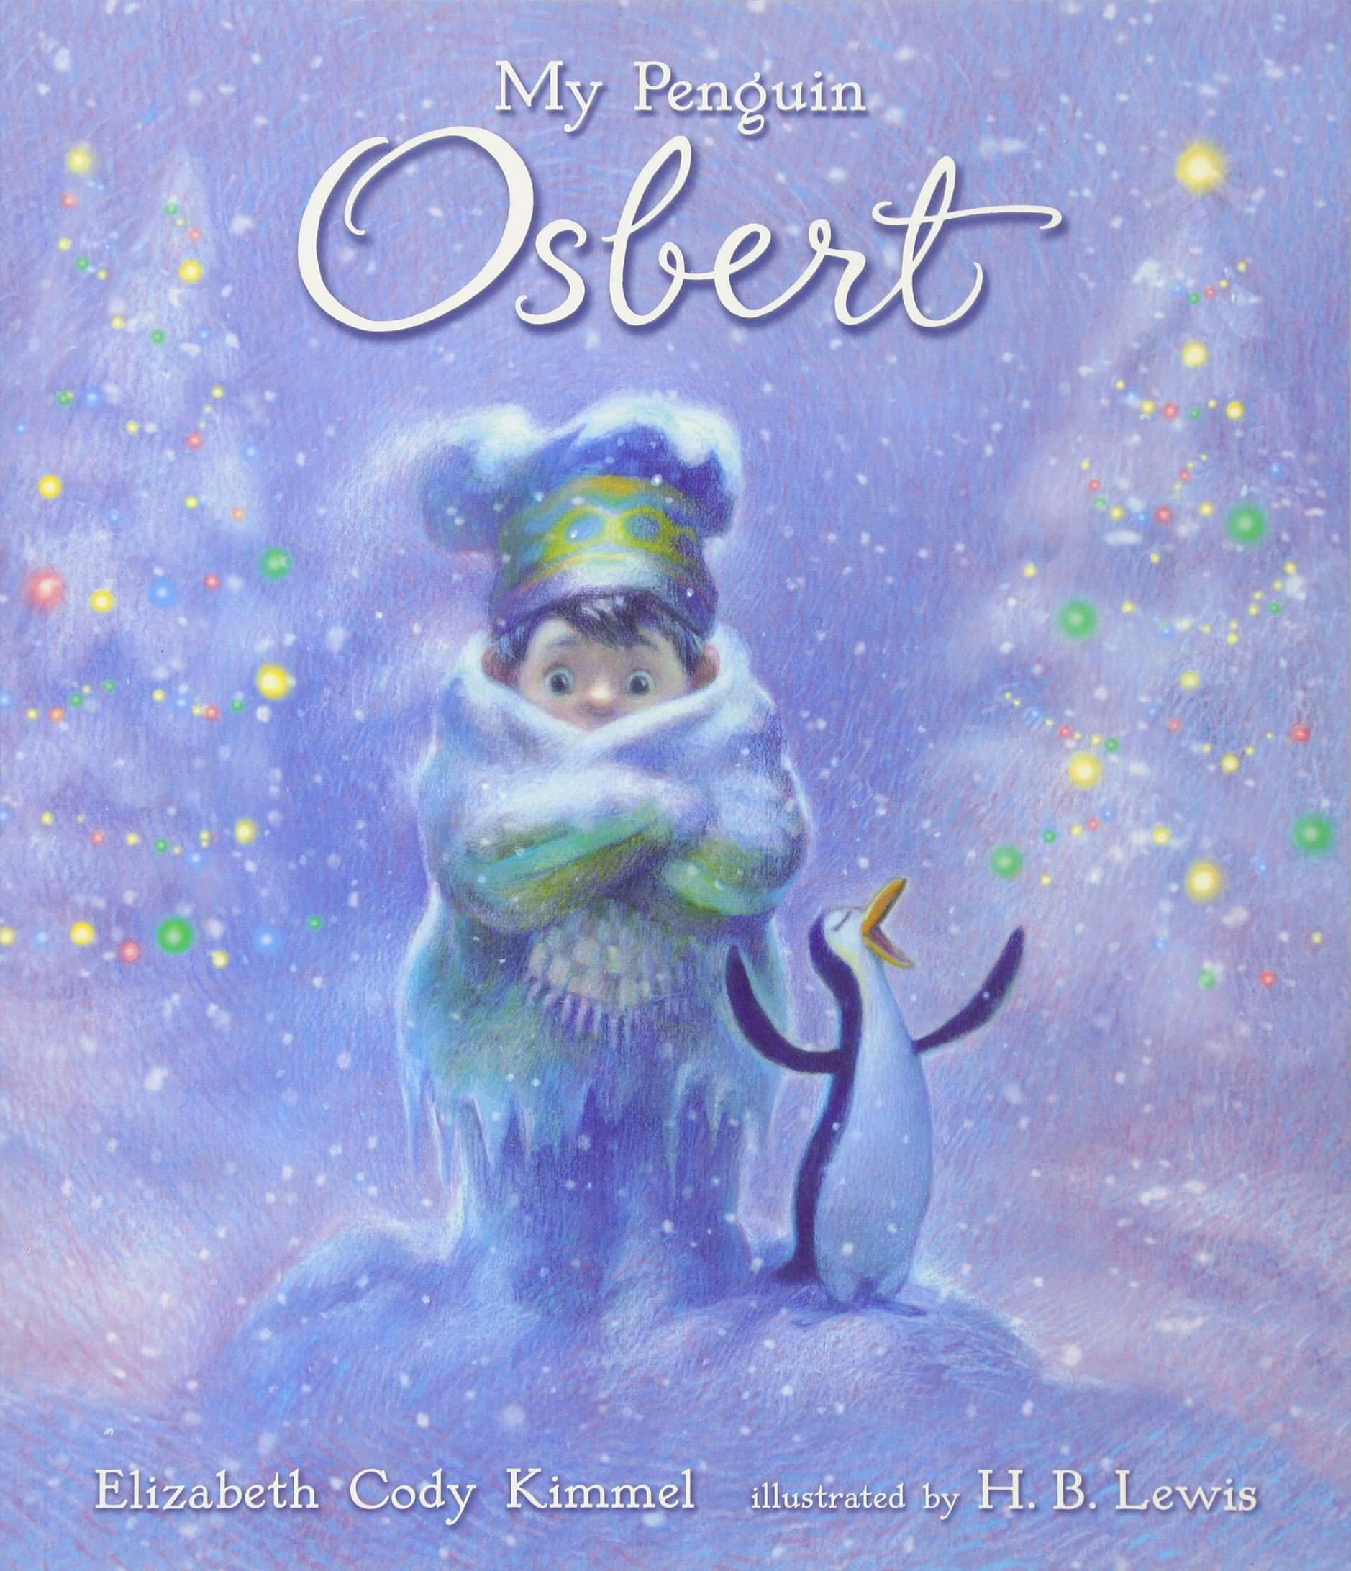

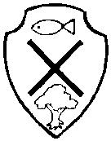

Science: Learning about Rocks.
This half term the children will be learning:
- To investigate the properties of different types of rocks.
- To compare and group together different kinds of rocks based upon their physical properties.
- To understand how igneous and sedimentary rocks are formed.
- To explain how fossils are formed.
- To explain how soil is formed.
- To explain how some rocks and soils are more permeable than others.
- To present their knowledge to others.

Other
- Topic – Angry Earth.
- Computing – We are bug fixers – continuing with coding.
- P.E – Invasion games and multi – skills.
- RE/PSHE – Different ways of describing God, looking at religious places and comparing religions.
- French – Learning Classroom phrases and animals.
- Art/D.T –Activities linked to topic.
- Weekly singing practice.
- Daily spellings, Grammar and mental maths.

Autumn 2
Nov-Dec
2017



