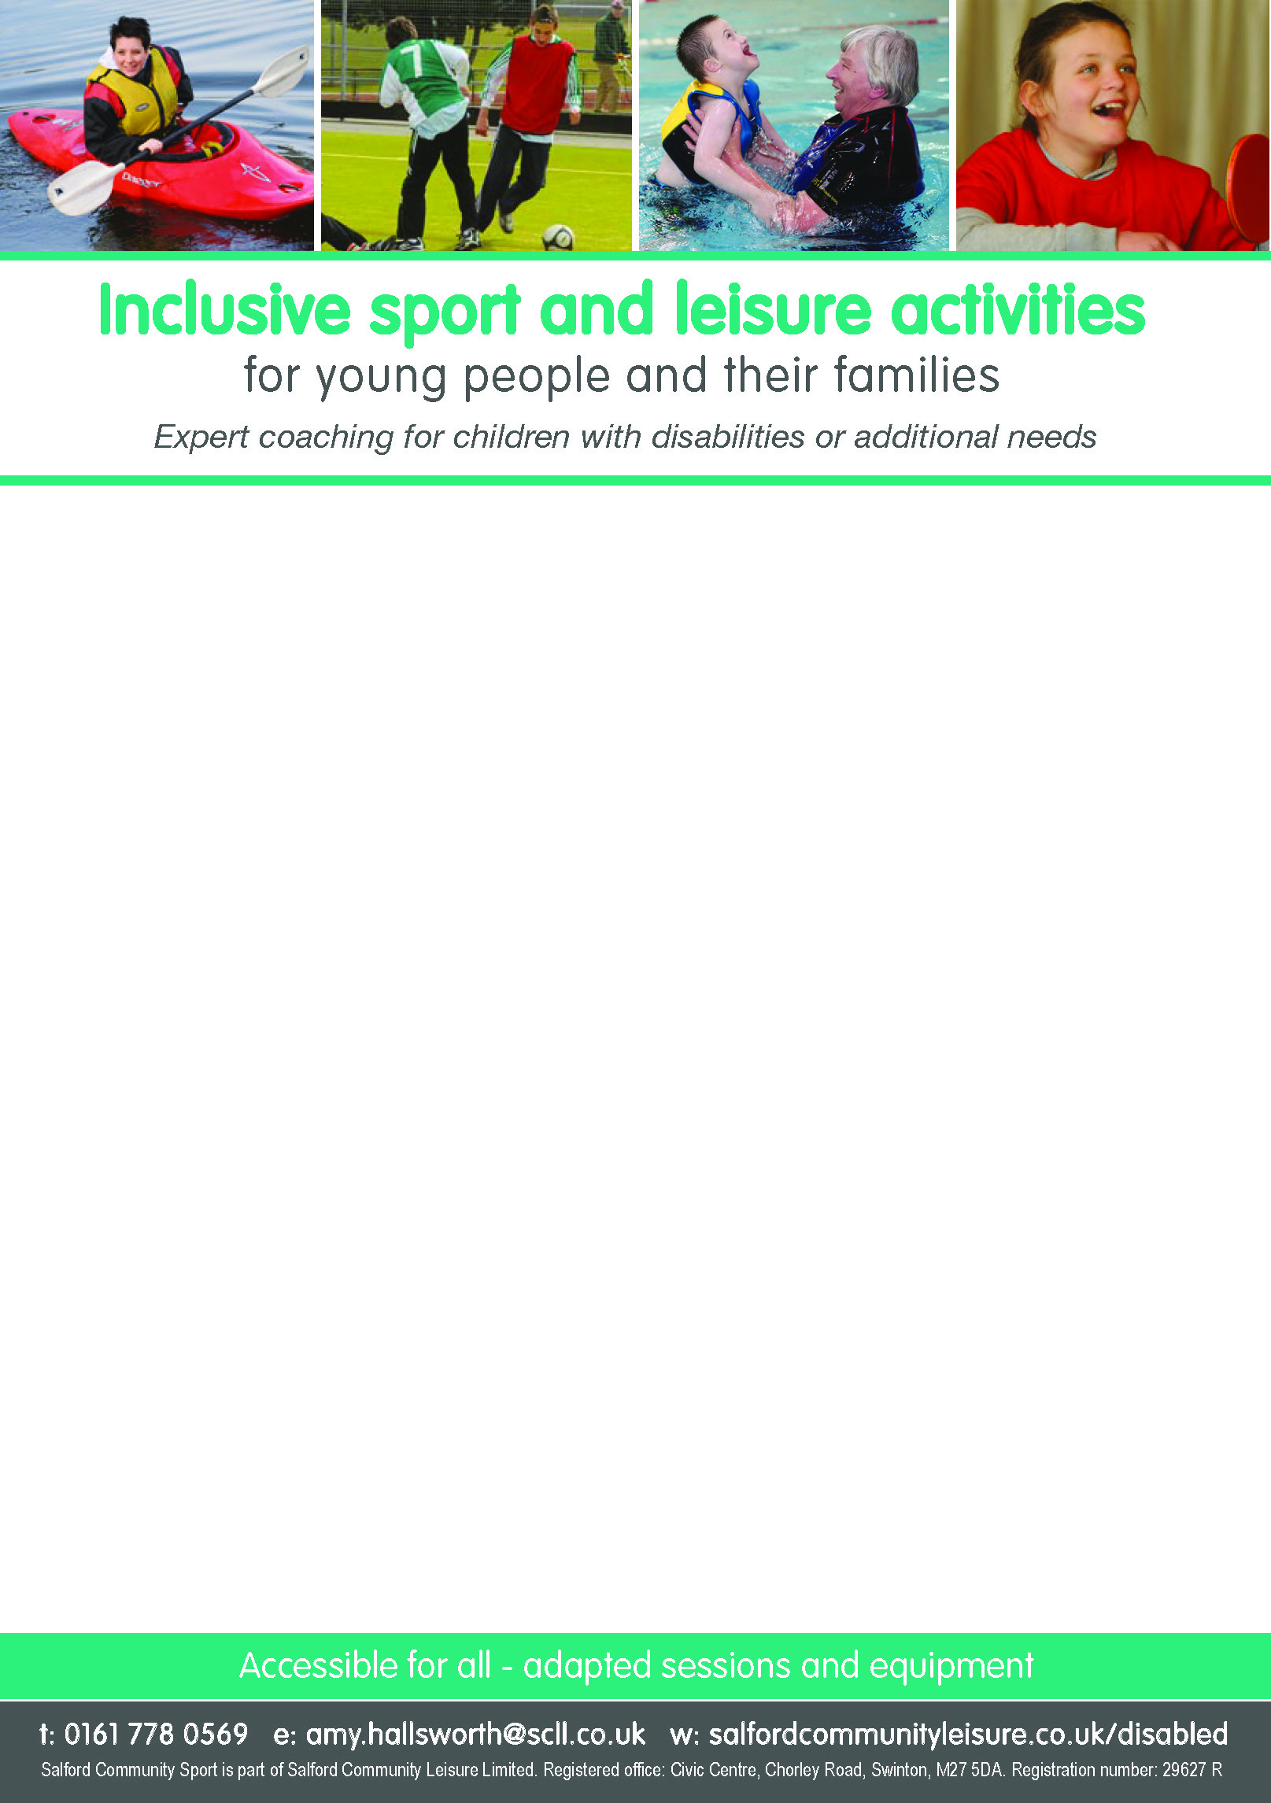

**May – June 2017**

**Swimability**

Family swim sessions

Worsley Leisure Centre / Sunday / 2:30 – 3:30 / £2

For more information, please contact Worsley Leisure Centre on 0161 790 2084

**Gymability and Trampolining**

Learn trampolining skills from the British Gymnastics Proficiency Award Scheme and have the chance to take part in inter-Centre competitions!

Ordsall Leisure Centre / Wednesdays term time only / 6:00 – 7:00 / £2 / 8-16 years

For more information, please contact the Gymnastics Team on 0161 778 0284/85/86

**Gymability and Danceability holiday camps**

These camps run during the school holidays, combining gymnastics and dance

For further details/information, please contact the gymnastics team on 01761 778 0284/85/86 or dance team on 0161 778 0561/0037

**Danceability**

Learn dance moves to the latest music, opportunities to perform at shows!

Rainbow Rooms Community Centre / Wednesdays term time only / 4:00 – 4:45 / £1.50 / age 6-11 years. (6-11 years commences 14th June)

5:00 – 6:00 / £2 / age 12 years+

**MAPAS**

A music and performing arts session

Rainbow Rooms Community Centre / Wednesdays term time only / 6:00 – 7:00 / £2 / age 8-16 years

**Outdoor ability**

Our experienced staff will lead fun sessions on the water. All safety equipment provided

Helly Hansen Water Sports Centre / Friday 2nd June / 2:00 – 4:00 / £4 / 8-16 years

**Wheels for All**

Family Cycling Session

Cleavley Athletics Track, Winton / Saturday/ 11:00 – 2:00 / £2

For more information, please contact Cath Sinclair on 07759 984559 / 01925 234213