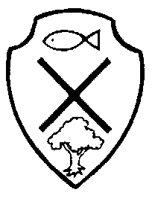
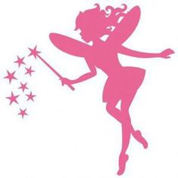

Year 1 Class Newsletter- Summer Term 1
Literacy
Writing- In our literacy lessons, the children will be completing written tasks surrounding our new focus on the genre of – ‘Fairy Tales’. We will be studying in detail some of the most popular, famous, traditional fairytales, such as: ‘The 3 Little Pigs’, ‘Goldilocks and The 3 Bears’ and ‘Jack and The Beanstalk’. We will also be introducing ‘non-fiction’ texts into our literacy lessons, as this is a significant aspect of study as we think about moving towards Y2. We will continue to concentrate on building sentences with the accurate use of capital letters, full stops, finger-spaces, sounding out for words and ensuring sentences read with cohesion/sense. Now that we are in the Summer Term, the children must now extend their written work further through the use of: question marks, exclamation marks and WOW language (for example- adjectives, prepositions and adverbs) and connectives to lengthen sentences (for example- because, so, but, and, although).
Reading- Please can I ask that daily reading at home is maintained, as part of ongoing homework- this is vital for your child’s progression, particularly now we are in the final term. The children are encouraged to place any finished reading books into the classroom’s- ‘Swap Box’, so that they can be changed for taking home, each evening. Books will be only be swapped in school, once they’ve been read and listened to by an adult; therefore it is important that reading records are signed. Please ensure reading book bags are sent into school every day. Practise of reading the key words list attached to your child’s reading record should be completed alongside home/school reading time, so a new list can be given, once they’ve achieved three ticks.
Reading at home each evening is crucial to your child’s reading development!
Phonics- The children will continue to complete daily phonic sessions, surrounding either- Phase 2 or 3 with extension then onto Phase 4/5, as the year progresses.

Term Dates

18th April-
26th May
Numeracy
In our numeracy lessons, the children will be covering work surrounding:
- To count in 5’s forwards/backwards upto 100.
- Measure length, height, weight, capacity and time.
- Name and order the days of the week and months of the year- including the accurate spelling for day/month names.
- To describe positions, directions and movement, including: quarter turn/half turn/three quarter turn/left and right/clockwise and anti-clockwise.

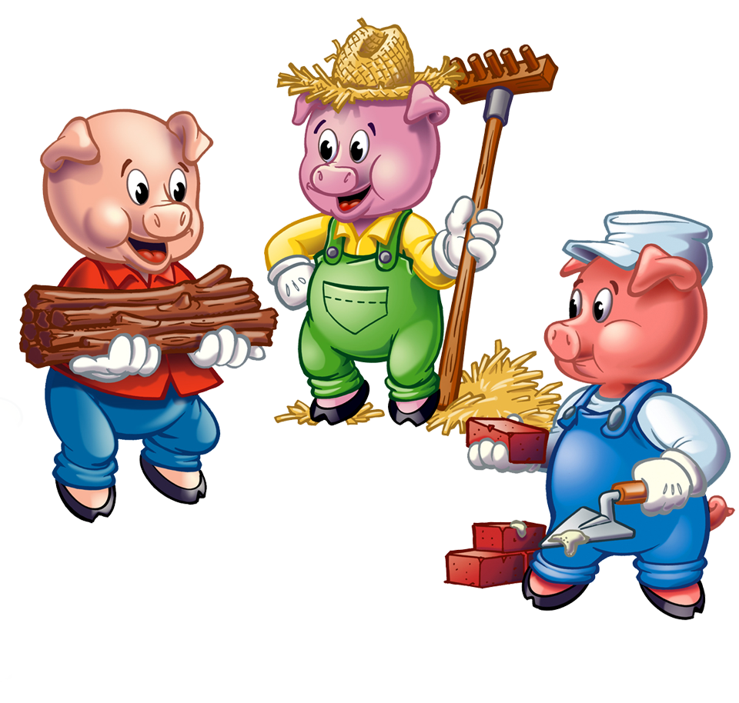
Special dates for your diary this half-term…
Y1 Class Assembly- Friday 28th April 2017- Y1 will lead the worship. Everybody welcome!

Bank Holiday- Monday 1st May 2017- school will be closed for May Day bank-holiday, re-opening on: Tuesday 2nd May.

Reading Family Workshop- Y1/2- Friday 5th May 2017- letters to be sent out shortly- limited places available!

Class photographs- Tuesday 16th May.

Water Workshop by United Utilities- Thursday 25th May- Y1 will take part in a Water Workshop in class delivered by United Utilities.

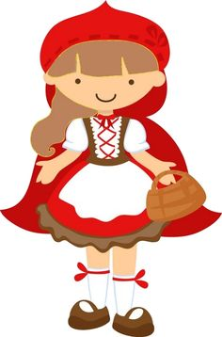
What else are Y1 learning about this term?
Geography- This term we will be studying the question: ‘Where do, and did, the wheels on the bus go?’ We will be looking closely at learning surrounding the United Kingdom.
RE/PSHE- The children will be completing work surrounding ‘holy books’ and their importance to religious groups.
Music- The children will participate in a weekly session of hymn practice to develop their singing skills. We will also be rehearsing for our class assembly, which will contain an element of ‘performing arts’.
Art/D&T- The children will look closely at art and crafts surrounding our season of Spring and growth.
PE- This half-term, the children will be learning how to play dodgeball, in order to develop their throwing and catching skills. This will also support their understanding of ‘team-work’ and how to play games appropriately, for example- sharing/turn-taking/sensibly accepting rules of the game.
Computing- In computing, the children will be learning how to use a website and record clips with sounds to then playback on the I-pads.
Science- The children will be completing a unit surrounding ‘plants and living things’, answering the question: ‘Which birds and plants would Little Red Riding Hood find in our park?’

