St Andrew’s Methodist Primary School.

Year 3 Newsletter of work.

Literacy
Work this half term will be linked to our Ancient Egypt topic and we will be using the story, ‘Charlie and the Chocolate Factory’ by Roald Dahl. Some of the skills we will be learning are:
- To use complex and compound sentences.
- Compose our own stories based on similar ones we are reading, using clear structures with setting, plot and characters.
- Non – fiction reports on Ancient Egypt.
- Writing in the present tense.
- Using adverbs, prepositions and conjunctions to express time, place and cause.
- Writing using direct speech with correct punctuation.
- Writing with joined up handwriting.
- Writing in clear paragraphs.

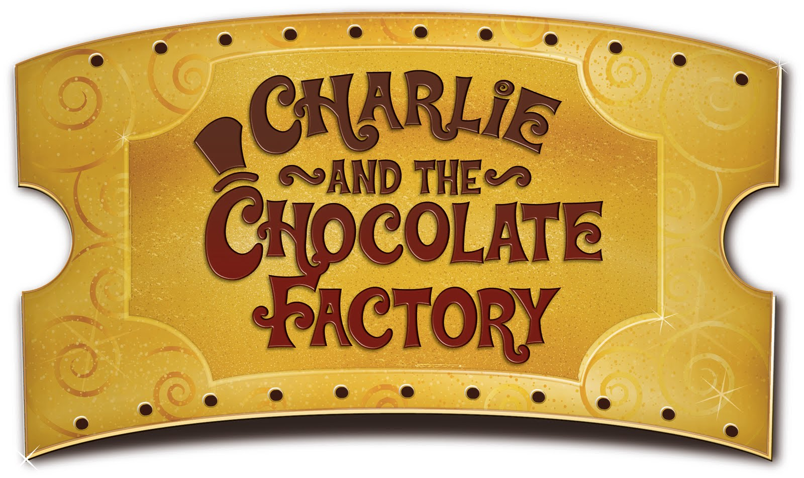
Numeracy

Some of the work will include:
- Recalling and using multiplication and division facts for the 3, 4 and 8 times tables.
- Solving missing number problems involving multiplicationand division.
- Writing and calculating mathematical statements using their knwledge of division and multiplication facts.
- Telling and writing the time from an analogue clock, inclusing roman numerals, 12 hour and 24 hour clocks.
- Estimating and reading time to the nearest minute.
- Comparing the duration of events.
- Recognising and using fractions as numbers.
- Recognising and writing fractions of objects with small denominators.

Spring 1
Jan-Feb
2017

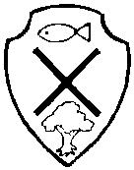

Science: Light
This half term the children will be learning about light and shadows.
- To recognise that they need light in order to see things and that dark is the absence of light.
- To notice that light is reflected from surfaces.
- To recognise that light from the sun can be dangerous and that there are ways to protect our eyes.
- To recognise that shadows are formed when the light source is blocked by a solid object.
- To find pattern in the way that the size of shadows change.

Other
- Topic – How can we re-discover the wonder of Ancient Egypt?
- Computing – Filming and presenting using video technology.
- P.E – Hockey.
- RE/PSHE – What do different people believe about God?
- French – Learning simple conversation and naming pets and food.
- Art/D.T –Activities linked to Ancient Egypt Topic.
- Weekly singing practice.
- Daily spellings.

