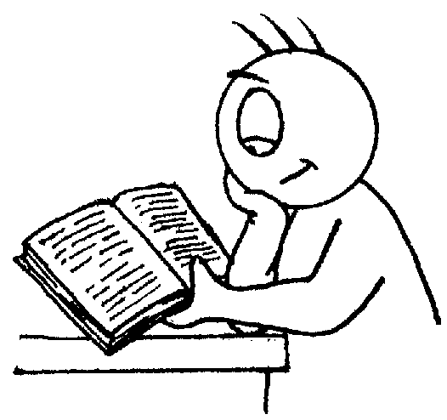
St Andrew’s Methodist Primary School

End of Year Expectations
for Year 5

This booklet provides information for parents and carers on the end of year expectations for children in our school. The staff have identified these expectations as being the minimum requirements your child must meet in order to ensure continued progress throughout the following year.

All the objectives will be worked on throughout the year and will be the focus of direct teaching. Any extra support you can provide in helping your children to achieve these is greatly valued.

If you have any queries regarding the content of this booklet or want support in knowing how best to help your children please talk to your child’s teacher.

Mathematics
- Count forwards & backward with positive & negative numbers through zero.
- Count forwards/backwards in steps of powers of 10 for any given number up to 1000000.
- Compare & order numbers with 3 decimal places.
- Read Roman numerals to 1000.
- Identify all multiples & factors, including finding all factor pairs.
- Use known tables to derive other number facts.
- Recall prime numbers up to 19.
- Recognise place value of any number up to 1000000.
- Round any number up to 1000000 to the nearest 10, 100, 1000, 10000 or 100000.
- Round decimals with 2dp to nearest whole number & 1dp.
- Add & subtract:
  - Numbers with more than 4-digits using efficient written method (column).
  - Numbers with up to t 2dp.
- Multiply:
  - 4-digits by 1-digit/ 2-digit
- Divide:
  - 4-digits by 1-digit
- Multiply & divide:
  - Whole numbers & decimals by 10, 100 & 1000
- Count up/down in thousandths.
- Recognise mixed numbers & fractions & convert from one to another.
- Multiply proper fractions by whole numbers.
- Solve time problems using timetables and converting between different units of time.
Reading

- Summarises main points of an argument or discussion within their reading & makes up own mind about issue/s.
- Can compare between two texts.
- Appreciates that people use bias in persuasive writing.
- Appreciates how two people may have a different view on the same event.
- Draw inferences and justify with evidence from the text.
- Varies voice for direct or indirect speech.
- Recognise:
  - clauses within sentences
- Uses more than one source when carrying out research.
- Creates set of notes to summarise what has been read.
Writing

- Add phrases to make sentences more precise & detailed.
- Use range of sentence openers – judging the impact or effect needed.
- Begin to adapt sentence structure to text type.
- Use pronouns to avoid repetition.
- Use:
  - Brackets.
  - Dashes.
  - Commas.
- Use commas to clarify meaning or avoid ambiguity.
- Link clauses in sentences using a range of subordinating & coordinating conjunctions.
- Use verb phrases to create subtle differences (e.g. she began to run).
- Consistently organize into paragraphs.
- Link ideas across paragraphs using adverbials of time (e.g. later), place (e.g. nearby) and number (e.g. secondly).
- Legible and fluent handwriting style.

