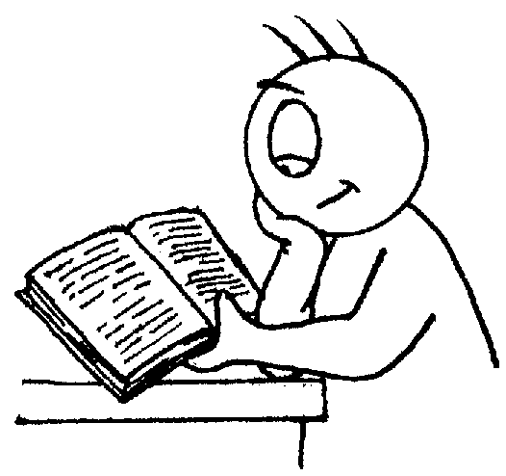
St Andrew’s Methodist Primary School

End of Year Expectations
for Year 4

This booklet provides information for parents and carers on the end of year expectations for children in our school. The staff have identified these expectations as being the minimum requirements your child must meet in order to ensure continued progress throughout the following year.

All the objectives will be worked on throughout the year and will be the focus of direct teaching. Any extra support you can provide in helping your children to achieve these is greatly valued.

If you have any queries regarding the content of this booklet or want support in knowing how best to help your children please talk to your child’s teacher.

Mathematics

- Count backwards through zero to include negative numbers.
- Compare & order numbers beyond 1000.
- Compare & order numbers with 2 decimal places.
- Read Roman numerals to 100.
- Find 1000 more/less than a given number.
- Count in multiples of 6, 7, 9, 25 & 1000.
- Recall & use multiplication & division facts all tables to 12x12.
- Recognise place value of any 4-digit number.
- Round any number to the nearest 10, 100 or 1000.
- Round decimals with 1dp to nearest whole number.
Add & subtract:
  - Numbers with up to 4-digits using efficient written method (column).
  - Numbers with up to 1dp.
Multiply:
  - 2-digit by 1-digit
  - 3-digit by 1-digit
Divide:
  - 3-digit by 1-digit
- Count up/down in hundredths.
- Write equivalent fractions
- Add and subtract fractions with same denominator.
- Read, write & convert time between analogue & digital 12 & 24 hour clocks.

Reading

- Give a personal point of view on a text.
- Can re-explain a text with confidence.
- Justify inferences with evidence, predicting what might happen from details stated or implied.
- Use appropriate voices for characters within a story.
- Identify how sentence type can be changed by altering word order, tenses, adding/deleting words or amending punctuation.
- Skims & scans to locate information and/or answer a question.
Writing

- Vary sentence structure, using different openers.
- Use adjectival phrases (e.g. biting cold wind).
- Appropriate choice of noun or pronoun.
- Apostrophe for singular & plural possession.
- Comma after fronted adverbial (e.g. Later that day, I heard bad news.).
- Use commas to mark clauses.
- Use connectives to link paragraphs.
- Legible, joined handwriting of consistent quality.

