St Andrew’s Methodist
Primary School
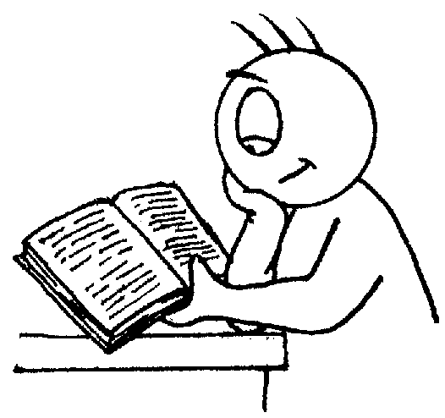

End of Year Expectations
for Year 2

This booklet provides information for parents and carers on the end of year expectations for children in our school. The staff have identified these expectations as being the minimum requirements your child must meet in order to ensure continued progress throughout the following year.

All the objectives will be worked on throughout the year and will be the focus of direct teaching. Any extra support you can provide in helping your children to achieve these is greatly valued.

If you have any queries regarding the content of this booklet or want support in knowing how best to help your children please talk to your child’s teacher.

Mathematics

- Compare & order numbers up to 100.
- Read & write all numbers to 100 in digits & words.
- Say 10 more/less than any number to 100.
- Count in multiples of 2, 3 & 5 & 10 from any number up to 100.
- Recall & use multiplication & division facts for 2, 5 & 10 tables.
- Recall & use +/- facts to 20.
- Derive & use related facts to 100.
- Recognise place value of any 2-digit number.
Add & subtract:
  - 2-digit numbers & ones
  - 2-digit numbers & tens
  - Two 2-digit numbers
  - Three 1-digit numbers
- Recognise & use inverse (+/-).
- Calculate & write multiplication & division calculations using multiplication tables.
- Recognise & use inverse (x/÷).
- Recognise, find, name & write 1/3; 1/4; 2/4; 3/4.
- Recognise equivalence of simple fractions.
- Tell time to five minutes, including quarter past/to.

Reading

- Secure at phase 6 phonics.
- Reads ahead to help with fluency & expression.
- Comments on plot, setting & characters in familiar & unfamiliar stories.
- Recounts main themes & events.
- Comments on structure of the text.
- Use commas, question marks & exclamation marks to vary expression.
- Read aloud with expression & intonation.
- Recognise:
  - speech marks
  - contractions
- Identify past/present tense.
- Use content and index to locate information.

Writing

- Write different kinds of sentence: statement, question, exclamation, command.
- Use expanded noun phrases to add description & specification.
- Write using subordination (when, if, that, because).
- Correct & consistent use of present tense & past tense.
- Correct use of verb tenses.
- Correct & consistent use of:
  - Capital letters.
  - Full stops.
  - Question marks.
  - Exclamation marks.
  - Commas in a list.
  - Apostrophe (omission).
  - Introduction of speech marks.
- Write under headings.
- Evidence of diagonal & horizontal strokes to join handwriting.

