St Andrew’s Methodist Primary School
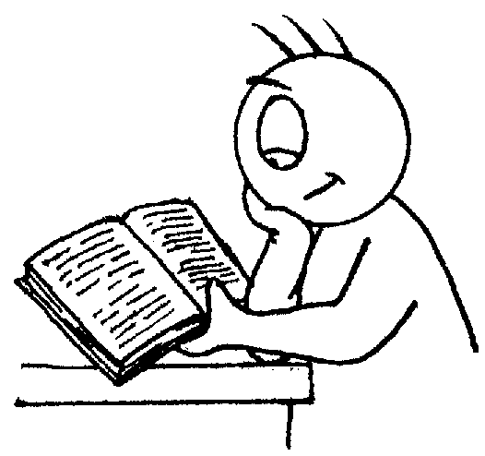

End of Year Expectations
for Reception

This booklet provides information for parents and carers on the end of year expectations for children in our school. The staff have identified these expectations as being the minimum requirements your child must meet in order to ensure continued progress throughout the following year.

All the objectives will be worked on throughout the year and will be the focus of direct teaching. Any extra support you can provide in helping your children to achieve these is greatly valued.

If you have any queries regarding the content of this booklet or want support in knowing how best to help your children please talk to your child’s teacher.

Oracy

- Talk about how a story starts.
- Know they need to vary speech and thought between talking to a friend and talking to the class.
- Use complete sentences to explain or describe things.
- Stand up in front of others and tell them about something that has happened to them.
- Use talk to co-operate and contribute when playing with others.
- Listen carefully to what is being said and repeat this if they need to.
- Know not to interrupt when someone else is saying something.

Mathematics

- Count reliably to 20.
- Order numbers 1 – 20.
- Say 1 more/1 less to 20.
- Add & subtract two single digit numbers.

Reading

- Secure at phase 4 phonics.
- Read some common irregular words.
- Identify rhymes and alliteration.
- Join in with rhyming patterns.
- Read & understand simple sentences.
- Demonstrate understanding when talking with others about what they have read.
- Make basic predictions.
- Identify start & end of a sentence.

Writing

- Write simple sentences which can be read by themselves & others.
- Write own names correctly.
- Use capital letters and full stops to demarcate sentences.
- Write clearly demarcated sentences.
- Correct pencil grip.
- Write name (correct upper & lower case).
- Correct letter formation for familiar words.

