YEAR 2
SCIENCE - YEAR 2 | AUTUMN | SPRING | SUMMER
SCIENCE - YEAR 2 | Uses of everyday materials  National curriculum objectives  Identify and compare the suitability of a variety of everyday materials, including wood, metal, plastic, glass, brick, rock, paper and cardboard for particular uses  - Identify the material that a group of objects are made from  - Compare and group objects by their properties  - Describe the properties of the everyday materials using scientific vocabulary i.e. transparent/opaque  - Investigate the suitability of different materials relating to their properties i.e. why are windows made from glass?  - Make a prediction as to which material would suit a purpose e.g. best raincoat material  Key Vocab  Material, Hard, Soft, Stiff, Rough, Smooth, Bendy, Brick, Fabrics,  Shiny, Stretchy, Dull, Waterproof, Absorbent, Opaque, Transparent, Cardboard, Elastic, Foil  TAPS PLAN LINKS  Materials: Waterproof  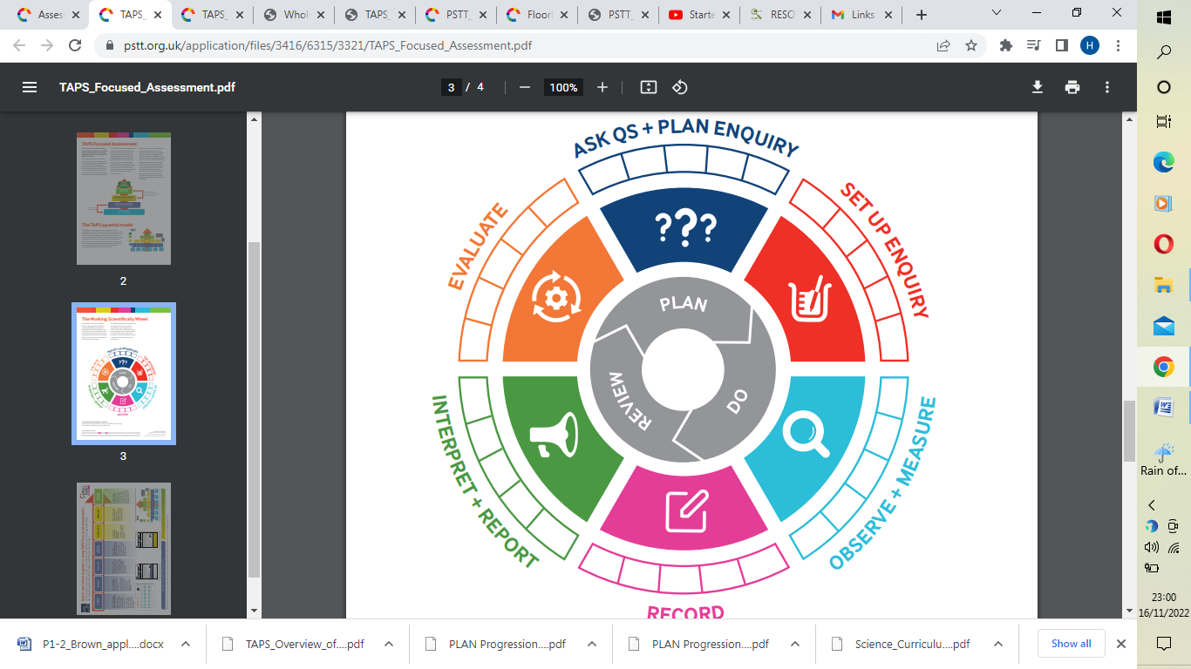  Materials: Rocket mice  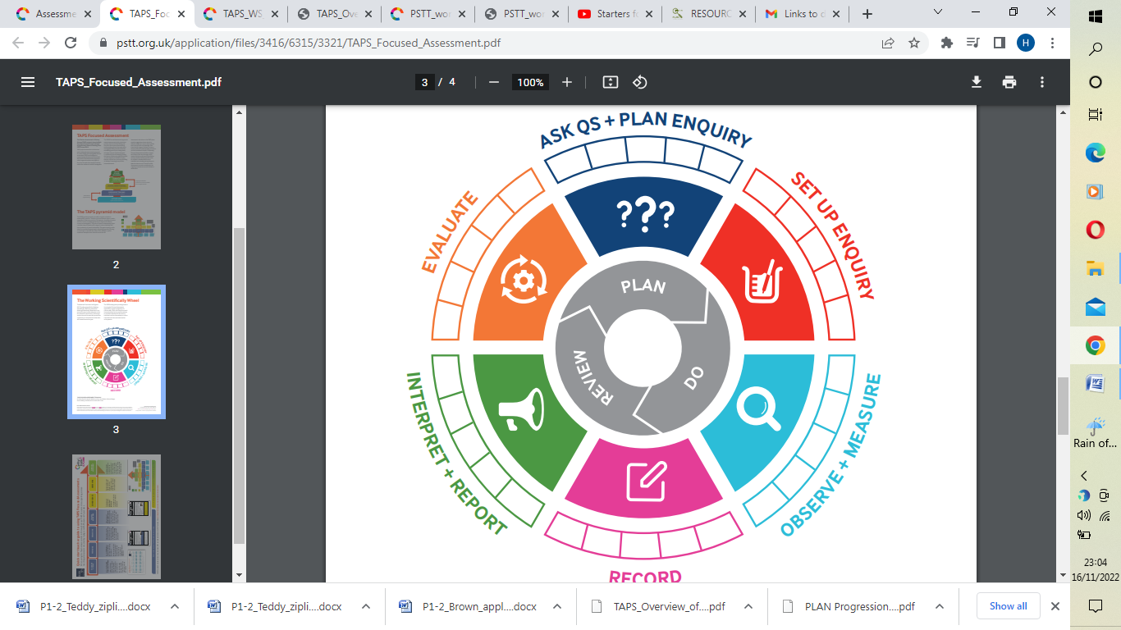  Materials hunt  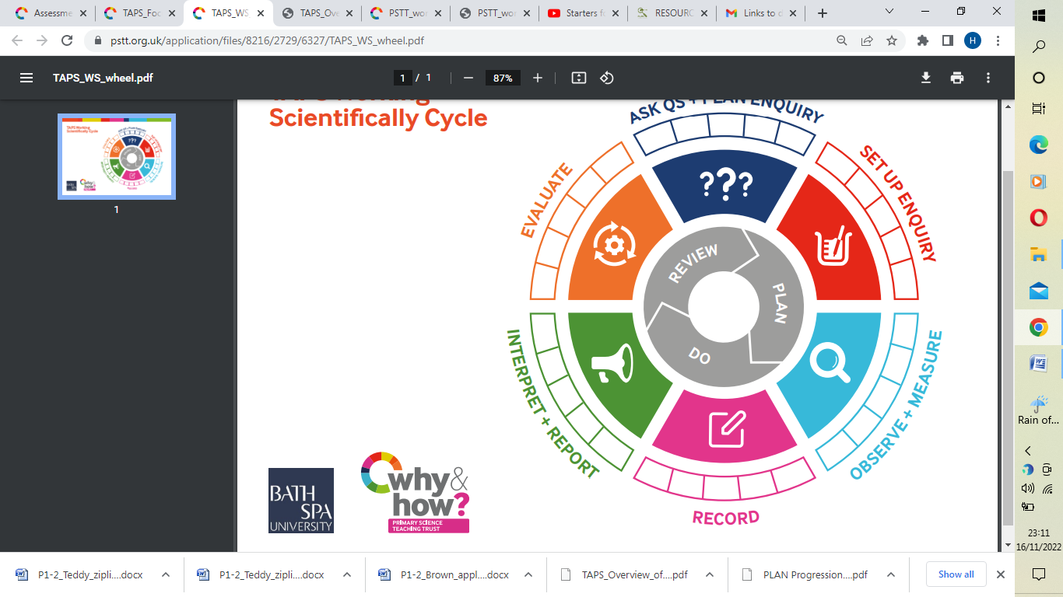  Materials: Boat  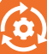 | Animals, including humans  National curriculum objectives  Notice that animals, including humans, have offspring which grow into adults, Find out about and describe the basic needs of animals, including humans, for survival (water, food and air) and describe the importance for humans of exercise, eating the right amounts of different types of food, and hygiene  - Understand that animals include humans  - Understand that animals produce offspring and name some  - Understand that offspring grow and change into adults  - Understand that animals have basic needs, which must be met, for survival  - Identify that animals need water, food and air in order to survive  - Understand that exercise is important and plays a role in keeping healthy  - Understand that in order to have a healthy diet, foods must be balanced  - Understand the importance of hygiene in keeping healthy  Key Vocab  Adult, Young, Offspring, Survival, Water, Air, Food, Kitten, Calf, Puppy, Exercise, Hygiene  TAPS PLAN LINKS  Animals inc Humans: Handspans | Living things and their habitats  National curriculum objectives  Explore and compare the differences between things that are living, dead, and things that have never been alive,identify that most living things live in habitats to which they are suited and describe how different habitats provide for the basic needs of different kinds of animals and plants, and how they depend on each other,identify and name a variety of plants and animals in their habitats, including microhabitats anddescribe how animals obtain their food from plants and other animals, using the idea of a simple food chain, and identify and name different sources of food  - Classify things by living, dead or never lived  - Know how a specific habitat provides for the basic needs of things living there (plants and animals)  - Match living things to their habitat  - Name some different sources of food for animals  - Know about and explain a simple food chain  Key Vocab  Pond, Lake, Living, Dead, Habitat, Food chain, Predator, Prey, Woodland, Desert  TAPS PLAN LINKS  Living Things: Woodlice habitats  Living Things: Nature spotters  Living and non-living  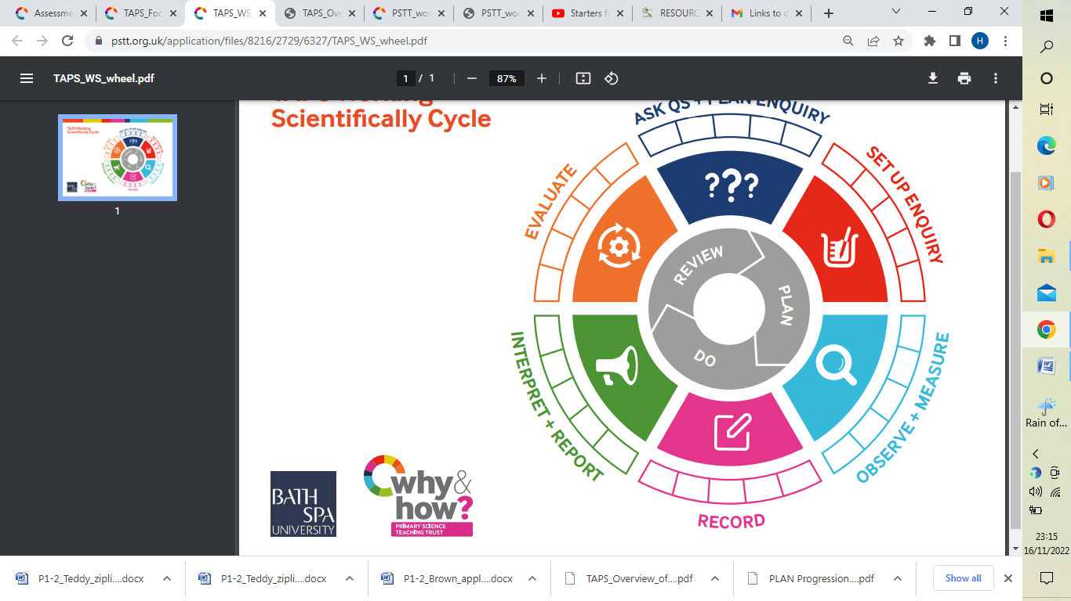
SCIENCE - YEAR 2 | (Changes in) Everyday materials  National curriculum objectives  Find out how the shapes of solid objects made from some materials can be changed by squashing, bending, twisting and stretching  - To understand that materials can change  - To explore and investigate squashing, bending, twisting and stretching a range of everyday materials  - To understand that a material changes by an action such as squashing, bending, twisting and stretching  Key Vocab  Solid, Shape, Squashing, Bending, Twisting, Stretching | Plants  National curriculum objectives  Observe and describe how seeds and bulbs grow into mature plants and find out and describe how plants need water, light and a suitable temperature to grow and stay healthy  - Understand that seeds and bulbs change and grow into mature plants  - Through observation, describe how seeds and bulbs change in appearance as they grow  - Investigate what plants need to grow and stay healthy  - Understand that plants need water, light and a suitable temperature to grow and stay healthy  Key Vocab  Grow, Seeds, Water, Bulbs, Sunlight, Suitable Temperature, Healthy, Germinate,  Decompose  TAPS PLAN LINKS  Plants: Compare Growth  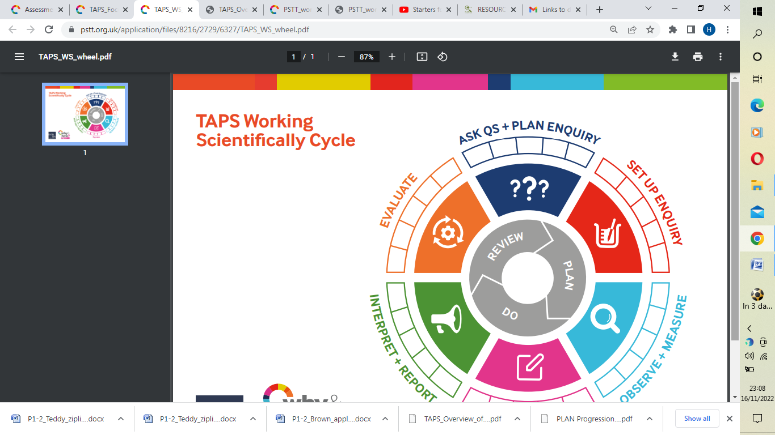
Working Scientifically

Observe Change Slowly Quickly Describe Name Identify Label Record Measure Bigger and Smaller Pattern Notice Cycle Predict

*Suggested Equipment Focus = Using Hand lenses (Magnifiers), Magnifiers linked to ICT, Egg Timers, Simple Digital Timers

Computing Year 2 | AUT1 Online Safety (unit 2.2)  Use technology safely and respectfully, keeping personal information private; identify where to go for help and support when they have concerns about content or contact on the internet or other online technologies.  - I know the consequences of not searching online safely.  - I can share work and communicate electronically – for example using 2Email or the display boards.  - I can report unkind behaviour and things that upset me online, to a trusted adult.  - I can see where technology is used at school such as in the office or canteen  Vocabulary – Personal Information, Private information, Sharing, Secure, Protection)  Effective Searching (Unit 2.5)  Recognise common uses of information technology beyond school  - I can find data using specific searches – for example, using 2Investigate.  - I know the consequences of not searching online safely.  - I can name, save and find my work.  - I can find information I need using a search engine.  Vocabulary  (Browser, Device, Network, Internet, Search engine, Web page, Web address)  AUT 2 Creating Pictures (2.6) – Additional unit ( Art link)  - I can name, save and find my work.  - I can include photos, text and sound in my creations.  Vocabulary  (Clipart, Fill, Line, Palette) | SPR 1 - Online safety – quiz only (unit 2.2)  Coding (unit 2.1)  Understand what algorithms are; how they are implemented as programs on digital devices; and that programs execute by following precise and unambiguous instructions  Create and debug simple programs  - I can explain an algorithm is a set of instructions to complete a task.  - I know I need to carefully plan my algorithm so it will work when I make it into code.  - I can design a simple program using 2Code that achieves a purpose.  - I can find and correct some errors in my program.  - I can say what will happen in a program.  - I can spot something in a program that has an action or effect (does something)  - I understand that my creations such as programs in 2Code, need similar skills to the adult world. e.g. The program used for collecting money for school trips.  Vocabulary – (Algorithm, Bug, Events, Command, De-bug, Object, Output, Sequence)  SPR 2 - Presenting (unit 2.8) Literacy link  Use logical reasoning to predict the behaviour of simple programs.  Recognise common uses of information technology beyond school  - I can use several programs to organise information – for example, using binary trees such as 2Question or spreadsheets such as 2Calculate.  - I can name, save and find my work.  - I can include photos, text and sound in my creations.  Vocabulary (E-book, presentation)  Making Music ( unit 2.7) Music link (additional unit)  I can edit digital data such as data in music composition software like 2Sequence.  - I can name, save and find my work.  - I can edit digital data such as data in music composition software like 2Sequence.  Vocabulary (Soundtrack, Sound effect) | SUM 1 - Online safety - quiz only (unit 2.2)  Questions – (unit 2.4) – Maths link to data pictograms etc  Use technology purposefully to create, organise, store, manipulate and retrieve digital content.  - I can organise data – for example, using a database such as 2Investigate. I can find data using specific searches – for example, using 2Investigate.  - I can use several programs to information – for example, using binary trees such 2Question or spreadsheets such as 2Calculate.  - I can name, save and find my work.  Vocabulary  (Avatar, Database, Information, Record, Search, Sort)  SUM 2 - Spreadsheets (unit 2.3)  Use technology purposefully to create, organise, store, manipulate and retrieve digital content.  - I can organise data – for example, using a database such as 2Investigate.  Vocabulary  (Cell, Data, Drag, Equals, Total, Cut, Paste)

Geography | Autumn  Locational Knowledge and Geographical Skills and fieldwork- London (links to history topic of The Great Fire of London)  Name, locate and identify the characteristics of the four countries and capital cities of the UK and its surrounding seas  Use world maps, atlases and globes to identify the UK and its countries  - To name the 4 capital cities in each country of the UK and locate these cities on a map  - To identify some of the main characteristics of the four countries  - To locate the main seas that surround the UK  Key Vocabulary  - Capital cities/Capital  - Landmarks  - London (Edinburgh, Cardiff, Belfast)  - Irish Sea  - English Channel  - North Sea  - Atlantic Ocean  - British Isles  - Great Britain  - City | Spring  Locational & Place Knowledge - The Polar Regions (Antarctica Study)  Name and locate the world’s seven continents and five oceans  Understand geographical similarities and differences through studying the human and physical geography of a small area of the UK and a small area in a contrasting non-European country  Use world maps, atlases and globes to identify continents and oceans  - Name and locate the 7 continents and 5 oceans of the world  - To locate the cold polar regions on the globe, in relation to the Equator and the poles  - To compare the geographical similarities and difference between Antarctica and the UK  - To have an awareness of the global warming impact in Antarctica - SDG 13 Global Warming  Key Vocabulary  - Antarctica  - Arctic  - North Pole  - South Pole  - Equator  - Atlantic, Pacific, Southern, Indian and Arctic Ocean  - Continents  - Asia, North America, South America, Antarctica, Europe, Africa, Australia  - Polar regions  - Polar ice caps  - Climate  - Temperatures  - Empire penguins  - Compare  - Research  - Global Warming | Summer  Place Knowledge  Skills and field work – Local Area (Walkden)  Understand geographical similarities and differences through studying the human and physical geography of a small area of the United Kingdom  - To use a compass to walk in the correct direction, using right and left  - To use a maps and aerial images to locate places of interest/importance within their locality  - To study the school grounds, using observational skills and devise a simple map of the school grounds including symbols in a key  - To understand how local amenities benefit their local community of Walkden  Key Vocabulary  - Direction, e.g. near, far, left, right  - Locality  Human and Physical Geography  - To identify the physical features of a mountain, lake, island, valley, river, cliff, forest and beach (Katie Morag topic)  - To compare human and physical features  - Explain some of the advantages and disadvantages of living in a city or village  Key Vocabulary  - Human features  - Physical features  - Mountain  - Lake  - Island  - Valley  - Cliff  - Beach  - coast  - Forest  - Hill  - Sea  - Ocean  - River  - Soil  - Valley  - Vegetation  - City

History |  | The Great Fire of London  National curriculum objectives  Events beyond living memory that are significant nationally or globally  - Know about an event/events that happened long ago  - Know when the Great Fire of London occurred  - Know what materials were to build houses in 1666  - Know why so many buildings were destroyed  - Know how the Great Fire influenced the way houses were built  - Know that the fire brigade was set up after the Great Fire  Key vocabulary  bakery, diary, flammable, eye-witness, fire-hook | Significant and brave individuals – Neil Armstrong  National curriculum objectives  - the lives of significant individuals in the past who have contributed to national and international achievements  - changes within living memory  - Know about a famous person from outside the UK and explain why they are famous  - Know why Neil Armstrong is famous  - Know when he was born  - Know when he died  - Know a basic timeline of his life  - Know when the first moon landing was  Key vocabulary  astronaut, famous, timeline, space flight, orbit, pilot, historical | Worsley/Walkden Long Ago  National curriculum objectives  Significant historical events, people and places in their own locality  - Know how the local area is different to the way it used to be a long time ago  - Differentiate between things that were here 100 years ago and things that were not (including buildings, tools, toys etc.)  - Know what a canal is  - Know what a canal is for  - Know where the Bridgewater Canal is in the local area  - Know why the Bridgewater Canal was important in the past  - Know how the Bridgewater Canal has changed over the years  Key vocabulary  canal, transport, waterways, Bridgewater, industrial
D.T | Sculpture  National curriculum objectives  Design  design purposeful, functional, appealing products for themselves and other users based on design criteria  generate, develop, model and communicate their ideas through talking, drawing, templates, mock-ups and, where appropriate, information and communication technology  Make  select from and use a range of tools and equipment to perform practical tasks [for example, cutting, shaping, joining and finishing] select from and use a wide range of materials and components, including construction materials, textiles and ingredients, according to their characteristics  Evaluateexplore and evaluate a range of existing products  evaluate their ideas and products against design criteria Technical knowledge  build structures, exploring how they can be made stronger, stiffer and more stable  explore and use mechanisms [for example, levers, sliders, wheels and axles], in their products  -Build structures exploring ways to stiffen, stabilise and strengthen  -Explore and use mechanisms e.g. levers, wheels and axles |  | Food Technology  National curriculum objectives  Design  design purposeful, functional, appealing products for themselves and other users based on design criteria  generate, develop, model and communicate their ideas through talking, drawing, templates, mock-ups and, where appropriate, information and communication technology  Make  select from and use a range of tools and equipment to perform practical tasks [for example, cutting, shaping, joining and finishing] select from and use a wide range of materials and components, including construction materials, textiles and ingredients, according to their characteristics  Evaluate  explore and evaluate a range of existing products  evaluate their ideas and products against design criteria Technical knowledge  build structures, exploring how they can be made stronger, stiffer and more stable  explore and use mechanisms [for example, levers, sliders, wheels and axles], in their products  -Understand where food comes from  -Use basic principle of a healthy and varied diet to prepare dishes | National curriculum objectives  Design  design purposeful, functional, appealing products for themselves and other users based on design criteria  generate, develop, model and communicate their ideas through talking, drawing, templates, mock-ups and, where appropriate, information and communication technology  Make  select from and use a range of tools and equipment to perform practical tasks [for example, cutting, shaping, joining and finishing] select from and use a wide range of materials and components, including construction materials, textiles and ingredients, according to their characteristics  Evaluate  explore and evaluate a range of existing products  evaluate their ideas and products against design criteria Technical knowledge  build structures, exploring how they can be made stronger, stiffer and more stable  explore and use mechanisms [for example, levers, sliders, wheels and axles], in their products  -Design products for others and themselves that are purposeful, functional and appealing based on a design criteria  -Generate, develop, model and communicate ideas through talking, drawing, templates, mock ups, and ICT
Art |  | Drawing  NC- to use drawing, painting and sculpture to develop and share their ideas, experiences and imagination - to develop a wide range of art and design techniques in using colour, pattern, texture, line, shape, form and space  - Choose and use different grades of pencil when drawing, showing patterns using dots and lines. Artist link- Paul Klee (Autumn 2)  - Know how to use charcoal, pencil and pastel to create art. Artist link- Paul Klee (Autumn 2) | NC- to use drawing, painting and sculpture to develop and share their ideas, experiences and imagination  - Use thick and thin brushes to produce lines, shapes, textures and patterns. Artist link- Henri Rousseau (Spring 2)  - Know how to mix paint to create all the secondary colours. Artist link- Henri Rousseau (Spring 2)  - Know how to create tints with paint by adding white and black. Artist link- Henri Rousseau (Spring 2)  NC- to use a range of materials creatively to design and make products  - Know how to use different effects within an IT paint package. | NC- to use a range of materials creatively to design and make products.  - Know how to make a clay sculpture by creating and combining shapes. Artist link- Joan Miro (Summer 2)  - In collage, mix materials to create texture e.g. coiling, overlapping and montage. Artist link- Joan Miro (Summer 2)  - In textiles, weave and join materials using glue or stitch Artist link- Joan Miro (Summer 2)  NC- to use a range of materials creatively to design and make products  - Know how to create a printed piece of art by pressing or overlapping shapes, rolling, rubbing and stamping. Artist link- Joan Miro (Summer 2)

P.E | Gymnastics  National curriculum objectives  developing balance, agility and co-ordination and begin to apply these in a range of activities  Make body tense, relaxed, curled and stretched, in a range of movements. Perform a sequence with changes in speed & direction including 3 different actions (sometimes giving advice to others).  Be still on single/two + points of contact on floor/apparatus showing tension & control.  Link known shape/travel/roll/jump to a balance using floor & on apparatus Jump/land with control using different body shapes in flight.  Is able to show good control when balancing on the floor and on the equipment.  Beginning to work alongside a partner.  Is able to balance with a partner.  Dance  Change rhythm, speed, level and direction with consistency.  Dance with control and co-ordination. Make a sequence by linking sections together.  Link some movement to show a mood or feeling.  Uses some of their own ideas to respond to stimuli.  Confidently expresses and communicates their ideas and feelings.  Beginning to create and perform dances using simple movement patterns from different cultures and times. | Hockey  National curriculum objectives  master basic movements including running, jumping, throwing and catching and participate in team games, developing simple tactics for attacking and defending  Begin to show how to hold a hockey stick and which side to use.  Use a simple push pass to another team mate.  Dribble the ball keeping it close to me using the correct side of stick.  Show some signs of an approaching a player to tackle and cause pressure.  Begin to attempt to score a goal from anywhere.  Play small sided competitive games.  Understand the importance of rules in games and follows these the majority of the time.  Beginning to recognise when a rule has been broken in a game.  Shows increasing control, hand eye co-ordination and technique.  Develop strong spatial awareness and is learning how to move around team mates successfully. | Athletics  Run with agility and confidence.  Learn the best jumping techniques for distance.  Throw different objects in a variety of ways. Hurdle an obstacle and maintain effective running style.  Run for distance.  Complete an obstacle course with control and agility.

 | Year 2
 | Autumn |  | Spring | Summer
Relationships and Health Education (RHE) |  | Autumn 1- RELATIONSHIPS  Friendship; feeling lonely; managing arguments  What makes a good friend?  Pupils learn  - How to make friends with others  - How to recognise when they feel lonely and what they could do about it  - How people behave when they are being friendly and what makes a good friend  - How to resolve arguments that can occur in friendships  - How to ask for help if a friendship is making them unhappy  Autumn 2- RELATIONSHIPS  Behaviour; bullying; words and actions; respect for others  What is bullying?  - How words and actions can affect how people feel  - How to ask for and give/not give permission regarding physical contact and how to respond if physical contact makes them uncomfortable or unsafe  - Why name calling, hurtful teasing, bullying and deliberately excluding others is unacceptable  - How to respond if this happens in different situations  - How to report bullying or other hurtful behaviour, including online to a trusted adult and the importance of doing so | Spring 1- LIVING IN THE WIDER WORLD  People and jobs; money; role of the internet  What jobs do people do?  Pupils learn  - How jobs help people earn money to pay for things they need and want  - About a range of different jobs, including those done by people they know or people who work in their community  - How people have different strengths and interests that enable them to do different jobs  - How people use the internet and digital devices in their jobs and everyday life  Spring 2- HEALTH AND WELLBEING  Keeping safe; recognising risk; rules  What helps us to keep safe?  - How rules and restrictions help them to keep safe (eg basic road, fire, cycle, water safety; in relation to medicines/household products and online)  - How to identify risky and potentially unsafe situations (in familiar and unfamiliar environments, including online) and take steps to avoid or remove themselves from them  - How to resist pressure to do something that makes them feel unsafe or uncomfortable, including keeping secrets  - How not everything they see online is true or trustworthy and that people can pretend to be someone they are not  - How to tell a trusted adult if they are worried for themselves or others, worried that something is unsafe or if they come across something that scares or concerns them | Summer 1- HEALTH AND WELL BEING  Being healthy: eating, drinking, playing and sleeping  What can help us grow and stay healthy?  Pupils learn  - that different things help their bodies to be healthy, including food and drink, physical activity, sleep and rest  - that eating and drinking too much sugar can affect their health, including dental health  - how to be physically active and how much rest and sleep they should have everyday  - that there are different ways to learn and play; how to know when to take a break from screen-time  - how sunshine helps bodies to grow and how to keep safe and well in the sun  Summer 2- HEALTH AND WELLBEING  Feelings; mood; times of change; loss and bereavement; growing up  -How do we recognise our feelings?  Pupils learn  - how to recognise, name and describe a range of feelings  - what helps them to feel good, or better if not feeling good  - how different things/times/experiences can bring about different feelings for different people (including loss, change and bereavement or moving on to a new class/year group)  - how feelings can affect people’s in their bodies and behaviour  - ways to manage big feelings and the importance of sharing their feeling with someone they trust  - how to recognise when they might need help with feelings and how to ask for help
Y2 Religious Education |  | 1.8 How should we care for others in the world and why does it matter? Living  Give examples what Jesus said about the importance of people (A2)  • Identify two examples of religious believers caring for people(B1)  • Say what you know about the Jewish practice of Tzedekah (B1)  • Identify the links between the teaching in the Torah and caring (B1)  • Give simple reasons why Jesus told the story of the Good Samaritan (A2)  • Answer questions such as what would it be like if everyone followed the golden rule? (C2)  • Describe different ideas about what God might be like from reading the creation story(C1)  • Share their own creative ideas about what the creation story says about God(C1)  Key Vocabulary  - Tzedekah  - charity  - Good Samaritan  - rule  - Creation  - Difference  - Unique  - Valuable  Understanding Christianity unit Incarnation KS1  (incorporate Christmas)  - Give a clear, simple account of the story of Jesus’ birth and why Jesus is important for Christians.  - Recognise that stories of Jesus’ life come from the Gospels.  - Give examples of ways in which Christians use the story of the nativity to guide their beliefs and actions at Christmas.  - Decide what they personally have to be thankful for at Christmas time. | 1.6 How and why do we celebrate special and sacred times?  Expressing  • Identify some ways Christians celebrate Christmas/Easter/Harvest/Pentecost and some ways a festival is celebrated in another religion (A1).  • Re‐tell stories connected with Christmas/ Easter/Harvest/Pentecost and a festival in another religion and say why these are important to believers (A2).  • Ask questions and suggest answers about stories to do with Christian festivals and a story from a festival in another religion (B1).  • Collect examples of what people do, give, sing, remember or think about at the religious celebrations studied, and say why they matter to believers (C1).  Key Vocabulary  - celebration  - remember  - festival  - event  Celebrate John Wesley Day on 24th May – Methodism | 1.2 Who is a Muslim and what do they believe? Believing  • Talk about some simple ideas about Muslim beliefs about God, making links with some of the 99 Names of Allah (A1).  • Re-tell a story about the life of the Prophet Muhammad (A2).  • Recognise some objects used by Muslims and suggest why they are important (A2).  • Identify some ways Muslims mark Ramadan and celebrate Eid-ul-Fitr and how this might make them feel (B1).  • Find out about and respond with ideas to examples of cooperation between people who are different (C2).  Key Vocabulary  - Prophet  - Muhammad  - PBUH (Peace Be Upon Him)  - Muslim  - Islam  - Mosque  - Qu’ran  - Pillars  1.4 What can we learn from sacred books? Believing  • Recognise that sacred texts contain stories which are special to many people and should be treated with respect (B3).  • Re-tell stories from the Christian Bible and stories from another faith; suggest the meaning of these stories (A2).  • Ask and suggest answers to questions arising from stories Jesus told and from another religion (C1).  • Talk about issues of good and bad, right and wrong arising from the stories (C3).  Key Vocabulary  - Right  - Wrong  - Good  - Bad  - Bible  - Qu’ran  - Torah

Music | Charanga Unit of work: Friendship Song | Charanga Unit of work: Ho Ho Ho Christmas performance | Charanga Unit of work: I Wanna Play In A Band | Charanga Unit of work: Hands, Feet, Heart | Charanga Unit of work:Instruments - Djembe | History of Music Musical genres Musical timeline influential music people

