 | Year 3
 | Autumn |  | Spring | Summer
Science | Rocks  National curriculum objectives  Compare and group together different kinds of rocks on the basis of their appearance and simple physical properties, describe in simple terms how fossils are formed when things that have lived are trapped within rock and recognise that soils are made from rocks and organic matter  - Compare and group together different kinds of rocks on the basis of their appearance and simple physical properties, giving reasons  - Describe in simple terms how fossils are formed when things that have lived are trapped within rock  - Recognise that soils are made from rocks and organic matter.  - Know about and explain the difference between sedimentary, metamorphic and igneous rock  Key Vocab  Fossils, Soils, Sandstone, Granite, Marble, Pumice, Crystals,  Sedimentary, Metamorphic, Igneous, Absorbent, Porous, Durable, Permeable, Impermeable  TAPS PLAN LINKS  Rocks: Rock reports  Eco Action  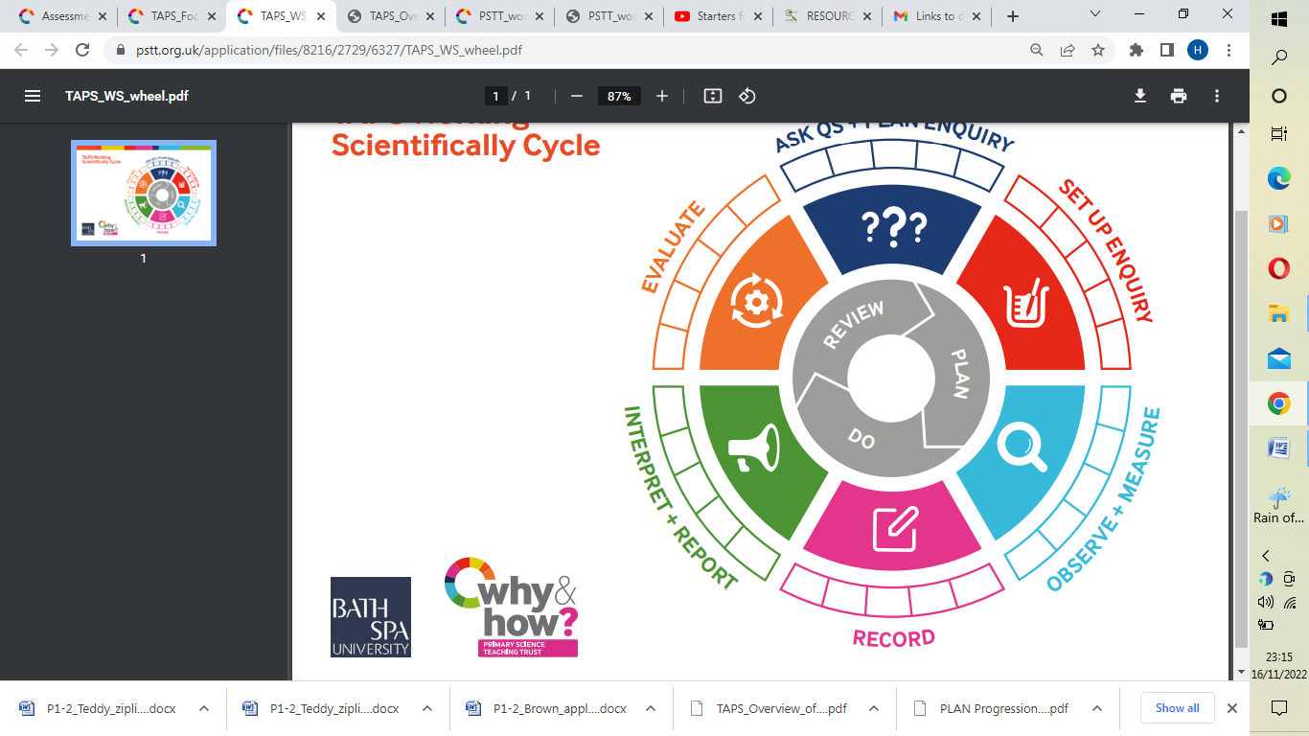  Light  National curriculum objectives  Recognise that they need light in order to see things and that dark is the absence of light, notice that light is reflected from surface, recognise that light from the sun can be dangerous and that there are ways to protect their eyes, recognise that shadows are formed when the light from a light source is blocked by an opaque object and find patterns in the way that the size of shadows change.  - Recognise that they need light in order to see things and that dark is the absence of light  - Notice that light is reflected from surfaces  - Recognise that light from the sun can be dangerous and that there are ways to protect their eyes  - Recognise that shadows are formed when the light from a light source is blocked by an opaque object  - Find patterns in the way that the size of shadows change.  Key Vocab  Light, Dark, Shadows, Mirror, Reflective, Reflection, Light Source, Cast  TAPS PLAN LINKS  Light: Making Shadows  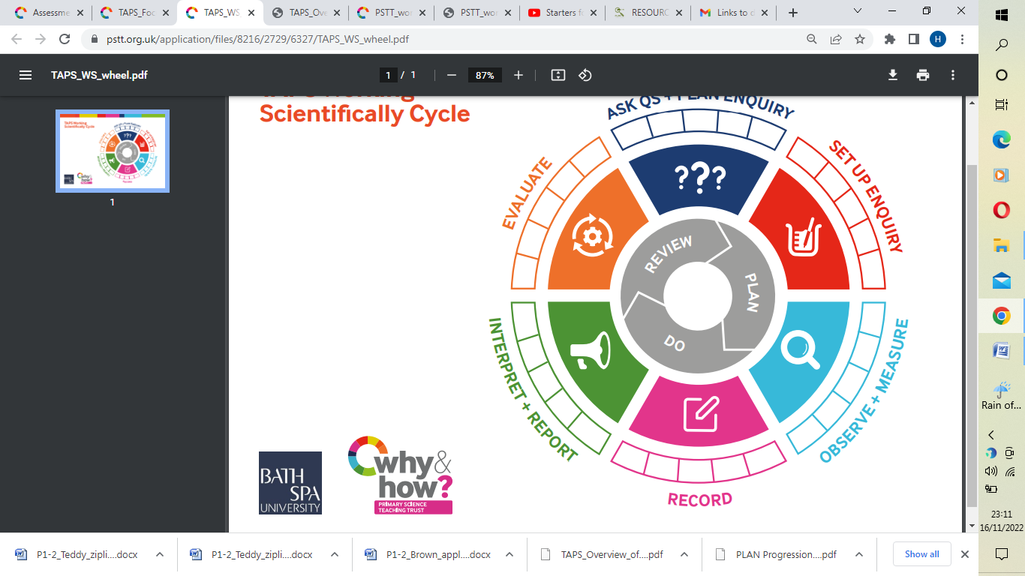 |  | Forces and Magnets  National curriculum objectives  Compare how things move on different surfaces, notice that some forces need contact between 2 objects, but magnetic forces can act at a distance, observe how magnets attract or repel each other and attract some materials and not others, compare and group together a variety of everyday materials on the basis of whether they are attracted to a magnet, and identify some magnetic materials, describe magnets as having 2 poles and predict whether 2 magnets will attract or repel each other, depending on which poles are facing.  - Compare how things move on different surfaces  - Notice that some forces need contact between two objects, but magnetic forces can act at a distance  - Observe how magnets attract or repel each other and attract some materials and not others, giving reasons  - Compare and group together a variety of everyday materials on the basis of whether they are attracted to a magnet, and identify some magnetic materials  - Describe magnets as having two poles  - Predict whether two magnets will attract or repel each other, depending on which poles are facing.  - Know how a simple pulley works and use one to lift an object  Key Vocab  Push, Pull, Attract, Magnetic, Force, Contact, Attract, Repel, Friction, Poles  TAPS PLAN LINKS  Forces: shoe grip  Forces: magnet tests  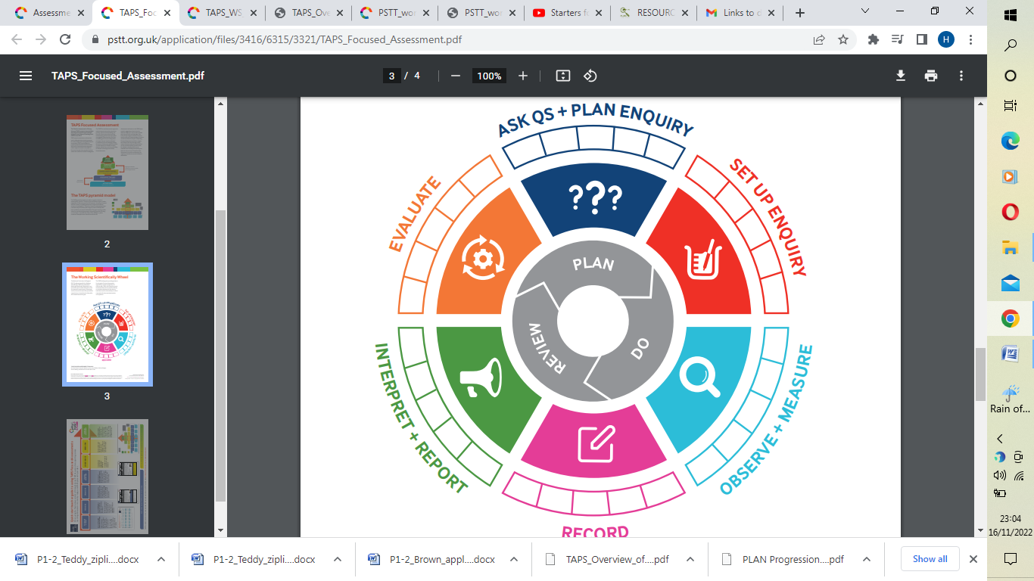  Forces: Cars down ramps  Forces: Balloon rockets  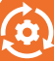  Animals including Humans  National curriculum objectives (Split)  Identify that animals, including humans, need the right types and amount of nutrition, and that they cannot make their own food; they get nutrition from what they eat.  - Identify that animals, including humans, need the right types and amount of nutrition, and that they cannot make their own food; they get nutrition from what they eat  - Know about the importance of a nutritious, balanced diet  - Know how nutrients, water and oxygen are transported within animals and humans  Key Vocab  Nutrition, Balanced  TAPS PLAN LINKS  Cupcake parachutes  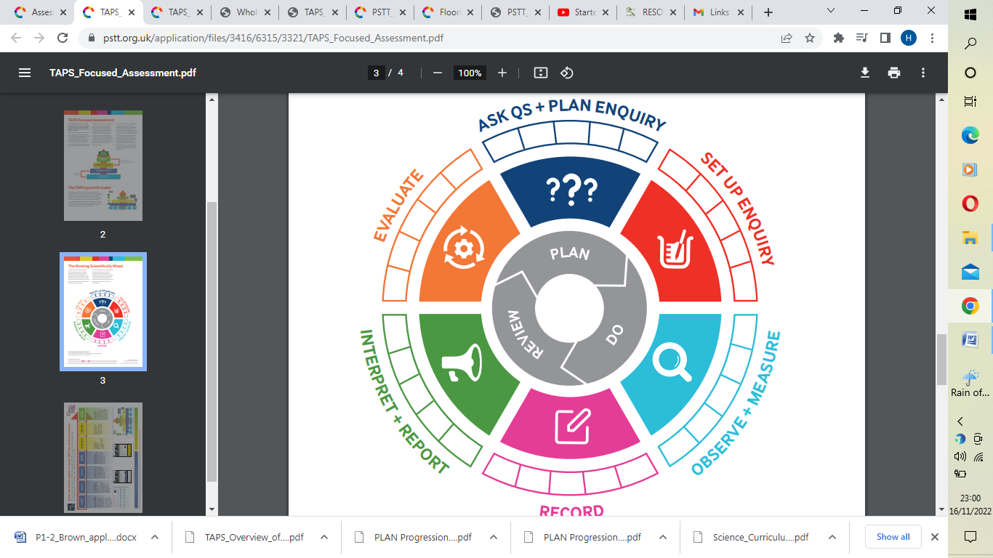 | Animals including Humans  National curriculum objectives (Split)  Identify that humans and some other animals have skeletons and muscles for support, protection and movement.  - Identify that humans and some other animals have skeletons and muscles for support, protection and movement  Key Vocab  Movement, Protection, Muscles, Bones, Skull, Skeletons  TAPS PLAN LINKS  Animals inc Humans: investigating skeletons  Plants  National curriculum objectives  Identify and describe the functions of different parts of flowering plants: roots, stem/trunk, leaves and flowers, explore the requirements of plants for life and growth (air, light, water, nutrients from soil, and room to grow) and how they vary from plant to plant, investigate the way in which water is transported within plants and explore the part that flowers play in the life cycle of flowering plants, including pollination, seed formation and seed dispersal.  - Identify and describe the functions of different parts of flowering plants: roots, stem/trunk, leaves and flowers  - Explore the requirements of plants for life and growth (air, light, water, nutrients from soil, and room to grow) and how they vary from plant to plant  - Investigate the way in which water is transported within plants  - Explore the part that flowers play in the life cycle of flowering plants, including pollination, seed formation and seed dispersal.  Key Vocab  Light, Water, Flower, Soil, Air, Nutrients, Compost, Reproduction, Transportation, Dispersal, Pollination,  TAPS PLAN LINKS  Plants: measuring plants  Ice cream  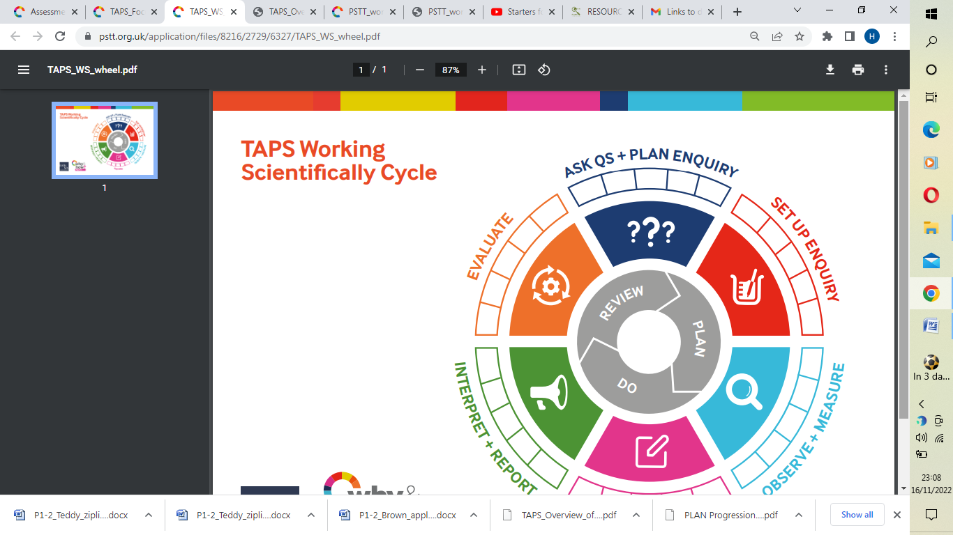  Plants: Function of stem
Computing | AUT 1 – Unit 3.2 Online Safety  -use technology safely, respectfully and responsibly; recognise acceptable/unacceptable behaviour; identify a range of ways to report concerns about content and contact.  - I can create a secure password.  - I can explain the importance of having a secure password and not sharing it with others  - I can explain the negative consequences of not keeping passwords safe and secure.  - I understand the importance of keeping safe online and behaving respectfully.  - I can report unacceptable content and contact online in more than one way to a trusted adult.  - I can use communication tools such as 2Email respectfully and use good etiquette.  Vocabulary – ( Appropriate, password, personal information, permission)  AUT 1 Begin Coding using coding books – stop after coding section  -design, write and debug programs that accomplish specific goals, including controlling or simulating physical systems; solve problems by decomposing them into smaller parts  -use sequence, selection, and repetition in programs; work with variables and various forms of input and output  -use logical reasoning to explain how some simple algorithms work and to detect and correct errors in algorithms and programs  AUT 2 Unit 3.1- Coding using Purple Mash  - I can make a real-life situation into an algorithm for a program.  - I can design an algorithm carefully, thinking about what I want it to do and how I can turn it into code.  - I can identify an error in my program and fix it.  - I can experiment with timers in my programs.  - I can identify the difference in using between the effect of a timer or repeat command in my code.  - I know that a variable stores information while a program is running (executing).  - I can identify ‘If’ statements, repetition and variables.  - I can read programs with several steps and predict what it will do.  Vocabulary- ( Action, Algorithm, Background, Bug, Events, Code, Input, Repeat, Command) |  | SPR1 – Online Safety 3.2 quiz only  -use technology safely, respectfully and responsibly; recognise acceptable/unacceptable behaviour; identify a range of ways to report concerns about content and contact.  understand computer networks including the internet; how they can provide multiple services, such as the world wide web; and the opportunities they offer for communication and collaboration  select, use and combine a variety of software (including internet services) on a range of digital devices to design and create a range of programs,  Spreadsheets - Unit 3.3  - I can collect data and input it into software  - I can analyse data using features within software to help such as, formula in 2Calculate  - I can present data and information using different software such as 2Question (branching database) or 2Graph (graphing tool  - I can create purposeful (appropriate) content and attach this to emails.  (Vocabulary – Bar graph, Cell address, data)  Touch type - Unit 3.4 - Additional unit  (Vocabulary – Keys, Space bar, Typing)  Simulations – Unit 3.7  - I can create purposeful (appropriate) content and attach this to emails.  Vocabulary – Simulation, realistic, unrealistic)  SPR2 –Email - Unit 3.5  - I can identify different ways that the internet can be used for communication.  - I can use email such as 2Email to respond to others appropriately and attach files.  - I can create purposeful (appropriate) content and attach this to emails.  - I can explain the importance of having a secure password and not sharing it with others  - I can explain the negative consequences of not keeping passwords safe and secure.  - I can use communication tools such as 2Email respectfully and use good etiquette.  Vocabulary – Email, Inbox, Attachment, Personal information)  All units - I can consider what the most appropriate software to use when given a task by my teacher.  All units - I can carry out searches to find digital content on a range of online systems, such as within Purple Mash or on an internet search engine | SUM 1 – Online Safety 3.2 quiz only  -use technology safely, respectfully and responsibly; recognise acceptable/unacceptable behaviour; identify a range of ways to report concerns about content and contact.  select, use and combine a variety of software (including internet services) on a range of digital devices to design and create a range of programs, systems and content that accomplish given goals, including collecting, analysing, evaluating and presenting data and information  Databases – Unit 3.6  I can collect data and input it into software  I can analyse data using features within software to help such as, formula in 2Calculate  I can present data and information using different software such as 2Question (branching database) or 2Graph (graphing tool  I can create purposeful (appropriate) content and attach this to emails.  Vocabulary – Binary tree, branching databases, data, database, debug)  Graphing – Unit 3.8 (maths link for data)  I can collect data and input it into software  I can analyse data using features within software to help such as, formula in 2Calculate  I can present data and information using different software such as 2Question (branching database) or 2Graph (graphing tool  I can create purposeful (appropriate) content and attach this to emails.  Vocabulary- (Column, data, row, graph, survey, title, axis)  SUM2 – Presenting – Unit 3.9 – Literacy link  I can present data and information using different software such as 2Question (branching database) or 2Graph (graphing tool  I can create purposeful (appropriate) content and attach this to emails.  Vocabulary – Animation, Fill colour, Font formatting, Presentation, Design, Slide, Slideshow, word art)
Geog | Autumn  Location Knowledge & Place Knowledge – Mediterranean  To extend knowledge and understanding beyond the local area to include Europe. To locate the world’s countries, using maps to focus on Europe, concentrating on their environmental regions, key physical and human characteristics, countries and major cities. To describe and understand key aspects of climate zones  - To know and locate major cities and counties in the UK  - To know the regions within the UK, including hills  - To locate different countries in the UK  - To understand what is meant by the term Climate Zone  - To know the differences between living in the UK and a Mediterranean country  - To understand typical foods grown in the Mediterranean regions/climate  - To know the climate in the Mediterranean  - To know the different islands in the region  - To describe some of the main attributes of one of the countries located in the Mediterranean  Key Vocabulary  - Region  - Destination  - Location  - Mediterranean  - Tourist  - Attraction  - Population |  | Spring  Human & Physical geography -  Volcanoes and Earthquakes  To describe and understand key aspects of volcanoes and earthquakes  - To know and label the three layers of the earth  - To explain how a volcano is formed  - To know where a famous volcano is located across the world  - To have an understanding of where ‘The Ring of Fire’ is located  - To understand how people might feel during an eruption/earthquake and understand the devastation this can cause  - To know what causes an earthquake  Key Vocabulary – Volcanos  - Core  - Crust  - Dormant  - Vent  - Eruption  - Extinct  - Lava  - Gas  - Layers  - Magma  - Mantle  - Malton  - Magnitude  - Ash cloud  - Earth’s crust  - Inner core  - Outer core  Vocab – Earthquakes  - Tectonic plates  - Boundaries  - Devastation  - Aftershock | Summer  Skills and fieldwork - Ancient Egypt (links to history topic)  To use maps, atlases, globes and digital/computer mapping to locate countries and describe features studied  - To know and use the eight points of a compass  - To follow instructions and complete a route using compass direction  - To follow direction instructions on a four figure grid references  - Use Google Earth/maps to locate different places around the world  Key Vocabulary  - Landscape  - Industry  - Farming  - Floor plan  - Symbol  - Settlement  - Land use
Hist | National curriculum objectives  Pupils should be taught:  Roman Empire  A local history study  - -The Roman Empire and its impact on Britain  - Julius Caesar’s attempted invasion in 55-54 BC  - The Roman Empire by AD 42 and the power of its army  - Successful invasion by Claudius and conquest, including Hadrian’s Wall  - British resistance, for example, Boudica  - ‘Romanisation’ of Britain: sites such as Caerwent and the impact of technology, culture and beliefs, including early Christianity  Key Vocabulary  - Emperor  - Empire  - Legion  - Invade  - Conquer  - Settlers  - Gladiator  - Architecture  - Peasant  - Theatre  - Coliseum |  |  | National curriculum objectives  Pupils should be taught:  Ancient Egypt  -the achievements of the earliest civilizations – an overview of where and when the first civilizations appeared and an in depth study of one of the following: Ancient Sumer; The Indus Valley; Ancient Egypt; The Shang Dynasty of Ancient China  -Know about, and name, some of the advanced societies that were around 3000 years ago  - Know about the key features of Ancient Egypt  - To know what the word Ancient means  - To know that 7500BC is when the first settlers arrived in the Nile Valley  - To know about Mummification  - To know why people lived on the banks of the Nile in Ancient history and today.  - The Ancient Egyptians invented lots of things we still use today.  - To know why Tutankhamun was so famous.  - To know the significance of the pyramids.  - To know that the Ancient Egyptians worshiped more than one God.  Key Vocabulary  - Archaeologist  - Pharaoh  - Tomb  - Pyramid  - Hieroglyphics  - Sarcophagus  - Mummy  - Papyrus  - Amulet
D.T |  | DT – Romans  (Link with Science)  How to make a Roman catapult  (See Technical Knowledge DT plan)  -Apply understanding of how to strengthen, stiffen and reinforce structures  -Identify range of mechanical systems and how they work (gears, pulleys, cams, levers)  Design  -Communicate ideas using different strategies .e.g. discussion, sketch  -Use research to inform design  -Take risks to become innovative and resourceful  Make  -Select from and use a range of tools, equipment, materials and components including construction materials, textiles and ingredients.  Evaluate  -Investigate a range of existing products that address real/relevant problems, in a range of relevant contexts e.g. home, school leisure  -Evaluate own ideas and designs against given design criteria and consider the views of others to improve their work
Art |  | National curriculum objectives  Pupils should be taught to:  -to create sketch books to record their observations and use them to review and revisit ideas  -to improve their mastery of art and design techniques, including drawing, painting and sculpture with a range of materials [for example, pencil, charcoal, paint, clay]  -about great artists, architects and designers in history. | National curriculum objectives  Pupils should be taught to:  -to create sketch books to record their observations and use them to review and revisit ideas  -to improve their mastery of art and design techniques, including drawing, painting and sculpture with a range of materials [for example, pencil, charcoal, paint, clay]  -about great artists, architects and designers in history |  | National curriculum objectives  Pupils should be taught to:  -to create sketch books to record their observations and use them to review and revisit ideas  -to improve their mastery of art and design techniques, including drawing, painting and sculpture with a range of materials [for example, pencil, charcoal, paint, clay]  -about great artists, architects and designers in history.
P.E |  | National curriculum objectives  Pupils should be taught to:  Gymnastics and Dance  -develop flexibility, strength, technique, control and balance [for example, through athletics and gymnastics]  -perform dances using a range of movement patterns  -compare their performances with previous ones and demonstrate improvement to achieve their personal best.  - adapt sequences to suit different types of apparatus and criteria  - explain how strength and suppleness affect performance  - improvise freely and translate ideas from a stimulus into movement  - share and create phrases with a partner and small group  - remember and repeat dance perform phrases | National curriculum objectives  Pupils should be taught to:  Athletics  - use running, jumping, throwing and catching in isolation and in combination  - develop flexibility, strength, technique, control and balance [for example, through athletics and gymnastics]  - Run at fast, medium and slow speeds: changing speed and direction  - Take part in relay, remembering when to run and what to do |  | National curriculum objectives  Pupils should be taught to:  Competitive games  -play competitive games, modified where appropriate [for example, badminton, basketball, cricket, football, hockey, netball, rounders and tennis], and apply basic principles suitable for attacking and defending  - take part in outdoor and adventurous activity challenges both individually and within a team  - Be aware of space and use it to support team-mates and to cause problems for the opposition  - Know and uses rules fairly

R.E | What does it mean to be a Christian today?  Agreed Syllabus  -Describe some examples of what Christians do  to show their faith, and make connections with  some Christian beliefs and teachings (A1).  -Describe some ways in which Christian express  their faith through hymns and modern worship  songs (A2).  -Suggest at least two reasons why being a  Christian is a good thing in Britain today, and  two reasons why it might be hard sometimes  (B2).  -Discuss links between the actions of Christians  in helping others and ways in which people of  other faiths and beliefs, including pupils  themselves, help others (C2). | What do different people believe about God?  Agreed Syllabus  - Describe some of the ways in  which Christians Hindus and/or  Muslims describe God (A1).  -Ask questions and suggest some  of their own responses to ideas  about God (C1).  -Suggest why having a faith or  belief in something can be hard  (B2).  -Identify how and say why it  makes a difference in people’s  lives to believe in God (B1). | Why is the Bible important for Christians today?  Agreed Syllabus  Make connections between  stories in the Bible and what  Christians believe about  creation, the Fall and  salvation (A2).  -Give examples of how and  suggest reasons why  Christians use the Bible today  (B1).  -Describe some ways  Christians say God is like,  with examples from the  Bible, using different forms  of expression (A1).  -Discuss their own and others’  ideas about why humans do  bad things and how people  try to put things right (C3).  Why do people pray?  Agreed Syllabus  -Describe the practice of prayer in the  religions studied (A2).  -Make connections between what  people believe about prayer and  what they do when they pray (A3).  -Describe ways in which prayer can  comfort and challenge believers  (B2).  -Describe and comment on  similarities and differences between  how Christians, Muslims and Hindus  pray (B3).
Languages | National curriculum objectives  Pupils should be taught to:  Ourselves  Celebrations  -listen attentively to spoken language and show understanding by joining in and responding -explore the patterns and sounds of language through songs and rhymes and link the spelling, sound and meaning of words  -engage in conversations; ask and answer questions; express opinions and respond to those of others; seek clarification and help*  -speak in sentences, using familiar vocabulary, phrases and basic language structures -develop accurate pronunciation and intonation so that others understand when they are reading aloud or using familiar words and phrases*  -present ideas and information orally to a range of audiences*  -read carefully and show understanding of words, phrases and simple writing  -appreciate stories, songs, poems and rhymes in the language  -broaden their vocabulary and develop their ability to understand new words that are introduced into familiar written material, including through using a dictionary  -write phrases from memory, and adapt these to create new sentences, to express ideas clearly  -describe people, places, things and actions orally* and in writing  -understand basic grammar appropriate to the language being studied, including (where relevant): feminine, masculine and neuter forms and the conjugation of high-frequency verbs; key features and patterns of the language; how to apply these, for instance, to build sentences; and how these differ from or are similar to English.  - Name and describe people, a place and an object  - Give response using a short phrase  - Write phrases from memory  - Write 2-3 short sentences on a familiar topic | National curriculum objectives  Pupils should be taught to:  School  Weather  -listen attentively to spoken language and show understanding by joining in and responding -explore the patterns and sounds of language through songs and rhymes and link the spelling, sound and meaning of words  -engage in conversations; ask and answer questions; express opinions and respond to those of others; seek clarification and help*  -speak in sentences, using familiar vocabulary, phrases and basic language structures -develop accurate pronunciation and intonation so that others understand when they are reading aloud or using familiar words and phrases*  -present ideas and information orally to a range of audiences*  -read carefully and show understanding of words, phrases and simple writing  -appreciate stories, songs, poems and rhymes in the language  -broaden their vocabulary and develop their ability to understand new words that are introduced into familiar written material, including through using a dictionary  -write phrases from memory, and adapt these to create new sentences, to express ideas clearly  -describe people, places, things and actions orally* and in writing  -understand basic grammar appropriate to the language being studied, including (where relevant): feminine, masculine and neuter forms and the conjugation of high-frequency verbs; key features and patterns of the language; how to apply these, for instance, to build sentences; and how these differ from or are similar to English.  - Read and understand a short passage  - Explain the main points in a short passage  - Read a short passage independently  - Use a bilingual dictionary or glossary to look up new words  - Start to speak, using a full sentence | National curriculum objectives  Pupils should be taught to:  Hobbies  Holidays  -listen attentively to spoken language and show understanding by joining in and responding -explore the patterns and sounds of language through songs and rhymes and link the spelling, sound and meaning of words  -engage in conversations; ask and answer questions; express opinions and respond to those of others; seek clarification and help*  -speak in sentences, using familiar vocabulary, phrases and basic language structures -develop accurate pronunciation and intonation so that others understand when they are reading aloud or using familiar words and phrases*  -present ideas and information orally to a range of audiences*  -read carefully and show understanding of words, phrases and simple writing  -appreciate stories, songs, poems and rhymes in the language  -broaden their vocabulary and develop their ability to understand new words that are introduced into familiar written material, including through using a dictionary  -write phrases from memory, and adapt these to create new sentences, to express ideas clearly  -describe people, places, things and actions orally* and in writing  -understand basic grammar appropriate to the language being studied, including (where relevant): feminine, masculine and neuter forms and the conjugation of high-frequency verbs; key features and patterns of the language; how to apply these, for instance, to build sentences; and how these differ from or are similar to English.  - Write about what they like/dislike about a familiar topic  - Have a short conversation, saying 3 to 4 things
Music | National curriculum objectives  Pupils should be taught to:  -play and perform in solo and ensemble contexts, using their voices and playing musical instruments with increasing accuracy, fluency, control and expression  -play clear notes on instruments and use different elements in composition  -improvise and compose music for a range of purposes using the inter-related dimensions of music  -combine different sounds to create a specific mood or feeling  -listen with attention to detail and recall sounds with increasing aural memory  -use and understand staff and other musical notations  -create repeated patterns with different instruments  - improve work: explaining how it has been improved  -appreciate and understand a wide range of high-quality live and recorded music drawn from different traditions and from great composers and musicians  -use musical words to describe a piece of music and compositions  -use musical words to describe what they like and do not like about a piece of music  -develop an understanding of the history of music.  -recognise the work of at least one famous composer

