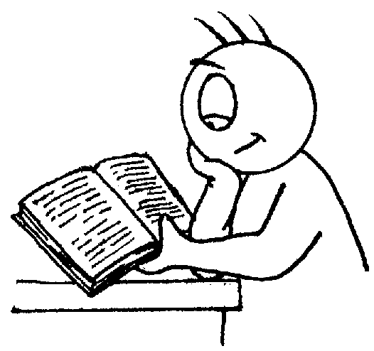
St Andrew’s Methodist Primary School

End of Year Expectations
for Year 6

This booklet provides information for parents and carers on the end of year expectations for children in our school. The staff have identified these expectations as being the minimum requirements your child must meet in order to ensure continued progress throughout the following year.

All the objectives will be worked on throughout the year and will be the focus of direct teaching. Any extra support you can provide in helping your children to achieve these is greatly valued.

If you have any queries regarding the content of this booklet or want support in knowing how best to help your children please talk to your child’s teacher.

Mathematics

- Read and write numbers to 10,000,000.
- Round any number to any degree of accuracy.
- Add and subtract negative integers.
- Use tables to work with decimals (to 1dp).
- Multiply 4-digit whole numbers by 2-digit whole numbers.
- Divide numbers up to 4-digits by a 2-digit whole numbers and recognise remainders.
- Multiply and divide decimals by 10, 100 or 1000 in their head.
- Multiply and divide a number with up to two decimal places by 1-digit and 2-digit whole numbers.
- Work out simple % of whole numbers.
- Use ratio to show the relative sizes of two quantities.

Reading

- Refers to text to support opinions and predictions.
- Gives a view about choice of vocabulary, structure etc.
- Distinguish between fact & opinion.
- Appreciates how a set of sentences has been arranged to create maximum effect.
- Recognise complex sentences
- Skims and scans to aid note-taking.

Writing

- Use subordinate clauses to write complex sentences.
- Use passive voice where appropriate.
- Use expanded noun phrases to convey complicated information concisely (e.g. The fact that it was raining meant the end of sports day).
- Evidence of sentence structure and layout matched to requirements of text type.
- Use:
  - Semi-colon, colon, dash to mark the boundary between independent clauses.
  - Correct punctuation of bullet points.
  - Hyphens to avoid ambiguity.
  - Full range of punctuation matched to requirements of text type.
- Use wide range of devices to build cohesion within and across paragraphs.
- Use paragraphs to signal change in time, scene, action, mood or person.
- Legible, fluent and personal handwriting style.
