St Andrew’s Methodist Primary School
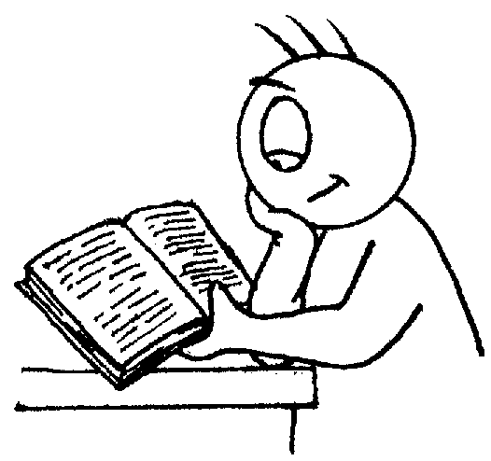

End of Year Expectations
for Year 3

This booklet provides information for parents and carers on the end of year expectations for children in our school. The staff have identified these expectations as being the minimum requirements your child must meet in order to ensure continued progress throughout the following year.

All the objectives will be worked on throughout the year and will be the focus of direct teaching. Any extra support you can provide in helping your children to achieve these is greatly valued.

If you have any queries regarding the content of this booklet or want support in knowing how best to help your children please talk to your child’s teacher.

Mathematics

- Compare & order numbers up to 1000.
- Read & write all numbers to 1000 in digits & words.
- Find 10 or 100 more/less than a given number.
- Count from 0 in multiples of 4, 8, 50 & 100.
- Recall & use multiplication & division facts for 3, 4, 8 tables.
- Recognise place value of any 3-digit number.
Add & subtract:
- 3-digit numbers & ones
- 3-digit numbers & tens
- 3-digit numbers & hundreds
- Add & subtract:
- Numbers with up to 3-digits using efficient written method (column).
- Use inverse to check.
Multiply:
- 2-digit by 1-digit
- Count up/down in tenths.
- Compare & order fractions with same denominator.
- Add and subtract fractions with same denominator with whole.
- Know pairs of fractions that total 1.
- Tell time using 12 and 24 hour clocks; and using roman numerals.
- Tell time to nearest minute.
- Know number of days in each month.

Reading

- Comments on the way characters relate to one another.
- Knows which words are essential in a sentence to retain meaning.
- Draw inferences such as inferring characters’ feelings, thoughts & motives from their actions.
- Recognise how commas area used to give more meaning.
- Recognise:
  - plurals
  - pronouns and how used
  - collective nouns
  - adverbs
- Can explain the difference that adjectives and verbs make.

Writing

- Use conjunctions (when, so, before, after, while, because).
- Use adverbs (e.g. then, next, soon).
- Use prepositions (e.g. before, after, during, in, because of).
- Experiment with adjectives to create impact.
- Correctly use verbs in 1st, 2nd & 3rd person.
- Use perfect form of verbs to mark relationships of time & cause.
- Correct use of speech marks for direct speech.
- Group ideas into paragraphs around a theme.
- Write under headings & sub-headings.
- Legible, joined handwriting.

