St. Andrew’s Methodist Nursery

Contact Details

The School address is: - Prescott Street,
Little Hulton,
Worsley,
Manchester
M28 0ZA

The School telephone number is: 0161 790 3194
The School Website address is: www.standrewsmethodistschool.co.uk

The maintaining authority is the Salford City Council Educational Authority.
The Education Office address is:-
Nick Page
Director of Children’s Services,
Civic Centre
Chorley Road
Swinton
The Education Office number is: 0161 778 0123

Welcome

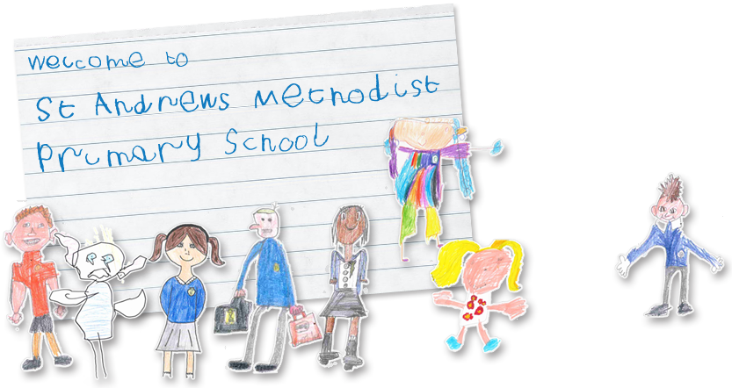
We would like to take this opportunity to welcome you and your family to our school. St. Andrew’s Nursery class is for boys and girls aged 3-4 years. The Nursery and Reception Class (for children aged 4-5 years) form the Foundation Stage of St. Andrew’s Methodist Primary School.

Staff Information

Mrs A Smith – Executive Headteacher
Miss K Harrild – Deputy Headteacher

There are five members of staff within our Early Years Team
The Early Years Staff are:-
Miss H Greenhalgh-Nursery Teacher/ Early Years Leader
Miss K Storey- Reception Teacher
Mrs P O’Leary- Teaching Assistant
Mrs J Gibbons- Teaching Assistant
Miss A Cunningham- Teaching Assistant

General Information- Nursery

The Nursery Day

Nursery times are: - Full Time (9.00am – 3.15pm)
Lunch (11.45am – 12.15pm)
Lunch break (12.00pm– 1.00pm)
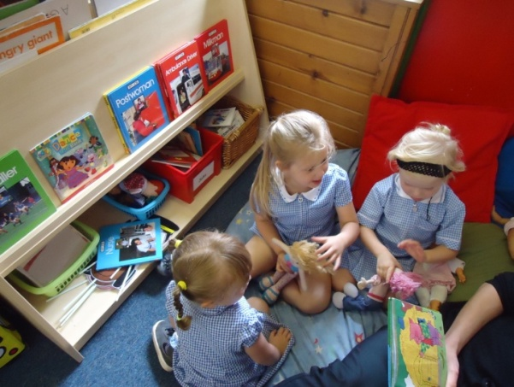
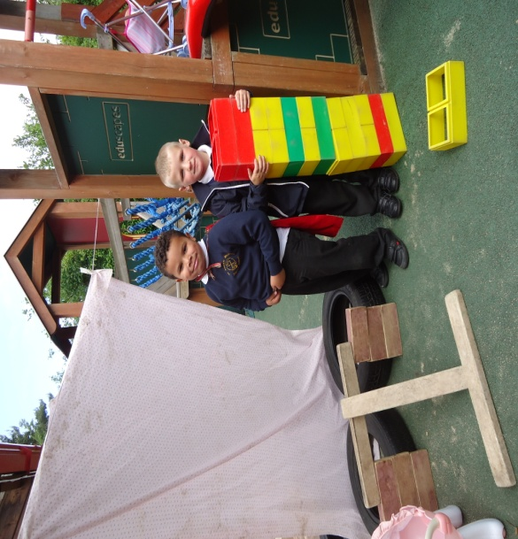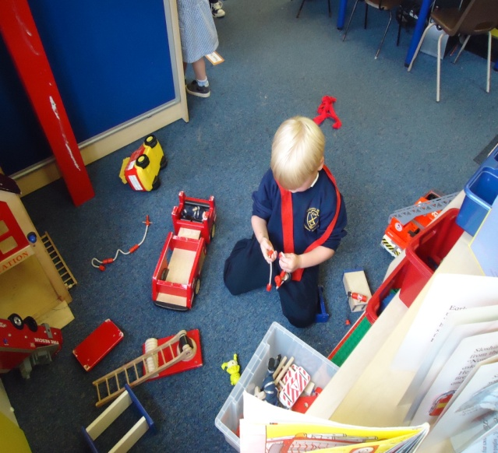
It is important that you are punctual at the start of the session. The gate will be locked at approximately 9.05am after which you will need to use the main entrance and let the office know your child has arrived. When waiting at the gate in the morning, please keep your child by your side and off the staff car park.

Lunchtime/Snack Provision in the Nursery

All children are required to have a school meal.
School meals currently cost £1.80 per day (£9.00 per week.) Please note that this is subject to change.
Please bring this money on Monday mornings in an envelope clearly marked with your child’s name, which should be placed inside their school bag, these are checked daily. It is also possible to pay monthly in advance. Please arrange this through the main school office.
You may be eligible for free school meals. For further information, contact:-
Salford Direct @ Civic Centre Tel: 0161 909 6508 (Office hours vary.)

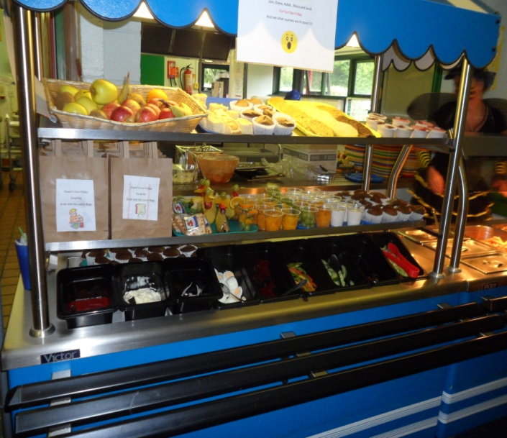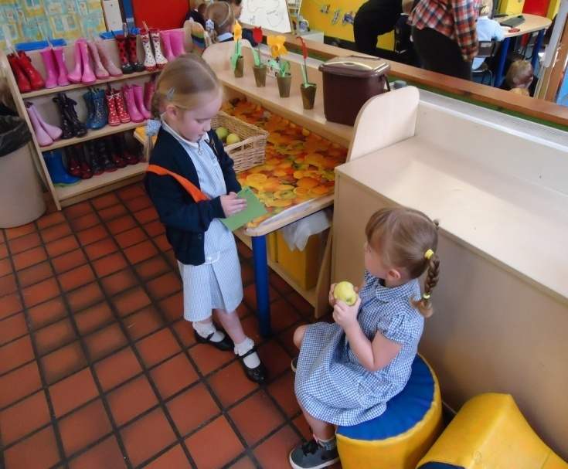
A carton of milk will be provided each day for your child along with a portion of fruit. School milk is provided free of charge to children under five years old. The milk and fruit will be provided on a snack table so the children have continuous access to it. In September the children will need to bring a named water bottle into school each day. Not the ‘Evian’ kind but the beaker kind that go with lunch boxes. These will be left at Nursery and refilled each day with fresh water.

Talking about Nursery

It is important that you talk about coming to Nursery before your child starts. Explain that there will be other children there, and lots of exciting things to do and play with. Explain that you will have to leave them in the nursery with the other children, but that you love them very much and will always come back. Mention the names of the Nursery staff in a happy positive way. Come and visit the Nursery soon so that you and your child can meet the staff and see what the Nursery looks like.
Below are some pictures that will assist you with talking about Nursery.

This door is where the children enter the nursery in the morning and where they leave the nursery at home time.
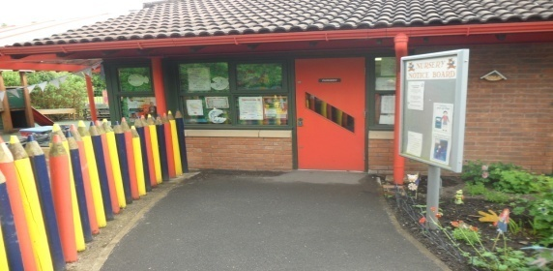

These are our nursery toilets.
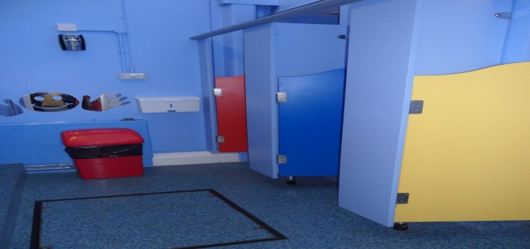

This is our exciting outdoor area.
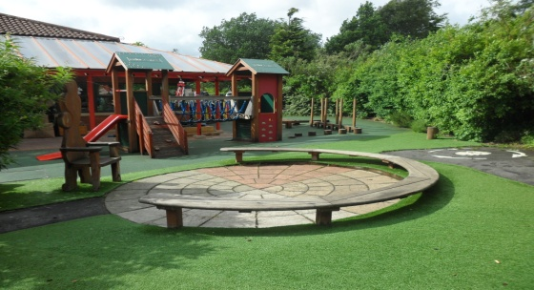

This is where they will hang their coat. 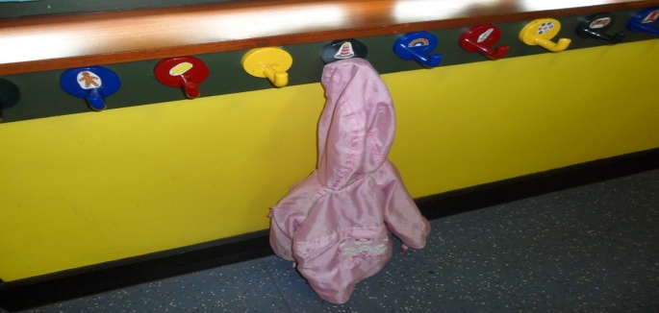

This is our carpet area.
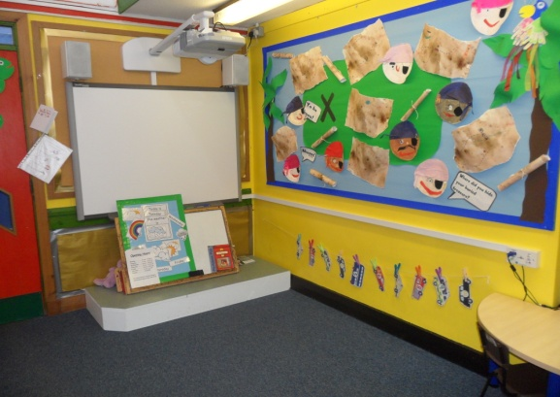

This is our hall where the children will eat their lunch.
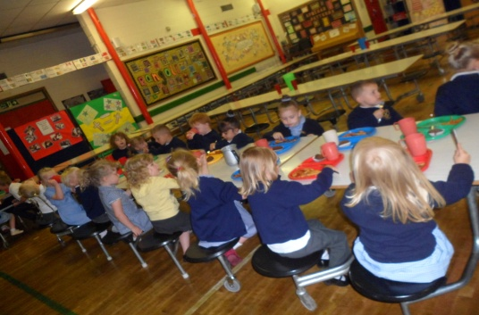

Other Nursery Information

When your child has settled in, the class will be separated into three groups and each group will be assigned a key worker. Your parents evening appointment will be with Miss Greenhalgh and your child’s key worker.

We have a Foundation Stage Fund to which we invite you to contribute. If you so wish, the sum of 50p each week will be collected by the Nursery Teacher on a Monday morning along with dinner money if applicable. We use the fund to buy tissues, baking ingredients, resources and other items, which we may need to buy for the benefit of the children. We have a lot of special events, days and celebrations in the Foundation Stage that the school fund pays for.

Sweets, crisps or chocolate are not allowed in the Nursery as a portion of fruit is given to each child every day as a snack.
We encourage children not to bring their own toys from home as it can cause upset if they become lost or broken. We have a wide variety of toys for the children to access each day at Nursery.
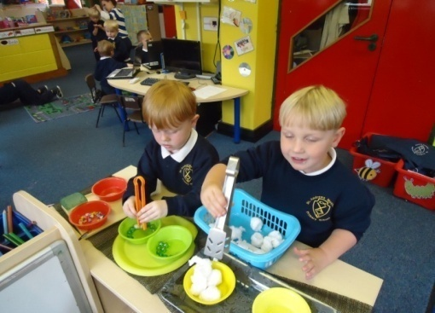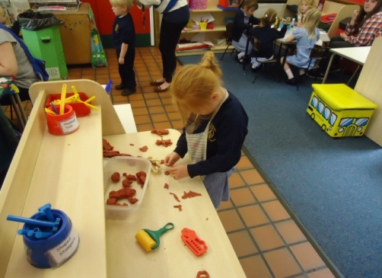
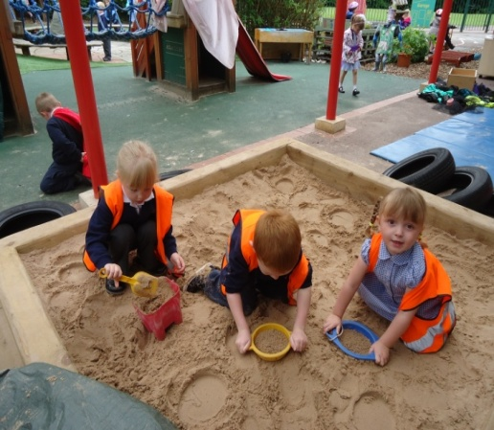

Uniform
We would like all the Nursery children to wear uniform.
The Nursery uniform comprises: -
Navy Sweatshirt with school logo,
White polo T-shirt,
Navy tracksuit bottoms.
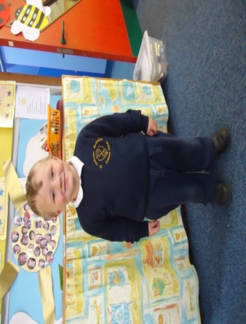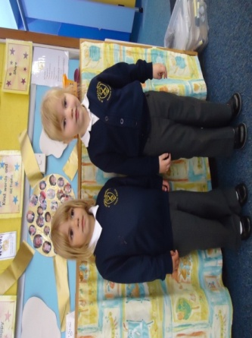
In summertime the girls may wear blue checked or striped dresses, and girls or boys may wear plain navy shorts with elasticated waists.
We are the main supplier for uniform. Below is a price list of uniform that can be purchased from our school office:
- Sweatshirts £ 9.00 (24” – 32”)
- Sweatshirts £10.50 (S M L)
- Sweatcardis £10.50
- PE Shirt £ 5.50
- Shorts £ 5.00
- PE Bags £ 2.50
- Buy all three items of PE kit £12.00
- Book Bags £ 3.50
Children should wear sensible shoes, preferably with a velcro fastening to encourage independence when dressing and undressing.
We would like the children to keep a pair of wellingtons in school for outdoor play on rainy days, and a sunhat for sunny ones. Included in our pack is a consent form for your permission for us to apply sun cream to your child.

Please put nametags in school clothing and coats, or mark them with a name to avoid confusion or loss.
We would like all children to have a school book-bag. They are available to buy from the school office.
If it is a wet day and your child comes to school in wellingtons, please bring shoes to change into.
We provide protective clothing and aprons for activities such as painting, sand and water play, art and baking. We also have waterproof jackets for outdoor play on rainy days.
Please do not allow your child to bring any other bags, as space in the cloakroom is limited.
A photographer will take individual photographs of your child before Christmas and as a group in the summer. Please remember that you are under no obligation to buy the photographs.
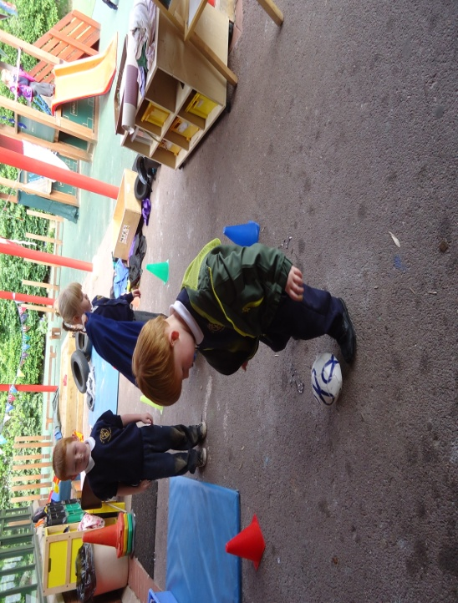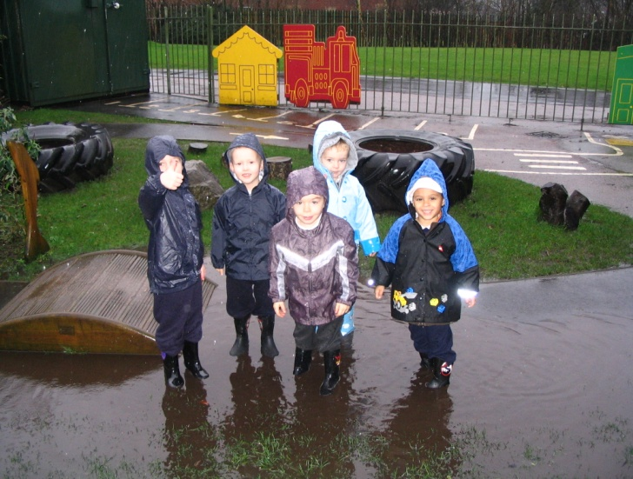

Absences from Nursery

If your child is ill and cannot come to school, please ring and let us know.
A poorly child is happier at home, even if he/she cries to come to school.
We do not administer any medicines in the Nursery. If your child needs an inhaler, you will need to provide an extra one for school and complete a form.

If your child needs a course of medicine e.g.: antibiotics, Penicillin etc, we feel it is necessary that he/she remains at home with you until the course of medicine is finished and your child is fully recovered.

If your child is taken ill whilst at Nursery, we will contact you at home or work. An emergency contact form must be completed when your child enters Nursery, with at least two phone numbers listed for emergencies. Please notify us immediately if there are any changes of phone numbers or place of work so that our records are kept up to date.

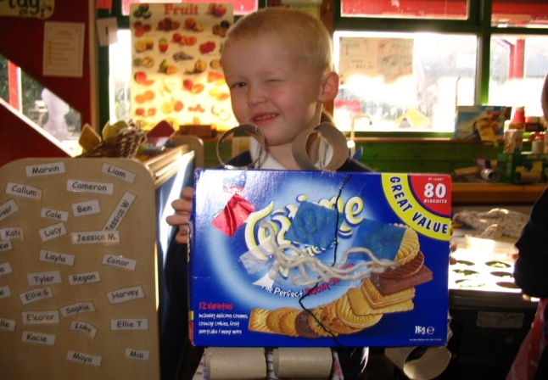
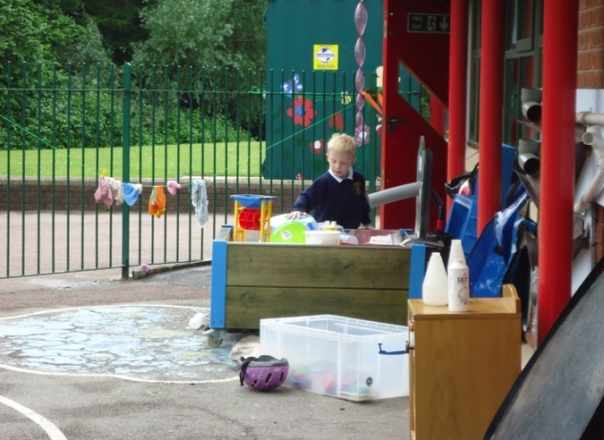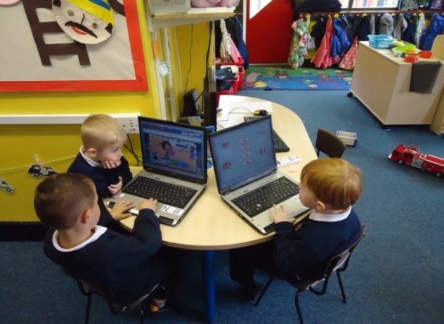

Learning in the Foundation Years
We will provide a happy, safe and caring environment for your child. We will provide a quality, well-planned Foundation Years education for your child in accordance with the Dfe document entitled ‘The Early Years Foundation Stage’. We will offer your child a wide range of valuable learning experiences, which aim to underpin all future learning. Our aims are to promote development in these areas.
Personal Social & Emotional Development
We aim to help your child adjust to and enjoy school, to relate to other children and adults in school, to learn to become part of a group, to share and take turns, to become more independent, to co-operate and to build self-confidence and self esteem.
Communication and Language
We aim to develop language to communicate needs, thoughts and feelings and to provide the foundations for literacy by developing the basic skills in reading and writing. We will be following the Letters and Sounds document for phonic development.
Physical Development

Physical skills and co-ordination are developed through use of apparatus and games. These skills include running, jumping, climbing, balancing, throwing etc. We have outdoor play every day at nursery in our exciting garden, which has a large climbing frame, mini assault course and roadway. There are also planned P.E sessions in the hall. Fine manipulative skills are developed in many ways, for example through threading, cutting, painting and colouring, pencil play, malleable activities and small construction kits. We aim to establish positive attitudes towards a healthy and active way of life.

Literacy- Reading and Writing
Children in the foundation stage are encouraged to read and write every day in a variety of different ways. In nursery, children will practise writing their name and forming letters correctly. Children will enjoy a variety of books, both fiction and non-fiction each day. We encourage parents to enjoy sharing books regularly with their child. Children in the nursery will take part in a daily phonics session each day. We use the ‘Letters and Sounds’ document to support our phonics teaching in school.

Mathematics – Number and Space, Shape and Measures
We aim to cover important aspects of mathematical understanding and provide the foundations for numeracy. This is achieved through a wide range of practical and play activities. This promotes understanding of patterns, sequences, sorting, matching, counting and problem solving and encourages the use of appropriate language to develop simple mathematical ideas.

Understanding of the World
We aim to encourage your child’s natural curiosity of the world around them by providing a wide range of exciting activities which encourage and require observation and which will foster an interest in the natural world and the people in it. The opportunities we provide will naturally encourage your child to ask questions Why? What? Where? Who? thus providing a foundation for historical, geographical, scientific and technological learning. Our Foundation Stage Outdoor Adventure Play Area will give many opportunities to observe plants and wildlife at first hand.

Expressive Arts and Design
We aim to develop the senses, imagination and to provide creative experiences through a wide range of art activities, drama, music, stories and poems.

How to Help Your Child Prepare for Nursery
All children must be toilet-trained. If this is proving a problem, please contact Nursery staff before your child is due to start at the Nursery. Occasionally, your child may have a toileting accident in school. If this happens, a member of the nursery staff will wash your child and change them into clean clothes. These clothes need to be cleaned and returned to school as soon as possible. If you have any objection to this, please inform the headteacher in writing.
If your child can do the following things it would be most helpful as we encourage independence as much as possible.
- Wash and dry own hands,
- use a knife, fork and spoon,
- suck through a straw,
- manage his/her own clothes at the toilet,
- put coat on and off and hang it up,
- wipe his/her nose,
- take off and put on shoes (without fastening them).
- take off and put on their socks

Please try to find time to read stories and nursery rhymes to your child. Choose books with large attractive illustrations. Visit the local library and encourage your child to choose their own books. Encourage him/her to sit with you to share, listen and look. It is also a good idea to watch suitable pre-school television programmes with your child and talk about them. Let your child help you around the house, with washing up, baking, setting the table, tidying away toys etc. Talk with your child as much as possible, explaining what you are doing and asking him/her simple questions. Listen to replies and respond to them giving praise for any achievement-
No matter how small. Your child learns from you!

Home-school Links

At St Andrew’s, we view parents as partners and value your contribution and support towards your child’s education and to all aspects of school life in general.
There are lots of ways in which St Andrew’s encourages links between home and school.
We hold whole school fund raising events, which we invite you to support and get involved in. In the nursery, we have special activities such as sponsored events, non-uniform days, etc.
You will also receive regular newsletters giving you information about things going on in the nursery as well as telling you about forthcoming events. Executive Headteacher newsletters for the whole school are also circulated where appropriate.
As well as this we will send out a letter at the beginning of the school year asking about your child’s interest and previous experience and learning. You will also receive a letter at the end of each term telling you what the topic will be for next half term.
Every term, you will be invited to spend the morning with your child in school as part of a ‘Come and Play’ Day. This is an opportunity to see the classroom and find out what your child likes to do in school.
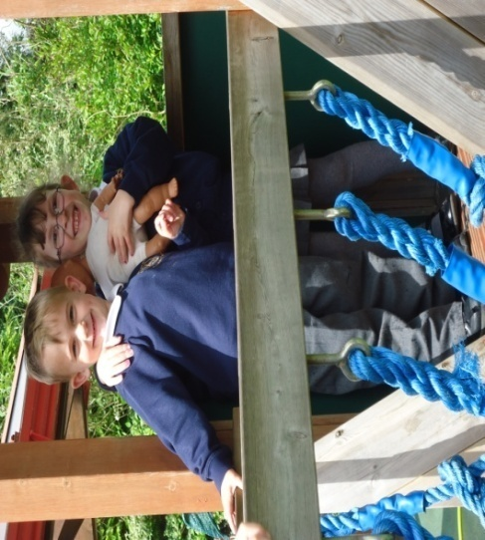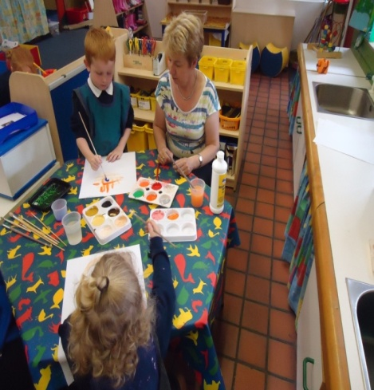

Your Child’s Progress
In the nursery, we hold two parents’ evenings during the school year – usually in October and March. This gives parents the opportunity to visit the nursery staff and talk with the nursery teacher about your child. Parents can also look at children’s work and see the range of activities available in the nursery.
You will also receive a detailed written report in July. At the end of Reception you will receive a Learning Journey which will be made up of the photos we have taken of your child to document their progress as part of their Foundation Stage Profile. You can always ask to look at your child’s Learning Journey. Please arrange this through your child’s key worker or the Nursery teacher.
Please feel free to come into the nursery before 9.00am or after 3.15pm to discuss any matters concerning your child. We will be more than happy to talk to you.

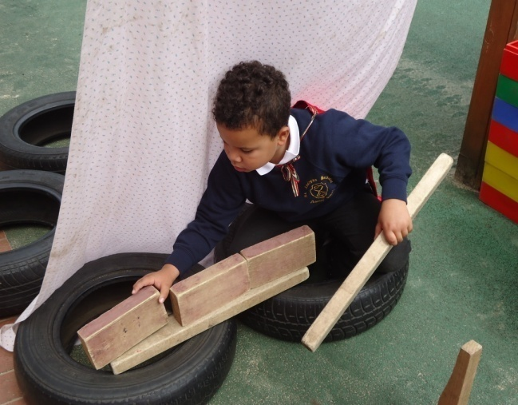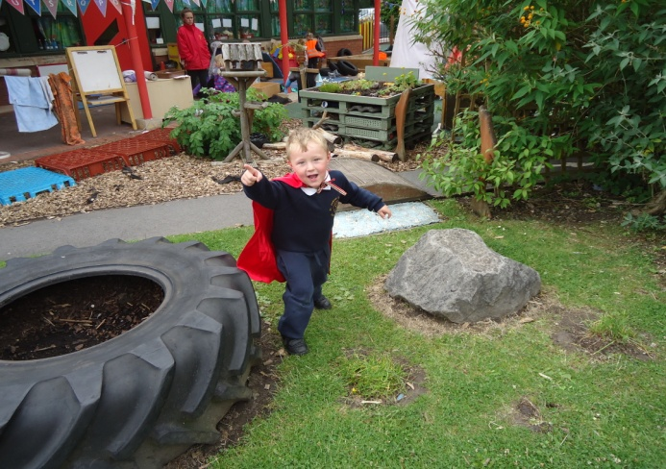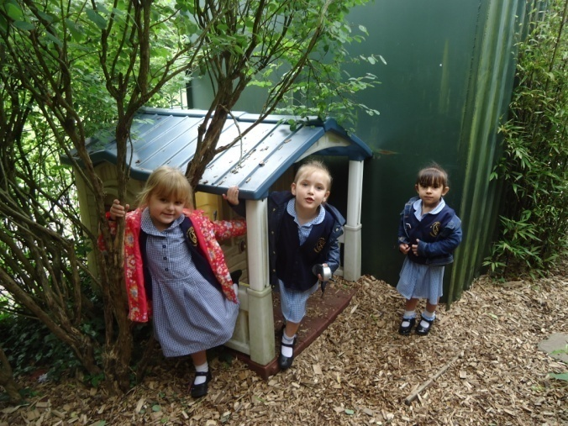

Conclusion

It is our aim to give your child the best possible start to his/her education. You can be confident that your child will develop in a stimulating, secure environment, which specifically caters for the needs of the children entrusted to our care. We look forward to working in partnership with you and your child at St Andrew’s Nursery.

Mrs A Smith
Executive Headteacher

In September we need:
A water bottle
A pair of wellies
A sunhat

